# Lab 3 Report

## Ruijie Song

## Feb.11.2021

Section 1 Report:



Figure . img22gd2.tif.





Figure . the image showing the connected set for s = (67, 45), and T = 2.

3.



Figure . the image showing the connected set for s = (67, 45), and T = 1.

4.



Figure . the image showing the connected set for s = (67, 45), and T = 3.

Section 2 Report:

1.

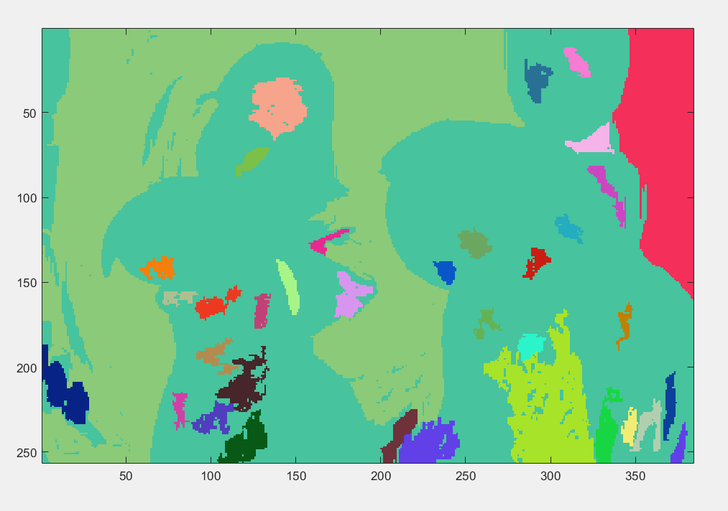

Figure . randomly colored segmentation for T = 1

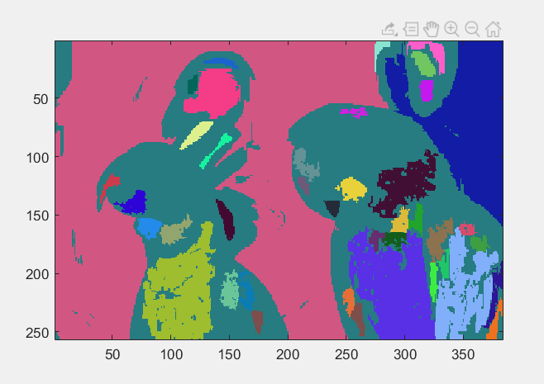

Figure . randomly colored segmentation for T = 2

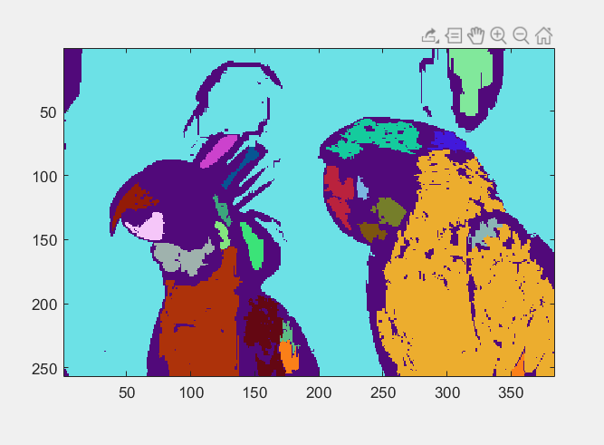

Figure . randomly colored segmentation for T = 3

2.

|  |  |  |  |
| --- | --- | --- | --- |
| T | 1 | 2 | 3 |
| The number of regions | 36 | 41 | 23 |