# Lab 6 Report

## Ruijie Song

## Mar.19

2 Plotting Color Matching Functions and Illuminants

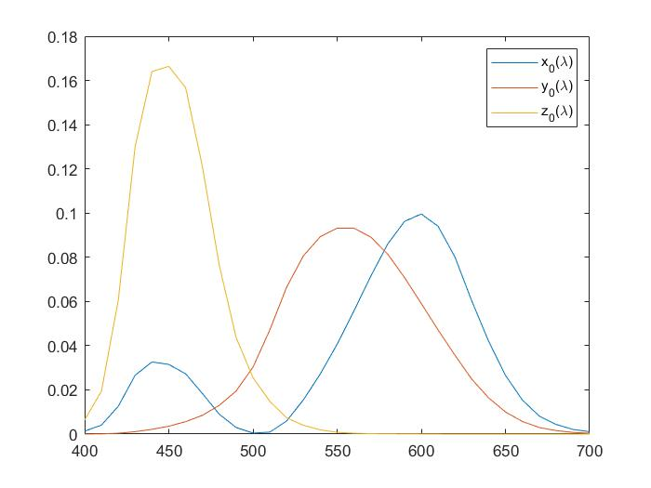

Figure . The plot of the x0, y0, and z0 color matching functions.

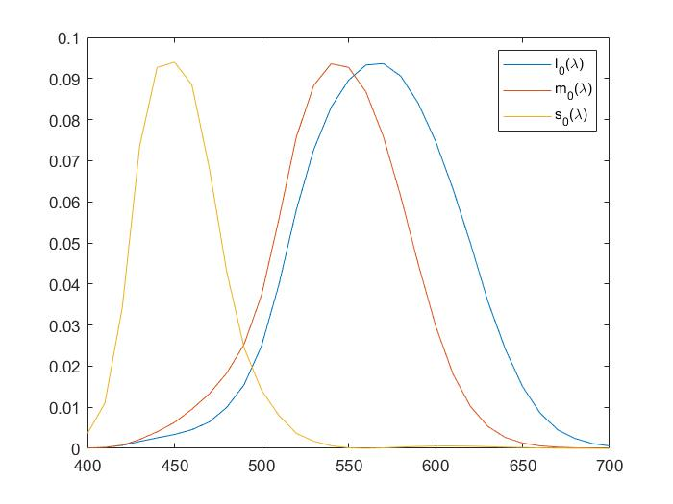

Figure 2. The plot of the l0, m0, and s0 color matching functions.

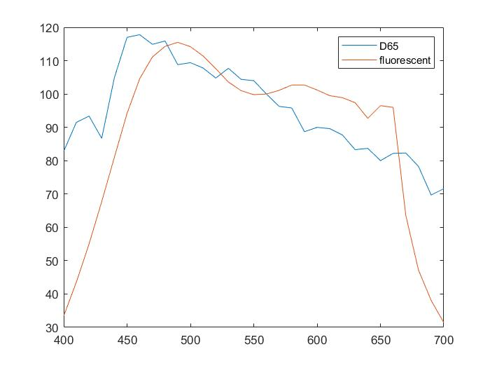

Figure 3. The plot of the D65 and fluorescent illuminants.

3 Chromaticity Diagrams

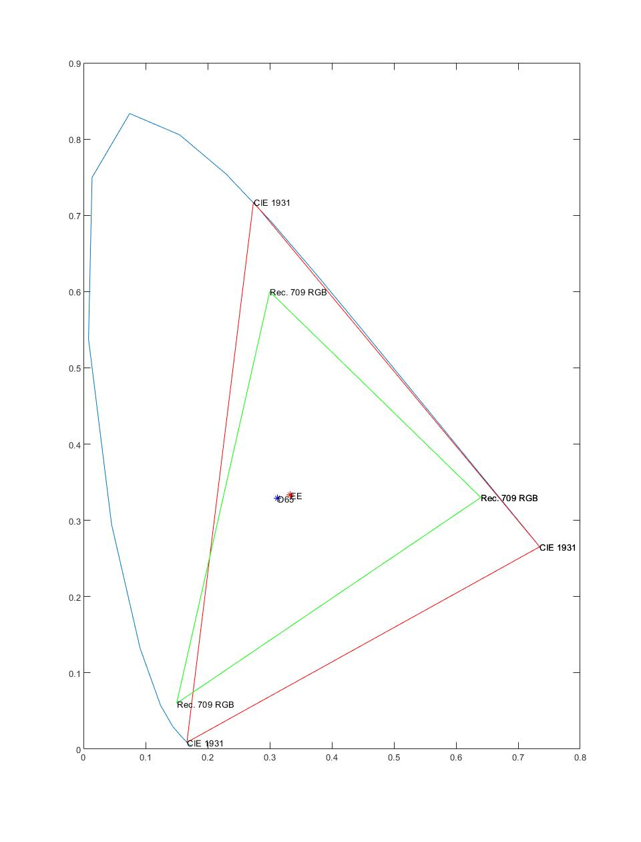

4 Rendering an Image from Illuminant, Reflectance, and Color Matching Functions

1.

0.412390799265959 0.357584339383878 0.180480788401834

0.212639005871510 0.715168678767756 0.0721923153607337

0.0193308187155918 0.119194779794626 0.950532152249661

2.



Figure 4. Image from D65



Figure 5. Image from fluorescent

3.

The image from D65 has more blue components, and the image from fluorescent has more green components.

5 Color Chromaticity Diagram

