# Lab 8 Report

## Ruijie Song

## Apr.16.2021

3.1



Figure 1. original image

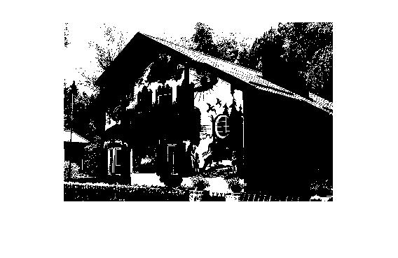

Figure 2. result of thresholding

RMSE = 87.3933165438293

Fidelity = 77.3371491724335

4.2 Exercise: Ordered Dithering

1.



Figure 3. 2x2 Bayer index matrices

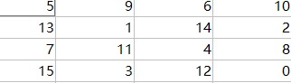

Figure 4. 4x4 Bayer index matrices

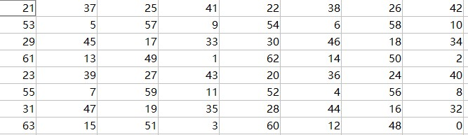

Figure 5. 8x8 Bayer index matrices

2.



Figure 6. halftoned image produced by 2x2 matix



Figure 7. halftoned image produced by 4x4 matix



Figure 8. halftoned image produced by 8x8 matix

3.

RMSE_2x2 = 97.6689721921400

Fid_2x2 = 50.056947960301500

RMSE_4x4 = 1.010069220156947e+02

Fid_4x4 = 16.558342510690416

RMSE_8x8 = 1.009145296239608e+02

Fid_8x8 = 14.691773433816397

5.1 Exercise: Error Diffusion

2.



3.

RMSE = 99.192402741527390

Fidelity = 14.140898102731818

4.

|  |  |  |
| --- | --- | --- |
|  | RMSE | fidelity |
| simple thresholding | 87.3933165438293 | 77.3371491724335 |
| 2x2 | 97.6689721921400 | 50.056947960301500 |
| 4x4 | 1.010069220156947e+02 | 16.558342510690416 |
| 8x8 | 1.009145296239608e+02 | 14.691773433816397 |
| error diffusion | 99.192402741527390 | 14.140898102731818 |

From the results, we can observe that RMSE does not change much for different methods, but fidelity decreases for different methods. When the quality is better, the fidelity is smaller.