The Impact of Music Packaging on Simulated Music Popularity

Ruining Li
Business Economics
York University
June, 2026

- Introduction
Music packaging is widely used in the music industry to attract listeners. However, whether packaging itself can change listener choice remain unclear. Packaging plays an important role not only in music industry, it also includes branding, social media, and product marketing. This project uses simulated model to investigate the effect of music packaging on listener choice.

- Building Model
In this experiment, we assume the impact diminishes as the intense of packaging increases:

U = log (P + 1) + $ε$

U is the utility function of each listener with 1 observable explanatory variable P, and one stochastic error term $ε$. P stands for the intense of the packaging, P $∈$ [0, $∞$); $ε$~ N (0, 1), which included social influence, personal tastes, quality and other related factors.

- Methodology
The simulation generates 100 songs with uniformly distributed packaging intensity with range [0,100) and 1000 listener utility function, which $ε$ ~ N (0, 1). Each song was evaluated by one listener, repeat this process until 1000 listeners finished the evaluation.

If the utility is greater than 2, listeners will choose to play the song, which reflected on scatter plot.

- Results
The following graph shows the relationship between packaging intensity and simulated plays. The results indicate that the marginal impact of packaging diminishes as packaging intensity increases. At low levels of packaging intensity, simulated plays increase rapidly. However, the growth slows as packaging intensity becomes stronger.
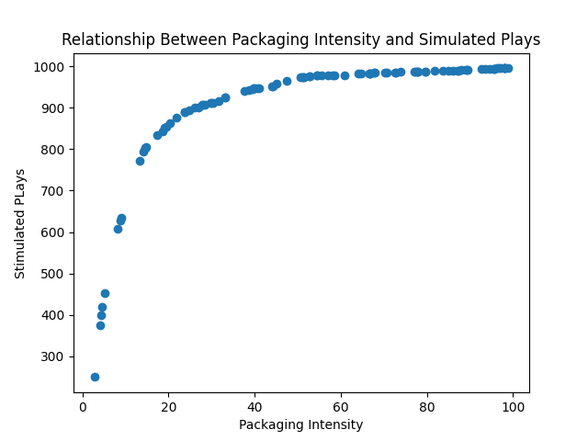

- Discussion
The results illustrated packaging appears to be more influential when initial packaging intensity is low. For music producer, packaging may be useful for attracting listeners, but it cannot guarantee unlimited growth.

- Limitations
The model of packaging and popularity does have many limitations, the impact of packaging is not absolutely independent; music quality, public tastes, artists reputation, and social influence could affect the results, but they are all included in error term, which means this model is sensitive to any additional factors.

Another limitation of this project is that the relationship between packaging intensity and listener choice is already determined by utility function. The logarithm in utility function described diminishing marginal benefits of packaging. However, different utility function may have different results, for instance linear or quadratic functions. Therefore, the results should be interpreted as a prediction in a specific situation rather than real-world phenomenon.

- Conclusion
This project investigated the relationship between packaging and listener choice through a simplified simulated model.

The results suggested stronger packaging intensity increase simulated plays. However, the marginal effect diminishes as increases packaging intensity. For music producers, packaging might be useful to attract listeners, but not forever.

