**Assignment1**

**Author: Ruiqi Kuang**

*TASK1: visualize Make-Moons dataset*

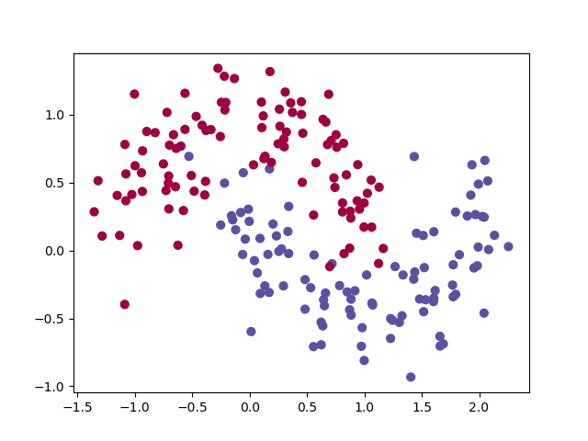

*Task2: train with different activation function*

*Relu:*

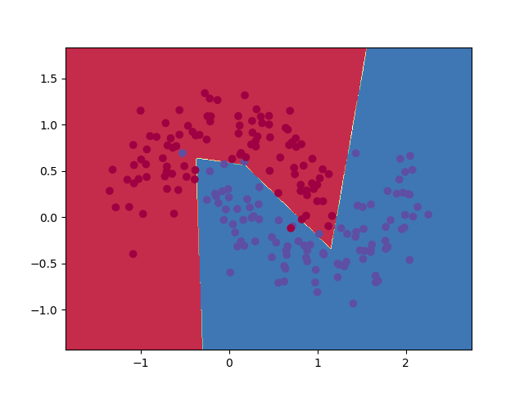

*Tanh:*

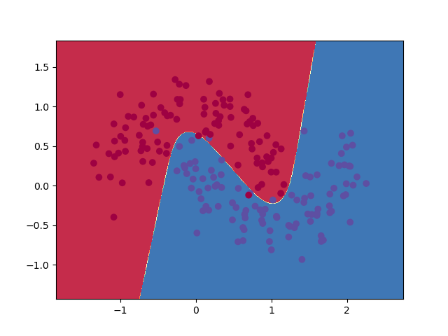

*Sigmoid:*

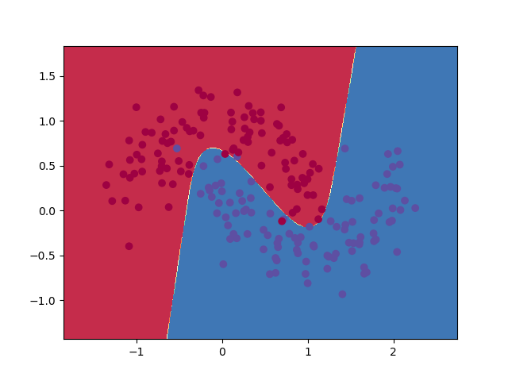

The boundary relu created is several straight lines, while tanh and sigmoid create smooth curves. That may be cause by the fact that relu is a piece-wise function where each part is a proportional function.

*Task3: train with different the number of hidden units*

nn_hidden_dim=10

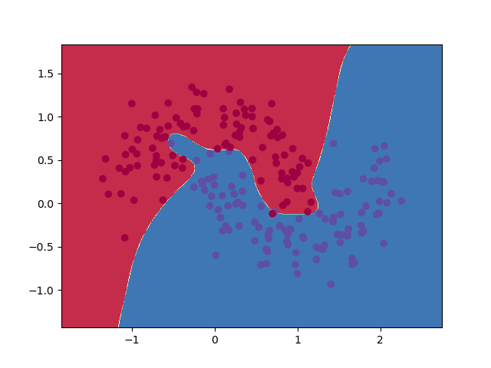

nn_hidden_dim=20

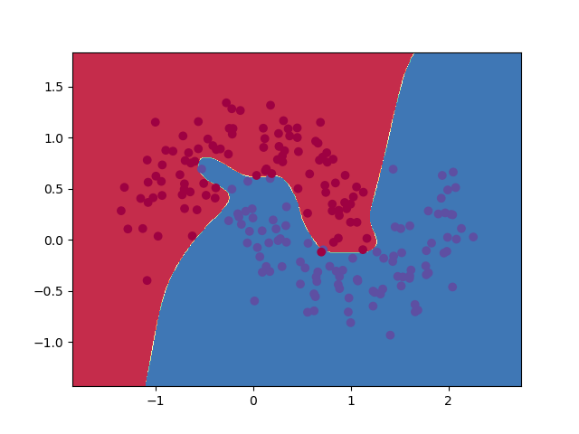

nn_hidden_dim=30

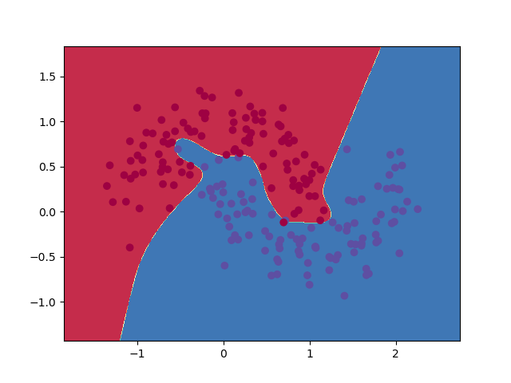

The loss decrease while the dimension of the hidden layer increase. The decision boundary doesn’t change dramatically while dimension increase.