1. An element has an atomic number of 16. What will be the charge on the ions that form?
   1. +2
   2. +1
   3. -1
   4. -2
2. Name the following compounds:
   1. KBr: Potassium Bromide
   2. Li­3N: lithium nitride
   3. BaS: Barium Sulfide
   4. AlI3: Aluminum iodide
   5. BeO: Beryllium Oxide
3. An element forms a covalently bonded compound with hydrogen that has the formula XH3 where X is the element. In which group of the periodic table would you expect to find X?

15

1. Two atoms each provide two electrons that are shared by the two atoms. This is a description of a
   1. Single covalent bond
   2. Double covalent bond
   3. Triple covalent bond
   4. Quadruple covalent bond
2. A non-metal usually forms two covalent bonds in its compounds. How many electrons will it have in its valence level?
   1. 2
   2. 4
   3. 6
   4. 8
3. The noble gases do not usually form chemical compounds because
   1. They have very stable nuclei.
   2. The bonds between their atoms are very strong.
   3. They already have complete valence electron levels.
   4. They are not polar.
4. Which one of the following compounds contains both ionic and covalent bonds?
   1. SiO2
   2. BaF2
   3. Na2CO3
   4. Cl2O
5. From the electronic structures of the following pairs of elements, deduce the numbers of covalent bonds, if any, that each would normally form, and hence predict the formula of the compound you would expect to result.
   1. Helium and sulfur: none
   2. Chlorine and hydrogen: 2; Cl2O
   3. Nitrogen and chlorine: 1; NCl
   4. Silicon and fluorine: 4, SiF4
   5. Phosphorus and oxygen: 5, P2O2
6. From the electronic structures of the pairs of elements given, predict the type of bonding that you would expect in the compound they form.
   1. 2.4 and 1: C, H: covalent
   2. 2.8.5 and 2.8.7: P, Cl: Covalent
   3. 2.1 and 2.8.6: Li, S: ionic
   4. 2.6 and 2.7: O, F: covalent
   5. 2.8 and 2.2.6: ???
7. Draw Lewis diagrams of the following molecules:
   1. HCl
   2. O2
   3. PH3
   4. F2O
   5. H2CO
8. If a molecule has a pyramidal shape, how many non-bonding pairs of electrons are there in the valence level of the central atom?
   1. 1
   2. 2
   3. 3
   4. 4
9. What shapes would you predict for the following molecules?
   1. SiF4: tetrahedral
   2. PCl3: trigonal pyramidal
   3. H2S: bent
   4. NF3: trigonal pyramidal
   5. CCl4­: tetrahedral
10. Sketch the shapes and predict the bond angles in each of the following species:
    1. H – CO – OH

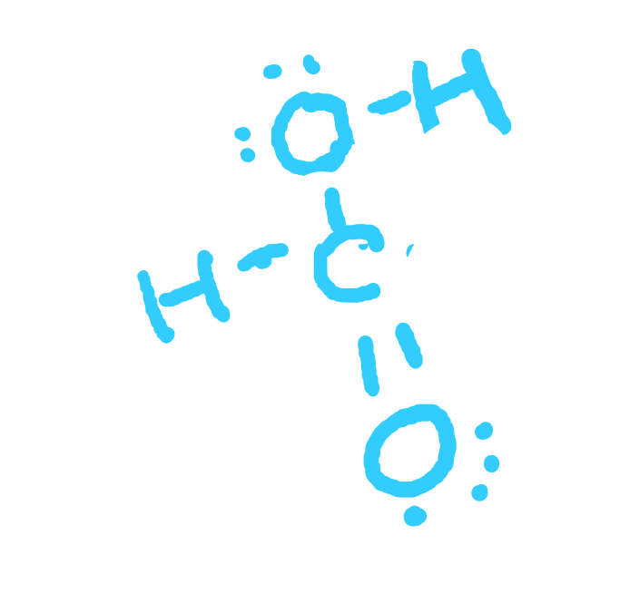

* 1. CH3 – NH2

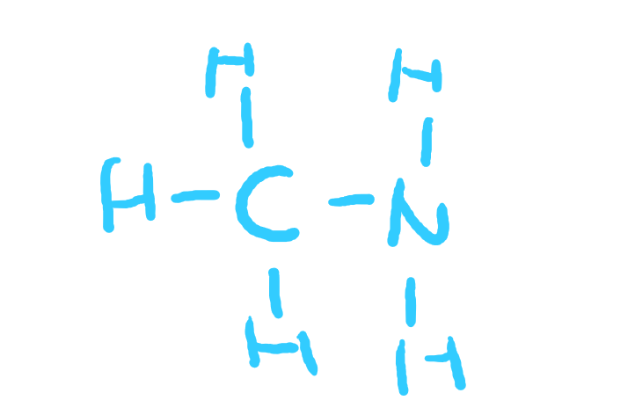

* 1. H – CN



1. Which one of the following bonds would be the most polar?
   1. C-N 0.5
   2. S-O 1
   3. Si-F 1.2
   4. P-Cl 0.8
2. Carbon and chlorine form a series of compounds: CH4; CH3Cl; CH2Cl2; CHCl3; CCl4. Which of these will be polar molecules?
3. State whether you would expect the molecules below to be polar or non-polar.
   1. SiF4
   2. PCl3
   3. H2S
   4. NF3
   5. CCl4
4. Which atom in the following bonds would you expect to carry a partial negative charge?
   1. H-N
   2. O-P
   3. C-F
   4. S-S
   5. B-O
5. For each of the following species:
   * 1. Draw the Lewis structure, including all non-bonding electrons.
     2. Give a sketch of the shape of the molecule, including bond angles.
     3. State whether it would be polar or non-polar.
   1. BeCl2(g)

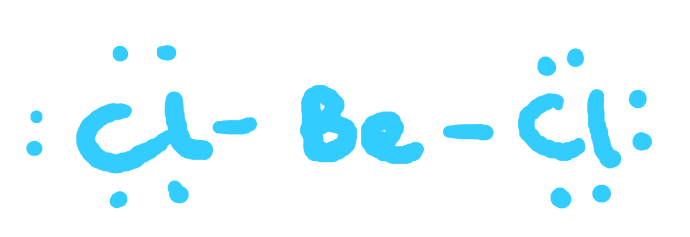

180°

Non-polar

* 1. H­2CO

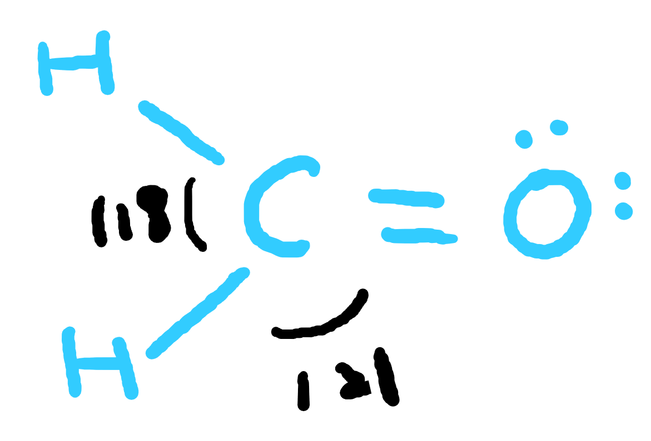

polar

* 1. N2F2 (note: 2 different forms exist)

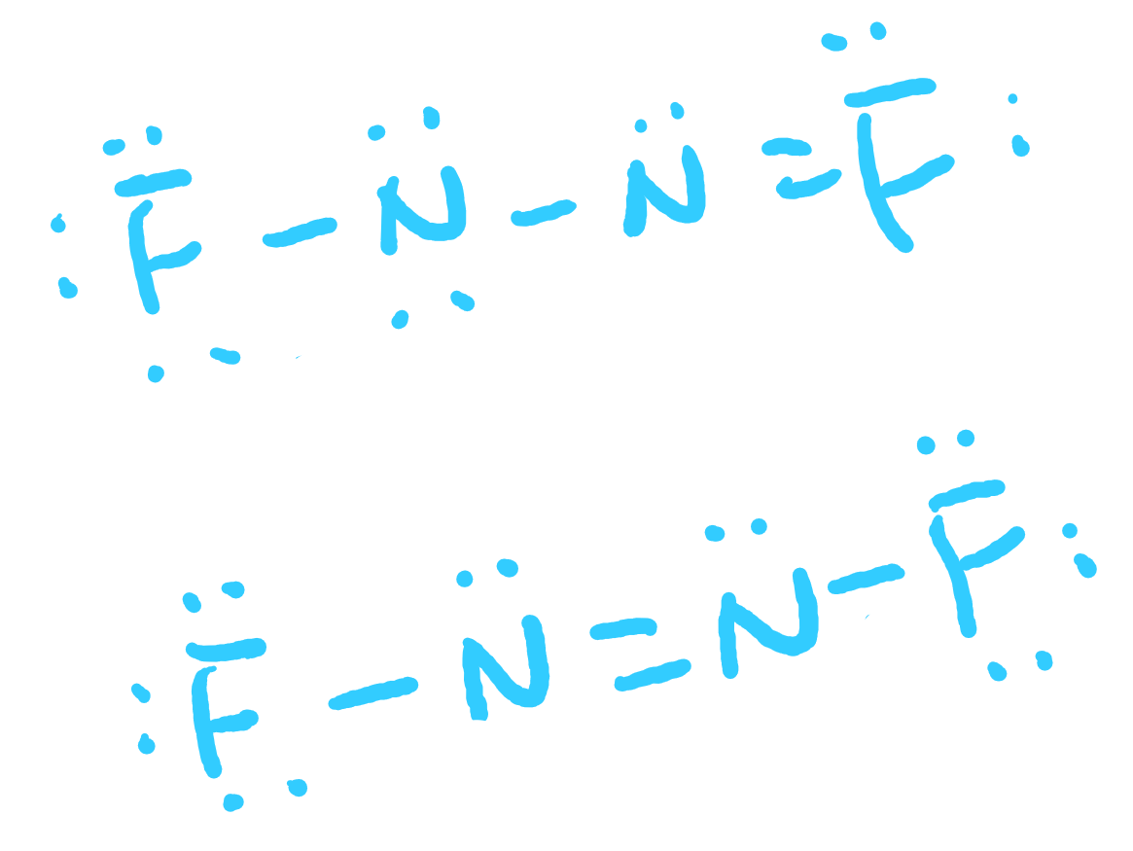

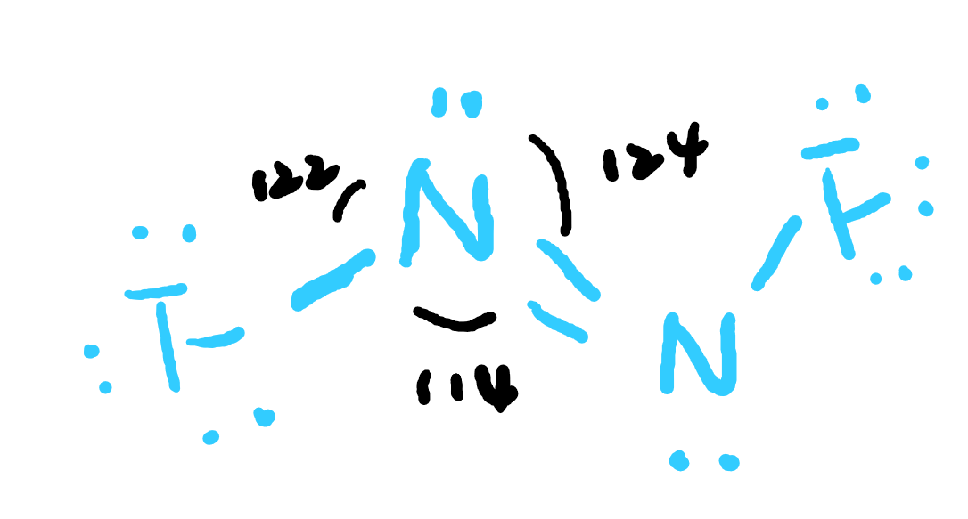

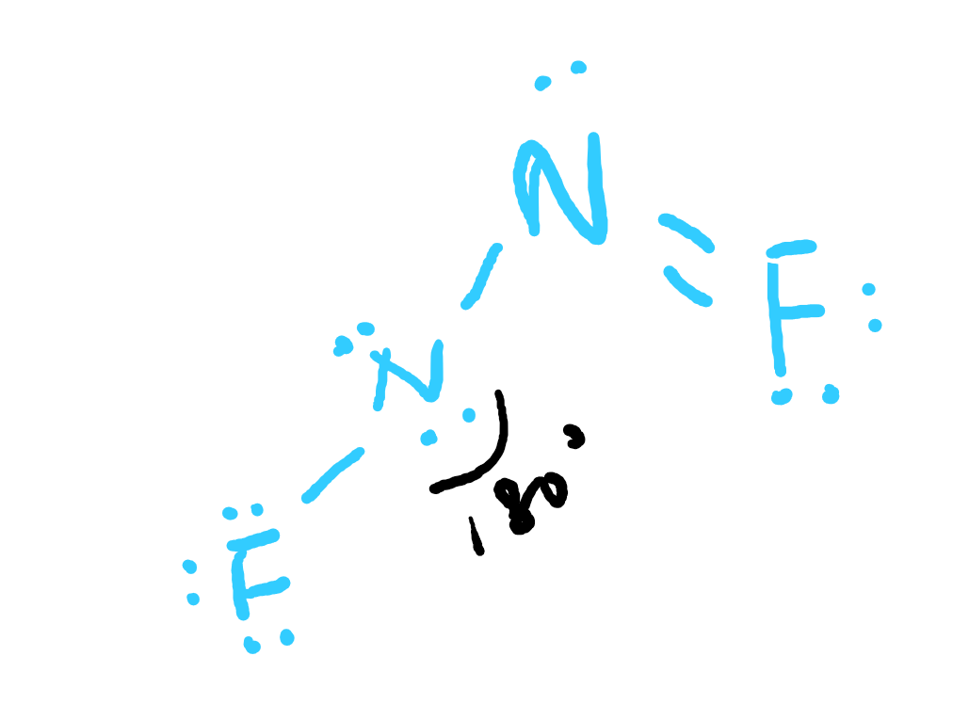

Polar

1. In which one of the following compounds would hydrogen bonding occur?
   1. COCl2
   2. PH­3
   3. H2CO
   4. CH3OH
2. Which one of the following molecules would you expect to have the highest boiling point?

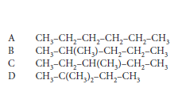A

1. In which of the following substances would there be the strongest forces between the molecules?
   1. SiH4
   2. H2C=O
   3. CH3 – CH3
   4. O2
2. Which one of the following usually produces the weakest interaction between particles of similar molar mass?
   1. Hydrogen bonding
   2. Covalent bonds
   3. Dipole-dipole forces
   4. London dispersion forces
3. In which one of the following substances is hydrogen bonding **not** significant?
   1. Ice
   2. Polythene (polyethene)
   3. DNA
   4. Protein
4. Explain the following observations in terms of the intermolecular forces that exist.
   1. At room temperature and pressure chlorine is a gas, bromine is a liquid and iodine is a solid.

All of them are non-polar, so we should compare their LDF:

Cl2 has smaller molecular mass, meaning there are relatively less electrons, so the London force is smaller;

Bromine has a bit larger molecular mass, so it has larger LDF and thus it is a liquid;

I2 has the largest molecular mass, so it has largest LDF and thus is a solid.

* 1. Water is a liquid at room temperature and pressure, but hydrogen sulfide is a gas.

Because H2O has H-bond and thus greater intermolecular forces, which makes it harder to break. So the boiling point is higher;

However, S2O does not have H-bond and thus lower boiling point.

* 1. Ethanol (CH3CH2OH) has a much higher boiling point than its isomer methoxymethane (CH3OCH3).

Ethanol has H-bond.

* 1. 1-pentanol (CH3CH2CH2CH2CH2OH) boils at 137°C, whereas 3-pentanol (CH3CH2CH(OH)CH2CH3) boils at 116°C.
  2. The boiling point of sulfur dioxide is 24°C higher than that of chlorine.

1. Explain why the boiling points of hydrogen fluoride, water and ammonia are significantly higher than those of the analogous compounds in the next period. What other effects on physical properties occur as a consequence of the bonding you describe? Give specific examples.
2. Which one of the following substances would you expect to be most soluble in water?

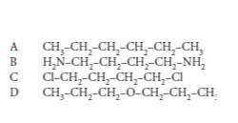**B**

1. In cookery class, Anita expresses surprise that sugar melts so much more easily than salt when in many other ways they are similar. Her friend Jenny, wanting to show off the fact that she is taking science, says “That’s because sugar has covalent bonds and salt has ionic bonds. Ionic bonds are stronger than covalent ones.” As is often the case, there is some truth in what Jenny says. Using suitable examples, explain why this statement, as it stands, is not accurate and then express more accurately what Jenny meant.
2. Ethanoic acid (CH3COOH) reacts with sodium hydroxide to form sodium ethanoate (CH3COO- Na+) and with ethanol to form ethyl ethanoate (CH3COOCH2CH3). Explain why ethanoic acid and sodium ethanoate both dissolve in water, but ethyl ethanoate does not.
3. Explain why the boiling points of the halogens increase as you go down the periodic table.