**Intermolecular Forces**

Ruiyan Maggie Huang

2/18/2019

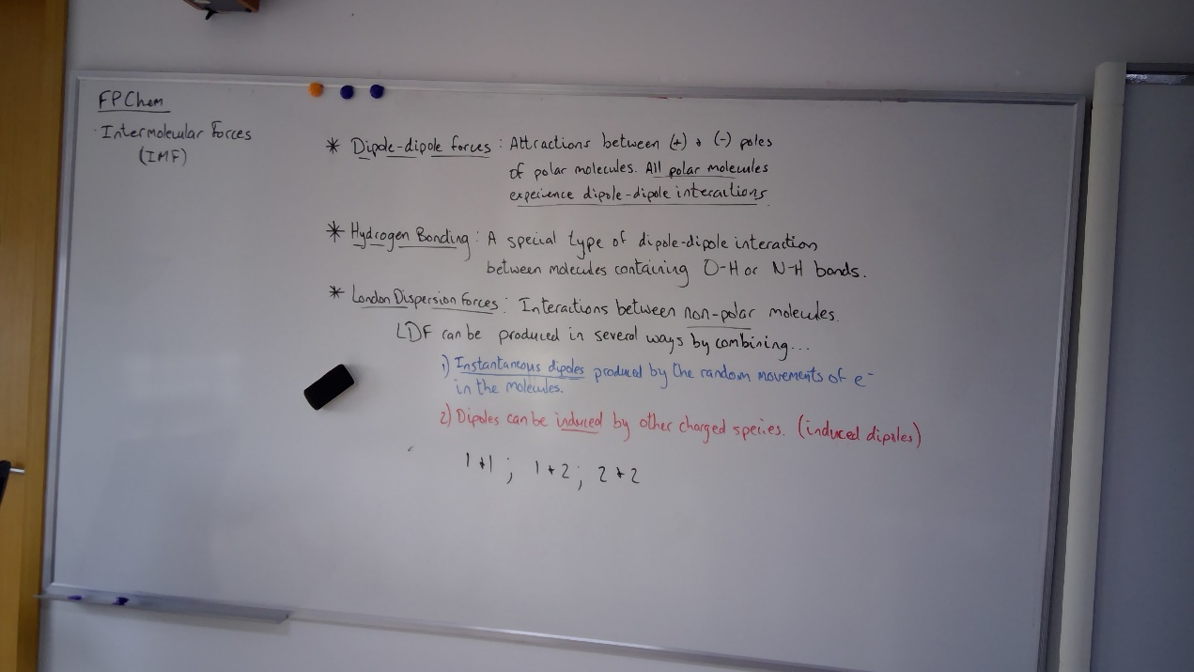

**Task 1**

**List the IMFs, giving a definition/description and a picture to represent how the bonds are formed.**

Intermolecular Forces are the forces that attract molecules to each other.

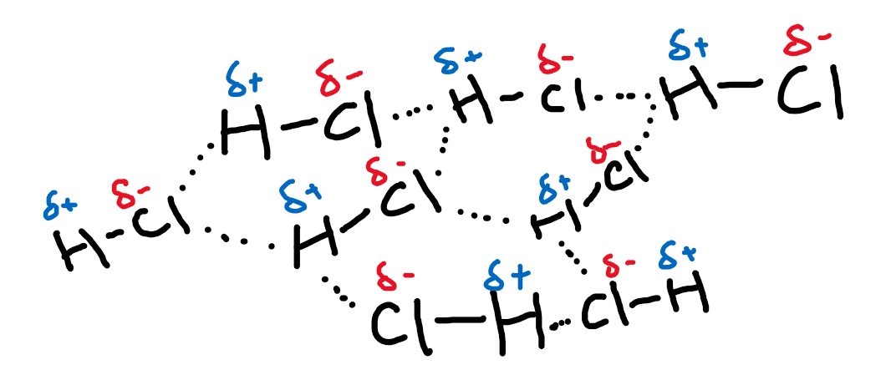

**Task 2**

**Design an experiment to determine the relative strength of each IMF. You will have access to DI water, ethanol, acetone/propanone, and either hexane, heptane, or cyclohexane.**

I come up with two experiment, but cannot decide which is the better way.

1. **Boiling point (Saxena)**

The first method to determine the relative strength of each IMF is through boiling, and thus get the boiling point for each of the matter:

* Variables:

Independent variable:

Different matters and thus different IMFs.

Control variable:

The mass of matter, the initial temperature, the same water temperature, the same boiling method, etc.

* Safety and environmental considerations:

Can I dispose everything down the sink?

Yes. We can.

Am I going to use anything hot or fragile that may cause potential danger?

Yes. We are using heating devices for boiling and beakers as containers.

Is anything hazardous in this experiment?

Yes, ethanol is highly flammable, sucrose can cause eye and skin irritation

* Outline of the procedure

1. Prepare four beakers, hot plate, thermometer, measuring cylinder (50 mL), balance
2. Measure out 30g of each liquid on the balance.
3. Put the beakers on the hot plate one at a time and heat them.
4. Wait until the liquid begins boiling, and measure the boiling point.
5. Record all the data in a table.

1. **Viscosity**

This method makes use of the property of liquids’ viscosity, and that liquids with higher intermolecular forces should have higher viscosity.

* Materials:

a test tube, and two droppers, a phone

* Outline of the procedure

1. Use the two droppers to each drop one kind of liquid onto the wall of the test tube with a certain.
2. Compare the speed of the two liquids to reach a marker that reaches the bottom of the funnel, (better with a slow-motion camera on phone)
3. Change to different liquids and repeat the process.
4. **Surface tension:**

* Materials: a dropper, and a glass dish
* Outline of procedure

1. Use a dropper to add a drop of each liquid on the glass dish.
2. Compare the diameter of each drop.

**Task 3**

**Design an experiment or database research to answer the following research question:**

**How does molecular mass affect the strength of London dispersion forces?**

I will design a database research for the boiling points for different molecules: H2, N2, O2, F2, Cl2, Br2, I2, and make a chart that draws the relationship between molecular masses and boiling points of each molecule. And since London forces are also proportional to boiling points (Saxena), we can thus infer the relationship between London forces and molecular masses.

Saxena, Vivek. “How Can You Determine If a Molecule Has a Higher Boiling Point?” *Sciencing.com*, Sciencing, 10 Jan. 2019, sciencing.com/can-determine-molecule-higher-boiling-point-11415535.html.