**Taxes, subsidies and market outcomes**

**Indirect taxes** can be added to the prices of goods and services

*But why do governments want to increase the prices and restrict the supply of some products?*

* *to discourage their consumption because it can be harmful, e.g. _________________*
* *to reduce their production because it can be harmful, e.g. the burning of ____________________and gas releases harmful emissions*
* *to conserve limited natural resources, e.g. taxes on energy and ________________ use*

**Subsidies** can be paid to producers towards their costs of production

*But why do governments want to increase the supply and reduce the prices of some products?*

* *to make products more affordable for those on the lowest incomes, e.g. basic ___________________*
* *to encourage their consumption because it can be beneficial, e.g. __________________*
* *to encourage their development and production because it is beneficial and creates employment, e.g. _________________ and solar energy panels*

**What effect does a tax have on a market?**

Over a range of prices, the demand and supply schedules record the quantity demanded of cigarettes per month and quantity supplied per month. This is shown in the first three columns below. Equilibrium price is_______________ and equilibrium quantity is _____________.

|  |  |  |  |
| --- | --- | --- | --- |
| Price (RMB) | Quantity demanded  (millions of packets) | Quantity supplied (millions of packets) | Quantity supplied after tax  (millions of packets) |
| 50 | 1 | 7 | 6 |
| 45 | 2 | 6 | 5 |
| 40 | 3 | 5 | 4 |
| 35 | 4 | 4 | 3 |
| 30 | 5 | 3 | 2 |
| 25 | 6 | 2 | 1 |

The effect of putting a tax on the good has been to shift the supply curve up by RMB 5- the amount of the new tax. Note, however, the new equilibrium price has not shifted up by the same amount as the demand curve is sloping and not vertical. In fact, the new price has increased by ___________ to ___________ and the equilibrium quantity has fallen to___________.

**The economic effects of a tax on producers**

**Objective**: to reduce harmful exhaust emissions by the reducing the consumption of petrol

**Before tax of 40 cents per litre:** 600 million litres of petrol are traded each month at the market price of 80 cents per litre

**After tax of 40 cents per litre:** 500 million litres of petrol are traded each month at a new market price of $1 per litre

**But why doesn’t the market price rise from 80 cents to $1.20 per litre?** Because demand contracts as price rises, so petrol producers end up having to pay some of the tax to government

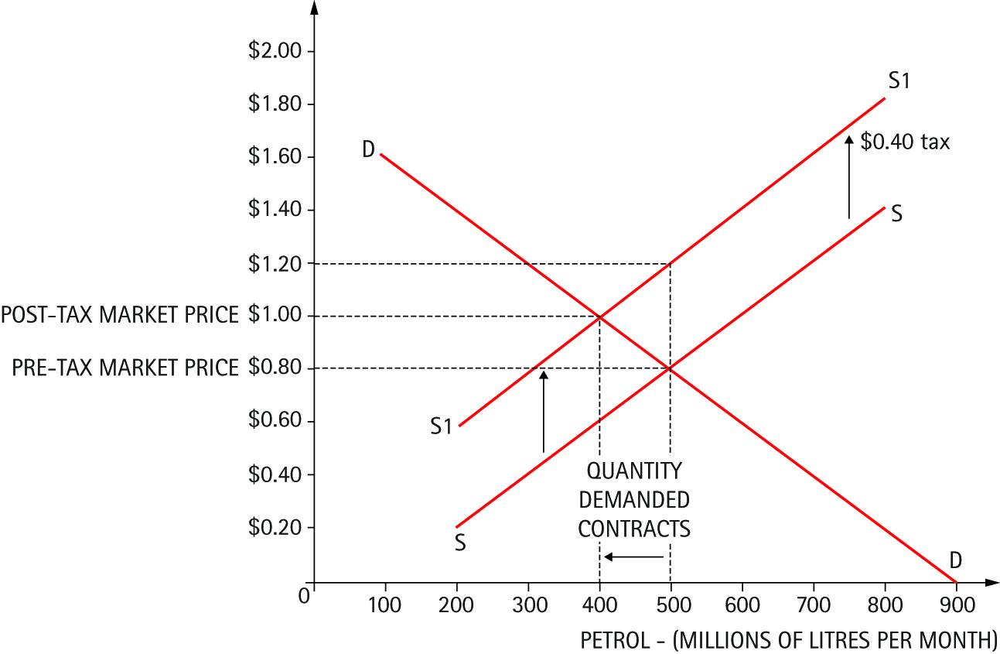

**The economic effects of a subsidy on producers**



**Objective:** to encourage the production and consumption of biofuel

**Before a subsidy of $20 per barrel:** 40 million barrels of biofuel are supplied and traded each month at the market price of $60 per barrel

**After a subsidy of $20 per barrel:**

50 million barrels of biofuel are supplied and traded each month at a new market price of $50 per barrel

**But why doesn’t the market price fall from $60 to $40 per barrel?**

Because demand extends as price falls so producers do not have to pass on the full amount of the subsidy