EXPERIMENT 3: MOMENT OF FORCES

OBJECTIVE

* To check the moment of forces in equilibrium.

INFERENCES

1. Moment of force is measure of its tendency to rotate an object about some point.
2. It can be calculated using the following equation:

Moment = Force x Perpendicular distance

M = F x d

1. Moment in equilibrium is sum of moment rotating clockwise equals sum of moment rotating anticlockwise.

HYPOTHESIS

1. Sum of moment rotating anticlockwise equal to sum of moment rotating clockwise.
2. Sum of force acting upward equal to sum of force acting downward.
3. The moment of force is equal to the magnitude of the force multiplied by the perpendicular distance between its line of action and the axis of rotation.

APPARATUS

Spring Balance (10 N) Stainless Steel Ruler

 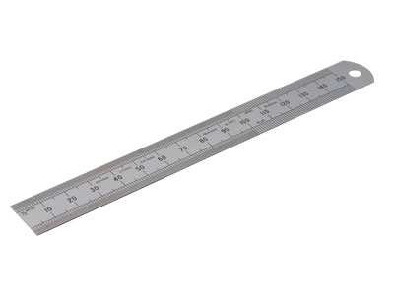

Wooden Meter Ruler with Retort Stand

Binder Holes

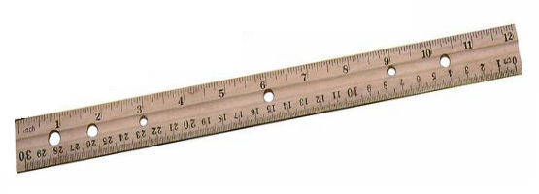 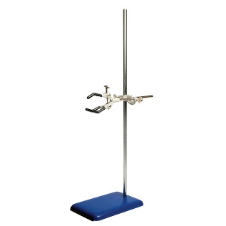

Masses & Hanger ( 10 gm) String

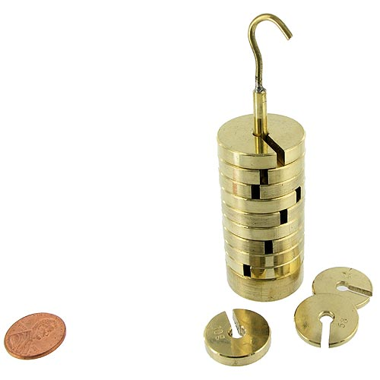 

Scissor



PROCEDURES

1. Set up the apparatus as Figure 1.
2. Ensure that the beam is in horizontal position and at the same height.
3. Record the earlier reading of the spring.
4. Place three weights which are not of the same weight on the beam with conditions:
5. The distance of Weight 1 ( should not exceed spring balance A )
6. The distance of Weight 2 ( between spring balance A and B )
7. The distance of Weight 3 ( should exceed spring balance B )
8. Record the reading of X1 , X2 , X3, X4, and X5.
9. Record the reading of spring balances and the value of weights into the table.
10. Repeat the above procedures ny using different weights.

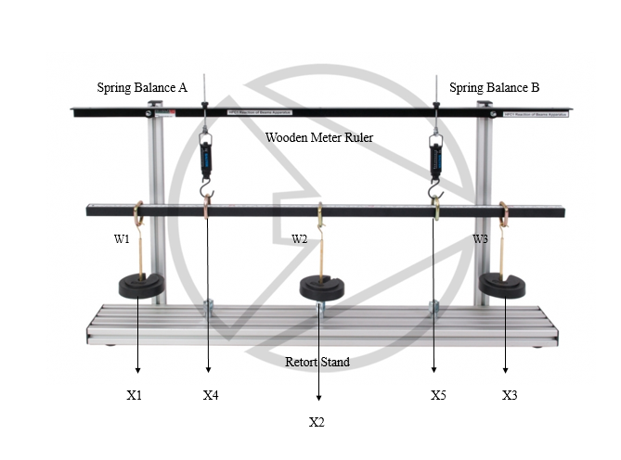

Figure 1