**Mark scheme for PreDP l10/IS 10 Final May Exam 16 May 2018 .**

1(a)  kg ***A1***

(b)   ***A1)***  
 ***A1*(ft),  *N2***

**Note:** Award ***(A1)*** for identifying quartiles, ***(A1)*(ft)** for correct subtraction of their quartiles.

(c)  ***A1***

(d) 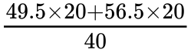 ***M1***

**Note:** Award ***(M1)*** for multiplication of midpoints by frequencies.

 kg ***A1,***   ***N2***

2. (a) P(2 different colours) = $P\left(Blue first ∩Red second\right)+P\left(Red first ∩Blue second\right)$

= $\frac{2}{8}×\frac{6}{7}+\frac{6}{8}×\frac{2}{7}$ M1 A1  
 = $\frac{3}{7} or \frac{24}{56}$ A1

(b) P(second is blue) = $P\left(Blue first ∩Blue second\right)+P\left(Red first ∩Blue second\right)$

= $\frac{2}{8}×\frac{1}{7}+\frac{6}{8}×\frac{2}{7}$ M1  
 = $\frac{1}{4} or \frac{14}{56}$ A1

(c) P( First Red | Second Blue) = $\frac{P\left(Red first ∩Blue second\right)}{P(Second is blue)}$  
 = $\frac{12/56}{14 /56}$ or 6/7 (M1) A1

Note: M1 evidence of using conditional probability.

3ai) 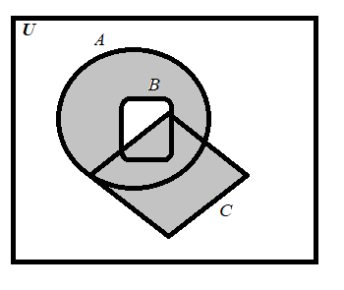A1 for shading $A ∩B'$ A1 for shading **C.**   
(aii) Not equal . A1  
(aii) $C∪\left(A ∩B^{'}\right)$ = $\left(C∪A\right)∩\left(C∪B^{'}\right)$ the compliment is with set B and not for $\left(C∪B\right)$ and thus we cannot apply DeMorgan’s Law. R1

3b) $\left(A ∩C ∩B^{'}\right)∪\left(B ∩C ∩A^{'}\right)$

A1 for each correct group including set notation.   
A1 for the Union sign between the two groups.   
Award A1A1A1 equivalent answer.

4. Let , where *k* is a positive integer and each $x_{1}, x_{2}, …, x_{k}$ is unique. *A1*

Let $A=\left\{ x_{1}, x_{2}, …, x_{k}, a_{1}, a_{2}, …, a_{l}\right\}$ and *n(A) = k + l ; l is a positive integer A1*Let $B=\left\{ x_{1}, x_{2}, …, x_{k}, b_{1}, b_{2}, …, b_{m}\right\}$ and *n(B)) = k + m; m is a positive integer*Thus, $A ∪ B=\left\{ x_{1}, x_{2}, …, x_{k}, a_{1}, a_{2}, …, a_{l}, b_{1}, b_{2}, …, b_{m}\right\}$ and *A1*  
*n( $A ∪ B)=k+l+m.$ A1  
 = (k+l) +(k+m) – k A1  
 = n(A) + n(B) – n(* ◼

5. (a) P(Male $∩Commedy) ×751$ = $\frac{386}{751}×\frac{217}{751}×751$ (M1)   
 = $\frac{386}{751}×217 or\frac{83762}{751}$ A1A1

A1 for correct numerator. A1 for correct denominator.   
Accept 112.

(b) H1: the most watched programme type is NOT independent of gender**.** A1

(c) (2-1)x(4-1) = 3 . A1  
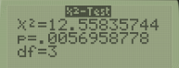

(d) 0.00570 (3 s.f.) A1

(e) Since the p-value of 0.00570 is smaller than the significance level at 0.05 R1  
then we will reject the null hypothesis and failed to reject the alternative that “the most  
watched programme type is not independent of gender.” A1

6.   
(a)  ***A1A1***

(b) (i)   ***A1 (ft)***

(ii)  (micrograms per cubic metre) ***A1 (ft)***

**Note:** Follow through from part (a) irrespective of working seen.

iii)   ***G2 (ft)***

**Note:** Follow through from part (a) irrespective of working seen.

(c)

 ***A1 (ft) A1 (ft)***

**Note:** Award ***(A1)*(ft)** for . Award ***(A1)*(ft)** for . If answer is not an equation award at most ***(A1)*(ft)*(A0)***. Follow through from part (a) irrespective of working seen.

(di)  ***M1***

**Note:** Award ***(M1)*** for correct substitution into their regression line.

 ***A1(ft) G2***

**Note:** Follow through from part (c). Accept  from use of  significant figure values.

(dii) Ernesto’s estimate is not reliable ***A1***

this is extrapolation ***R1***

**OR**

 is not within the range (outside the domain) of distances given  ***R1***

**Note:** Do not accept “ is too high” or “ is an outlier” or “result not valid/not reliable” if explanation not given. Do not award ***(A1)(R0)***. Do not accept reasoning based on the strength of .

7a) Show that the opposite angles of a cyclic quadrilateral add up to  .

## Markscheme

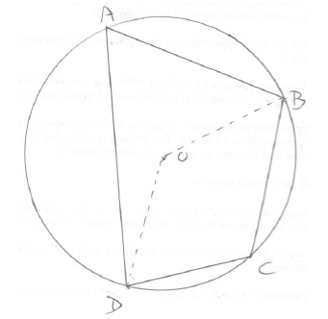

recognition of relevant theorem  ***(M1)***

*eg*  ***A1***

 ***A1***

so  ***AG***

***[3 marks]***

**7b.** *[7 marks]*

A quadrilateral ABCD is inscribed in a circle  . The four tangents to  at the vertices A, B, C and D form the edges of a quadrilateral EFGH. Given that EFGH is cyclic, show that AC and BD intersect at right angles.

## Markscheme

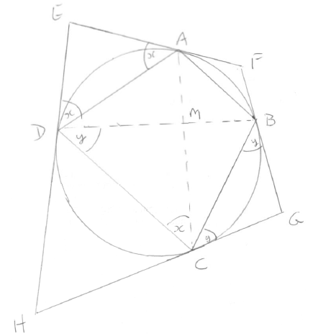

diagram showing tangents EAF, FBG, GCH and HDE; diagonals cross at M.  ***M1***

let  ;  ***A1***

 ***M1A1***

 and  , as angles in alternate segments ***M1A1***

 ***A1***

so the diagonals cross at right angles ***AG***

***[7 marks]***

**7c.** *[6 marks]*

The circle  has centre O. The point Q is fixed in the plane of the circle and outside the circle. The point P is constrained to move on the circle.

Show that the locus of a point  , which satisfies 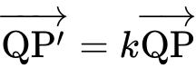 , is a circle  , where ***k*** is a constant and  .

## Markscheme

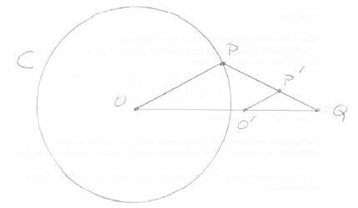

***M1***

let  be the point on OQ such  is parallel to OP ***A1***

using similar triangles  , so  is a fixed point  ***M1A1***

and  which is constant ***A1***

so  lies on a circle centre  ***R1***

so the locus of  is a circle ***AG***

***[6 marks]***