|  |
| --- |
| cid:image001.png@01D20823.0E63E130  **L10 & IS 10 Pre-DP 2018 Year-end Test**  16 May 2018 (Pre-DP)  **60 minutes** |
| Name of Candidate: _____________________________________________  Name of Teacher: Donnie Xia / KokMing Lee.   (Circle the appropriate name.) |
| * Write your name in the slot above. * Do not open this examination paper until instructed to do so. * A graphic display calculator is required. * Section A: answer all questions. Answers must be written within the answer boxes below. * Section B: answer all questions in the answer sheets provided. Fill in your name and candidate number on the front of the answer sheets and attach them to this test paper. * Unless otherwise stated in the question, all numerical answers must be given exactly or correct to three significant figures. * The maximum mark for this examination paper is **[60 marks].**   Total number of pages:___9__ |

|  |
| --- |
| Please **do not** write on this page.  Answers written on this page  will not be marked. |

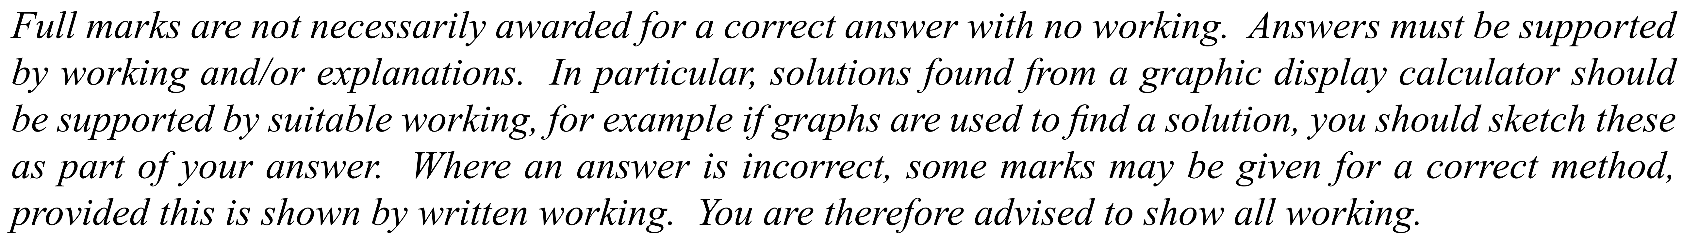

1.  *[Maximum mark: 6]* The weights in kg, of 80 adult males, were collected and are summarized in the box and whisker plot   
 shown below.

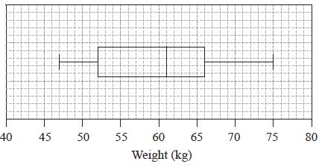

1. Write down the median weight of the males. [1]
2. Calculate the interquartile range. [2]
3. Estimate the number of males who weigh between  kg and  kg. [1]
4. Estimate the mean weight of the lightest  males. [2]

|  |
| --- |
| ---------------------------------------------------------------------------------------------------------------------------------------------------------------------------------------------------------------------------------------------------------------------------------------------------------------------------------------------------------------------------------------------------------------------------------------------------------------------------------------------------------------------------------------------------------------------------------------------------------------------------------------------------------------------------------------------------------------------------------------------------------------------------------------------------------------------------------------------------------------------------------------------------------------------------------------------------------------------------------------------------------------------------------------------------------------------------------------------------------------------------------------------------------------------------------------------------------------------------------------------------------------------------------------------------------------------------- |

2. *[Maximum mark: 7]*

A box contains six red marbles and two blue marbles. XiaoXiao selects a marble from the box.   
He then selects a second marble without replacement.

1. Calculate the probability that the XiaoXiao select two marbles of different colours. [3]
2. Calculate the probability that the second marble is blue. [2]
3. Hence or otherwise, calculate the probability the first marble is red given the second marble is blue. [2]

|  |
| --- |
| ---------------------------------------------------------------------------------------------------------------------------------------------------------------------------------------------------------------------------------------- ----------------------------------------------------------------------------------------------------------------------------------------------------------------------------------------------------------------------------------------------------------------------------------------------------------------------------------------------------------------------------------------------------------------------------------------------------------------------------------------------------------------------------------------------------------------------------------------------------------------------------------------------------------------------------------------------------------------------------------------------------------------------------------------------------------------------------------------------------------------------------------------------------------------------------------------------------------------  ------------------------------------------------------------------------------------------------------------------------------------------------------------------------------------------------------------------------------------------------------------------------------------------------------------------------------------------------------------------------------------------------------------------------------------------------------------------------------------------------------------------------------------------------------------------------------------------------------------------------------------------------------------------------------------------------------------------------ |

3. *[Maximum mark: 6]*

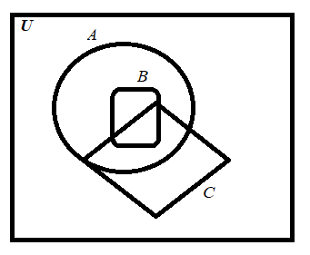

(a) (i) Use the Venn diagram above to shade the region corresponding to . [2]

(ii) State the relationship between and . [1]

(iii) Explain your answer in (aii) above. [1]   
  
 (b) Describe the shaded regions below with appropriate set notations. [2] 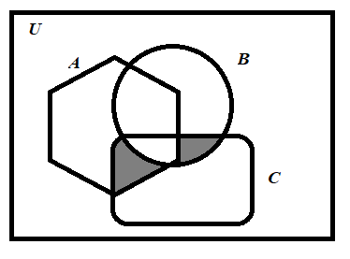

|  |
| --- |
| -------------------------------------------------------------------------------------------------------------------------------------------------------------------------------------------------------------------------------------------------------------------------------------------------------------------------------------------------------------------------------------------------------------------------------------------------------------------------------------------------------------------------------------------------------------------------------------------------------------------------------------------------------------------------------------------------------------------------------------------------------------------------------------------------------------------------------------------------------------------------------------------------------------------------------------------------------------------------------------------------------------------------------------------------------------------------------------------------------------------------------------------------------------------------------------------------------- |

4*.**[Maximum mark: 5]*

The symbol means the number of elements in set *A*.

Proof that

|  |
| --- |
| ------------------------------------------------------------------------------------------------------------------------------------------------------------------------------------------------------------------------------------------------------------------------------------------------------------------------------------------------------------------------------------------------------------------------------------------------------------------------------------------------------------------------------------------------------------------------------------------------------------------------------------------------------------------------------------------------------------------------------------------------------------------------------------------------------------------------------------------------------------------------------------------------------------------------------------------------------------------------------------------------------------------------------------------------------------------------------------  ------------------------------------------------------------------------------------------------------------------------------------------------------------------------------------------------------------------------------------------------------------------------------------------------------------------------------------------------------------------------------------------------------------------------------------------------------------------------------------------------------------------------------------------------------------------------------------------------------------------------------------------------------------------------------------------------------------------------------------------------------------------------------------------------------------------------------------------------------------------------------------------------------------------------------------------------------------------------------------------------------------------------------------------------------------------------------------ |



5. *[Maximum Mark: 8]*

Manuel conducts a survey on a random sample of 751 people to see which television programme type they watch most from the following: Drama, Comedy, Film, News. The results are as follows.

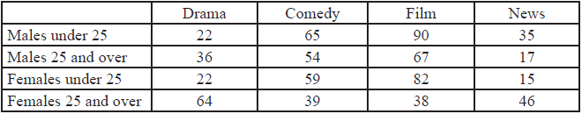

Manuel decides to ignore the ages and to test at the 5 % level of significance whether the most watched programme type is independent of gender**.**

1. A  test at the 5% significance level is carried out on the results.   
   Find the expected frequency of a male and watch mostly Comedy. [3]
2. Write down the alternative hypothesis for this test; [1]
3. Write down the number of degrees of freedom. [1]
4. Write down the -value for the test; [1]
5. State the result of the test. Give a reason for your answer. [2]

6. *[Maximum Mark: 12]*

(a) For an ecological study, Ernesto measured the average concentration  of the fine dust, , in the air at different distances  from a power plant. His data are represented on the following scatter diagram. The concentration of  is measured in micrograms per cubic metre and the distance is measured in kilometres.

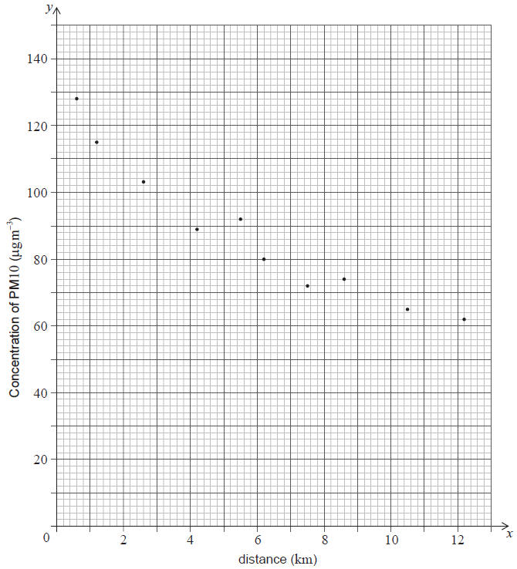

His data are also listed in the following table.

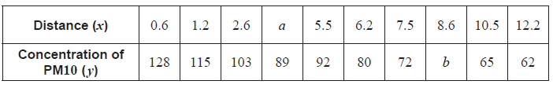

Use the scatter diagram to find the value of  and of  in the table. [2]

(b) Calculate [4]

(i)  , the mean distance from the power plant;

(ii)  , the mean concentration of  ;

(iii)  , the Pearson’s product–moment correlation coefficient.

**(c)**  Write down the equation of the regression line  on  . [2]

(d) Ernesto’s school is located  from the power plant. He uses the equation of the regression line to estimate the concentration of  in the air at his school. [4]

(i) Calculate the value of Ernesto’s estimate.

(ii) State whether Ernesto’s estimate is reliable. Justify your answer.

7. *[Maximum mark: 16]*

(a) Show that the opposite angles of a cyclic quadrilateral add up to . [3]

(b) A quadrilateral ABCD is inscribed in a circle  . The four tangents to  at the vertices A, B, C and D form the edges of a quadrilateral EFGH. Given that EFGH is cyclic, show that AC and BD intersect at right angles. [7]

(c) The circle  has centre O. The point Q is fixed in the plane of the circle and outside the circle. The point P is constrained to move on the circle.  
Show that the locus of a point  , which satisfies 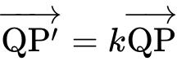 , is a circle  , where ***k*** is a constant and  . [6]

_________________________________________________________________________________________________