Year 1 FM Test

**MATHEMATICS Name:__________________________  
Further Math**

15 February 2017  
Number Theory 2

50 Minutes

INSTRUCTIONS TO CANDIDATES

* Write your name in the slot above.
* Do not open this examination paper until instructed to do so.
* You are permitted access to any calculator which is permitted in IB Exam for this paper.
* Answer all questions in answer sheets
* Unless otherwise stated in the question, all numerical answers must be given exactly or correct to three significant figures.

|  |  |  |
| --- | --- | --- |
| Mark | Percentage | Grade |
|  |  |  |

*Full marks are not necessarily awarded for a correct answer with no working. Answers must be supported by working and/or explanations. Where an answer is incorrect, some marks may be given for a correct method, provided this is shown by written working. You are therefore advised to show all working.*

1. [Total 6marks]



1. [Total 12marks]

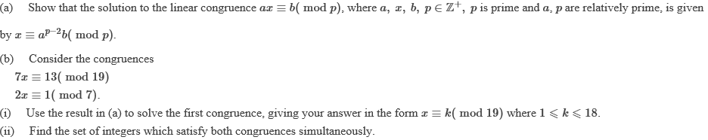

1. [Total 7marks]

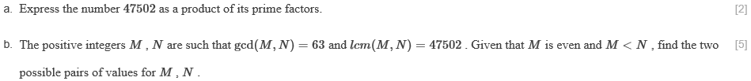

1. [Total 9marks]

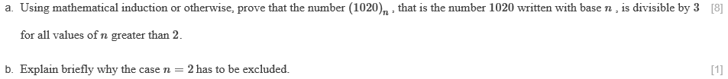

1. [Total 11marks]

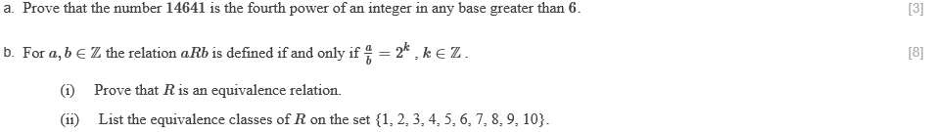

1. [Total 6 marks]

