PreDP Sample Test L10IS10 Unit 1 Sept 2017 – Mark scheme

1. 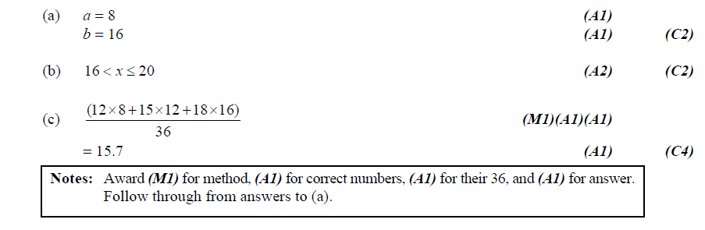
2. 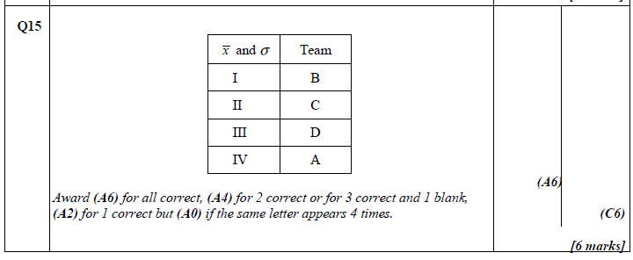
3. 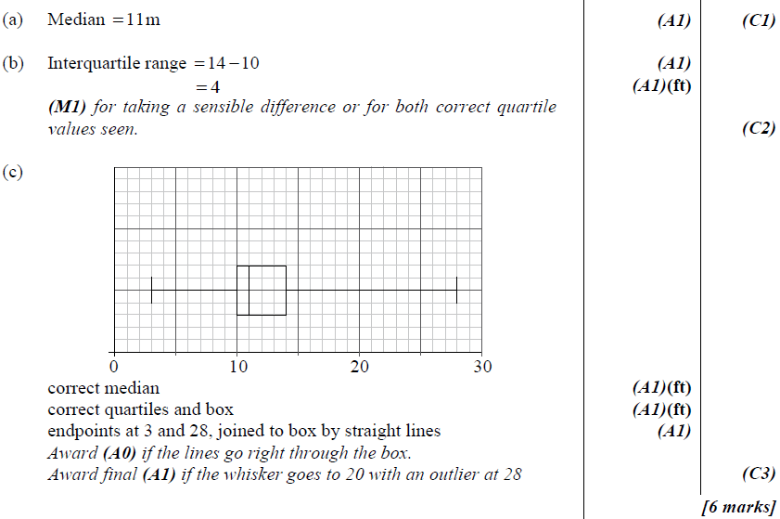
4. 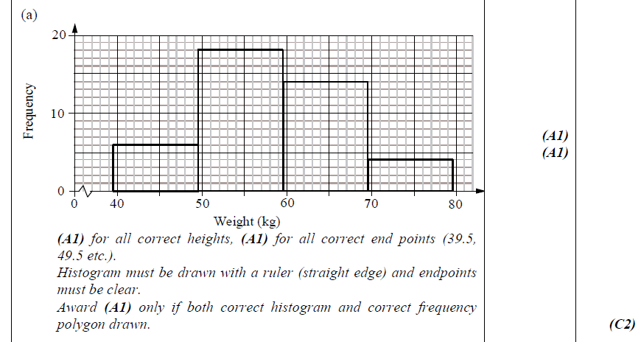 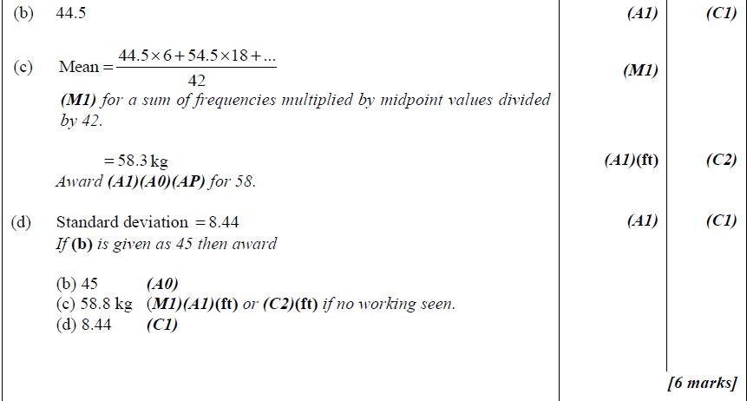
5. 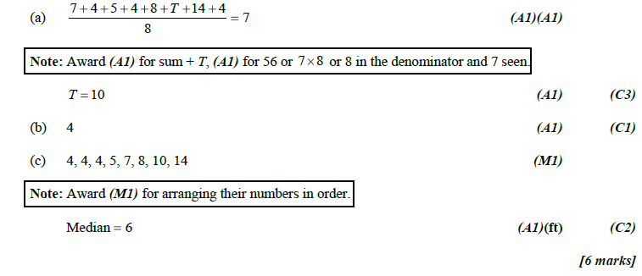
6. 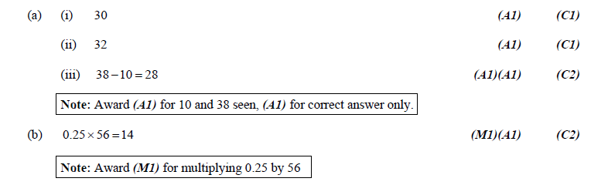
7. 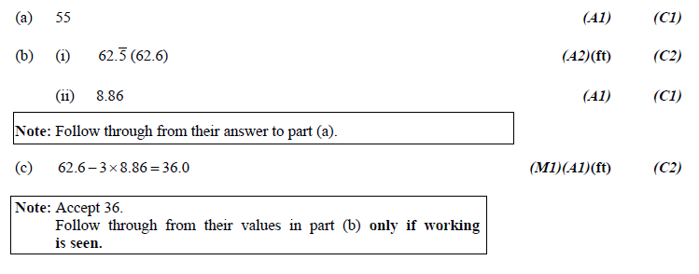
8. (a) $\overline{x}= \frac{\left(x_{1}+ x_{1}+ ⋯+x_{1}\right)+\left(x_{2}+ x_{2}+ ⋯+x_{2}\right)+⋯+\left(x_{n}+ x_{n}+ ⋯+x_{n}\right) }{f_{1}+f_{2}+ ⋯+f_{n}}$  
   ;   
   where there are *fi*of *xi* for *i*=1, 2, 3, …, *n*. M1 A1  
   Note: M1 for an attempt to use the definition of sample mean. $\overline{x}= \frac{f_{1}x_{1}+f_{2}x_{2}+⋯+f_{n}x_{n} }{f_{1}+f_{2}+ ⋯+f_{n}}$  
    A1

$\overline{x}= \frac{\sum_{i=1}^{n}{f_{i}x_{i}}}{\sum_{i=1}^{n}{f_{i}}}$ AG

(b) $\overline{X+a}= \frac{\sum_{i=1}^{n}{f_{i}{(x}_{i}+a)}}{\sum_{i=1}^{n}{f_{i}}}$ $\overline{X+a}= \frac{\sum_{i=1}^{n}{{(f}_{i}x_{i}+f_{i}a)}}{\sum_{i=1}^{n}{f_{i}}}$ 
 M1 $\overline{X+a}= \frac{\sum_{i=1}^{n}{f_{i}x_{i}}}{\sum_{i=1}^{n}{f_{i}}}+ \frac{\sum_{i=1}^{n}{f_{i}a}}{\sum_{i=1}^{n}{f_{i}}}$

$$\overline{X+a}= \frac{\sum_{i=1}^{n}{f_{i}x_{i}}}{\sum_{i=1}^{n}{f_{i}}}+ a\frac{\sum_{i=1}^{n}{f_{i}}}{\sum_{i=1}^{n}{f_{i}}}$$

$\overline{X+a}= \overline{x}+ a$ A1  
Var( *X + a*) = $\frac{\sum_{i=1}^{n}{{f_{i}(x_{i}+a-\left( \overline{X+a}\right))}^{2}}}{\sum_{i=1}^{n}{f_{i}}}$ M1

Var( *X + a*) = $\frac{\sum_{i=1}^{n}{{f_{i}(x_{i}+a-\left( \overline{x}+ a\right))}^{2}}}{\sum_{i=1}^{n}{f_{i}}}$ A1  
Var( *X + a*) = $\frac{\sum_{i=1}^{n}{{f_{i}(x_{i}-\overline{x})}^{2}}}{\sum_{i=1}^{n}{f_{i}}}$  
 Var( *X + a*) = Var(*X*) AG

(c) $\overline{bX}= \frac{\sum_{i=1}^{n}{f_{i}{(bx}_{i})}}{\sum_{i=1}^{n}{f_{i}}}$ M1 $\overline{bX}= \frac{b\sum_{i=1}^{n}{f_{i}{(x}_{i})}}{\sum_{i=1}^{n}{f_{i}}}$ $\overline{bX}= b\overline{x}$
   
 A1

Var(*bX*) = $\frac{\sum_{i=1}^{n}{{f_{i}({bx}_{i}-\left( \overline{bX}\right))}^{2}}}{\sum_{i=1}^{n}{f_{i}}}$ M1

Var(*bX*) = $\frac{\sum_{i=1}^{n}{{f_{i}({bx}_{i}-b\overline{x})}^{2}}}{\sum_{i=1}^{n}{f_{i}}}$ 2

Var(*bX*) = $\frac{\sum_{i=1}^{n}{{f_{i}b^{2}(x_{i}-\overline{x})}^{2}}}{\sum_{i=1}^{n}{f_{i}}}$ A1

Var(*bX*) = $\frac{b^{2}\sum_{i=1}^{n}{{f_{i}(x_{i}-\overline{x})}^{2}}}{\sum_{i=1}^{n}{f_{i}}}$

Var(*bX*) = $b^{2}$ Var(*X*) AG

1. Proof by Contradiction   
   Let *n* be a positive integer, *P*= $\sqrt{2}+\sqrt{n}$ and *P* is rational. M1  
   Since *P*= $\sqrt{2}+\sqrt{n}$ then *P* -

*n* = (*P* - )2  M1

*n = P2 – 2P+ 2* A1

*2P = P2 + 2 – n ------------------------------------------- (1)*  A1From (1) it can be infer that *P* is a non-zero rational.

$\sqrt{2}= \frac{P^{2}+2-n}{2P}$*________________________________(2)*  A1Since *P2 + 2 – n* are rational and 2*P* are rational then the RHS in (2) is rational.   
(2) implies that $\sqrt{2}$ is rational. R1  
This is a contradiction.

Hence, by the proof by contradiction, *P*= $\sqrt{2}+\sqrt{n}$ is irrational.