PreDP **SAMPLE** Test

**MATHEMATICS Name:__________________________**

30 Sep 2017  
Statistics 1

50 Minutes

INSTRUCTIONS TO CANDIDATES

* Write your name in the slot above.
* Do not open this examination paper until instructed to do so.
* You are permitted access to any calculator which is permitted in IB Exam for this paper.
* Answer all questions in answer sheets
* Unless otherwise stated in the question, all numerical answers must be given exactly or correct to three significant figures.

*Full marks are not necessarily awarded for a correct answer with no working. Answers must be supported by working and/or explanations. Where an answer is incorrect, some marks may be given for a correct method, provided this is shown by written working. You are therefore advised to show all working.*

1. [8 marks]

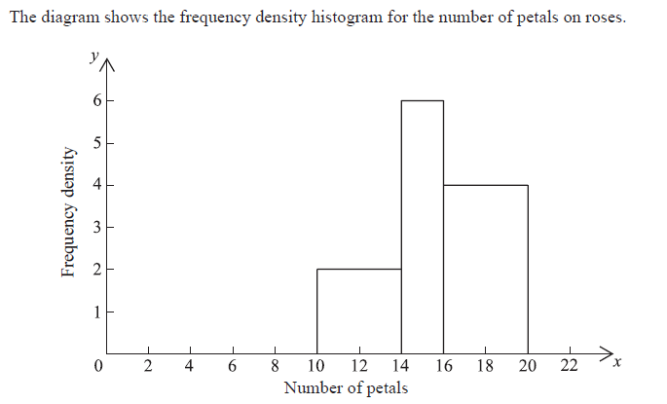 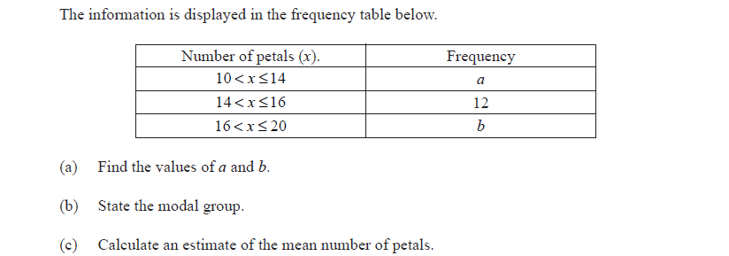

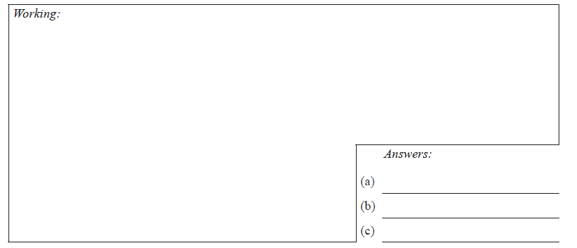

1. [6 marks]

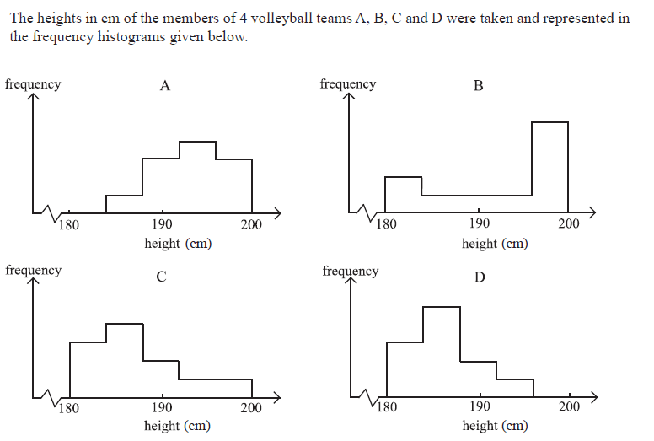

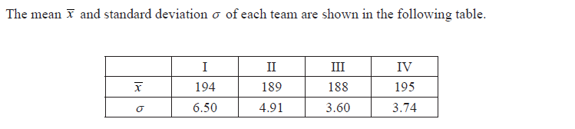 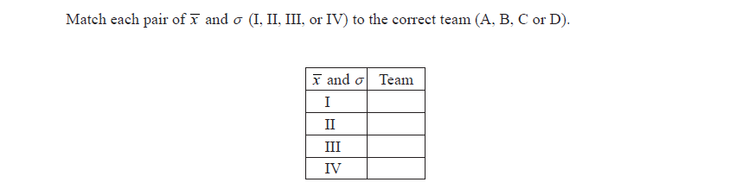 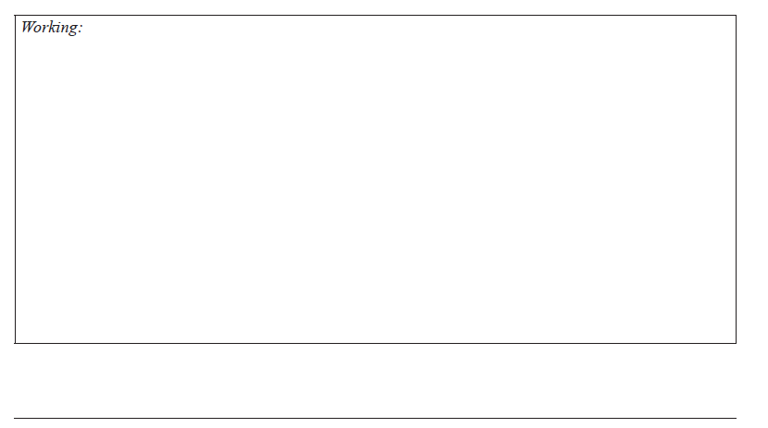

1. [6 marks]  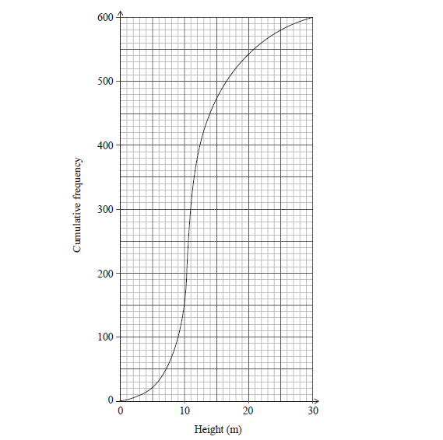 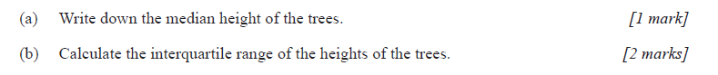

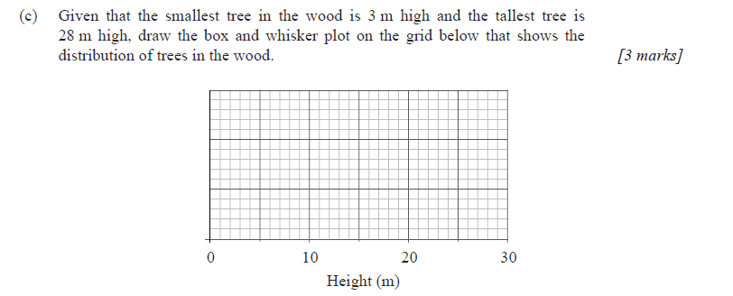 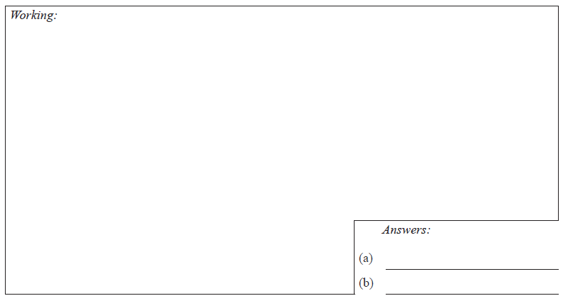

1. [6 marks]

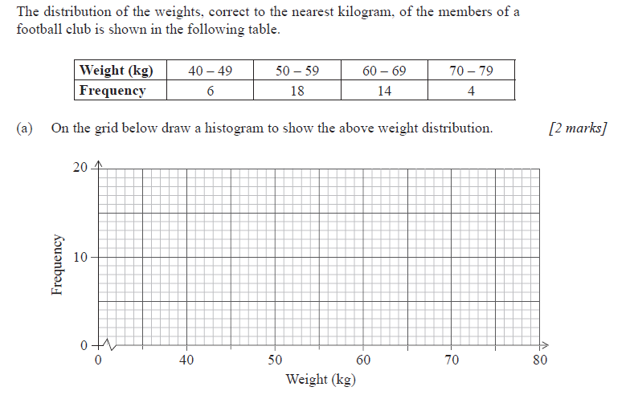 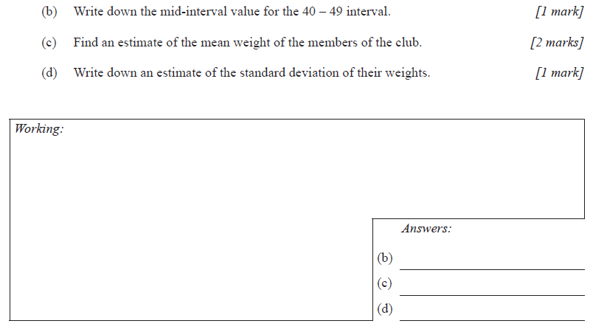

1. [6 marks]

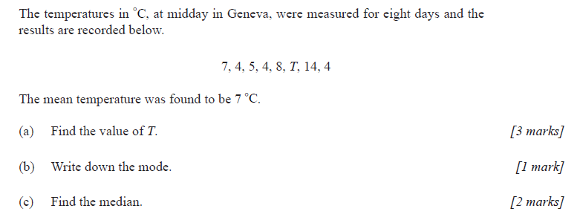 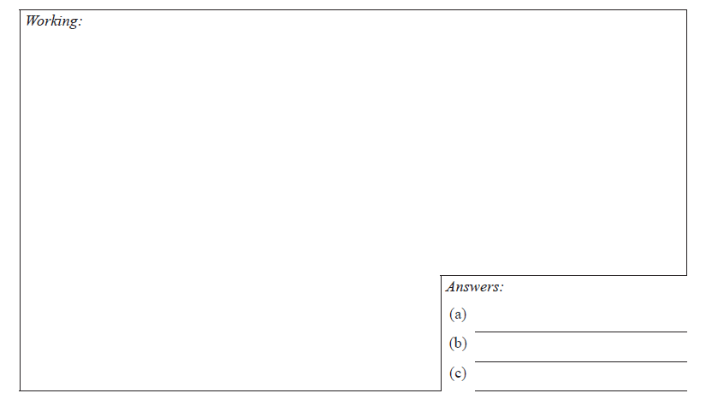

1. [6 marks] 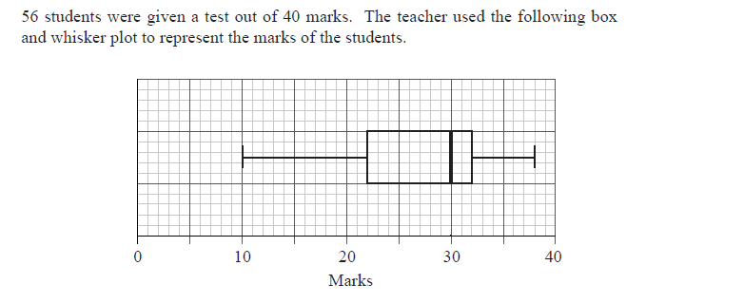

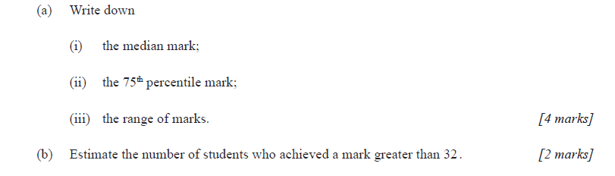 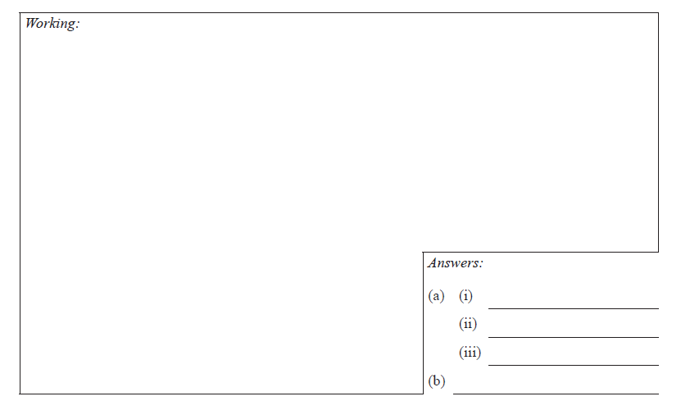

1. [6 marks]

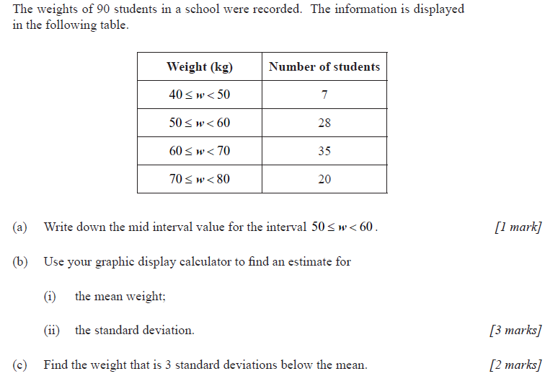

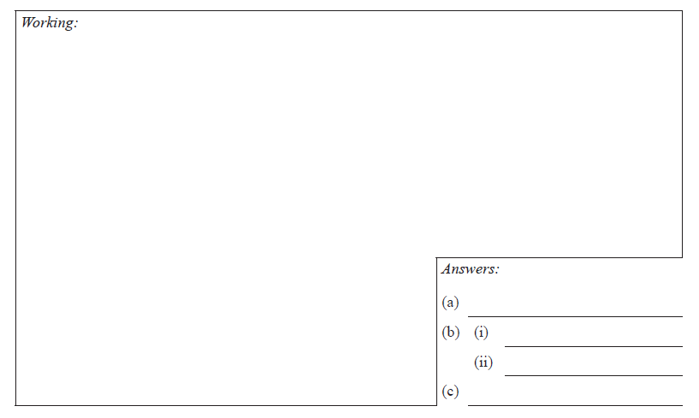

Extended questions for L10 and IS10.

*[The* ***ACTUAL*** *test for L10 and IS10 will also be 50 minutes in total. This sample test is 66 marks forL10 and IS10. ]*

1. The frequency table of a random variable X is shown as below. The sample mean of X is

|  |  |  |  |  |  |
| --- | --- | --- | --- | --- | --- |
| X | *x*1 | *x*2 | *x*3 | … | *x*n |
| Frequency | *f1* | *f2* | *f3* | *…* | *fn* |

(a) Use the definition of mean to prove that $\overline{x}$ = $\frac{\sum_{i=1}^{n}{f_{i}x_{i}}}{\sum_{i=1}^{n}{f_{i}}}$; where *n* is a positive integer.   
 *[2 marks]*

Let the variance of X above be Var(X).

(b) A non-zero real number *a* is added to each data point *x*i .   
 Use the definition of variance to prove that Var(X+ *a*) = Var(X). *[4 marks]*

(c) A non-zero real number *b* is multiplied to each data point *x*i .   
 Use the definition of variance to prove that Var(*b*X) = *b*2Var(X). *[4 marks]*

1. Prove that if *n* is any positive integer then $\sqrt{n}+\sqrt{2}$ is irrational. *[6 marks]*

_____________________________________________________________________________________