**如何改变部分青少年对自身内向性格的消极观念**

**How To Change Adolescents' Negative Opinions Towards Their Introversion**

# 摘 要

本报告将会针对如何改变青少年对自身内向性格的观念这一课题展开详细讨论，并提出可行的解决方案。小组首先经过多样调查证明，因为自身的内向性格而遭到长辈的不断质疑与误解这一社会现象已成为众多中国青少年的困扰。延续此研究，我们查阅大量资料以进一步调查研究产生自身内向性格的自卑情绪和其他负面观念的原因及其解决方案，并提出假设：青少年可通过“矛盾意向法”而正视自身的内向性格。为验证此方法的可行性，小组积极展开心理成长团体项目，深入了解内向人群对自身的观念与改变；同时，小组发布成员拍摄的采访等视频以做进一步宣传。

**关键词**：内向性格；青少年

**Abstract**

II

This report will focus on the discussion of how to change adolescents’ negative opinion toward their introversion, and provide a solution. By means of surveys, speeches and interviews on various social groups, our group discovered the common phenomenon that adolescents do have been troubled a lot by the undervalue from their parents or teachers. Following that discovery, we did a great many researches and readings, and thus hypothesized that the introversive adolescents can accept themselves through the method of paradoxical intentions. To verify the validity of this method, we launched the psychological group project, along with publication the videos for further publicity.

**Key words:** Introversion; Adolescents

**Topic Introduction**

In China, a large number of teenagers are suffering, for they face plenty of misunderstanding and potential biases towards their introversion. They hear others -mostly their parents- urging them to be open, to be social all the time. As our surveys and interviews show, people think highly of the extrovert blindly. Many people have little ideas of why and how the children’s personalities are formed, and they make their decisions based on their ignorance and prejudice. As a result, many teenagers are self-conscious and are ashamed of their own personalities. They become unwilling to communicate with others simply because their parents’ feeling. Fortunately, this problem can be solved. Along with the popularization of the precise definition of introvert, the method of paradoxical intentions can help the introverts gain their confidence and thus play a better role in society in the future.

Our research question is how to let some introvert adolescents think positively about themselves despite others’ possible bias. Our targeted group is Chinese young introverts, most of which may once be disappointed by people around them, especially parents, because of their seemingly asocial personalities. Our goal is to make those introverts keep an open mind to those bias, and be their real selves. We are trying to let the youngsters know that they should pay no attention to whatever others judges their personalities.

Our hypothesis is that since many people prefer extroversive children rather than introverts, introverts can be even more unsocial if they are frequently denied and excluded by adults due to their preference of being alone. However, introversion is not that useless and can have infinite benefits in some circumstances, and adolescents’ introversion can be changed by our effort by applying the method of paradoxical intentions.

**研究分析/ Analysis**

How can the word “introvert” be defined? This question is seem to be so controversial that it is not likely to reach a consensus within a short span. According to Merriam-Webster, “introvert” is characterized as “a reserved or shy person who enjoys spending time alone.”; or as a verb, “to concentrate or direct upon oneself.” Another definition found is “a quiet, shy person who finds it difficult to talk to people” (Collins), “a shy, reticent person” (Oxford), “someone who prefers to spend time alone rather than often being with others” (Oxford) from varied dictionaries. But do most of the introverts have difficulty taking to people? Are all the introverts being shy or they are merely pretending to be shy? Do the introverts authentically show more concentration on themselves, as documented? And is introvert a positive or negative noun as been used in all occasions? Another pivotal questions to ask are: can people be classified or tagged by “introverts” or “extroverts”? Do introverts suffer more prejudgments than extrovert? And how do people’s opinion towards introverts about success and what is the real outcome? Should teenagers change or accept themselves if they think they are introverts? These are fairly asked questions by puzzled people, pondering who they actually are everyday.

Hans Eysenck classified Extroverts and Introverts according to arousal, which “extraverts seek excitement and social activity in an effort to heighten their arousal level, whereas introverts tend to avoid social situations in an effort to keep such arousal to a minimum.” (Wikipedia, 2018) However, it is not very visible or comprehensible. In addition, though people get to know the definition of introverts, “This is actually a problem that was identified at least as early as 1980, when one study found that the "scientific" and "common-sense" definitions of introversion didn't quite match up” (Goudreau 2012).

**Researching Methods**

1. Survey

Researchers used self-reports. They insofar conducted four Questionnaires in total, using closed questions and open questions. Sampling technique is opportunity sampling. In order to reduce the effect of the technique, which makes the result non-representative, researchers chose adults randomly and students from 4 schools, including 2 international schools and 2 normal secondary schools with students of all ages.

* 1. The first survey targeted on 96 adolescents. The questions are all open questions, including self-recognition and peer-assessment of introversion or extroversion, preferences of friends, types of friends, family and friend opinion on introversion and extroversion, and our own definition of introvert and extrovert.

The questions were:

1 Do you think you are introverted?

2 Please give a proportion of your extroverted friends : your introverted friends

3 Would you prefer an introverted friend or an extroverted one?

4 Do you think your family members care about your own introversion.

5 Do you think your peers care about your own introversion.

6

* 1. In the second survey, researchers collected information from 62 peers. The questions were all open questions including preference and benefits of being introvert or extrovert, assessment of the behaviors, academic and working performance of introverts and extroverts, chances of altering between extrovert and introvert, necessity of being extroverts, existence of bias of introverts and extroverts of surrounding people.
  2. In the third survey, we collected information from 433 adults. The questions were closed questions including self-recognition of introversion or extroversion, marking extroversion and extroversion of themselves and their children, opinion on introvert, and pressure of being introvert or extrovert.
  3. In the fourth survey, we collected information from 457 adolescents. The questions included self-recognition of introversion or extroversion, preference of extroversion and extroversion, opinion on introvert, and pressure of being introvert or extrovert.

1. Interview

We randomly interviewed 35 adolescents. Typically, we asked pertinent questions as listed below:

Topic 1: My Definition of Introvert

Topic 2: My Parents/Friends’ View of Introvert

Topic 3: From Introvert to Extrovert

Topic 4: The Bias to the Introvert

Topic 5: A Letter to the Introvert

Topic 6: Turn Extrovert, or not?

Topic 7: Stay Introvert, Stay with Advantages?

1. Speech

We gave a Speech about Introvert or Extrovert around campus on 15th December, which included 15 speakers and approximately 350 audiences. We set 7 different topics, as formerly listed, to assure people could find topics that interest them the most.

1. Research based on dictionaries, discourses, bibliography and websites

Dictionaries: We have checked the definitions of introvert and extrovert of several dictionaries including Merriam-Webster, Collins, Oxford, Cambridge, Modern Chinese, and Urban.

Websites: We have searched resources from Forbes, Psychology Today, BBC and have searched perspectives of Susan Cain, the best author on the cultural dominance of extroverts, Sophia Dembling, the author of The Introverts Way: Living a Quiet Life in a Noisy and Introverts in Love: The Quiet Way to Happily Ever After, Clive Thompson, an author of American Magazine Wired, Jon Ronson, an author of Guardian, Judith Warner, an author of New York Times and vice versa.

Results of the Survey:

The first survey was in the form of paper and they typically covered many free response questions. The advantages of short answers are that we can get more detailed ideas and we can investigate diverse ideas of how people perceiving introvert people. However, the problem is that many people do not take the survey serious enough. We have planned to receive 150 forms but it turns out that only 96 of them are effective. We got even fewer of the serious answers of definitions of introvert since many people deem filling a form of short answer question is a waste of time. In the next survey, thereby, we adopted an all multiple choice, which every answer is required to be filled. Nonetheless, as we made all those questions in multiple choice, we might plausibly restricted the yields. Also, someone might still be frivolous when doing the form. Thus, the outcome might not be utterly credible. We adopted electronic forms along with paper forms in 3rd and 4th survey. Some interview answers are also included. We set the double check question to check the credibility for the answers. Since the 3rd and the 4th survey we collected information from a much larger samples, it took much more time. The 3rd and 4th survey is much more reliable as we increased sample size and set credibility checks.

Reflection for interview and speech:

The advantages of interview and speech are we can hear fully developed and completed ideas. New inspiration can we received since people considered and prepared more for them. We can actually learn from them. The most serious setback is that most volunteer interviewees and speakers are extroverts. Though some introverts like to express themselves and some introverts prefer to train themselves, we generally received more extroverts than introverts. Thus, some voices are lost, which makes the outcome not complete. Nevertheless, speech has an advantage in demonstrating people about the ideas of introverts and extroverts. And since most speakers held positive or neutral view of introvert, it influenced the audiences to face introverts and accept themselves. Furthermore, we can see vivid visual presentation though PowerPoint.

Reflection for the research paper:

Since the restriction of accessing to paper books on this topics, most of researches are completed through online reading. The problem is that we can hardly find any authoritative essays. We acquired most of the ideas from unauthorized websites which lower down the credibility of the researches. The advantages are we can get access to opinions worldwide. Furthermore, since our project is not only about cold facts and statistics, it is helpful to read some disparate opinions worldwide to broaden our horizons and enhance our comprehension on this topic.

**There are more introverts than we believed.**

Introverts are not alone. They generally compose a great proportion of our society. It can be approximately half of our entire population, even though many of us are little informed of that fact.

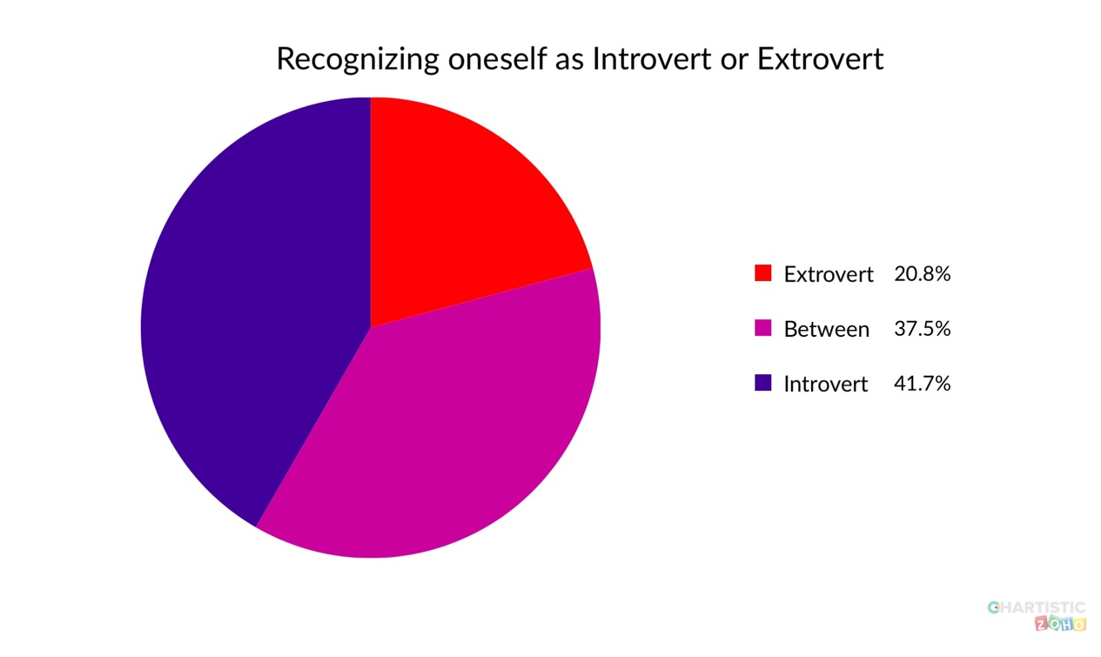

Cain, American author of Quiet: The Power of Introverts In a World That Can't Stop Talking, argues that although a third of the population are introverts, most institutions, from schools to workplaces, are geared towards extroverts, while introverts are often undervalued or misunderstood (Barford 2012). Some mentions that researchers estimate extroverts make up 50 - 74 percent of the population and the other 16 - 50 percent of the population consists of introverts, who get their energy from having “alone time.” (Buettner 2012).

**We may not so introvert as ourselves recognized.**



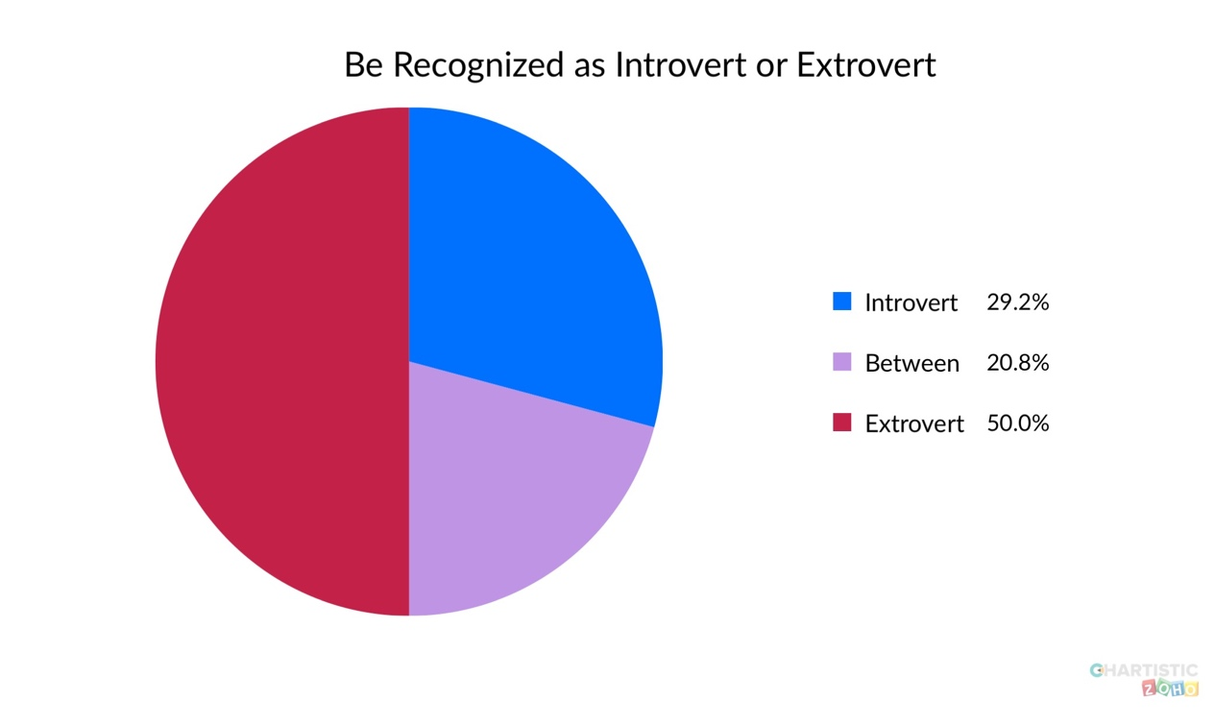

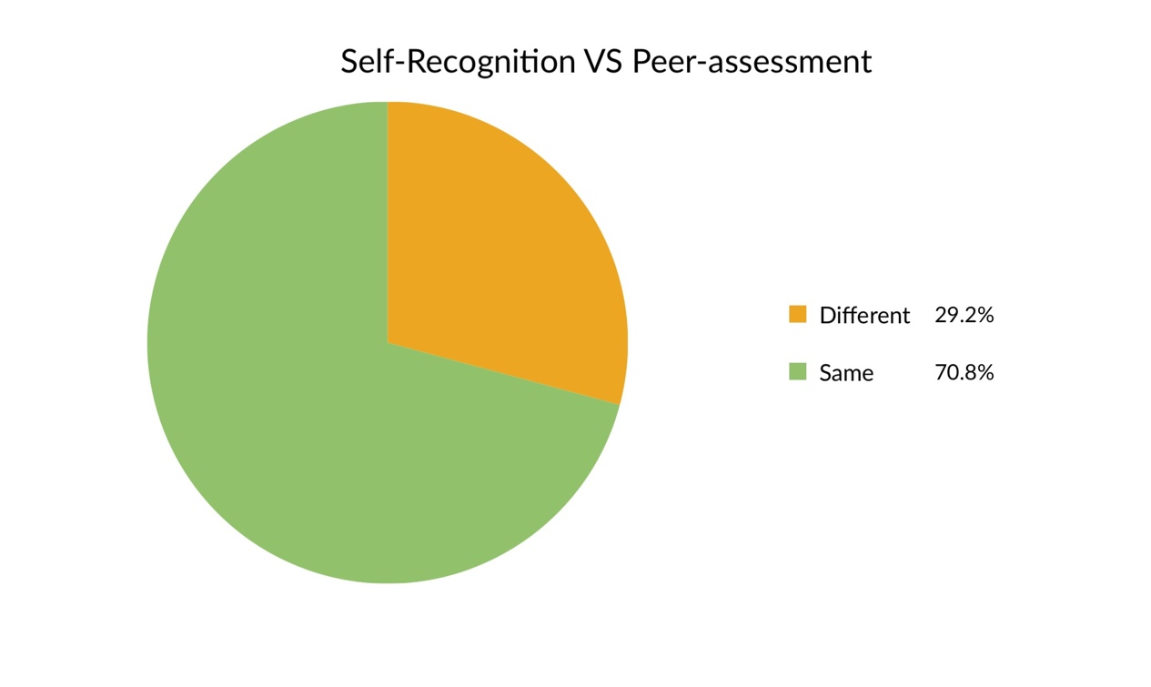

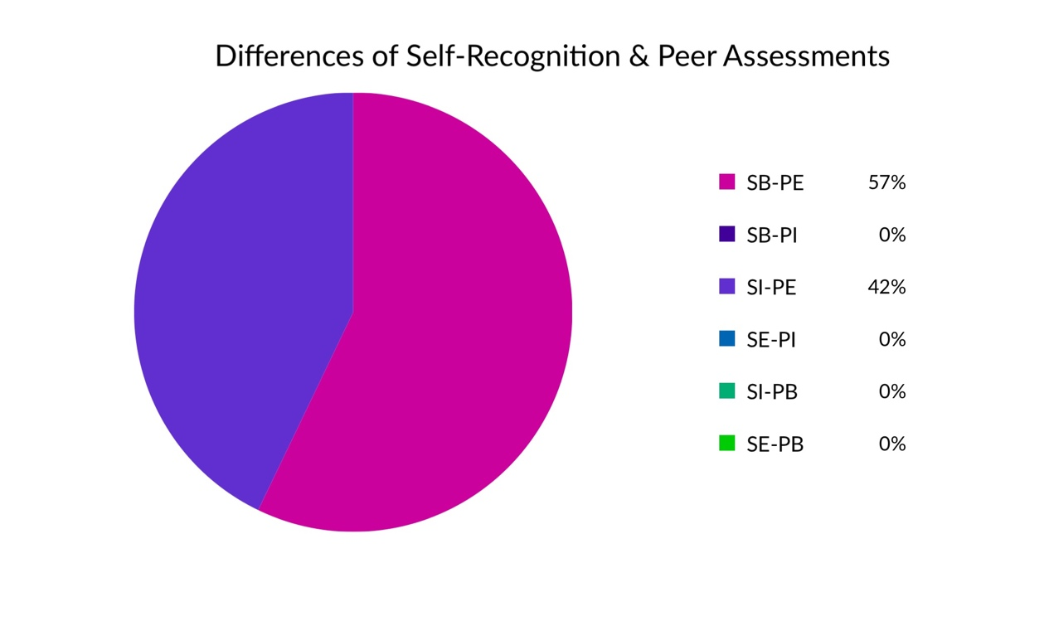

S=Self-Recognition

P=Peer-Assessment

B=Between Introvert & Extrovert

E=Extrovert

I=Introvert

SB-PE=Self-recognized as between introvert and extrovert but peers assessed as extrovert

SI-PE=Self-recognized as introvert but peer assessed as extrovert

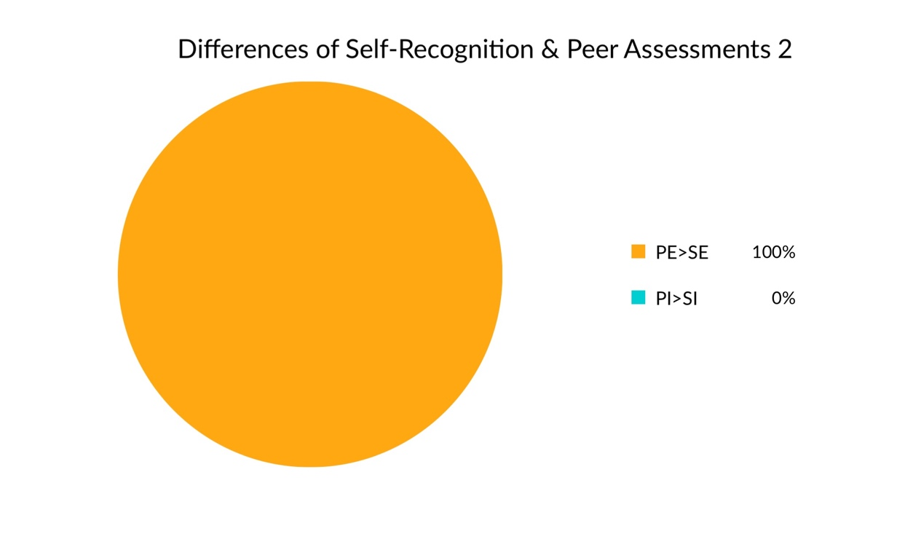

From the graph, we can observe, that adolescents generally recognized themselves more introvert than the peers do.

*Adolescents (who is 13-18 in 2019) generally recognized introvert as a neutral personality. And more people believes introvert is positive than negative. However, they prefer to be an extrovert because parents and relatives pressure, fear of solitude, stereotype of success, and self-recognition.*

**The Peer Pressure May Not Even Existed.**

In survey of 96 adolescents, 77.6% of students believe that introvert is neutral and there are more than twice adolescents believe that introvert is positive than negative. While a lot of introverts suffered a lot from the peer pressure, it may not be existed. In our interviews and final speech, none of the speakers think introvert is negative. Some suggested that an extrovert must be with an introvert, others suggested that being introvert may be a presentation of protecting privacy of both oneself and others, the rest suggested introverts can better concentrate in thinking and completing their own affairs.

Here are one insight we collected from adolescents:

Introverts prefer to stay alone. But if you think they do not like to talk, it might not be the case. Maybe they just do not want to waste time on idling time, or maybe they just have not meet the one who they want to poor their feelings to. Maybe you think they are shy and indifferent, but, actually, they are just faithful to what they believe, and they think debates with others are meaningless. They sorely want to meet the right person and do the proper thing. If you are a friend of an introvert, then he or she will genuinely and sincerely treat you as his or her few “true friend.”

--Zheng Ruyin(translated to English)

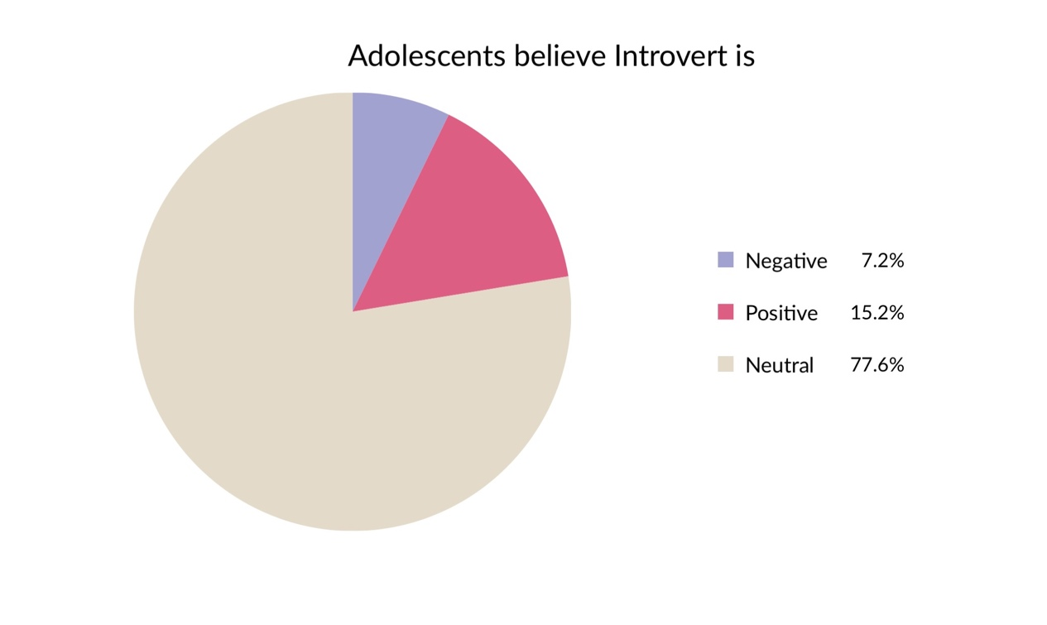

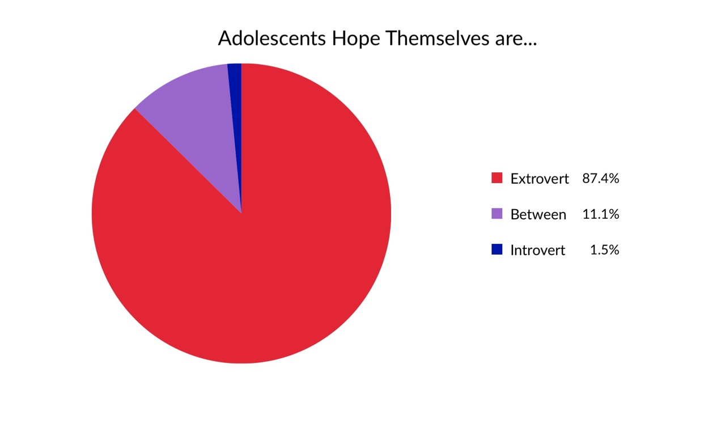

**Parents And Relatives Contribute To Significant Pressure.**

Adults regard being introvert as a negative characteristic. Adults generally hope themselves and their children to be extrovert due to the highly competitive world, intensified peer pressure, and stereotypical remarks made on the introverts.

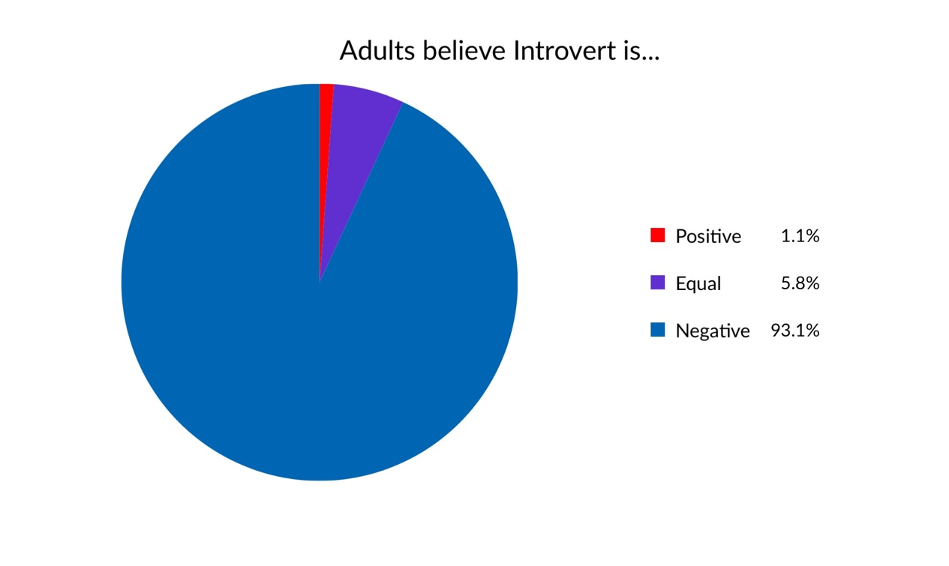

In the survey composed of 433 adults, as high as 93.1% of them believe introversion can be a negative personality. Only 5.8% of them believe it is a neutral trait and as low as 1.1% of them believe it is a positive trait.

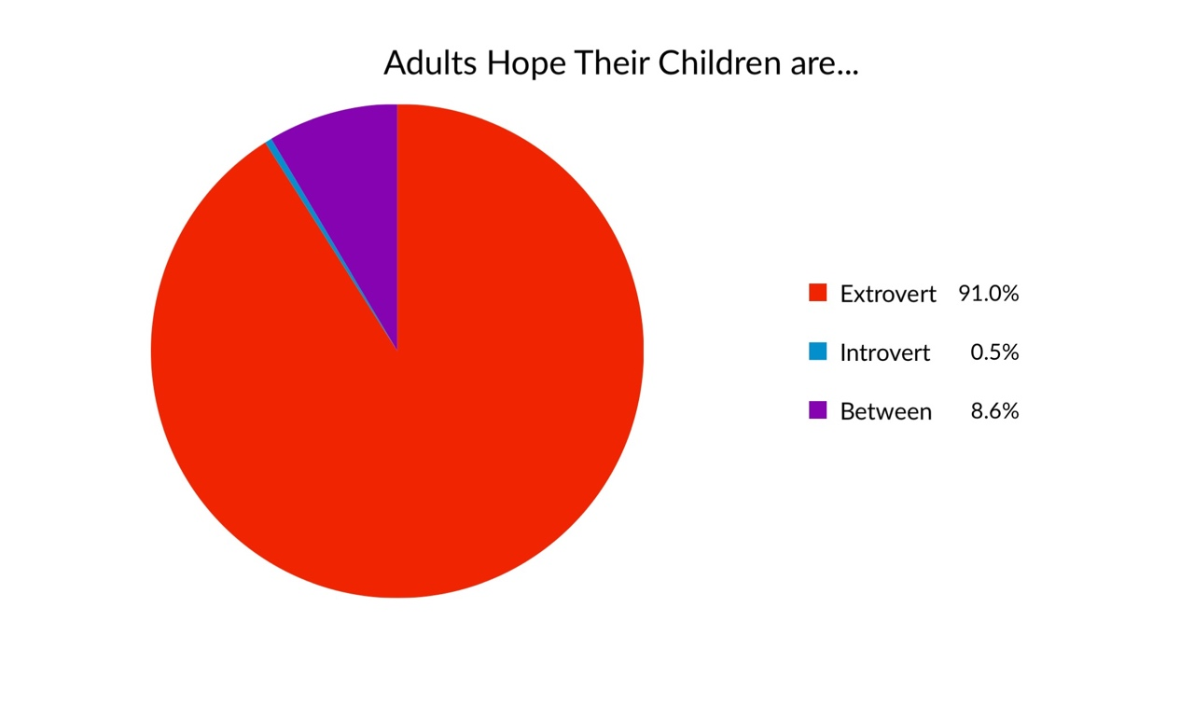

Almost no parents are hoping their children to be introverts, only a minuscule proportion of 0.8% as indicated in the graph. By the contrast, as high as 91% of parents hope their children to be extrovert.

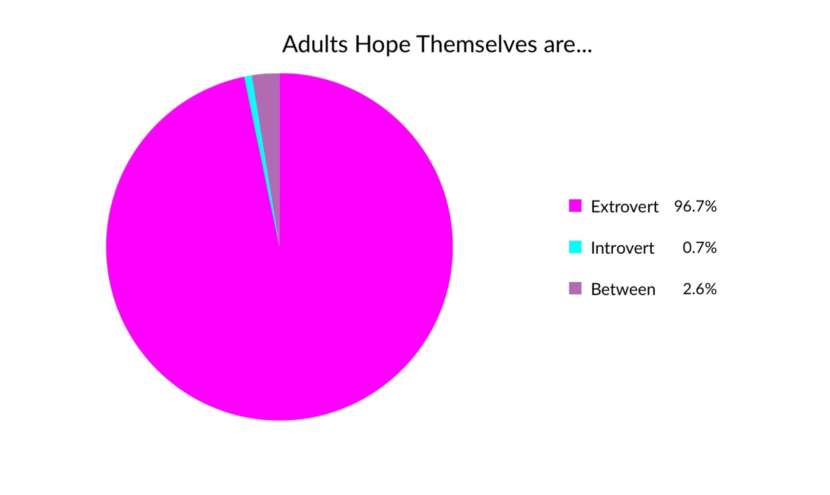More than half adolescents find it is hard to get parents agreed on what an introverts is like, no matter the introverts or the extroverts.

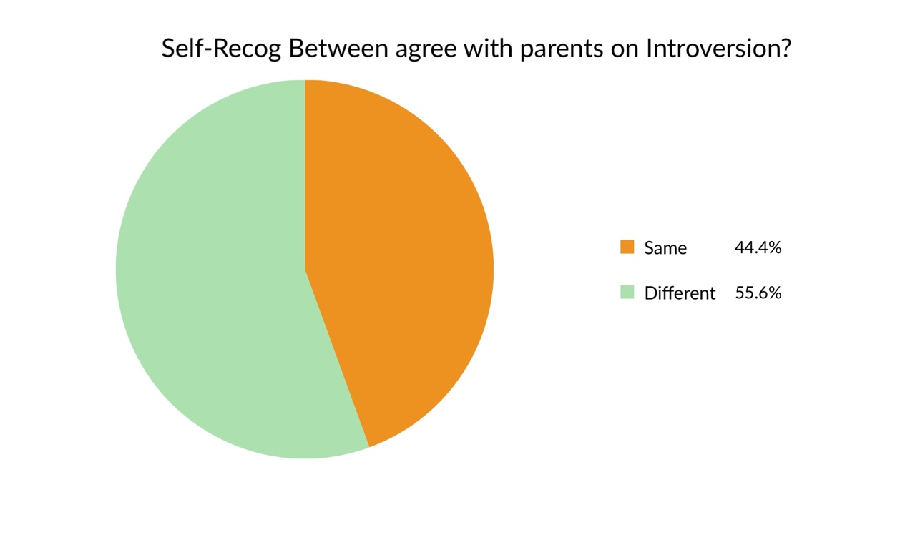

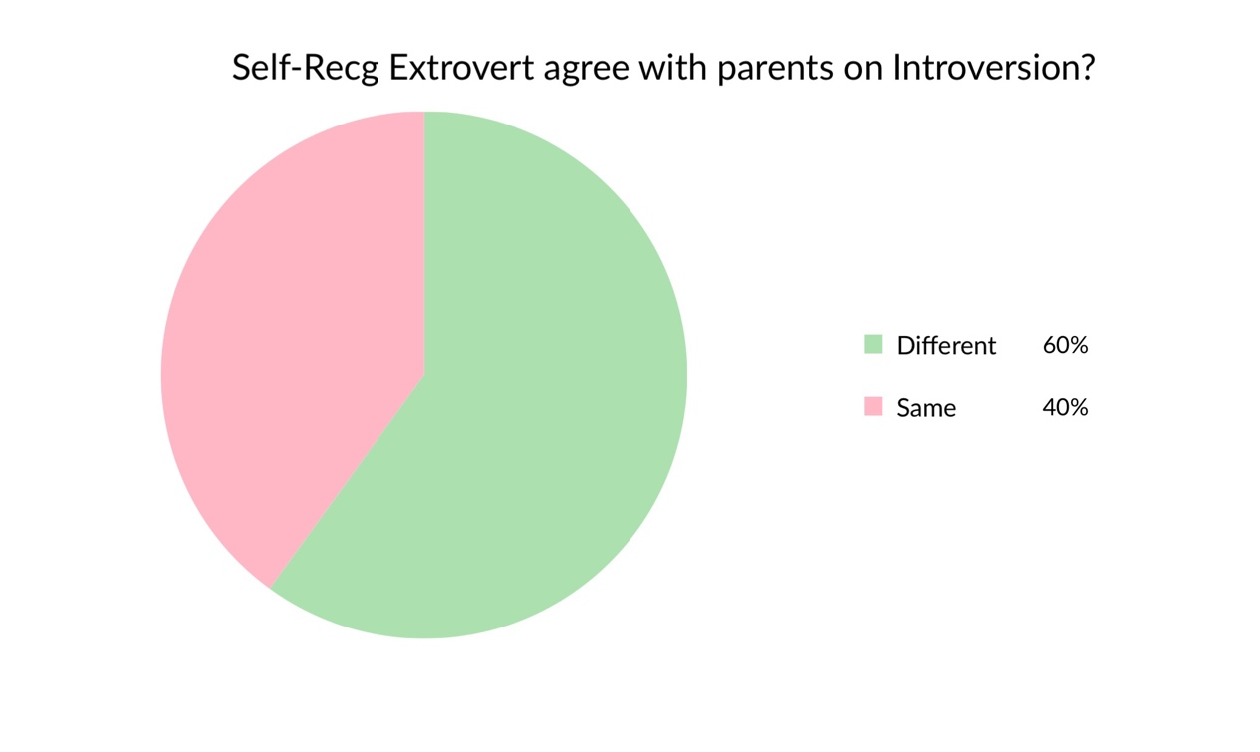

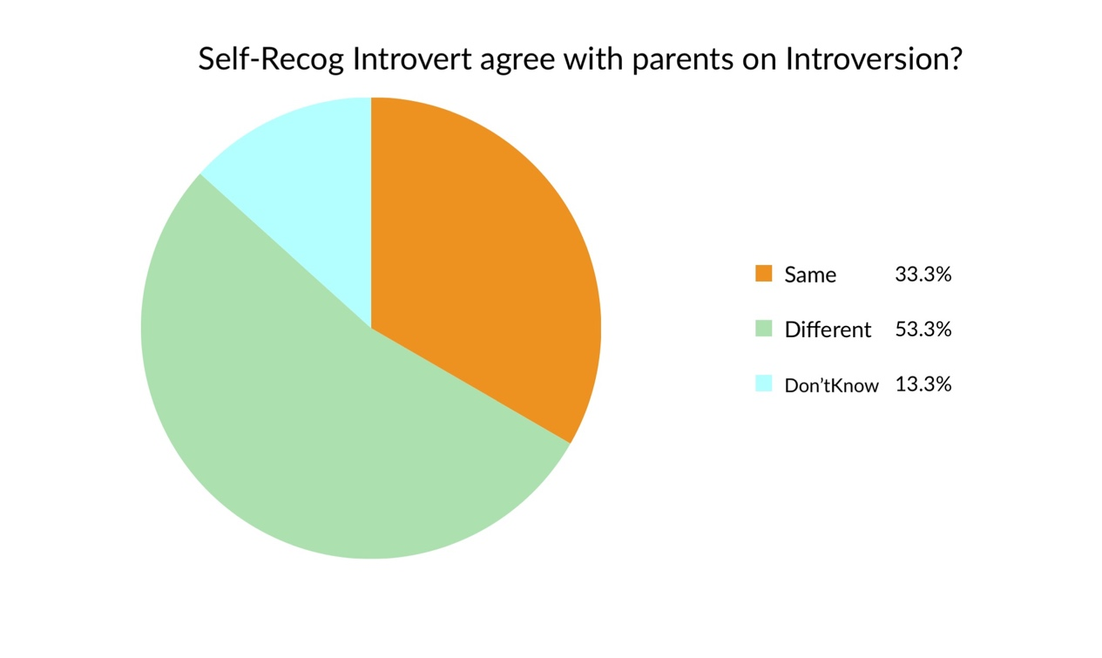

**Introverts can be really trustworthy friends**

Adolescents who are struggling to be an extrovert can be recognized as as extrovert but simultaneously suffer the self-recognition as an introvert. They are likely to feel lonely and not being fully understand. However, they may not be such lonely if they can be themselves rather than pretending. Introvert friends are acceptable and though the number is not as high as extrovert friends. It is commonly recognized that introvert people have more solid friendships. The both the extrovert and introvert people prefer to have a few introvert friends because they know the introvert person are less likely to turn their back on to their close friends and they have more responsibility which is more reliable. The benefit of an introvert friends includes:

1. They are less likely to leak out secrets.
2. They are more sensitive to the pain or the difficulties the friends are going though.
3. They spend more time on a single friend.
4. Their friendship last longer.
5. They can provide more meticulous and insightful suggestions and solutions to an extrovert person.
6. They can tell the extrovert person what they know and make the extrovert person sounds more knowledgeable and charismatic.
7. They reduce tension among a group if they have been in a group of any sort.

Not all of them are true for a person but most introverts can find more than one of these benefits.

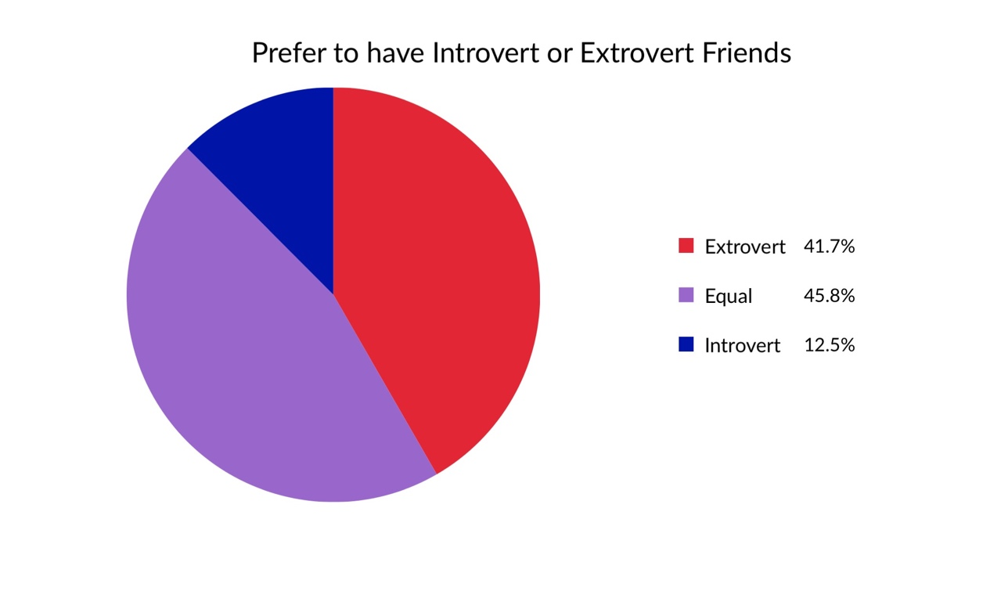

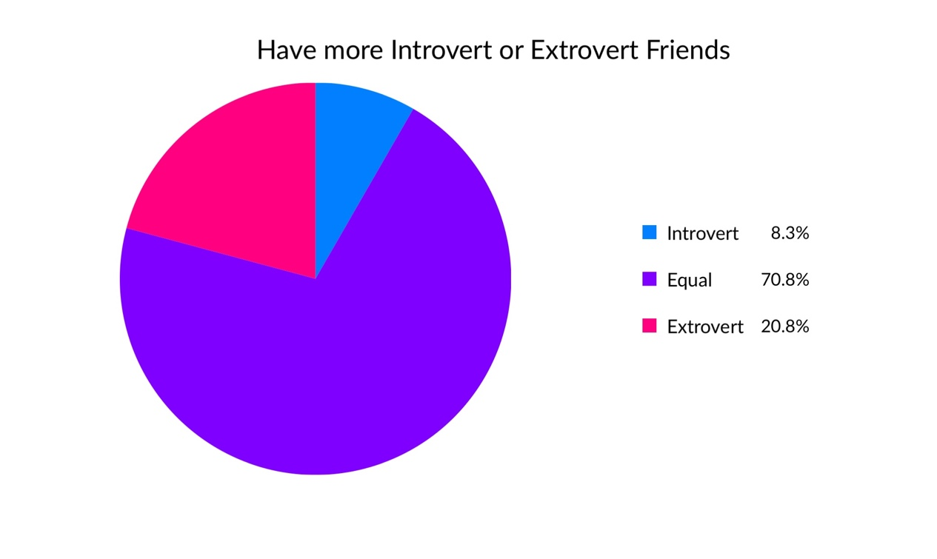

**Introverts Prefer Introvert Friends? Not Necessarily.**

What of introverts who surround themselves with extroverts?

The author of *The Introvert's Way: Living a Quiet Life in a Noisy World*and*Introverts in Love: The Quiet Way to Happily Ever After* gives the following answer:

*These introverts might want to search their souls to make sure that they are not confusing introversion with shyness. Are you drawn to extroverts because you actually love being around lots of people but find it hard to do? If that's the case, I see nothing wrong with letting other people do the heavy lifting while you hang out and enjoy the scene. As long as everyone is happy, why not?”*

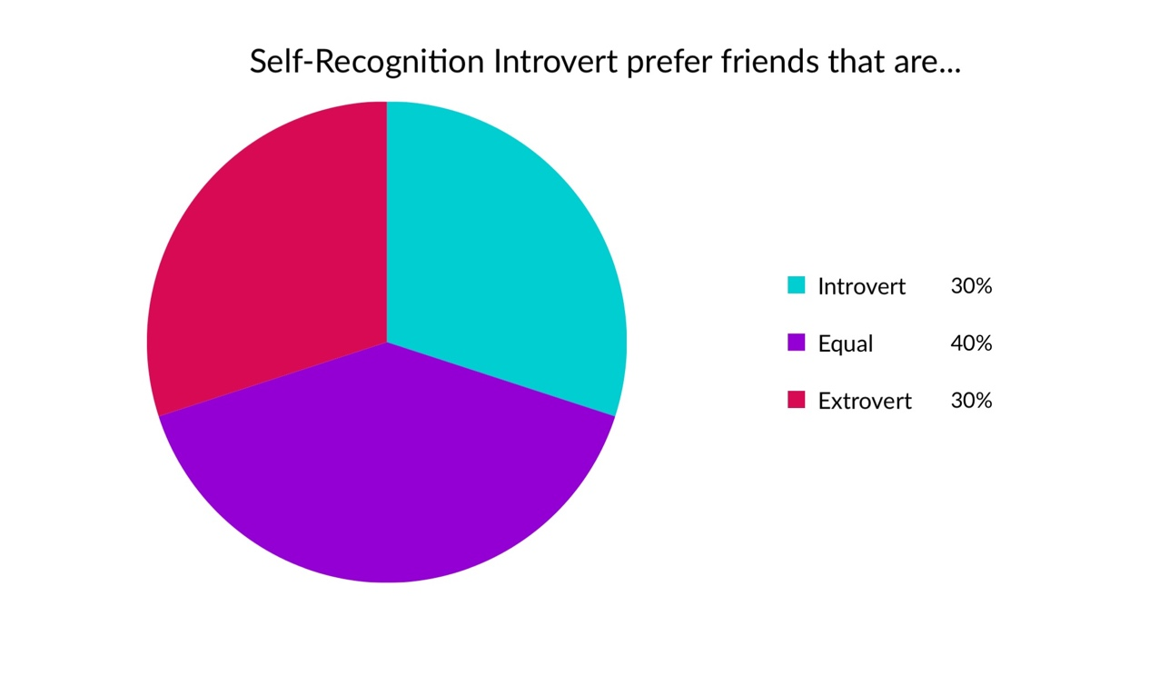

**We are expecting ourselves to be more extroverted than what we really are.**

"In the 1990s, when the Myers-Briggs personality type test went through validation with UK and Europe distributors, 92% of people said it was better to be extrovert, even though only half of the population is extrovert in the type version” (Barford 2012).

People are too fervent in pursuing extroversion. However, only half of the pursuers are or can be extroverts. The rest of them suffer from not being extrovert which has in return, troubled them a lot.

**Introverts are actually hard to be defined.**

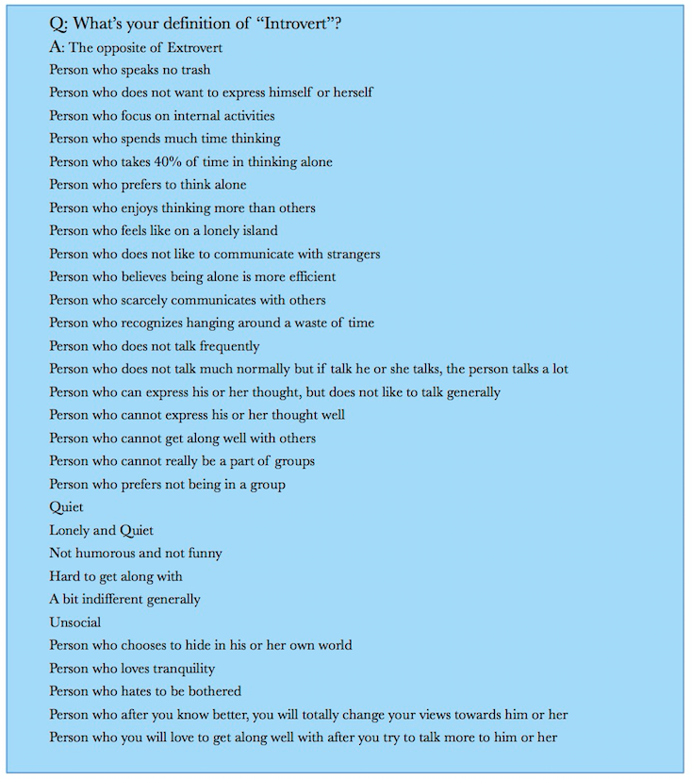

**Introverts can be classified into different types and categories.** Some people can not really be told as an introvert or extrovert. Introvert and extrovert is not *absolute.*

Not all introverts have problems expressing themselves.

In fact, most introverts can express their ideas very clear in rather organized way. Some are even very articulate. Some only have not so much will to express themselves.

Not all introverts execrate social activities.

Some introverts enjoy many social activities such as dancing, singing, traveling. Even they do not enjoying talking so much it does not mean they do not enjoy being with a lot of person. They may even enjoy noise sometimes. Some introverts even enjoying talking if it does not require a lot and the companion is with not difficulty finding new topics all the time.

Not all introverts are shy and timid.

“Shyness is about the fear of social judgments – at a job interview or a party you might be excessively worried about what people think of you. Whereas an introvert might not feel any of those things at all, they simply have the preference to be in a quieter setting. And an example of this is Bill Gates, who is often described as introverted and comes across as quite private – but you don't get the feeling that he is very fazed about what people think about him. You don't imagine him sitting up at night worrying about that. In practice many introverts are also shy, but many are not” (Tucker 2012).

Not all introverts are quiet.

Introverts can be loud person. But they talk less which makes them introverts. They can be calm, firm, clear, loud, and persuasive when they are trying to convince. Some of them scarcely talk normally but can make fantastic speeches.

Some researchers come up with the idea that there are four kinds of introversion: social, thinking, anxious, and restrained, which many introverts demonstrated one or more of them.

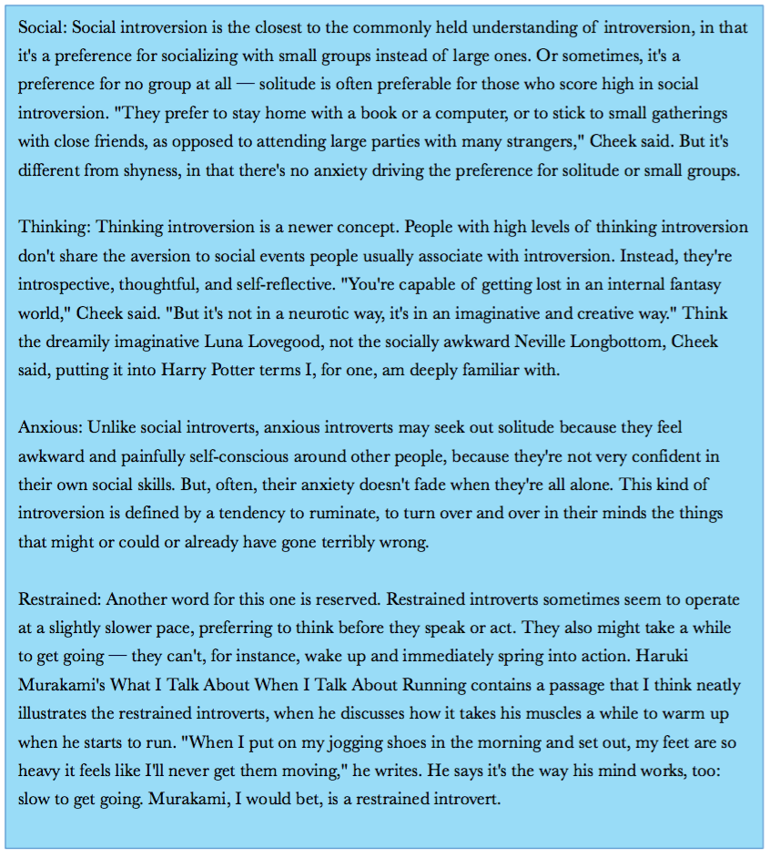

**It may be wrong and bring negative effects to categorize or tag people as introverts or extroverts.**

Some people suggested that “there are no absolute extrovert or introvert. We need to be away from the definitions and tags. We need to be pro-extrovert but keep interpersonal activities; we need to be pro-introvert but keep interpersonal activities.”

In the interview and survey among peers, some people told that they fear the tag are likely to make one more introvert. The person without being tagged may be both introvert and extrovert due to the situation and the need. It is actually the best situation. However, if we tagged someone they are likely to imply themselves that they are introverts and they are afraid of communicating, dislike social activities, and tired of join in groups which they initially may not. The worst assumption and stereotypes of introvert may take up them which generate very outcomes.

**Introvert doesn’t necessary to be the opposite of Extrovert.**

The definitions of introvert and extrovert are not exactly the counterparts. And they are not the antonyms in real life. As in my case, I am not so fond of talking to others and usually hopes to stay alone quietly. I feel boring to stay with groups of people to long if I am not so familiar with them. I am relatively quiet when meet strangers unless it is a task for me. However, I like expressing myself and I am confident on a stage. In fact, I really fond of stage and debating. It makes me feel boring as well if there are few presentation and performance for me. Am I an introvert or extrovert? It is hard to decide.

In previous section, it has been explained that some researchers and scientists believe there are 4 types of introvert. Thus, I could probably be categorized as a social introvert. Maybe a thinking introvert as well. But I am definitely not an anxious introvert or a restrained introvert. So what’s the opposite of me? An extrovert? An introvert? I strongly believe is neither. Cases like me is common to see in our researches, people are generally not completely introvert or extrovert.

**“Someone is an Extrovert, it does not necessarily mean they do extroversion well”** (Barford 2012).

Some extroverts may not be articulate, may not really deal with relationship, counseling, and propaganda better than the introverts do. Extroverts generally much fond of talking but they deem it more like something that is arbitrary. Evaluating the proficiency of talking, debating, and making speeches, an introvert can be more logistic, and have cold ethos. And an introvert can even be really appeal to pathos even they might feel so close with others normally.

**Not only introvert traits can get criticism, extrovert traits also do.**

Urban Dictionary No.3 definition of extroverts is “Assholes who doesn't know when to shut their goddamn mouth. Sadly, they make up most of the population on Earth” (IDunKnow, 2007, Urban Dictionary) and No.4 definition is “A highly overconfident, outgoing and outrageous person who enjoys singing the song Macho-Man from the Village People by being gay and merry one minute and violent and hysterical the next. Their "LAW OF THE LOUT", "LOUD AND THE PROUD", "MIGHT IS RIGHT" and their "LARGE AND IN CHARGE" mindset have long been regarded as the principal reason into why the Jerry Springer Show stayed on air for two decades. These obnoxious attention seeking show-ponies can usually to be found dwelling in various watering holes, cafes, pubs or other social gatherings desperately looking around for fights or other peoples attention and approval” (Octavia, 2013, Urban Dictionary). Extroverts may not be so appreciated by others because people might jealous of people who attracts to much attention. Introverts appear to be more vulnerable to words bullying so few people will criticize introverts hard face to face. However, people generally recognized extroverts are more careless to those words, partly because the extroverts may joke around and laugh at others more than the introverts do. But the fact is both introverts and extroverts may feel desperate after such kinds of criticism. Most extroverts still need to pretend nothing and really firm after such words. It can be a hard time for extroverts as well.

**Introvert can be equally persuasive.**

“You[Introverts] sometimes do have to push yourself to speak more than you feel like doing. But Once you have done that, I have found you need to speak out of conviction. Even if you are not the loudest voice or the most dominant voice, it kind of doesn't matter, it's the conviction which carries the day. So that's the homework to do!” (Sustain Cain, bestselling author on cultural dominance of extroverts interviewed by Ian Tucker, 2012).

Introverts can be a strong persuasive as they can think alone and be very considerate. The evaluation of being persuasive is not how many sentences one can say, but how deep the content is. Introverts can speak in terse sentences which is very appreciable.

**Introvert can become very successful in academic, political and even acting field.** There is no boundary for what introverts can do and they are not inferior to extrovert.

A variety of recognizable scientists are introverts. Isaac Newton was known to be "a deeply introverted character and fiercely protective of his privacy." As one of the world's most recognized and revered physicists, Einstein has often been quoted as saying, “The monotony and solitude of a quiet life stimulates the creative mind.”

Thomas Jefferson, James Madison, John Quincy Adams, Abraham Lincoln, Woodrow Wilson, Calvin Coolidge, Dwight D. Eisenhower, John F. Kennedy, Richard Nixon, Barack Obama and vice versa, they are all introverts. “Introverts have been to known to be pretty solid and efficient leaders because, as noted by Bruna Martinuzzi on the OPEN Forum, they are better listeners, quietly process their thoughts, have humility, are calm and collected, and make more meaningful connections” (Rampton 2015).

Though it seems entrepreneurs really need to be extroverts, it turns out that Larry Page, Bill Gates, Warren Buffet, Mark Zuckerberg, Elon Musk are all introverts. Thus, introversion does not really indicate ones behavior and it does have advantages such as more contemplative and more though thinkers. One can always make up for ones weakness and become successful.

Even Keira Knightley, the famous British stars, admitted she is very introvert. Additionally, Beyoncé and Lady Gaga also explained they are introverts.

“There are a lot of misconceptions regarding introverts. Some look at those they consider to be introverted and toss out all kinds of hyperbole, such as, ‘they are so shy they would not being able to deliver a speech in a public,’ or ‘she is so shy and introverted -- she does not like people all.’ However, these prejudicial overstatements rarely hold water. After all, introverts have been responsible for some of the greatest achievements in history, as well as being some of the most successful business and political leaders in the world” (Rampton, 2015)

Introverts can be in all kinds of fields and there are great number and proportion of successful people that are introverts. Introverts do not show any inferior of success. Both introverts and extroverts have their advantages and disadvantages and it is true an introvert’s value may not be revealed as much as an extrovert do in a short time interview. However, some suggest an introvert person may be easier to rise to higher position than an extrovert does. Nevertheless, there are no certainty and most of these can not be simply judged by introvert or extrovert. Introverts and Extroverts have similarly possibilities to succeed.

**Conclusion**

Generally Speaking,

1. **There are more introverts than we believed.**
2. **The Peer Pressure May Not Existed.**
3. **Parents and Relatives Contribute To Significant Pressure.**
4. **Introverts can be really beneficial friends for extroverts.**
5. **Introverts Prefer Introvert Friends? Not Necessary. It Actually Depends.**
6. **We expect to be extrovert far more than the actually percent that can be achieved.**
7. **Introverts are actually hard to be defined.**
8. **Introverts are different.**
9. **It may be wrong and bring negative effects to categorize or tag people as introverts or extroverts.**
10. **Introvert doesn’t necessary to be the opposite of Extrovert.**
11. **Someone is an Extrovert; it does not necessarily mean they do extroversion well**
12. **Not only introvert traits can get criticism, extrovert traits also do.**
13. **Introvert can be equally persuasive.**
14. **Introvert can become very successful in academic, political and even acting field.**

As a result, we conclude that it is not necessary for adolescents to suffer pressure of not being extrovert. We need to change our mindset of what being introvert is really like. Parents, relatives, and stereotype do give introverts a hard time. However, as the peer generally believe introvert as neutral or positive and we do see significant advantages introverts have. It is not necessary to put oneself to be introvert if it is really uncomfortable. In addition, as not all introverts are shy or have problem expressing oneself, the past image of introverts should be updated. More introverts are shining himself or herself and there are a lot of successful introverts in all kinds of fields. Introversion does not equal to inferiority, and nor does extroversion equal to superiority. Inversion is more likely to be equal to extroversion and they two are not necessarily to serve as antonyms. It is the existence of both introverts and extroverts that make our society more diverse, coming up with more good ideas and advancing day and night.

The two challenges are

1. The surveys lack of samples and credibility.
2. The researching lacks of systematic plan and authoritative essays.

**It may be wrong and bring negative effects to categorize or tag people as introverts or extroverts.’** is in fact to some extent contrary to our discussion. Because all our surveys are leading the subjects to tag themselves and let themselves be tagged by peers of introvert or extrovert. The discussion of this point will weaken our statement and make our researches and projects seem to be harmful in some ways. However, the purpose of our projects is to reduce others’ stereotypes of introvert and diminish the what introverts suffer now.

If we have more times, we want to research and investigate:

1. What is the proportion does each types of introverts take?
2. Are there more types of introverts than the 4 types have mentioned?
3. Who can do extroversion well? Introvert or Extrovert? What’s the comparison?
4. Who suffer more pressure from traits? Introverts or Extroverts?
5. Can introvert or extrovert be easily changed or took pains?
6. How parents’ stereotypes influence the adolescents?

**参考文献/ References**

1. Barford, Vanessa. “Do We Really Give Introverts a Hard Time?” BBC News, BBC, 27 Mar. 2012, www.bbc.com/news/magazine-17510163.
2. Buettner, Dan. “Are Extroverts Happier Than Introverts?” Psychology Today, Sussex Publishers, www.psychologytoday.com/us/blog/thrive/201205/are-extroverts-happier-introverts.
3. Cain, Susan.
4. Dahl, Melissa. “So Apparently There Are 4 Kinds of Introversion.” Daily Intelligencer, Intelligencer, 25 June 2015, nymag.com/scienceofus/2015/06/apparently-there-are-four-kinds-of-introversion.html.
5. Dembling, Sophia. “Introvert-Extrovert Friendships: Hows, Whys, and Why Nots.” Psychology Today, Sussex Publishers, www.psychologytoday.com/us/blog/the-introverts-corner/201102/introvert-extrovert-friendships-hows-whys-and-why-nots.
6. DeMers, Jayson. “5 Mega-Successful Entrepreneurs Who Are Introverts.” Entrepreneur, Entrepreneur, 19 Jan. 2017, www.entrepreneur.com/article/286611.
7. “Dictionary by Merriam-Webster: America's Most-Trusted Online Dictionary.” Merriam-Webster, Merriam-Webster, www.merriam-webster.com/.
8. “English Dictionary, Translations & Thesaurus.” Cambridge Dictionary, dictionary.cambridge.org/.
9. “Extraversion and Introversion.” Wikipedia, Wikimedia Foundation, 24 Dec. 2018, en.wikipedia.org/wiki/Extraversion_and_introversion.
10. “Extrovert.” Urban Dictionary, [www.urbandictionary.com/define.php?term=Extrovert](http://www.urbandictionary.com/define.php?term=Extrovert).
11. Goudreau, Jenna. “So Begins A Quiet Revolution Of The 50 Percent.” Forbes, Forbes Magazine, 12 Aug. 2012, www.forbes.com/sites/jennagoudreau/2012/01/30/quiet-revolution-of-the-50-percent-introverts-susan-cain/#40a7f22a93fb.
12. “Hans Eysenck.” Wikipedia, Wikimedia Foundation, 25 Sept. 2018, en.wikipedia.org/wiki/Hans_Eysenck#Model_of_personality.
13. “Introvert.” Urban Dictionary, www.urbandictionary.com/define.php?term=Introvert.
14. “Introvert.” Dictionary.com, Dictionary.com, www.dictionary.com/browse/introvert.
15. Rampton, John. “10 U.S. Presidents Who Were Introverts.” Inc.com, Inc., 21 Aug. 2015, www.inc.com/john-rampton/are-you-an-introvert-so-were-these-10-us-presidents.html.
16. Rampton, John. “23 Of the Most Amazingly Successful Introverts in History.” Inc.com, Inc., 20 July 2015, www.inc.com/john-rampton/23-amazingly-successful-introverts-throughout-history.html.
17. Tucker, Ian. “Susan Cain: 'Society Has a Cultural Bias towards Extroverts'.” The Guardian, Guardian News and Media, 31 Mar. 2012, www.theguardian.com/technology/2012/apr/01/susan-cain-extrovert-introvert-interview.
18. Waude, Adam. “Extraversion And Introversion.” Psychologist World, 2 Feb. 2017, www.psychologistworld.com/influence-personality/extraversion-introversion.