Principle of moments experiment

Apparatus:
Metre ruler, knife edge, set of 100g masses
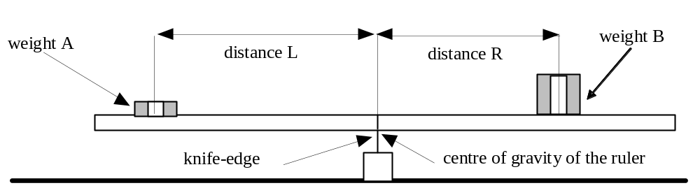
Diagram:

Procedure:
1. Place the metre ruler (without the weights shown in the above diagram) on the knife-edge so that it is balanced.
The knife-edge should be roughly below the 50cm mark on the ruler.
Note down the precise position of the knife-edge below the ruler to the nearest cm.
This is the position of the ruler's centre of gravity.

2. Place a 100g mass, a weight of 1N, called weight A in the diagram, near the left-hand end of the ruler as shown in the diagram above. The ruler will tip down on this side.

3. Place a mass of 200g, a weight of 2N, called weight B in the diagram, on the right-hand side of the ruler as shown.
Move this weight until the ruler balances (or near enough does).

4. Measure the distance L (in cm) between the centre of the 1N weight (A) and the knife-edge position and the distance R (in cm) between the knife-edge position and the position of the 2N weight (B).

5. Record your measurements in a copy of the table below in your class book. Leave a lot of space for your results.
Calculate the entries for (A x L) and (B x R).

Weight A  in newtons | Distance L  in cm | Weight B  in newtons | Distance R  in cm | (A x L)  in Ncm | (B x R)  in Ncm
1.0 |  | 2.0

6. Repeat stages 2 to 5 for values of weight (B) = 3N to 8N.
Remember to measure distance R to the centre of weight B.
Enter your results into your table

7. Repeat stages 2 to 6 with weight (A) = 2N and for values of weight (B) = 3N, 5N & 7N.
Note you may need to move weight (A) nearer to the knife-edge to achieve a balance.

8. If you have time, try some other combinations. e.g. weight (A) = 5N; weight (B) = 2N.

Questions:
1. For each weight combination, what do you notice about the values of (A x L) and (B x R) ?

2. The principle of moments in this situation states that when the ruler is balanced:
weight (A) x Distance (L) = weight (B) x Distance (R)
Explain how well your results confirm this equation.

3. Use this equation to predict the unknown values in the following cases:
- weight (A) = 5N; weight (B) = 15N; Distance (L) = 30cm; Distance (R) = ?
- weight (A) = 30N; weight (B) = 5N; Distance (L) = 5cm; Distance (R) = ?
- weight (A) = 8N; Distance (L) = 50cm; Distance (R) = 10cm; weight (B) = ?
- Distance (L) = 24cm; Distance (R) = 36cm; weight (B) = 6N; weight (A) = ?
- weight (A) = 60N; weight (B) = 12N; Distance (R) = 36cm; Distance (L) = ?

