Homework 5: Pareto and Kuznets on the Grand Tour

We continue working with the World Top Incomes Database [<https://wid.world>], and the Pareto distribution, as in the lab. We also continue to practice working with data frames, manipulating data from one format to another, and writing functions to automate repetitive tasks.

wtid_report=read_csv("data/wtid-report.csv")

## Parsed with column specification:  
## cols(  
## Country = col_character(),  
## Year = col_double(),  
## `P90 income threshold` = col_double(),  
## `P95 income threshold` = col_double(),  
## `P99 income threshold` = col_double(),  
## `P99.5 income threshold` = col_double(),  
## `P99.9 income threshold` = col_double(),  
## `P99.99 income threshold` = col_double()  
## )

We saw in the lab that if the upper tail of the income distribution followed a perfect Pareto distribution, then We could estimate the Pareto exponent by solving any one of these equations for $a$; in lab we used

Because of measurement error and sampling noise, we can’t find find one value of $a$ which will work for all three equations –. Generally, trying to make all three equations come close to balancing gives a better estimate of $a$ than just solving one of them. (This is analogous to finding the slope and intercept of a regression line by trying to come close to all the points in a scatterplot, and not just running a line through two of them.)

1. We estimate $a$ by minimizing
$${\left({\left(\frac{P99}{P99.9}\right)}^{−a+1}−10\right)}^{2}+{\left({\left(\frac{P99.5}{P99.9}\right)}^{−a+1}−5\right)}^{2}+{\left({\left(\frac{P99}{P99.5}\right)}^{−a+1}−2\right)}^{2}$$

2. Write a function, percentile_ratio_discrepancies, which takes as inputs P99, P99.5, P99.9 and a, and returns the value of the expression above. Check that when P99=1e6, P99.5=2e6, P99.9=1e7 and a=2, your function returns 0.

percentile_ratio_discrepancies=function(P99,P99.5,P99.9,a){  
 return(((P99/P99.9)^(1-a)-10)^2+((P99.5/P99.9)^(1-a)-5)^2+((P99/P99.5)^(1-a)-2)^2)  
}  
percentile_ratio_discrepancies(1e6,2e6,1e7,2)

## [1] 0

1. Write a function, exponent.multi_ratios_est, which takes as inputs P99, P99.5, P99.9, and estimates a. It should minimize your percentile_ratio_discrepancies function. The starting value for the minimization should come from . Check that when P99=1e6, P99.5=2e6 and P99.9=1e7, your function returns an a of 2.

exponent.multi_ratios_est=function(q99,q99.5,q99.9,a=1-log(10)/log(q99/q99.9)){  
 return(nlm(percentile_ratio_discrepancies,a,P99=q99,P99.5=q99.5,P99.9=q99.9)$estimate)  
}  
exponent.multi_ratios_est(1e6,2e6,1e7)

## [1] 2

1. Write a function which uses exponent.multi_ratios_est to estimate $a$ for the US for every year from 1913 to 2012. (There are many ways you could do this, including loops.) Plot the estimates; make sure the labels of the plot are appropriate.

a_estimate=function(){  
 result=vector(length = 100)  
for(i in 1:100){  
 result[i]=exponent.multi_ratios_est(wtid_report$`P99 income threshold`[i],wtid_report$`P99.5 income threshold`[i],wtid_report$`P99.9 income threshold`[i])  
}  
 result=tibble(a_estimate=result) %>% mutate(year=wtid_report$Year)  
 return(result)  
}  
ggplot(data=a_estimate(),aes(x=year,y=a_estimate))+  
 geom_point()+  
 geom_line(col='blue')

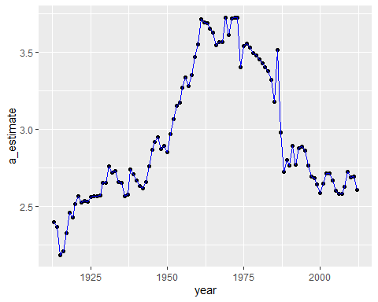

1. Use to estimate $a$ for the US for every year. Make a scatter-plot of these estimates against those from problem 3. If they are identical or completely independent, something is wrong with at least one part of your code. Otherwise, can you say anything about how the two estimates compare?

answer:from the plot, we can know there is a little difference between the new estimate and the old estimate

wtid_report=wtid_report %>% mutate(a_estimate_new=1-log(10)/log(`P99 income threshold`/`P99.9 income threshold`))  
plot(a_estimate()$a_estimate,wtid_report$a_estimate_new)

