Stat461 HW8 Ruizhi Qiao

1.> data = read.table('auditor.dat',header=T,sep='\t')

> block = as.factor(data[,1])

> method = as.factor(data[,2])

> score = data[,3]

> interaction.plot(block,method,score)

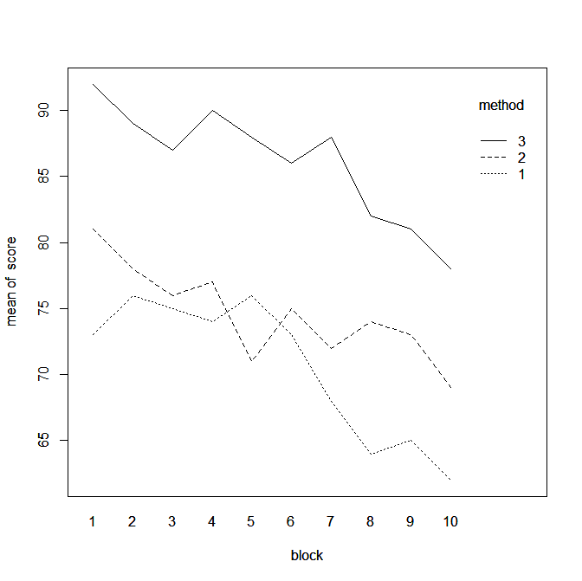

In the plot, there are interactions between method 1 and method 2. So there is interaction effect.

Because the slope is not equal to 0, so there exists block effect.

Because there are three separate lines for three methods, so there exists method effect.

2.> d = read.table('CH19PR20.txt')

> y = d[,1]

> A = as.factor(d[,2])

> B = as.factor(d[,3])

> fit=lm(y~A+B+A*B)

> anova(fit)

Analysis of Variance Table

Response: y

Df Sum Sq Mean Sq F value Pr(>F)

A 1 39447 39447 458.02 2.983e-14 ***

B 2 36412 18206 211.39 3.158e-13 ***

A:B 2 20165 10083 117.07 4.816e-11 ***

Residuals 18 1550 86

---

Signif. codes: 0 ‘***’ 0.001 ‘**’ 0.01 ‘*’ 0.05 ‘.’ 0.1 ‘ ’ 1

> qf(0.95,2,18)

[1] 3.554557

F statistics = 117.07 > f critical = 3.554557

Thus, we cannot reject Ho. So, there is interaction effect.

So it is meaningful.

3.a) yij=µ. +Ʈi+Ɛij for scenario 1

yij=µ..+Ʈi+βj+Ɛij for scenario 2

b) In a design without blocking, the researcher would pick plots and randomly assign treatments to them. This is known as unrestricted randomization. Blocking designs have restricted randomization since the treatments are randomly assigned within each block.

c)

|  |  |
| --- | --- |
| Source | df |
| Treatment | 3 |
| Error | 20 |
| Total | 23 |

|  |  |
| --- | --- |
| Source | df |
| Treatment | 3 |
| Block | 5 |
| Tr`Bl (Error) | 15 |
| Total | 23 |

4.

> data = read.table('P1.txt',header=T)

> score = data[,1]

> teacher = as.factor(data[,2])

> method = as.factor(data[,3])

> fit=lm(score~ method+teacher+teacher*method)

> anova(fit)

Analysis of Variance Table

Response: score

Df Sum Sq Mean Sq F value Pr(>F)

method 2 1295.00 647.50

teacher 9 433.37 48.15

teacher:method 18 112.33 6.24

residuals 0 0.00

F=647.50/6.24=103.75>f2,18(.05)=3.55

Tukey=qtukey(0.95,3,18)/sqrt(2)

[1] 2.552163

> tapply(data$score,data$method,mean)

1 2 3

70.6 74.6 86.1

LSD=tukey*sqrt(6.24(1/10+1/10))=2.85112

74.6-70.6=4>LSD, so significant.

86.1-74.6=11.5>LSD, significant.

Therefore, 1 and 2, 2 and 3, 1 and 3 are significantly different.