sesame

Ruizhi Qiao

September 9, 2017

library(xlsx)

## Loading required package: rJava

## Loading required package: xlsxjars

SS=read.xlsx('sesame.xlsx', sheetIndex = 1)

SS$improvenumb=SS$postnumb-SS$prenumb  
SS$improvelet=SS$postlet-SS$prelet  
SS$improveform=SS$postform-SS$preform  
SS$improvebody=SS$postbody-SS$prebody  
SS$improverelat=SS$postrelat-SS$prerelat  
SS$improveclasf=SS$postclasf-SS$preclasf

site1=SS[SS$site==1,]  
site2=SS[SS$site==2,]  
site3=SS[SS$site==3,]  
site4=SS[SS$site==4,]  
site5=SS[SS$site==5,]

sesame=SS  
sesame$s1[sesame$site==1]=1  
sesame$s1[sesame$site>1]=0  
sesame$s2[sesame$site==2]=1  
sesame$s2[sesame$site>2]=0  
sesame$s2[sesame$site<2]=0  
sesame$s3[sesame$site==3]=1  
sesame$s3[sesame$site>3]=0  
sesame$s3[sesame$site<3]=0  
sesame$s4[sesame$site==4]=1  
sesame$s4[sesame$site>4]=0  
sesame$s4[sesame$site<4]=0  
sesame$sex[sesame$sex==2]=0  
sesame$setting[sesame$setting==2]=0  
sesame$viewenc[sesame$viewenc==2]=0  
sesame$vc1[sesame$viewcat==1]=1  
sesame$vc1[sesame$viewcat>1]=0  
sesame$vc2[sesame$viewcat==2]=1  
sesame$vc2[sesame$viewcat>2]=0  
sesame$vc2[sesame$viewcat<2]=0  
sesame$vc3[sesame$viewcat==3]=1  
sesame$vc3[sesame$viewcat>3]=0  
sesame$vc3[sesame$viewcat<3]=0

attach(SS)  
pairs(~age+improveclasf+improvebody+improverelat+peabody+prenumb+prelet+preform+improvenumb+improvelet+improveform)

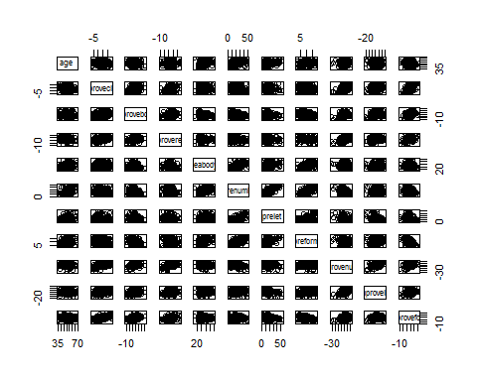

boxplot(improvenumb~site)

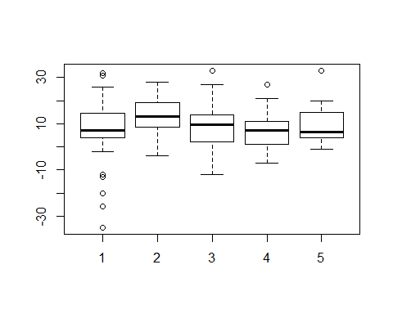

boxplot(improvenumb~sex)

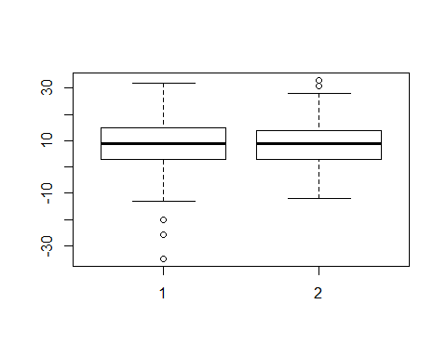

boxplot(improvenumb~viewcat)

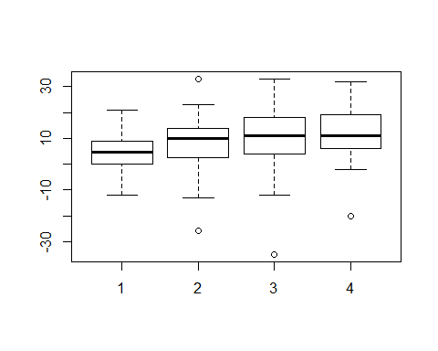

boxplot(improvenumb~setting)

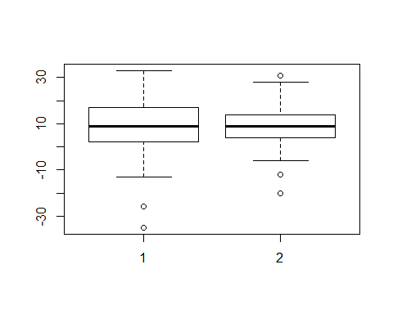

boxplot(improvenumb~viewenc)

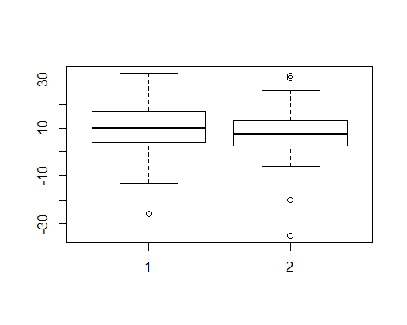

boxplot(improvenumb~agecat)

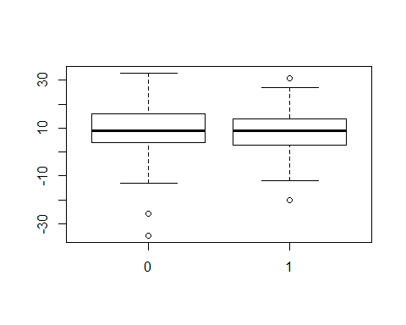

boxplot(improvenumb~encour)

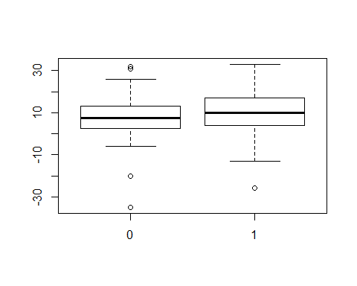

boxplot(improvenumb~regular)

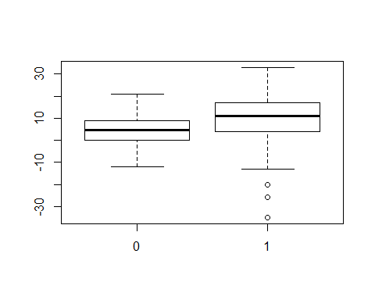

boxplot(improvelet~site)

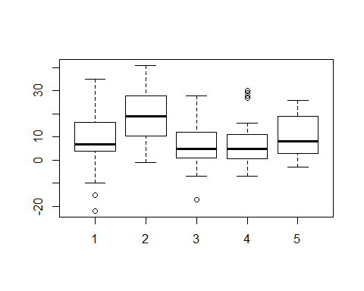

boxplot(improvelet~sex)

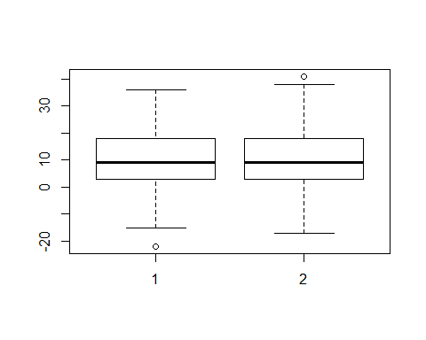

boxplot(improvelet~viewcat)

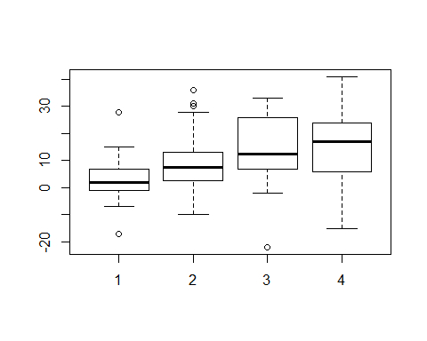

boxplot(improvelet~setting)

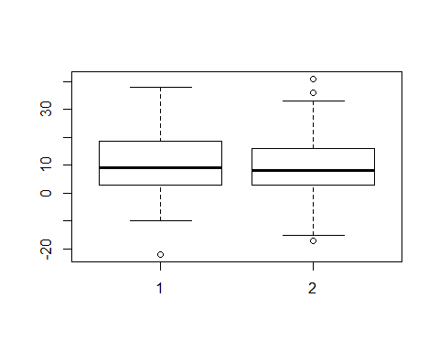

boxplot(improvelet~viewenc)

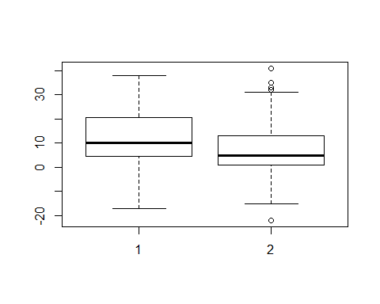

boxplot(improvelet~agecat)

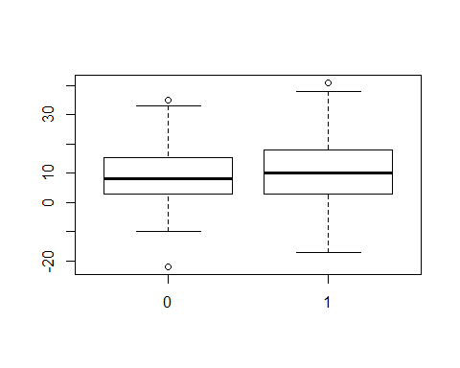

boxplot(improvelet~encour)

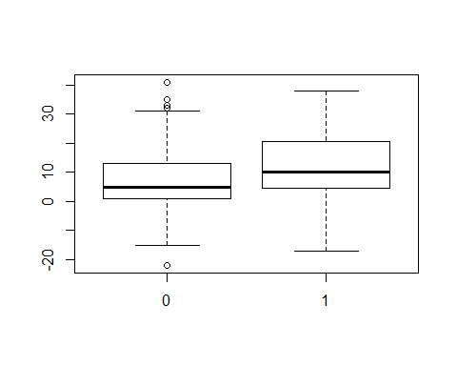

boxplot(improvelet~regular)

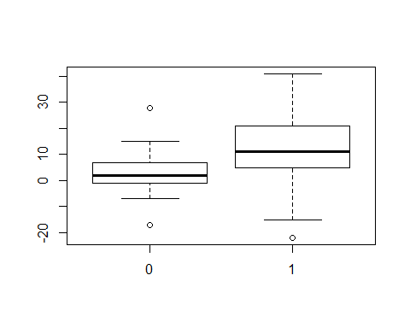

boxplot(improveform~site)

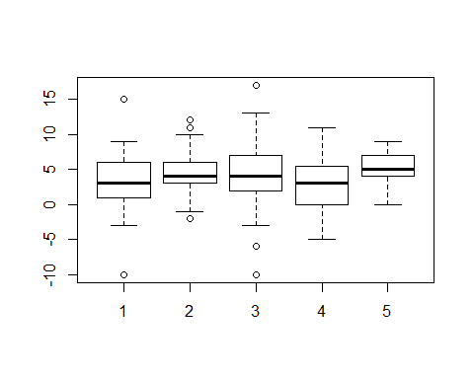

boxplot(improveform~sex)

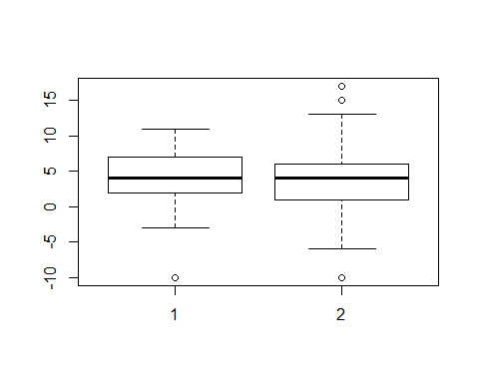

boxplot(improveform~viewcat)

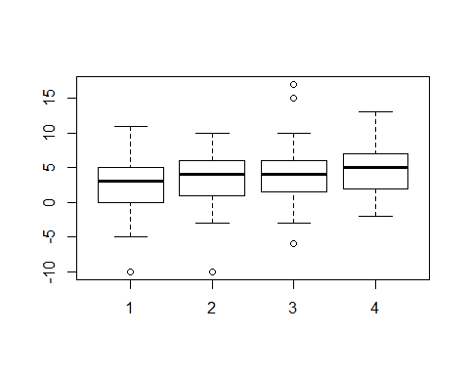

boxplot(improveform~setting)

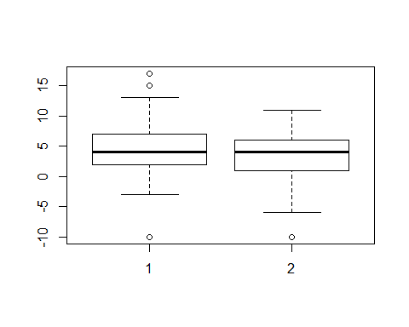

boxplot(improveform~viewenc)

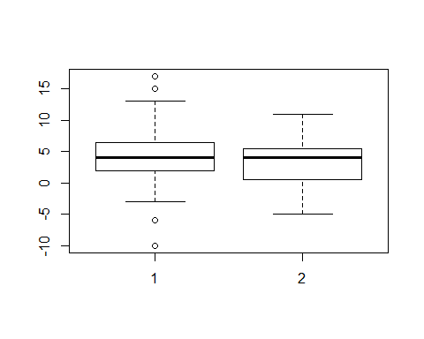

boxplot(improveform~agecat)

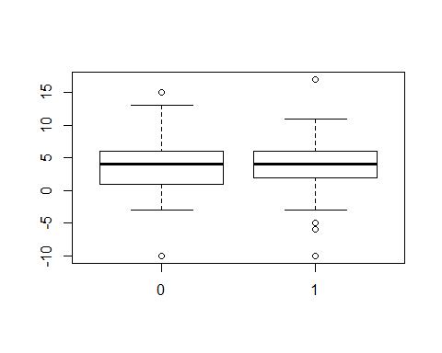

boxplot(improveform~encour)

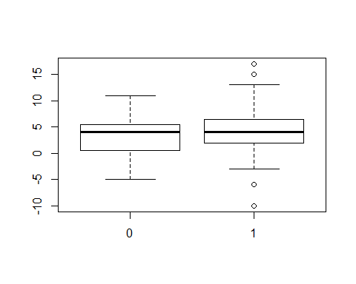

boxplot(improveform~regular)

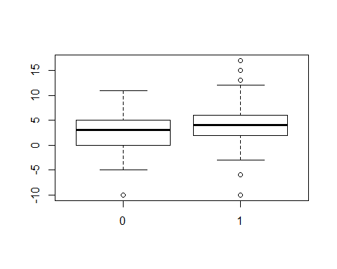

attach(sesame)

## The following objects are masked from SS:  
##   
## age, agecat, encour, id, improvebody, improveclasf,  
## improveform, improvelet, improvenumb, improverelat, peabody,  
## postbody, postclasf, postform, postlet, postnumb, postrelat,  
## prebody, preclasf, preform, prelet, prenumb, prerelat,  
## regular, setting, sex, site, viewcat, viewenc

fit1=lm(improvenumb~sex+age++setting+viewenc+improveclasf+improvebody+improverelat+peabody+agecat+encour+regular+s1+s2+s3+s4+vc1+vc2+vc3+prenumb)  
summary(fit1)

##   
## Call:  
## lm(formula = improvenumb ~ sex + age + +setting + viewenc + improveclasf +   
## improvebody + improverelat + peabody + agecat + encour +   
## regular + s1 + s2 + s3 + s4 + vc1 + vc2 + vc3 + prenumb)  
##   
## Residuals:  
## Min 1Q Median 3Q Max   
## -30.5908 -4.9256 0.5411 5.1912 19.2199   
##   
## Coefficients: (2 not defined because of singularities)  
## Estimate Std. Error t value Pr(>|t|)   
## (Intercept) -5.99254 7.26005 -0.825 0.41002   
## sex -0.41252 1.00956 -0.409 0.68321   
## age 0.31786 0.14235 2.233 0.02655 *   
## setting -2.02893 1.16055 -1.748 0.08180 .   
## viewenc -0.52323 1.20103 -0.436 0.66351   
## improveclasf 0.68216 0.12698 5.372 1.96e-07 ***  
## improvebody 0.17509 0.10992 1.593 0.11260   
## improverelat 0.54541 0.16780 3.250 0.00133 **   
## peabody 0.04131 0.04529 0.912 0.36272   
## agecat -1.43906 1.62901 -0.883 0.37798   
## encour NA NA NA NA   
## regular 5.69209 1.73648 3.278 0.00121 **   
## s1 -2.81290 2.26393 -1.242 0.21537   
## s2 0.73833 2.26318 0.326 0.74455   
## s3 -3.86603 2.18469 -1.770 0.07817 .   
## s4 -3.77837 2.30706 -1.638 0.10289   
## vc1 NA NA NA NA   
## vc2 -2.17541 1.45627 -1.494 0.13664   
## vc3 0.37270 1.39058 0.268 0.78893   
## prenumb -0.30707 0.06660 -4.610 6.78e-06 ***  
## ---  
## Signif. codes: 0 '***' 0.001 '**' 0.01 '*' 0.05 '.' 0.1 ' ' 1  
##   
## Residual standard error: 7.586 on 222 degrees of freedom  
## Multiple R-squared: 0.4313, Adjusted R-squared: 0.3878   
## F-statistic: 9.906 on 17 and 222 DF, p-value: < 2.2e-16

MSE1=(summary(fit1)$sigma)^2  
step(fit1, scale=MSE1, direction="backward")

## Start: AIC=18  
## improvenumb ~ sex + age + +setting + viewenc + improveclasf +   
## improvebody + improverelat + peabody + agecat + encour +   
## regular + s1 + s2 + s3 + s4 + vc1 + vc2 + vc3 + prenumb  
##   
##   
## Step: AIC=18  
## improvenumb ~ sex + age + setting + viewenc + improveclasf +   
## improvebody + improverelat + peabody + agecat + encour +   
## regular + s1 + s2 + s3 + s4 + vc2 + vc3 + prenumb  
##   
##   
## Step: AIC=18  
## improvenumb ~ sex + age + setting + viewenc + improveclasf +   
## improvebody + improverelat + peabody + agecat + regular +   
## s1 + s2 + s3 + s4 + vc2 + vc3 + prenumb  
##   
## Df Sum of Sq RSS Cp  
## - vc3 1 4.13 12779 16.072  
## - s2 1 6.12 12781 16.106  
## - sex 1 9.61 12785 16.167  
## - viewenc 1 10.92 12786 16.190  
## - agecat 1 44.91 12820 16.780  
## - peabody 1 47.87 12823 16.832  
## - s1 1 88.84 12864 17.544  
## <none> 12775 18.000  
## - vc2 1 128.41 12903 18.232  
## - improvebody 1 146.01 12921 18.537  
## - s4 1 154.35 12929 18.682  
## - setting 1 175.88 12951 19.056  
## - s3 1 180.20 12955 19.131  
## - age 1 286.92 13062 20.986  
## - improverelat 1 607.97 13383 26.565  
## - regular 1 618.32 13393 26.745  
## - prenumb 1 1223.19 13998 37.256  
## - improveclasf 1 1660.76 14436 44.860  
##   
## Step: AIC=16.07  
## improvenumb ~ sex + age + setting + viewenc + improveclasf +   
## improvebody + improverelat + peabody + agecat + regular +   
## s1 + s2 + s3 + s4 + vc2 + prenumb  
##   
## Df Sum of Sq RSS Cp  
## - s2 1 6.63 12786 14.187  
## - sex 1 9.19 12788 14.232  
## - viewenc 1 10.69 12790 14.258  
## - agecat 1 45.29 12824 14.859  
## - peabody 1 46.47 12826 14.879  
## - s1 1 85.99 12865 15.566  
## <none> 12779 16.072  
## - improvebody 1 143.73 12923 16.570  
## - s4 1 150.75 12930 16.692  
## - setting 1 174.07 12953 17.097  
## - s3 1 176.75 12956 17.143  
## - vc2 1 209.56 12989 17.713  
## - age 1 287.06 13066 19.060  
## - improverelat 1 605.26 13384 24.590  
## - regular 1 830.21 13609 28.499  
## - prenumb 1 1234.15 14013 35.518  
## - improveclasf 1 1664.54 14444 42.998  
##   
## Step: AIC=14.19  
## improvenumb ~ sex + age + setting + viewenc + improveclasf +   
## improvebody + improverelat + peabody + agecat + regular +   
## s1 + s3 + s4 + vc2 + prenumb  
##   
## Df Sum of Sq RSS Cp  
## - sex 1 9.79 12796 12.357  
## - viewenc 1 11.75 12798 12.391  
## - agecat 1 44.01 12830 12.952  
## - peabody 1 52.21 12838 13.094  
## <none> 12786 14.187  
## - improvebody 1 138.40 12924 14.592  
## - setting 1 202.61 12988 15.708  
## - vc2 1 224.93 13011 16.096  
## - s1 1 280.04 13066 17.053  
## - age 1 280.49 13066 17.061  
## - s4 1 357.50 13143 18.399  
## - s3 1 443.55 13229 19.895  
## - improverelat 1 617.39 13403 22.916  
## - regular 1 902.72 13688 27.874  
## - prenumb 1 1232.77 14019 33.610  
## - improveclasf 1 1661.00 14447 41.051  
##   
## Step: AIC=12.36  
## improvenumb ~ age + setting + viewenc + improveclasf + improvebody +   
## improverelat + peabody + agecat + regular + s1 + s3 + s4 +   
## vc2 + prenumb  
##   
## Df Sum of Sq RSS Cp  
## - viewenc 1 11.60 12807 10.559  
## - agecat 1 38.71 12834 11.030  
## - peabody 1 49.24 12845 11.213  
## <none> 12796 12.357  
## - improvebody 1 135.34 12931 12.709  
## - setting 1 208.44 13004 13.979  
## - vc2 1 225.04 13021 14.268  
## - age 1 270.72 13066 15.062  
## - s1 1 287.40 13083 15.352  
## - s4 1 357.13 13153 16.563  
## - s3 1 444.86 13240 18.088  
## - improverelat 1 613.64 13409 21.021  
## - regular 1 895.84 13691 25.925  
## - prenumb 1 1223.10 14019 31.612  
## - improveclasf 1 1700.09 14496 39.901  
##   
## Step: AIC=10.56  
## improvenumb ~ age + setting + improveclasf + improvebody + improverelat +   
## peabody + agecat + regular + s1 + s3 + s4 + vc2 + prenumb  
##   
## Df Sum of Sq RSS Cp  
## - agecat 1 37.11 12844 9.2036  
## - peabody 1 56.70 12864 9.5440  
## <none> 12807 10.5587  
## - improvebody 1 138.04 12945 10.9576  
## - vc2 1 232.80 13040 12.6042  
## - setting 1 247.79 13055 12.8648  
## - age 1 265.40 13073 13.1707  
## - s1 1 277.20 13084 13.3759  
## - s4 1 353.92 13161 14.7089  
## - s3 1 449.15 13256 16.3639  
## - improverelat 1 613.60 13421 19.2217  
## - regular 1 938.57 13746 24.8689  
## - prenumb 1 1240.29 14048 30.1121  
## - improveclasf 1 1688.61 14496 37.9028  
##   
## Step: AIC=9.2  
## improvenumb ~ age + setting + improveclasf + improvebody + improverelat +   
## peabody + regular + s1 + s3 + s4 + vc2 + prenumb  
##   
## Df Sum of Sq RSS Cp  
## - peabody 1 43.73 12888 7.9635  
## <none> 12844 9.2036  
## - improvebody 1 134.88 12979 9.5474  
## - vc2 1 231.27 13076 11.2226  
## - setting 1 239.95 13084 11.3733  
## - s1 1 280.72 13125 12.0818  
## - age 1 305.33 13150 12.5095  
## - s4 1 361.11 13205 13.4788  
## - s3 1 465.53 13310 15.2934  
## - improverelat 1 599.70 13444 17.6249  
## - regular 1 926.83 13771 23.3096  
## - prenumb 1 1204.67 14049 28.1379  
## - improveclasf 1 1700.67 14545 36.7572  
##   
## Step: AIC=7.96  
## improvenumb ~ age + setting + improveclasf + improvebody + improverelat +   
## regular + s1 + s3 + s4 + vc2 + prenumb  
##   
## Df Sum of Sq RSS Cp  
## <none> 12888 7.9635  
## - improvebody 1 116.65 13005 7.9907  
## - vc2 1 226.58 13115 9.9010  
## - setting 1 231.26 13119 9.9823  
## - age 1 324.21 13212 11.5975  
## - s1 1 452.58 13341 13.8283  
## - s4 1 457.41 13345 13.9122  
## - improverelat 1 584.40 13472 16.1190  
## - s3 1 708.33 13596 18.2726  
## - regular 1 973.58 13862 22.8821  
## - prenumb 1 1234.41 14122 27.4148  
## - improveclasf 1 1777.87 14666 36.8588

##   
## Call:  
## lm(formula = improvenumb ~ age + setting + improveclasf + improvebody +   
## improverelat + regular + s1 + s3 + s4 + vc2 + prenumb)  
##   
## Coefficients:  
## (Intercept) age setting improveclasf improvebody   
## 0.1008 0.2207 -2.1803 0.6964 0.1533   
## improverelat regular s1 s3 s4   
## 0.5272 5.8245 -3.8196 -4.9801 -4.6306   
## vc2 prenumb   
## -2.4408 -0.2762

none=lm(improvenumb~1)  
step(none, scope=list(upper=fit1), scale=MSE1)

## Start: AIC=152.39  
## improvenumb ~ 1  
##   
## Df Sum of Sq RSS Cp  
## + improveclasf 1 5780.8 16685 53.937  
## + improverelat 1 3157.1 19308 99.531  
## + improvebody 1 1684.3 20781 125.125  
## + regular 1 1449.8 21016 129.199  
## + vc1 1 1449.8 21016 129.199  
## + prenumb 1 1001.5 21464 136.990  
## + s2 1 794.4 21671 140.589  
## + s4 1 310.2 22155 149.004  
## + vc3 1 267.9 22197 149.738  
## + viewenc 1 196.2 22269 150.985  
## + encour 1 196.2 22269 150.985  
## + s1 1 136.1 22329 152.030  
## <none> 22465 152.394  
## + vc2 1 39.7 22426 153.705  
## + sex 1 11.9 22453 154.187  
## + age 1 11.4 22454 154.197  
## + peabody 1 10.4 22455 154.214  
## + setting 1 7.0 22458 154.273  
## + s3 1 6.8 22459 154.276  
## + agecat 1 0.0 22465 154.394  
##   
## Step: AIC=53.94  
## improvenumb ~ improveclasf  
##   
## Df Sum of Sq RSS Cp  
## + improverelat 1 802.6 15882 41.989  
## + regular 1 650.8 16034 44.628  
## + vc1 1 650.8 16034 44.628  
## + prenumb 1 597.3 16087 45.557  
## + improvebody 1 561.3 16123 46.183  
## + s2 1 355.0 16329 49.767  
## + vc3 1 162.3 16522 53.117  
## <none> 16685 53.937  
## + s4 1 85.1 16599 54.458  
## + s1 1 78.3 16606 54.577  
## + setting 1 40.8 16644 55.228  
## + vc2 1 19.9 16665 55.591  
## + viewenc 1 18.3 16666 55.618  
## + encour 1 18.3 16666 55.618  
## + sex 1 3.2 16681 55.880  
## + agecat 1 2.4 16682 55.895  
## + s3 1 2.1 16682 55.901  
## + peabody 1 1.6 16683 55.908  
## + age 1 0.8 16684 55.923  
## - improveclasf 1 5780.8 22465 152.394  
##   
## Step: AIC=41.99  
## improvenumb ~ improveclasf + improverelat  
##   
## Df Sum of Sq RSS Cp  
## + regular 1 616.8 15265 33.270  
## + vc1 1 616.8 15265 33.270  
## + s2 1 484.2 15398 35.575  
## + prenumb 1 340.8 15541 38.066  
## + improvebody 1 334.7 15547 38.172  
## + vc3 1 195.1 15687 40.599  
## + s4 1 184.3 15698 40.786  
## <none> 15882 41.989  
## + setting 1 78.1 15804 42.632  
## + s1 1 39.5 15842 43.302  
## + age 1 38.1 15844 43.326  
## + s3 1 29.3 15852 43.479  
## + peabody 1 25.5 15856 43.545  
## + agecat 1 20.6 15861 43.631  
## + vc2 1 13.6 15868 43.753  
## + viewenc 1 8.9 15873 43.835  
## + encour 1 8.9 15873 43.835  
## + sex 1 2.7 15879 43.942  
## - improverelat 1 802.6 16685 53.937  
## - improveclasf 1 3426.3 19308 99.531  
##   
## Step: AIC=33.27  
## improvenumb ~ improveclasf + improverelat + regular  
##   
## Df Sum of Sq RSS Cp  
## + prenumb 1 607.45 14658 24.714  
## + s2 1 313.57 14951 29.821  
## + improvebody 1 307.87 14957 29.920  
## + setting 1 153.45 15112 32.603  
## + vc2 1 151.40 15114 32.639  
## <none> 15265 33.270  
## + s1 1 84.44 15181 33.802  
## + viewenc 1 60.00 15205 34.227  
## + encour 1 60.00 15205 34.227  
## + s3 1 46.09 15219 34.469  
## + vc3 1 39.38 15226 34.586  
## + age 1 33.70 15231 34.684  
## + s4 1 29.21 15236 34.762  
## + agecat 1 14.51 15250 35.018  
## + peabody 1 0.02 15265 35.269  
## + sex 1 0.01 15265 35.270  
## - regular 1 616.82 15882 41.989  
## - improverelat 1 768.69 16034 44.628  
## - improveclasf 1 2941.52 18207 82.387  
##   
## Step: AIC=24.71  
## improvenumb ~ improveclasf + improverelat + regular + prenumb  
##   
## Df Sum of Sq RSS Cp  
## + s2 1 581.31 14076 16.612  
## + vc2 1 305.98 14352 21.396  
## + age 1 303.42 14354 21.441  
## + peabody 1 269.28 14388 22.034  
## + setting 1 264.67 14393 22.114  
## + s3 1 171.59 14486 23.732  
## + improvebody 1 119.78 14538 24.632  
## + agecat 1 119.63 14538 24.635  
## <none> 14658 24.714  
## + viewenc 1 84.02 14574 25.254  
## + encour 1 84.02 14574 25.254  
## + s1 1 72.50 14585 25.454  
## + vc3 1 38.27 14619 26.049  
## + s4 1 31.36 14626 26.169  
## + sex 1 0.06 14658 26.713  
## - improverelat 1 442.54 15100 30.404  
## - prenumb 1 607.45 15265 33.270  
## - regular 1 883.47 15541 38.066  
## - improveclasf 1 2853.77 17511 72.305  
##   
## Step: AIC=16.61  
## improvenumb ~ improveclasf + improverelat + regular + prenumb +   
## s2  
##   
## Df Sum of Sq RSS Cp  
## + age 1 467.58 13609 10.487  
## + setting 1 244.23 13832 14.368  
## + vc2 1 218.26 13858 14.819  
## + improvebody 1 163.56 13913 15.770  
## + agecat 1 163.49 13913 15.771  
## <none> 14076 16.612  
## + viewenc 1 60.79 14016 17.556  
## + encour 1 60.79 14016 17.556  
## + vc3 1 43.98 14032 17.848  
## + peabody 1 43.30 14033 17.860  
## + s3 1 38.77 14038 17.938  
## + s4 1 1.28 14075 18.590  
## + sex 1 1.05 14075 18.594  
## + s1 1 0.25 14076 18.608  
## - improverelat 1 500.39 14577 23.308  
## - s2 1 581.31 14658 24.714  
## - regular 1 687.46 14764 26.558  
## - prenumb 1 875.19 14951 29.821  
## - improveclasf 1 2445.84 16522 57.115  
##   
## Step: AIC=10.49  
## improvenumb ~ improveclasf + improverelat + regular + prenumb +   
## s2 + age  
##   
## Df Sum of Sq RSS Cp  
## + vc2 1 203.84 13405 8.9444  
## + improvebody 1 158.50 13450 9.7323  
## + setting 1 124.04 13485 10.3311  
## <none> 13609 10.4866  
## + s3 1 98.75 13510 10.7706  
## + viewenc 1 60.65 13548 11.4326  
## + encour 1 60.65 13548 11.4326  
## + vc3 1 46.57 13562 11.6773  
## + agecat 1 32.19 13576 11.9272  
## + s1 1 25.60 13583 12.0418  
## + peabody 1 24.89 13584 12.0540  
## + s4 1 5.18 13604 12.3966  
## + sex 1 1.13 13608 12.4669  
## - age 1 467.58 14076 16.6120  
## - improverelat 1 597.02 14206 18.8614  
## - s2 1 745.46 14354 21.4410  
## - regular 1 757.48 14366 21.6498  
## - prenumb 1 1298.17 14907 31.0458  
## - improveclasf 1 2314.58 15923 48.7086  
##   
## Step: AIC=8.94  
## improvenumb ~ improveclasf + improverelat + regular + prenumb +   
## s2 + age + vc2  
##   
## Df Sum of Sq RSS Cp  
## + improvebody 1 132.74 13272 8.6376  
## + setting 1 128.38 13276 8.7135  
## + s3 1 122.54 13282 8.8149  
## <none> 13405 8.9444  
## + viewenc 1 50.51 13354 10.0666  
## + encour 1 50.51 13354 10.0666  
## + peabody 1 37.22 13368 10.2976  
## + agecat 1 31.63 13373 10.3947  
## - vc2 1 203.84 13609 10.4866  
## + s1 1 19.98 13385 10.5971  
## + sex 1 1.29 13404 10.9219  
## + s4 1 1.12 13404 10.9248  
## + vc3 1 0.55 13404 10.9348  
## - age 1 453.16 13858 14.8192  
## - improverelat 1 528.92 13934 16.1357  
## - s2 1 645.54 14050 18.1624  
## - regular 1 951.19 14356 23.4738  
## - prenumb 1 1419.95 14825 31.6198  
## - improveclasf 1 2239.14 15644 45.8554  
##   
## Step: AIC=8.64  
## improvenumb ~ improveclasf + improverelat + regular + prenumb +   
## s2 + age + vc2 + improvebody  
##   
## Df Sum of Sq RSS Cp  
## + setting 1 151.26 13121 8.0090  
## <none> 13272 8.6376  
## + s3 1 112.97 13159 8.6745  
## - improvebody 1 132.74 13405 8.9444  
## + viewenc 1 52.27 13220 9.7292  
## + encour 1 52.27 13220 9.7292  
## - vc2 1 178.08 13450 9.7323  
## + peabody 1 49.15 13223 9.7834  
## + s1 1 35.68 13236 10.0175  
## + agecat 1 32.47 13240 10.0733  
## + s4 1 4.69 13267 10.5561  
## + sex 1 2.28 13270 10.5980  
## + vc3 1 0.00 13272 10.6376  
## - age 1 449.47 13722 14.4484  
## - improverelat 1 455.88 13728 14.5597  
## - s2 1 689.63 13962 18.6218  
## - regular 1 847.58 14120 21.3666  
## - prenumb 1 1126.71 14399 26.2171  
## - improveclasf 1 2046.21 15318 42.1960  
##   
## Step: AIC=8.01  
## improvenumb ~ improveclasf + improverelat + regular + prenumb +   
## s2 + age + vc2 + improvebody + setting  
##   
## Df Sum of Sq RSS Cp  
## <none> 13121 8.0090  
## - setting 1 151.26 13272 8.6376  
## + s3 1 75.40 13045 8.6988  
## - improvebody 1 155.63 13276 8.7135  
## + peabody 1 71.26 13050 8.7706  
## - vc2 1 180.45 13301 9.1448  
## + agecat 1 35.52 13085 9.3917  
## + viewenc 1 16.27 13105 9.7263  
## + encour 1 16.27 13105 9.7263  
## + s4 1 14.15 13107 9.7631  
## + s1 1 10.24 13111 9.8311  
## + sex 1 0.70 13120 9.9969  
## + vc3 1 0.00 13121 10.0090  
## - age 1 322.00 13443 11.6047  
## - improverelat 1 461.21 13582 14.0238  
## - s2 1 650.20 13771 17.3081  
## - regular 1 935.39 14056 22.2639  
## - prenumb 1 1137.28 14258 25.7723  
## - improveclasf 1 2035.69 15156 41.3845

##   
## Call:  
## lm(formula = improvenumb ~ improveclasf + improverelat + regular +   
## prenumb + s2 + age + vc2 + improvebody + setting)  
##   
## Coefficients:  
## (Intercept) improveclasf improverelat regular prenumb   
## -4.2240 0.7350 0.4572 5.4536 -0.2574   
## s2 age vc2 improvebody setting   
## 4.2616 0.2145 -2.1799 0.1763 -1.7083

fit2=lm(improvelet~sex+age++setting+viewenc+improveclasf+improvebody+improverelat+peabody+agecat+encour+regular+s1+s2+s3+s4+vc1+vc2+vc3+prelet)  
summary(fit2)

##   
## Call:  
## lm(formula = improvelet ~ sex + age + +setting + viewenc + improveclasf +   
## improvebody + improverelat + peabody + agecat + encour +   
## regular + s1 + s2 + s3 + s4 + vc1 + vc2 + vc3 + prelet)  
##   
## Residuals:  
## Min 1Q Median 3Q Max   
## -24.7005 -4.9682 -0.3181 4.4473 21.1414   
##   
## Coefficients: (2 not defined because of singularities)  
## Estimate Std. Error t value Pr(>|t|)   
## (Intercept) -7.23623 7.62041 -0.950 0.343356   
## sex -0.74258 1.08949 -0.682 0.496214   
## age 0.20188 0.14921 1.353 0.177445   
## setting -0.75410 1.25952 -0.599 0.549971   
## viewenc 1.76889 1.29865 1.362 0.174546   
## improveclasf 0.46650 0.13686 3.409 0.000775 ***  
## improvebody 0.23854 0.11728 2.034 0.043143 *   
## improverelat 0.18170 0.18118 1.003 0.317010   
## peabody 0.07693 0.04577 1.681 0.094224 .   
## agecat 1.12824 1.75464 0.643 0.520888   
## encour NA NA NA NA   
## regular 9.15020 1.85926 4.921 1.67e-06 ***  
## s1 0.65346 2.43857 0.268 0.788973   
## s2 6.25533 2.45344 2.550 0.011458 *   
## s3 -5.26395 2.36766 -2.223 0.027205 *   
## s4 -1.23288 2.50203 -0.493 0.622674   
## vc1 NA NA NA NA   
## vc2 -5.52391 1.55803 -3.545 0.000478 ***  
## vc3 0.45904 1.50363 0.305 0.760433   
## prelet -0.34609 0.07312 -4.733 3.94e-06 ***  
## ---  
## Signif. codes: 0 '***' 0.001 '**' 0.01 '*' 0.05 '.' 0.1 ' ' 1  
##   
## Residual standard error: 8.195 on 222 degrees of freedom  
## Multiple R-squared: 0.4998, Adjusted R-squared: 0.4615   
## F-statistic: 13.05 on 17 and 222 DF, p-value: < 2.2e-16

MSE2=(summary(fit2)$sigma)^2  
step(fit2, scale=MSE2, direction="backward")

## Start: AIC=18  
## improvelet ~ sex + age + +setting + viewenc + improveclasf +   
## improvebody + improverelat + peabody + agecat + encour +   
## regular + s1 + s2 + s3 + s4 + vc1 + vc2 + vc3 + prelet  
##   
##   
## Step: AIC=18  
## improvelet ~ sex + age + setting + viewenc + improveclasf + improvebody +   
## improverelat + peabody + agecat + encour + regular + s1 +   
## s2 + s3 + s4 + vc2 + vc3 + prelet  
##   
##   
## Step: AIC=18  
## improvelet ~ sex + age + setting + viewenc + improveclasf + improvebody +   
## improverelat + peabody + agecat + regular + s1 + s2 + s3 +   
## s4 + vc2 + vc3 + prelet  
##   
## Df Sum of Sq RSS Cp  
## - s1 1 4.82 14915 16.072  
## - vc3 1 6.26 14917 16.093  
## - s4 1 16.31 14927 16.243  
## - setting 1 24.08 14934 16.358  
## - agecat 1 27.77 14938 16.413  
## - sex 1 31.20 14942 16.465  
## - improverelat 1 67.55 14978 17.006  
## - age 1 122.94 15033 17.831  
## - viewenc 1 124.61 15035 17.855  
## <none> 14910 18.000  
## - peabody 1 189.72 15100 18.825  
## - improvebody 1 277.86 15188 20.137  
## - s3 1 331.99 15242 20.943  
## - s2 1 436.60 15347 22.501  
## - improveclasf 1 780.36 15691 27.619  
## - vc2 1 844.26 15755 28.570  
## - prelet 1 1504.59 16415 38.402  
## - regular 1 1626.72 16537 40.220  
##   
## Step: AIC=16.07  
## improvelet ~ sex + age + setting + viewenc + improveclasf + improvebody +   
## improverelat + peabody + agecat + regular + s2 + s3 + s4 +   
## vc2 + vc3 + prelet  
##   
## Df Sum of Sq RSS Cp  
## - vc3 1 7.38 14922 14.182  
## - agecat 1 28.57 14944 14.497  
## - sex 1 31.12 14946 14.535  
## - setting 1 31.84 14947 14.546  
## - s4 1 68.21 14983 15.087  
## - improverelat 1 70.18 14985 15.117  
## - age 1 119.52 15035 15.851  
## - viewenc 1 120.38 15036 15.864  
## <none> 14915 16.072  
## - peabody 1 184.93 15100 16.825  
## - improvebody 1 273.31 15188 18.141  
## - improveclasf 1 776.03 15691 25.626  
## - s2 1 827.84 15743 26.398  
## - vc2 1 848.04 15763 26.698  
## - s3 1 1003.06 15918 29.006  
## - prelet 1 1504.53 16420 36.473  
## - regular 1 1708.32 16623 39.507  
##   
## Step: AIC=14.18  
## improvelet ~ sex + age + setting + viewenc + improveclasf + improvebody +   
## improverelat + peabody + agecat + regular + s2 + s3 + s4 +   
## vc2 + prelet  
##   
## Df Sum of Sq RSS Cp  
## - agecat 1 28.24 14951 12.602  
## - sex 1 30.12 14953 12.630  
## - setting 1 31.54 14954 12.651  
## - improverelat 1 65.77 14988 13.161  
## - s4 1 66.32 14989 13.169  
## - age 1 119.03 15042 13.954  
## - viewenc 1 120.26 15043 13.972  
## <none> 14922 14.182  
## - peabody 1 180.19 15103 14.864  
## - improvebody 1 268.52 15191 16.180  
## - improveclasf 1 778.31 15701 23.770  
## - s2 1 822.82 15745 24.433  
## - s3 1 999.59 15922 27.065  
## - vc2 1 1287.94 16210 31.358  
## - prelet 1 1525.78 16448 34.899  
## - regular 1 2343.60 17266 47.076  
##   
## Step: AIC=12.6  
## improvelet ~ sex + age + setting + viewenc + improveclasf + improvebody +   
## improverelat + peabody + regular + s2 + s3 + s4 + vc2 + prelet  
##   
## Df Sum of Sq RSS Cp  
## - setting 1 33.43 14984 11.100  
## - sex 1 40.51 14991 11.205  
## - s4 1 64.92 15016 11.569  
## - improverelat 1 71.94 15023 11.673  
## - viewenc 1 113.82 15065 12.297  
## <none> 14951 12.602  
## - peabody 1 203.47 15154 13.632  
## - improvebody 1 277.33 15228 14.731  
## - age 1 503.44 15454 18.098  
## - improveclasf 1 770.29 15721 22.071  
## - s2 1 824.45 15775 22.877  
## - s3 1 982.17 15933 25.226  
## - vc2 1 1283.27 16234 29.709  
## - prelet 1 1603.39 16554 34.475  
## - regular 1 2367.71 17319 45.855  
##   
## Step: AIC=11.1  
## improvelet ~ sex + age + viewenc + improveclasf + improvebody +   
## improverelat + peabody + regular + s2 + s3 + s4 + vc2 + prelet  
##   
## Df Sum of Sq RSS Cp  
## - sex 1 44.14 15028 9.7571  
## - s4 1 57.50 15042 9.9560  
## - improverelat 1 69.57 15054 10.1357  
## - viewenc 1 90.32 15074 10.4446  
## <none> 14984 11.0998  
## - peabody 1 181.56 15166 11.8031  
## - improvebody 1 259.85 15244 12.9688  
## - age 1 612.76 15597 18.2232  
## - improveclasf 1 786.25 15770 20.8064  
## - s2 1 864.59 15849 21.9728  
## - s3 1 1026.25 16010 24.3796  
## - vc2 1 1277.04 16261 28.1138  
## - prelet 1 1573.21 16557 32.5234  
## - regular 1 2373.84 17358 44.4441  
##   
## Step: AIC=9.76  
## improvelet ~ age + viewenc + improveclasf + improvebody + improverelat +   
## peabody + regular + s2 + s3 + s4 + vc2 + prelet  
##   
## Df Sum of Sq RSS Cp  
## - s4 1 51.51 15080 8.5241  
## - improverelat 1 66.56 15095 8.7481  
## - viewenc 1 90.11 15118 9.0987  
## <none> 15028 9.7571  
## - peabody 1 172.91 15201 10.3315  
## - improvebody 1 249.92 15278 11.4781  
## - age 1 586.89 15615 16.4954  
## - improveclasf 1 827.46 15856 20.0772  
## - s2 1 900.95 15929 21.1714  
## - s3 1 1008.47 16037 22.7723  
## - vc2 1 1277.55 16306 26.7785  
## - prelet 1 1550.63 16579 30.8444  
## - regular 1 2349.76 17378 42.7428  
##   
## Step: AIC=8.52  
## improvelet ~ age + viewenc + improveclasf + improvebody + improverelat +   
## peabody + regular + s2 + s3 + vc2 + prelet  
##   
## Df Sum of Sq RSS Cp  
## - improverelat 1 46.39 15126 7.2149  
## - viewenc 1 87.78 15168 7.8310  
## <none> 15080 8.5241  
## - peabody 1 166.48 15246 9.0029  
## - improvebody 1 230.96 15311 9.9628  
## - age 1 549.83 15630 14.7105  
## - improveclasf 1 907.44 15987 20.0349  
## - s3 1 1001.38 16081 21.4336  
## - s2 1 1115.03 16195 23.1259  
## - vc2 1 1316.04 16396 26.1187  
## - prelet 1 1504.18 16584 28.9199  
## - regular 1 2759.50 17839 47.6103  
##   
## Step: AIC=7.21  
## improvelet ~ age + viewenc + improveclasf + improvebody + peabody +   
## regular + s2 + s3 + vc2 + prelet  
##   
## Df Sum of Sq RSS Cp  
## - viewenc 1 88.40 15215 6.5310  
## <none> 15126 7.2149  
## - peabody 1 150.83 15277 7.4606  
## - improvebody 1 265.96 15392 9.1748  
## - age 1 516.50 15643 12.9051  
## - s3 1 972.40 16099 19.6930  
## - s2 1 1110.07 16236 21.7428  
## - improveclasf 1 1220.60 16347 23.3884  
## - vc2 1 1350.30 16477 25.3195  
## - prelet 1 1499.82 16626 27.5457  
## - regular 1 2803.19 17929 46.9517  
##   
## Step: AIC=6.53  
## improvelet ~ age + improveclasf + improvebody + peabody + regular +   
## s2 + s3 + vc2 + prelet  
##   
## Df Sum of Sq RSS Cp  
## <none> 15215 6.5310  
## - peabody 1 143.3 15358 6.6642  
## - improvebody 1 264.9 15480 8.4746  
## - age 1 524.2 15739 12.3365  
## - s3 1 909.8 16124 18.0768  
## - s2 1 1121.5 16336 21.2292  
## - improveclasf 1 1266.7 16481 23.3915  
## - vc2 1 1318.5 16533 24.1616  
## - prelet 1 1585.1 16800 28.1310  
## - regular 1 3690.4 18905 59.4775

##   
## Call:  
## lm(formula = improvelet ~ age + improveclasf + improvebody +   
## peabody + regular + s2 + s3 + vc2 + prelet)  
##   
## Coefficients:  
## (Intercept) age improveclasf improvebody peabody   
## -9.75733 0.25973 0.54348 0.22414 0.06387   
## regular s2 s3 vc2 prelet   
## 10.63175 6.38403 -4.87814 -5.84246 -0.34504

none=lm(improvelet~1)  
step(none, scope=list(upper=fit2), scale=MSE2)

## Start: AIC=205.84  
## improvelet ~ 1  
##   
## Df Sum of Sq RSS Cp  
## + s2 1 5497.4 24312 125.99  
## + regular 1 4826.4 24983 135.98  
## + vc1 1 4826.4 24983 135.98  
## + improveclasf 1 3977.5 25832 148.62  
## + peabody 1 2372.0 27438 172.52  
## + vc3 1 1536.4 28273 184.96  
## + s3 1 1467.8 28342 185.98  
## + viewenc 1 1192.2 28618 190.09  
## + encour 1 1192.2 28618 190.09  
## + s4 1 814.7 28995 195.71  
## + improverelat 1 672.7 29137 197.82  
## + improvebody 1 654.6 29155 198.09  
## + vc2 1 481.8 29328 200.66  
## + agecat 1 288.6 29521 203.54  
## + prelet 1 286.8 29523 203.57  
## <none> 29810 205.84  
## + age 1 82.4 29727 206.61  
## + sex 1 22.2 29788 207.51  
## + s1 1 20.3 29790 207.54  
## + setting 1 13.6 29796 207.64  
##   
## Step: AIC=125.99  
## improvelet ~ s2  
##   
## Df Sum of Sq RSS Cp  
## + regular 1 3118.7 21194 81.554  
## + vc1 1 3118.7 21194 81.554  
## + improveclasf 1 2941.6 21371 84.189  
## + vc3 1 1250.9 23062 109.364  
## + improvebody 1 1163.3 23149 110.667  
## + viewenc 1 1073.1 23239 112.011  
## + encour 1 1073.1 23239 112.011  
## + improverelat 1 872.0 23440 115.005  
## + prelet 1 678.6 23634 117.884  
## + s1 1 393.6 23919 122.127  
## + agecat 1 271.2 24041 123.950  
## + vc2 1 244.7 24068 124.344  
## + s3 1 217.7 24095 124.747  
## + peabody 1 157.9 24155 125.637  
## <none> 24312 125.988  
## + age 1 130.3 24182 126.047  
## + s4 1 99.7 24213 126.503  
## + setting 1 40.2 24272 127.389  
## + sex 1 1.6 24311 127.964  
## - s2 1 5497.4 29810 205.839  
##   
## Step: AIC=81.55  
## improvelet ~ s2 + regular  
##   
## Df Sum of Sq RSS Cp  
## + improveclasf 1 2153.9 19040 51.484  
## + vc2 1 1334.9 19859 63.678  
## + prelet 1 914.8 20279 69.933  
## + improvebody 1 826.5 20367 71.249  
## + improverelat 1 576.6 20617 74.969  
## + s3 1 490.7 20703 76.248  
## + vc3 1 338.4 20855 78.515  
## + agecat 1 233.2 20961 80.082  
## <none> 21194 81.554  
## + age 1 121.6 21072 81.743  
## + viewenc 1 102.7 21091 82.024  
## + encour 1 102.7 21091 82.024  
## + s1 1 100.4 21093 82.059  
## + s4 1 61.7 21132 82.636  
## + peabody 1 42.0 21152 82.929  
## + sex 1 25.7 21168 83.171  
## + setting 1 5.8 21188 83.467  
## - regular 1 3118.7 24312 125.988  
## - s2 1 3789.7 24983 135.979  
##   
## Step: AIC=51.48  
## improvelet ~ s2 + regular + improveclasf  
##   
## Df Sum of Sq RSS Cp  
## + vc2 1 1117.6 17922 36.844  
## + prelet 1 654.5 18385 43.739  
## + s3 1 507.9 18532 45.922  
## + vc3 1 350.0 18690 48.274  
## + improvebody 1 323.1 18717 48.674  
## + agecat 1 273.3 18767 49.416  
## + age 1 184.1 18856 50.743  
## <none> 19040 51.484  
## + s1 1 125.2 18915 51.621  
## + s4 1 92.8 18947 52.102  
## + peabody 1 56.5 18983 52.644  
## + viewenc 1 47.3 18993 52.781  
## + encour 1 47.3 18993 52.781  
## + improverelat 1 36.5 19003 52.941  
## + setting 1 15.0 19025 53.260  
## + sex 1 2.5 19037 53.447  
## - improveclasf 1 2153.9 21194 81.554  
## - regular 1 2330.9 21371 84.189  
## - s2 1 3239.3 22279 97.714  
##   
## Step: AIC=36.84  
## improvelet ~ s2 + regular + improveclasf + vc2  
##   
## Df Sum of Sq RSS Cp  
## + prelet 1 842.6 17080 26.298  
## + s3 1 593.3 17329 30.011  
## + improvebody 1 277.9 17644 34.707  
## + agecat 1 216.3 17706 35.624  
## + s4 1 142.2 17780 36.727  
## <none> 17922 36.844  
## + age 1 119.0 17803 37.072  
## + s1 1 92.8 17829 37.462  
## + viewenc 1 74.8 17847 37.730  
## + encour 1 74.8 17847 37.730  
## + peabody 1 51.1 17871 38.083  
## + improverelat 1 17.6 17905 38.582  
## + setting 1 12.3 17910 38.662  
## + vc3 1 3.7 17919 38.789  
## + sex 1 3.5 17919 38.792  
## - vc2 1 1117.6 19040 51.484  
## - improveclasf 1 1936.6 19859 63.678  
## - s2 1 2618.5 20541 73.831  
## - regular 1 3226.4 21149 82.882  
##   
## Step: AIC=26.3  
## improvelet ~ s2 + regular + improveclasf + vc2 + prelet  
##   
## Df Sum of Sq RSS Cp  
## + s3 1 891.3 16188 15.027  
## + age 1 464.4 16615 21.384  
## + agecat 1 433.0 16647 21.851  
## + peabody 1 355.7 16724 23.002  
## + s1 1 198.0 16882 25.350  
## + improvebody 1 141.0 16939 26.200  
## <none> 17080 26.298  
## + s4 1 119.7 16960 26.516  
## + setting 1 86.6 16993 27.010  
## + viewenc 1 22.2 17057 27.969  
## + encour 1 22.2 17057 27.969  
## + sex 1 3.7 17076 28.244  
## + vc3 1 1.0 17079 28.284  
## + improverelat 1 0.7 17079 28.289  
## - prelet 1 842.6 17922 36.844  
## - vc2 1 1305.7 18385 43.739  
## - improveclasf 1 1643.0 18723 48.761  
## - s2 1 2891.3 19971 67.347  
## - regular 1 3577.4 20657 77.562  
##   
## Step: AIC=15.03  
## improvelet ~ s2 + regular + improveclasf + vc2 + prelet + s3  
##   
## Df Sum of Sq RSS Cp  
## + age 1 622.2 15566 7.7641  
## + agecat 1 585.9 15602 8.3044  
## + peabody 1 221.1 15967 13.7351  
## + improvebody 1 144.8 16043 14.8711  
## <none> 16188 15.0273  
## + viewenc 1 86.1 16102 15.7451  
## + encour 1 86.1 16102 15.7451  
## + setting 1 32.5 16156 16.5428  
## + improverelat 1 11.1 16177 16.8620  
## + sex 1 6.2 16182 16.9352  
## + s1 1 4.6 16184 16.9590  
## + vc3 1 0.7 16188 17.0167  
## + s4 1 0.7 16188 17.0172  
## - s3 1 891.3 17080 26.2984  
## - prelet 1 1140.7 17329 30.0112  
## - vc2 1 1457.0 17645 34.7207  
## - improveclasf 1 1607.0 17795 36.9540  
## - s2 1 1638.1 17826 37.4176  
## - regular 1 4067.9 20256 73.5938  
##   
## Step: AIC=7.76  
## improvelet ~ s2 + regular + improveclasf + vc2 + prelet + s3 +   
## age  
##   
## Df Sum of Sq RSS Cp  
## + improvebody 1 208.2 15358 6.6642  
## <none> 15566 7.7641  
## + peabody 1 86.6 15480 8.4746  
## + viewenc 1 81.4 15485 8.5516  
## + encour 1 81.4 15485 8.5516  
## + improverelat 1 61.3 15505 8.8520  
## + agecat 1 60.9 15505 8.8577  
## + sex 1 24.2 15542 9.4032  
## + s4 1 12.0 15554 9.5847  
## + s1 1 1.0 15565 9.7485  
## + vc3 1 0.3 15566 9.7602  
## + setting 1 0.0 15566 9.7637  
## - age 1 622.2 16188 15.0273  
## - s3 1 1049.1 16615 21.3838  
## - vc2 1 1372.9 16939 26.2052  
## - prelet 1 1618.7 17185 29.8648  
## - improveclasf 1 1653.5 17220 30.3830  
## - s2 1 1705.2 17271 31.1535  
## - regular 1 4111.1 19677 66.9743  
##   
## Step: AIC=6.66  
## improvelet ~ s2 + regular + improveclasf + vc2 + prelet + s3 +   
## age + improvebody  
##   
## Df Sum of Sq RSS Cp  
## + peabody 1 143.3 15215 6.5310  
## <none> 15358 6.6642  
## + viewenc 1 80.8 15277 7.4606  
## + encour 1 80.8 15277 7.4606  
## - improvebody 1 208.2 15566 7.7641  
## + agecat 1 54.7 15303 7.8493  
## + improverelat 1 31.6 15326 8.1943  
## + sex 1 30.1 15328 8.2160  
## + s4 1 27.8 15330 8.2507  
## + s1 1 14.8 15343 8.4437  
## + setting 1 0.8 15357 8.6521  
## + vc3 1 0.2 15358 8.6611  
## - age 1 685.5 16043 14.8711  
## - s3 1 1063.4 16421 20.4977  
## - vc2 1 1303.8 16662 24.0772  
## - improveclasf 1 1324.4 16682 24.3829  
## - prelet 1 1448.3 16806 26.2276  
## - s2 1 1840.1 17198 32.0609  
## - regular 1 3911.9 19270 62.9086  
##   
## Step: AIC=6.53  
## improvelet ~ s2 + regular + improveclasf + vc2 + prelet + s3 +   
## age + improvebody + peabody  
##   
## Df Sum of Sq RSS Cp  
## <none> 15215 6.5310  
## - peabody 1 143.3 15358 6.6642  
## + viewenc 1 88.4 15126 7.2149  
## + encour 1 88.4 15126 7.2149  
## + improverelat 1 47.0 15168 7.8310  
## + sex 1 36.8 15178 7.9828  
## + agecat 1 36.3 15178 7.9908  
## + s1 1 31.4 15183 8.0627  
## + s4 1 29.5 15185 8.0922  
## + setting 1 7.9 15207 8.4140  
## - improvebody 1 264.9 15480 8.4746  
## + vc3 1 1.6 15213 8.5070  
## - age 1 524.2 15739 12.3365  
## - s3 1 909.8 16124 18.0768  
## - s2 1 1121.5 16336 21.2292  
## - improveclasf 1 1266.7 16481 23.3915  
## - vc2 1 1318.5 16533 24.1616  
## - prelet 1 1585.1 16800 28.1310  
## - regular 1 3690.4 18905 59.4775

##   
## Call:  
## lm(formula = improvelet ~ s2 + regular + improveclasf + vc2 +   
## prelet + s3 + age + improvebody + peabody)  
##   
## Coefficients:  
## (Intercept) s2 regular improveclasf vc2   
## -9.75733 6.38403 10.63175 0.54348 -5.84246   
## prelet s3 age improvebody peabody   
## -0.34504 -4.87814 0.25973 0.22414 0.06387

fit3=lm(improveform~sex+age++setting+viewenc+improveclasf+improvebody+improverelat+peabody+agecat+encour+regular+s1+s2+s3+s4+vc1+vc2+vc3+preform)  
summary(fit3)

##   
## Call:  
## lm(formula = improveform ~ sex + age + +setting + viewenc + improveclasf +   
## improvebody + improverelat + peabody + agecat + encour +   
## regular + s1 + s2 + s3 + s4 + vc1 + vc2 + vc3 + preform)  
##   
## Residuals:  
## Min 1Q Median 3Q Max   
## -6.7890 -1.6677 0.2768 1.6463 6.9293   
##   
## Coefficients: (2 not defined because of singularities)  
## Estimate Std. Error t value Pr(>|t|)   
## (Intercept) 2.46021 2.43719 1.009 0.31386   
## sex 0.33124 0.35018 0.946 0.34523   
## age 0.07161 0.04710 1.520 0.12987   
## setting -0.38683 0.40879 -0.946 0.34503   
## viewenc 0.13689 0.41987 0.326 0.74471   
## improveclasf 0.28536 0.04475 6.376 1.04e-09 ***  
## improvebody 0.07785 0.03799 2.049 0.04164 *   
## improverelat 0.09412 0.05828 1.615 0.10775   
## peabody 0.02037 0.01533 1.329 0.18513   
## agecat 0.20276 0.56125 0.361 0.71825   
## encour NA NA NA NA   
## regular 2.68778 0.62563 4.296 2.60e-05 ***  
## s1 -0.18751 0.79234 -0.237 0.81314   
## s2 0.39342 0.78953 0.498 0.61877   
## s3 -1.21059 0.75950 -1.594 0.11238   
## s4 -0.68070 0.80597 -0.845 0.39926   
## vc1 NA NA NA NA   
## vc2 -1.53450 0.51243 -2.995 0.00306 **   
## vc3 -0.93601 0.48560 -1.928 0.05519 .   
## preform -0.59619 0.06474 -9.210 < 2e-16 ***  
## ---  
## Signif. codes: 0 '***' 0.001 '**' 0.01 '*' 0.05 '.' 0.1 ' ' 1  
##   
## Residual standard error: 2.638 on 222 degrees of freedom  
## Multiple R-squared: 0.5395, Adjusted R-squared: 0.5043   
## F-statistic: 15.3 on 17 and 222 DF, p-value: < 2.2e-16

MSE3=(summary(fit3)$sigma)^2  
step(fit3, scale=MSE3, direction="backward")

## Start: AIC=18  
## improveform ~ sex + age + +setting + viewenc + improveclasf +   
## improvebody + improverelat + peabody + agecat + encour +   
## regular + s1 + s2 + s3 + s4 + vc1 + vc2 + vc3 + preform  
##   
##   
## Step: AIC=18  
## improveform ~ sex + age + setting + viewenc + improveclasf +   
## improvebody + improverelat + peabody + agecat + encour +   
## regular + s1 + s2 + s3 + s4 + vc2 + vc3 + preform  
##   
##   
## Step: AIC=18  
## improveform ~ sex + age + setting + viewenc + improveclasf +   
## improvebody + improverelat + peabody + agecat + regular +   
## s1 + s2 + s3 + s4 + vc2 + vc3 + preform  
##   
## Df Sum of Sq RSS Cp  
## - s1 1 0.39 1545.0 16.056  
## - viewenc 1 0.74 1545.4 16.106  
## - agecat 1 0.91 1545.6 16.131  
## - s2 1 1.73 1546.4 16.248  
## - s4 1 4.96 1549.6 16.713  
## - sex 1 6.23 1550.9 16.895  
## - setting 1 6.23 1550.9 16.895  
## - peabody 1 12.29 1556.9 17.767  
## <none> 1544.7 18.000  
## - age 1 16.08 1560.7 18.311  
## - s3 1 17.68 1562.3 18.541  
## - improverelat 1 18.15 1562.8 18.608  
## - vc3 1 25.85 1570.5 19.715  
## - improvebody 1 29.21 1573.9 20.198  
## - vc2 1 62.39 1607.0 24.968  
## - regular 1 128.42 1673.1 34.457  
## - improveclasf 1 282.87 1827.5 56.655  
## - preform 1 590.14 2134.8 100.816  
##   
## Step: AIC=16.06  
## improveform ~ sex + age + setting + viewenc + improveclasf +   
## improvebody + improverelat + peabody + agecat + regular +   
## s2 + s3 + s4 + vc2 + vc3 + preform  
##   
## Df Sum of Sq RSS Cp  
## - agecat 1 0.86 1545.9 14.180  
## - viewenc 1 0.92 1546.0 14.188  
## - setting 1 5.84 1550.9 14.896  
## - sex 1 6.23 1551.3 14.951  
## - s4 1 6.82 1551.9 15.037  
## - s2 1 7.18 1552.2 15.088  
## - peabody 1 13.64 1558.7 16.016  
## <none> 1545.0 16.056  
## - age 1 16.87 1561.9 16.481  
## - improverelat 1 17.88 1562.9 16.625  
## - vc3 1 26.82 1571.9 17.911  
## - improvebody 1 30.82 1575.9 18.485  
## - s3 1 33.60 1578.7 18.886  
## - vc2 1 62.46 1607.5 23.033  
## - regular 1 128.59 1673.6 32.537  
## - improveclasf 1 283.57 1828.6 54.812  
## - preform 1 605.64 2150.7 101.099  
##   
## Step: AIC=14.18  
## improveform ~ sex + age + setting + viewenc + improveclasf +   
## improvebody + improverelat + peabody + regular + s2 + s3 +   
## s4 + vc2 + vc3 + preform  
##   
## Df Sum of Sq RSS Cp  
## - viewenc 1 0.84 1546.7 12.301  
## - sex 1 5.70 1551.6 12.999  
## - setting 1 5.98 1551.9 13.039  
## - s4 1 6.67 1552.6 13.139  
## - s2 1 7.27 1553.2 13.225  
## <none> 1545.9 14.180  
## - peabody 1 14.65 1560.5 14.285  
## - improverelat 1 18.42 1564.3 14.827  
## - vc3 1 26.90 1572.8 16.046  
## - improvebody 1 31.34 1577.2 16.684  
## - s3 1 33.02 1578.9 16.925  
## - age 1 51.75 1597.7 19.618  
## - vc2 1 62.39 1608.3 21.146  
## - regular 1 129.69 1675.6 30.820  
## - improveclasf 1 282.92 1828.8 52.842  
## - preform 1 609.85 2155.8 99.829  
##   
## Step: AIC=12.3  
## improveform ~ sex + age + setting + improveclasf + improvebody +   
## improverelat + peabody + regular + s2 + s3 + s4 + vc2 + vc3 +   
## preform  
##   
## Df Sum of Sq RSS Cp  
## - setting 1 5.20 1551.9 11.048  
## - sex 1 5.65 1552.4 11.113  
## - s4 1 6.46 1553.2 11.229  
## - s2 1 7.59 1554.3 11.391  
## <none> 1546.7 12.301  
## - peabody 1 14.01 1560.8 12.314  
## - improverelat 1 18.37 1565.1 12.940  
## - vc3 1 26.79 1573.5 14.151  
## - improvebody 1 31.20 1577.9 14.785  
## - s3 1 32.19 1578.9 14.928  
## - age 1 52.57 1599.3 17.856  
## - vc2 1 61.66 1608.4 19.163  
## - regular 1 144.03 1690.8 31.002  
## - improveclasf 1 288.30 1835.0 51.735  
## - preform 1 611.65 2158.4 98.208  
##   
## Step: AIC=11.05  
## improveform ~ sex + age + improveclasf + improvebody + improverelat +   
## peabody + regular + s2 + s3 + s4 + vc2 + vc3 + preform  
##   
## Df Sum of Sq RSS Cp  
## - sex 1 5.07 1557.0 9.7759  
## - s4 1 5.76 1557.7 9.8751  
## - s2 1 8.62 1560.6 10.2866  
## - peabody 1 11.44 1563.4 10.6916  
## <none> 1551.9 11.0477  
## - improverelat 1 17.99 1569.9 11.6328  
## - vc3 1 26.83 1578.8 12.9043  
## - improvebody 1 29.35 1581.3 13.2655  
## - s3 1 35.25 1587.2 14.1142  
## - vc2 1 60.84 1612.8 17.7913  
## - age 1 64.97 1616.9 18.3859  
## - regular 1 139.55 1691.5 29.1037  
## - improveclasf 1 293.06 1845.0 51.1670  
## - preform 1 611.05 2163.0 96.8686  
##   
## Step: AIC=9.78  
## improveform ~ age + improveclasf + improvebody + improverelat +   
## peabody + regular + s2 + s3 + s4 + vc2 + vc3 + preform  
##   
## Df Sum of Sq RSS Cp  
## - s4 1 6.44 1563.5 8.7015  
## - s2 1 7.75 1564.8 8.8895  
## - peabody 1 11.96 1569.0 9.4942  
## <none> 1557.0 9.7759  
## - improverelat 1 18.61 1575.6 10.4503  
## - vc3 1 25.88 1582.9 11.4959  
## - improvebody 1 30.93 1587.9 12.2218  
## - s3 1 36.13 1593.1 12.9683  
## - vc2 1 59.78 1616.8 16.3682  
## - age 1 68.35 1625.4 17.5991  
## - regular 1 139.92 1696.9 27.8853  
## - improveclasf 1 288.77 1845.8 49.2777  
## - preform 1 608.34 2165.3 95.2069  
##   
## Step: AIC=8.7  
## improveform ~ age + improveclasf + improvebody + improverelat +   
## peabody + regular + s2 + s3 + vc2 + vc3 + preform  
##   
## Df Sum of Sq RSS Cp  
## - peabody 1 11.84 1575.3 8.4031  
## - s2 1 12.93 1576.4 8.5601  
## <none> 1563.5 8.7015  
## - improverelat 1 14.95 1578.4 8.8497  
## - vc3 1 27.31 1590.8 10.6272  
## - improvebody 1 28.31 1591.8 10.7707  
## - s3 1 29.73 1593.2 10.9746  
## - vc2 1 63.98 1627.4 15.8963  
## - age 1 64.59 1628.0 15.9838  
## - regular 1 169.13 1732.6 31.0085  
## - improveclasf 1 305.38 1868.8 50.5912  
## - preform 1 609.27 2172.7 94.2670  
##   
## Step: AIC=8.4  
## improveform ~ age + improveclasf + improvebody + improverelat +   
## regular + s2 + s3 + vc2 + vc3 + preform  
##   
## Df Sum of Sq RSS Cp  
## - improverelat 1 12.48 1587.8 8.1963  
## <none> 1575.3 8.4031  
## - improvebody 1 24.47 1599.8 9.9193  
## - s2 1 29.40 1604.7 10.6283  
## - vc3 1 29.82 1605.1 10.6887  
## - s3 1 33.41 1608.7 11.2043  
## - vc2 1 63.21 1638.5 15.4877  
## - age 1 78.08 1653.4 17.6245  
## - regular 1 173.05 1748.3 31.2744  
## - improveclasf 1 327.94 1903.2 53.5348  
## - preform 1 619.30 2194.6 95.4094  
##   
## Step: AIC=8.2  
## improveform ~ age + improveclasf + improvebody + regular + s2 +   
## s3 + vc2 + vc3 + preform  
##   
## Df Sum of Sq RSS Cp  
## <none> 1587.8 8.1963  
## - s2 1 27.09 1614.8 10.0894  
## - s3 1 30.09 1617.8 10.5208  
## - improvebody 1 30.30 1618.1 10.5511  
## - vc3 1 34.56 1622.3 11.1640  
## - age 1 70.17 1657.9 16.2809  
## - vc2 1 70.55 1658.3 16.3356  
## - regular 1 184.32 1772.1 32.6866  
## - improveclasf 1 422.97 2010.7 66.9860  
## - preform 1 628.83 2216.6 96.5724

##   
## Call:  
## lm(formula = improveform ~ age + improveclasf + improvebody +   
## regular + s2 + s3 + vc2 + vc3 + preform)  
##   
## Coefficients:  
## (Intercept) age improveclasf improvebody regular   
## 1.69450 0.09217 0.31890 0.07620 2.93696   
## s2 s3 vc2 vc3 preform   
## 0.90603 -0.91110 -1.60872 -1.06510 -0.56394

none=lm(improveform~1)  
step(none, scope=list(upper=fit3), scale=MSE3)

## Start: AIC=244.12  
## improveform ~ 1  
##   
## Df Sum of Sq RSS Cp  
## + improveclasf 1 962.15 2392.4 107.84  
## + preform 1 613.92 2740.6 157.89  
## + improverelat 1 361.93 2992.6 194.11  
## + improvebody 1 358.44 2996.1 194.61  
## + regular 1 74.60 3280.0 235.40  
## + vc1 1 74.60 3280.0 235.40  
## + s4 1 36.59 3318.0 240.86  
## + viewenc 1 27.99 3326.6 242.10  
## + encour 1 27.99 3326.6 242.10  
## + setting 1 27.42 3327.1 242.18  
## + s1 1 23.83 3330.7 242.70  
## + s2 1 17.60 3337.0 243.59  
## + peabody 1 16.49 3338.1 243.75  
## <none> 3354.6 244.12  
## + s3 1 10.31 3344.2 244.64  
## + age 1 4.34 3350.2 245.50  
## + vc2 1 2.57 3352.0 245.75  
## + vc3 1 0.53 3354.0 246.05  
## + agecat 1 0.33 3354.2 246.08  
## + sex 1 0.00 3354.6 246.12  
##   
## Step: AIC=107.84  
## improveform ~ improveclasf  
##   
## Df Sum of Sq RSS Cp  
## + preform 1 444.56 1947.8 45.948  
## + improvebody 1 142.06 2250.4 89.424  
## + improverelat 1 53.44 2339.0 102.161  
## + peabody 1 34.89 2357.5 104.827  
## + s1 1 13.93 2378.5 107.839  
## <none> 2392.4 107.841  
## + setting 1 13.80 2378.6 107.858  
## + s3 1 13.59 2378.8 107.888  
## + regular 1 11.62 2380.8 108.172  
## + vc1 1 11.62 2380.8 108.172  
## + s4 1 6.87 2385.5 108.854  
## + sex 1 4.36 2388.0 109.214  
## + viewenc 1 1.74 2390.7 109.591  
## + encour 1 1.74 2390.7 109.591  
## + agecat 1 1.61 2390.8 109.610  
## + vc2 1 0.72 2391.7 109.737  
## + vc3 1 0.57 2391.8 109.759  
## + age 1 0.12 2392.3 109.824  
## + s2 1 0.11 2392.3 109.826  
## - improveclasf 1 962.15 3354.6 244.124  
##   
## Step: AIC=45.95  
## improveform ~ improveclasf + preform  
##   
## Df Sum of Sq RSS Cp  
## + regular 1 117.99 1829.9 30.990  
## + vc1 1 117.99 1829.9 30.990  
## + s2 1 57.29 1890.5 39.714  
## + improvebody 1 47.88 1900.0 41.066  
## + peabody 1 42.75 1905.1 41.803  
## + age 1 32.39 1915.5 43.292  
## + agecat 1 32.22 1915.6 43.318  
## + s4 1 18.92 1928.9 45.228  
## + improverelat 1 17.62 1930.2 45.416  
## <none> 1947.8 45.948  
## + sex 1 11.37 1936.5 46.313  
## + s3 1 10.98 1936.9 46.370  
## + viewenc 1 8.31 1939.5 46.754  
## + encour 1 8.31 1939.5 46.754  
## + vc2 1 6.75 1941.1 46.978  
## + vc3 1 1.69 1946.2 47.705  
## + s1 1 0.81 1947.0 47.831  
## + setting 1 0.15 1947.7 47.926  
## - preform 1 444.56 2392.4 107.841  
## - improveclasf 1 792.80 2740.6 157.890  
##   
## Step: AIC=30.99  
## improveform ~ improveclasf + preform + regular  
##   
## Df Sum of Sq RSS Cp  
## + vc2 1 50.32 1779.5 25.758  
## + s2 1 44.47 1785.4 26.598  
## + age 1 44.44 1785.4 26.603  
## + peabody 1 40.83 1789.0 27.122  
## + agecat 1 37.76 1792.1 27.563  
## + improvebody 1 31.33 1798.5 28.487  
## + s3 1 28.96 1800.9 28.829  
## <none> 1829.9 30.990  
## + improverelat 1 11.30 1818.6 31.367  
## + setting 1 8.06 1821.8 31.831  
## + sex 1 7.80 1822.0 31.869  
## + vc3 1 4.63 1825.2 32.324  
## + s1 1 2.87 1827.0 32.578  
## + viewenc 1 2.74 1827.1 32.596  
## + encour 1 2.74 1827.1 32.596  
## + s4 1 0.71 1829.1 32.888  
## - regular 1 117.99 1947.8 45.948  
## - preform 1 550.94 2380.8 108.172  
## - improveclasf 1 630.07 2459.9 119.545  
##   
## Step: AIC=25.76  
## improveform ~ improveclasf + preform + regular + vc2  
##   
## Df Sum of Sq RSS Cp  
## + vc3 1 45.92 1733.6 21.159  
## + peabody 1 43.45 1736.1 21.512  
## + age 1 42.90 1736.6 21.592  
## + agecat 1 36.64 1742.9 22.492  
## + s2 1 35.97 1743.6 22.589  
## + s3 1 35.56 1744.0 22.647  
## + improvebody 1 25.71 1753.8 24.062  
## <none> 1779.5 25.758  
## + setting 1 9.48 1770.0 26.395  
## + sex 1 8.14 1771.4 26.587  
## + improverelat 1 8.07 1771.5 26.598  
## + s1 1 2.17 1777.4 27.446  
## + viewenc 1 1.69 1777.8 27.515  
## + encour 1 1.69 1777.8 27.515  
## + s4 1 0.01 1779.5 27.756  
## - vc2 1 50.32 1829.9 30.990  
## - regular 1 161.56 1941.1 46.978  
## - improveclasf 1 578.46 2358.0 106.895  
## - preform 1 597.06 2376.6 109.568  
##   
## Step: AIC=21.16  
## improveform ~ improveclasf + preform + regular + vc2 + vc3  
##   
## Df Sum of Sq RSS Cp  
## + age 1 42.62 1691.0 17.033  
## + peabody 1 37.65 1696.0 17.748  
## + s3 1 34.93 1698.7 18.138  
## + agecat 1 34.78 1698.8 18.160  
## + s2 1 30.50 1703.1 18.776  
## + improvebody 1 21.19 1712.4 20.113  
## <none> 1733.6 21.159  
## + setting 1 10.02 1723.6 21.718  
## + sex 1 9.62 1724.0 21.776  
## + improverelat 1 4.45 1729.2 22.519  
## + viewenc 1 1.40 1732.2 22.957  
## + encour 1 1.40 1732.2 22.957  
## + s1 1 0.80 1732.8 23.043  
## + s4 1 0.02 1733.6 23.156  
## - vc3 1 45.92 1779.5 25.758  
## - vc2 1 91.60 1825.2 32.324  
## - regular 1 207.29 1940.9 48.950  
## - improveclasf 1 547.56 2281.2 97.855  
## - preform 1 631.04 2364.7 109.852  
##   
## Step: AIC=17.03  
## improveform ~ improveclasf + preform + regular + vc2 + vc3 +   
## age  
##   
## Df Sum of Sq RSS Cp  
## + s3 1 51.65 1639.3 11.610  
## + s2 1 40.50 1650.5 13.213  
## + peabody 1 28.53 1662.5 14.932  
## + improvebody 1 25.02 1666.0 15.437  
## <none> 1691.0 17.033  
## + improverelat 1 9.57 1681.4 17.658  
## + sex 1 6.62 1684.4 18.082  
## + setting 1 3.47 1687.5 18.535  
## + agecat 1 1.84 1689.2 18.769  
## + viewenc 1 1.37 1689.6 18.836  
## + encour 1 1.37 1689.6 18.836  
## + s1 1 0.01 1691.0 19.032  
## + s4 1 0.01 1691.0 19.032  
## - age 1 42.62 1733.6 21.159  
## - vc3 1 45.63 1736.6 21.592  
## - vc2 1 89.61 1780.6 27.912  
## - regular 1 218.59 1909.6 46.449  
## - improveclasf 1 549.07 2240.1 93.947  
## - preform 1 673.20 2364.2 111.787  
##   
## Step: AIC=11.61  
## improveform ~ improveclasf + preform + regular + vc2 + vc3 +   
## age + s3  
##   
## Df Sum of Sq RSS Cp  
## + improvebody 1 24.50 1614.8 10.089  
## + s2 1 21.29 1618.1 10.551  
## + peabody 1 16.00 1623.3 11.311  
## + improverelat 1 15.17 1624.2 11.431  
## <none> 1639.3 11.610  
## + s1 1 6.97 1632.4 12.608  
## + sex 1 6.72 1632.6 12.645  
## + s4 1 5.40 1634.0 12.834  
## + agecat 1 2.46 1636.9 13.257  
## + setting 1 1.03 1638.3 13.462  
## + viewenc 1 0.01 1639.3 13.609  
## + encour 1 0.01 1639.3 13.609  
## - vc3 1 44.81 1684.2 16.050  
## - s3 1 51.65 1691.0 17.033  
## - age 1 59.34 1698.7 18.138  
## - vc2 1 97.92 1737.3 23.684  
## - regular 1 251.13 1890.5 45.703  
## - improveclasf 1 507.52 2146.9 82.552  
## - preform 1 710.79 2350.1 111.766  
##   
## Step: AIC=10.09  
## improveform ~ improveclasf + preform + regular + vc2 + vc3 +   
## age + s3 + improvebody  
##   
## Df Sum of Sq RSS Cp  
## + s2 1 27.09 1587.8 8.1963  
## + peabody 1 24.02 1590.8 8.6375  
## <none> 1614.8 10.0894  
## + improverelat 1 10.17 1604.7 10.6283  
## + s4 1 10.05 1604.8 10.6448  
## + sex 1 5.31 1609.5 11.3259  
## + s1 1 4.88 1610.0 11.3876  
## - improvebody 1 24.50 1639.3 11.6103  
## + agecat 1 2.09 1612.8 11.7886  
## + setting 1 1.65 1613.2 11.8530  
## + viewenc 1 0.00 1614.8 12.0894  
## + encour 1 0.00 1614.8 12.0894  
## - vc3 1 40.02 1654.9 13.8408  
## - s3 1 51.12 1666.0 15.4368  
## - age 1 63.59 1678.5 17.2292  
## - vc2 1 87.10 1702.0 20.6072  
## - regular 1 221.55 1836.4 39.9312  
## - improveclasf 1 457.52 2072.4 73.8451  
## - preform 1 605.73 2220.6 95.1454  
##   
## Step: AIC=8.2  
## improveform ~ improveclasf + preform + regular + vc2 + vc3 +   
## age + s3 + improvebody + s2  
##   
## Df Sum of Sq RSS Cp  
## <none> 1587.8 8.1963  
## + improverelat 1 12.48 1575.3 8.4031  
## + peabody 1 9.37 1578.4 8.8497  
## + sex 1 6.57 1581.2 9.2514  
## + s4 1 2.93 1584.8 9.7745  
## + setting 1 1.81 1586.0 9.9364  
## + agecat 1 1.22 1586.5 10.0205  
## - s2 1 27.09 1614.8 10.0894  
## + s1 1 0.71 1587.0 10.0941  
## + viewenc 1 0.00 1587.8 10.1962  
## + encour 1 0.00 1587.8 10.1962  
## - s3 1 30.09 1617.8 10.5208  
## - improvebody 1 30.30 1618.1 10.5511  
## - vc3 1 34.56 1622.3 11.1640  
## - age 1 70.17 1657.9 16.2809  
## - vc2 1 70.55 1658.3 16.3356  
## - regular 1 184.32 1772.1 32.6866  
## - improveclasf 1 422.97 2010.7 66.9860  
## - preform 1 628.83 2216.6 96.5724

##   
## Call:  
## lm(formula = improveform ~ improveclasf + preform + regular +   
## vc2 + vc3 + age + s3 + improvebody + s2)  
##   
## Coefficients:  
## (Intercept) improveclasf preform regular vc2   
## 1.69450 0.31890 -0.56394 2.93696 -1.60872   
## vc3 age s3 improvebody s2   
## -1.06510 0.09217 -0.91110 0.07620 0.90603

fitnumb=lm(improvenumb ~ age + setting + improveclasf + improvebody +   
 improverelat + regular + s1 + s3 + s4 + vc2 + prenumb)

fitlet=lm(improvelet ~ age + improveclasf + improvebody +   
 peabody + regular + s2 + s3 + vc2 + prelet)

fitform=lm(improveform ~ age + improveclasf + improvebody +   
 regular + s2 + s3 + vc2 + vc3 + preform)

library(car)  
vif(fitnumb)

## age setting improveclasf improvebody improverelat   
## 1.416666 1.188046 1.307876 1.239401 1.373446   
## regular s1 s3 s4 vc2   
## 1.458296 1.450593 1.643332 1.654628 1.183147   
## prenumb   
## 1.686522

vif(fitlet)

## age improveclasf improvebody peabody regular   
## 1.213414 1.117841 1.166377 1.750337 1.281832   
## s2 s3 vc2 prelet   
## 1.540665 1.227579 1.165028 1.308130

vif(fitform)

## age improveclasf improvebody regular s2   
## 1.141672 1.152656 1.178393 1.958513 1.284762   
## s3 vc2 vc3 preform   
## 1.294780 1.650758 1.540375 1.685507

summary(fitnumb)

##   
## Call:  
## lm(formula = improvenumb ~ age + setting + improveclasf + improvebody +   
## improverelat + regular + s1 + s3 + s4 + vc2 + prenumb)  
##   
## Residuals:  
## Min 1Q Median 3Q Max   
## -29.6134 -5.2796 0.4747 5.1154 19.6492   
##   
## Coefficients:  
## Estimate Std. Error t value Pr(>|t|)   
## (Intercept) 0.10084 4.74760 0.021 0.983073   
## age 0.22069 0.09215 2.395 0.017434 *   
## setting -2.18031 1.07794 -2.023 0.044275 *   
## improveclasf 0.69644 0.12418 5.608 5.89e-08 ***  
## improvebody 0.15334 0.10674 1.437 0.152215   
## improverelat 0.52718 0.16396 3.215 0.001492 **   
## regular 5.82453 1.40346 4.150 4.69e-05 ***  
## s1 -3.81957 1.34987 -2.830 0.005077 **   
## s3 -4.98011 1.40685 -3.540 0.000485 ***  
## s4 -4.63062 1.62785 -2.845 0.004851 **   
## vc2 -2.44077 1.21910 -2.002 0.046457 *   
## prenumb -0.27622 0.05911 -4.673 5.07e-06 ***  
## ---  
## Signif. codes: 0 '***' 0.001 '**' 0.01 '*' 0.05 '.' 0.1 ' ' 1  
##   
## Residual standard error: 7.518 on 228 degrees of freedom  
## Multiple R-squared: 0.4263, Adjusted R-squared: 0.3986   
## F-statistic: 15.4 on 11 and 228 DF, p-value: < 2.2e-16

summary(fitlet)

##   
## Call:  
## lm(formula = improvelet ~ age + improveclasf + improvebody +   
## peabody + regular + s2 + s3 + vc2 + prelet)  
##   
## Residuals:  
## Min 1Q Median 3Q Max   
## -26.1732 -4.9991 -0.4583 4.6262 20.8643   
##   
## Coefficients:  
## Estimate Std. Error t value Pr(>|t|)   
## (Intercept) -9.75733 4.64297 -2.102 0.036683 *   
## age 0.25973 0.09226 2.815 0.005298 **   
## improveclasf 0.54348 0.12420 4.376 1.83e-05 ***  
## improvebody 0.22414 0.11202 2.001 0.046567 *   
## peabody 0.06387 0.04340 1.472 0.142471   
## regular 10.63175 1.42342 7.469 1.67e-12 ***  
## s2 6.38403 1.55046 4.118 5.34e-05 ***  
## s3 -4.87814 1.31538 -3.709 0.000261 ***  
## vc2 -5.84246 1.30867 -4.464 1.26e-05 ***  
## prelet -0.34504 0.07049 -4.895 1.85e-06 ***  
## ---  
## Signif. codes: 0 '***' 0.001 '**' 0.01 '*' 0.05 '.' 0.1 ' ' 1  
##   
## Residual standard error: 8.133 on 230 degrees of freedom  
## Multiple R-squared: 0.4896, Adjusted R-squared: 0.4696   
## F-statistic: 24.52 on 9 and 230 DF, p-value: < 2.2e-16

summary(fitform)

##   
## Call:  
## lm(formula = improveform ~ age + improveclasf + improvebody +   
## regular + s2 + s3 + vc2 + vc3 + preform)  
##   
## Residuals:  
## Min 1Q Median 3Q Max   
## -7.4959 -1.4593 0.4011 1.7237 7.3122   
##   
## Coefficients:  
## Estimate Std. Error t value Pr(>|t|)   
## (Intercept) 1.69450 1.48989 1.137 0.25658   
## age 0.09217 0.02891 3.188 0.00163 **   
## improveclasf 0.31890 0.04074 7.828 1.81e-13 ***  
## improvebody 0.07620 0.03637 2.095 0.03726 *   
## regular 2.93696 0.56839 5.167 5.15e-07 ***  
## s2 0.90603 0.45738 1.981 0.04879 *   
## s3 -0.91110 0.43640 -2.088 0.03792 *   
## vc2 -1.60872 0.50323 -3.197 0.00158 **   
## vc3 -1.06510 0.47599 -2.238 0.02620 *   
## preform -0.56394 0.05909 -9.544 < 2e-16 ***  
## ---  
## Signif. codes: 0 '***' 0.001 '**' 0.01 '*' 0.05 '.' 0.1 ' ' 1  
##   
## Residual standard error: 2.627 on 230 degrees of freedom  
## Multiple R-squared: 0.5267, Adjusted R-squared: 0.5082   
## F-statistic: 28.44 on 9 and 230 DF, p-value: < 2.2e-16

mean(improvenumb)

## [1] 9.154167

mean(improvelet)

## [1] 10.80417

mean(improveform)

## [1] 3.8125

plot(fit1)

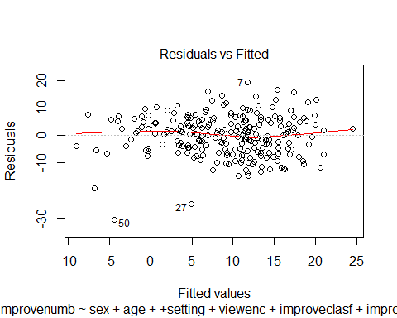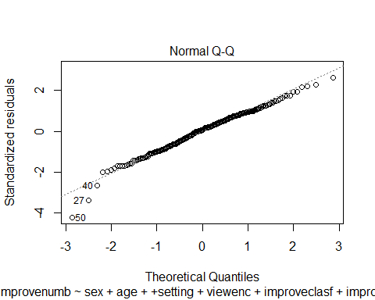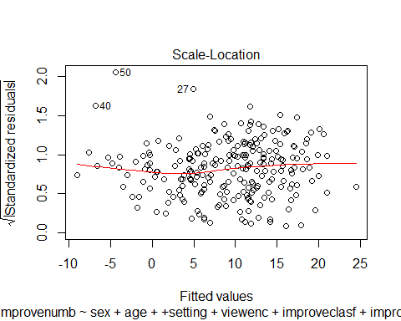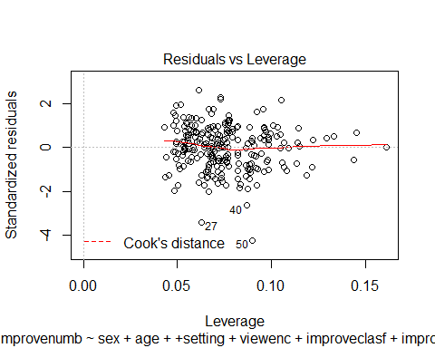

plot(fit2)

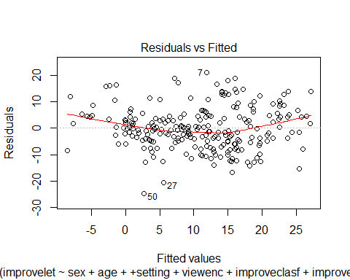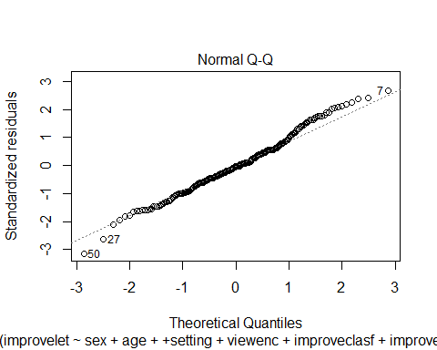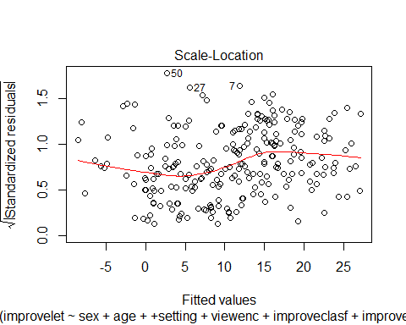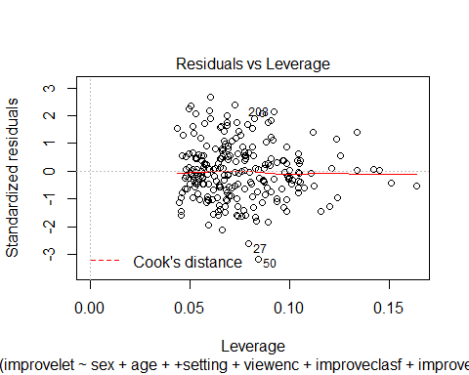

plot(fit3)

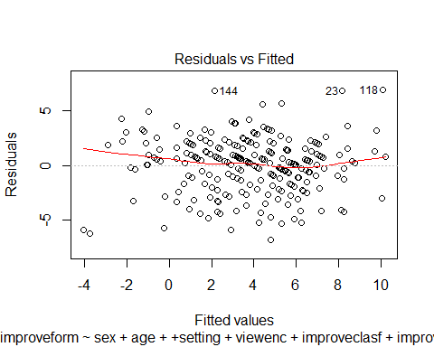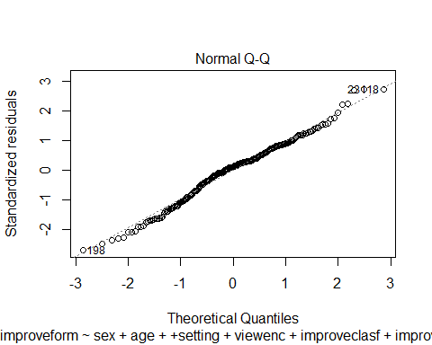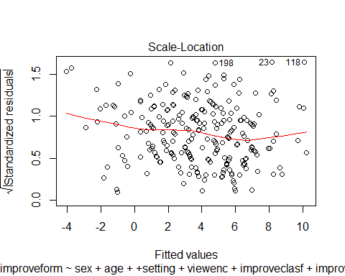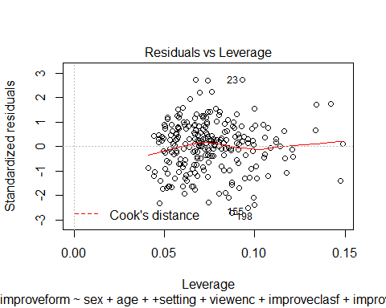

plot(fit1,which=4)

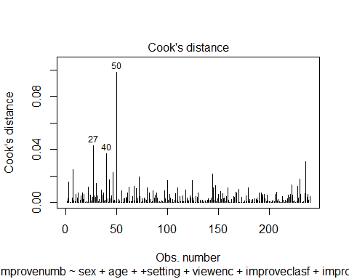

plot(fit2,which=4)

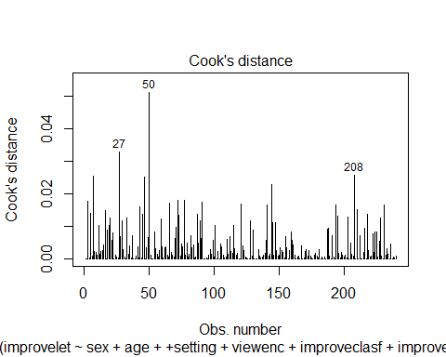

plot(fit3,which=4)

