Supplementary Material
Table S1. Number of stocks used for analysis.
Criterion | Number of Stocks | Number of Assessments
All RAMLDB stocks | 1,330 (412 U.S., 208 Europe, 250 Canada, 88 Japan, 372 elsewhere) | 2,163
Stocks with at-least two assessments | 449 (88 U.S., 167 Europe, 31 Canada, 15 Japan, 148 elsewhere) | 1,284
Stocks with biomass and fishing mortality estimates | 263 (72 U.S., 60 Europe, 18 Canada, 14 Japan, 99 elsewhere) | 804
Extra stocks (14) in the U.S South Atlantic from SouthEast Data, Assessment, and Review (SEDAR) Stock Assessment Program (http://sedarweb.org/sedar-projects) | 277 (86 U.S., 60 Europe, 18 Canada, 14 Japan, 99 elsewhere) | 838

Table S2. Prior distributions for the estimated parameters. Gamma (a, b) represents a gamma prior with shape parameter = a and rate parameter = b.
Parameter | Prior
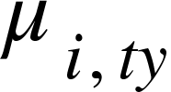 | 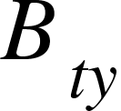 | Uniform (0, 25)
 |  | Uniform (0, 25)
 | 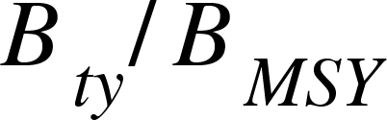 | Uniform (-5, 5)
 | 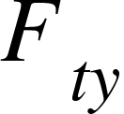 | Uniform (-10, 1)
 |  | Uniform (-10, 1)
 | 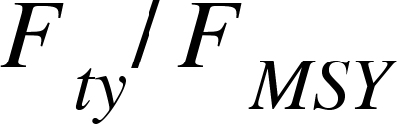 | Uniform (-8, 5)
 |  | Uniform (0, 25)
 | Gamma (1, 0.01)
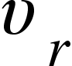 | Uniform (0, 10)
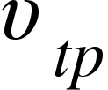 | Uniform (0, 10)
 | Uniform (0, 100)

Table S3. Model selection for the 7 estimates.
Model | $∆$DIC | $∆$WAIC | $∆$LOO |  | Model | $∆$DIC | $∆$WAIC | $∆$LOO
M3-a | 0 | 0 | 0 |  | M3-a | 0 | 0 | 0
M3-b | -8 | 22 | 3 |  | M3-b | -8 | 17 | 10
M2 | 169 | 185 | 174 |  | M2 | 35 | 64 | 57
M1 | 669 | 953 | 932 |  | M1 | 447 | 718 | 732
Model | $∆$DIC | $∆$WAIC | $∆$LOO |  | Model | $∆$DIC | $∆$WAIC | $∆$LOO
M3-a | 0 | 0 | 0 |  | M3-a | 0 | 0 | 0
M3-b | -12 | 8 | 1 |  | M3-b | -86 | 18 | 11
M2 | -7 | 16 | 8 |  | M2 | 70 | 19 | 12
M1 | 472 | 733 | 725 |  | M1 | 111 | 566 | 553
Model | $∆$DIC | $∆$WAIC | $∆$LOO |  | Model | $∆$DIC | $∆$WAIC | $∆$LOO
M3-b | 0 | 0 | 0 |  | M3-b | 0 | 0 | 0
M2 | 8 | 1 | 5 |  | M2 | 1 | 2 | 1
M3-a | 7 | 1 | 8 |  | M3-a | 11 | 4 | 3
M1 | 198 | 270 | 278 |  | M1 | 139 | 306 | 323
Model | $∆$DIC | $∆$WAIC | $∆$LOO
M3-b | 0 | 0 | 0
M3-a | 13 | 6 | 13
M2 | 32 | 17 | 18
M1 | 283 | 475 | 497

Table S4. DIC, WAIC, LOO and global mean CV for each model estimate (results only for the selected model) under two scenarios. The first scenario is the current setting that assumes that the truth is essentially the mean estimate, and assessment results are random and independent samples from an underlying distribution. The second scenario assumes that the last assessment is the best and the mean estimate is from the most recent assessment. Median values and 95% credible intervals (in the brackets) are listed.
Estimate | Selected model | Current setting (unknown $μ$) |  |  |  | $μ$ = most recent estimate
Estimate | Selected model | $∆$DIC | $∆$WAIC | $∆$LOO | Global mean CV (%) | $∆$DIC | $∆$WAIC | $∆$LOO | Global mean CV (%)
 | M3-a | 0 | 0 | 0 | 39 (29, 52) | 1392 | 1504 | 1405 | 41 (31, 54)
 | M3-a | 0 | 0 | 0 | 46 (36, 59) | 1381 | 1469 | 1367 | 48 (39, 61)
 | M3-a | 0 | 0 | 0 | 31 (21, 49) | 1353 | 1440 | 1403 | 33 (22, 47)
 | M3-a | 0 | 0 | 0 | 23 (14, 38) | 1078 | 1225 | 1190 | 22 (12, 41)
 | M3-b | 0 | 0 | 0 | 25 (18, 35) | 1100 | 1174 | 1120 | 28 (20, 39)
 | M3-b | 0 | 0 | 0 | 43 (29, 64) | 1221 | 1226 | 1178 | 46 (31, 64)
 | M3-b | 0 | 0 | 0 | 45 (31, 69) | 1188 | 1251 | 1191 | 49 (34, 71)

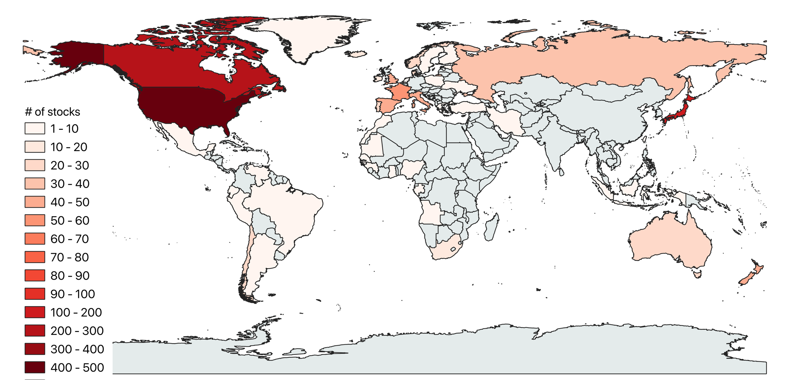
Figure S1. Distribution of stocks included in the RAM Legacy database (1,330 stocks in total). Each stock is an area-country-species triple. Map is built using QGIS3.10. There are 18 tuna stocks included in the database, including Southern bluefin tuna in the Indian Ocean, Bigeye tuna in the Eastern Pacific, Yellowfin tuna in the Eastern Pacific, Albacore tuna in the Mediterranean Sea, Albacore tuna in the Northern Atlantic, Albacore tuna in the South Atlantic, Atlantic bluefin tuna in the Eastern Atlantic, Atlantic bluefin tuna in the Western Atlantic, Bigeye tuna in the Atlantic Ocean, Yellowfin tuna in the Atlantic Ocean, Albacore tuna in the Indian Ocean, Bigeye tuna in the Indian Ocean, Yellowfin tuna in the Indian Ocean, Albacore tuna in the North Pacific Ocean, Pacific bluefin tuna in the Pacific Ocean, Albacore tuna in the South Pacific Ocean, Bigeye tuna in the Central Western Pacific Ocean, and Yellowfin tuna in the Central Western Pacific Ocean.
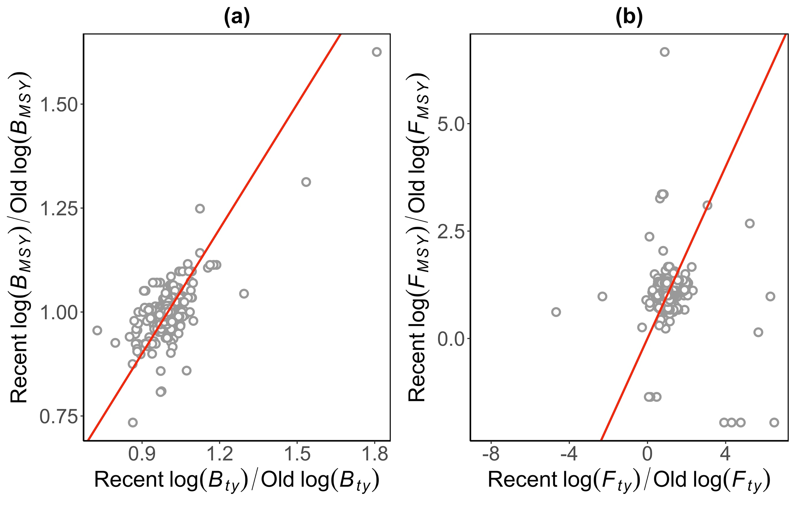
Figure S2. (a) A comparison of changes in and , (b) a comparison of changes in and . Plot is made using R package ggplot2 (version 3.3.2, https://ggplot2.tidyverse.org) in statistical program R (version 3.6.3, http://www.R-project.org/).
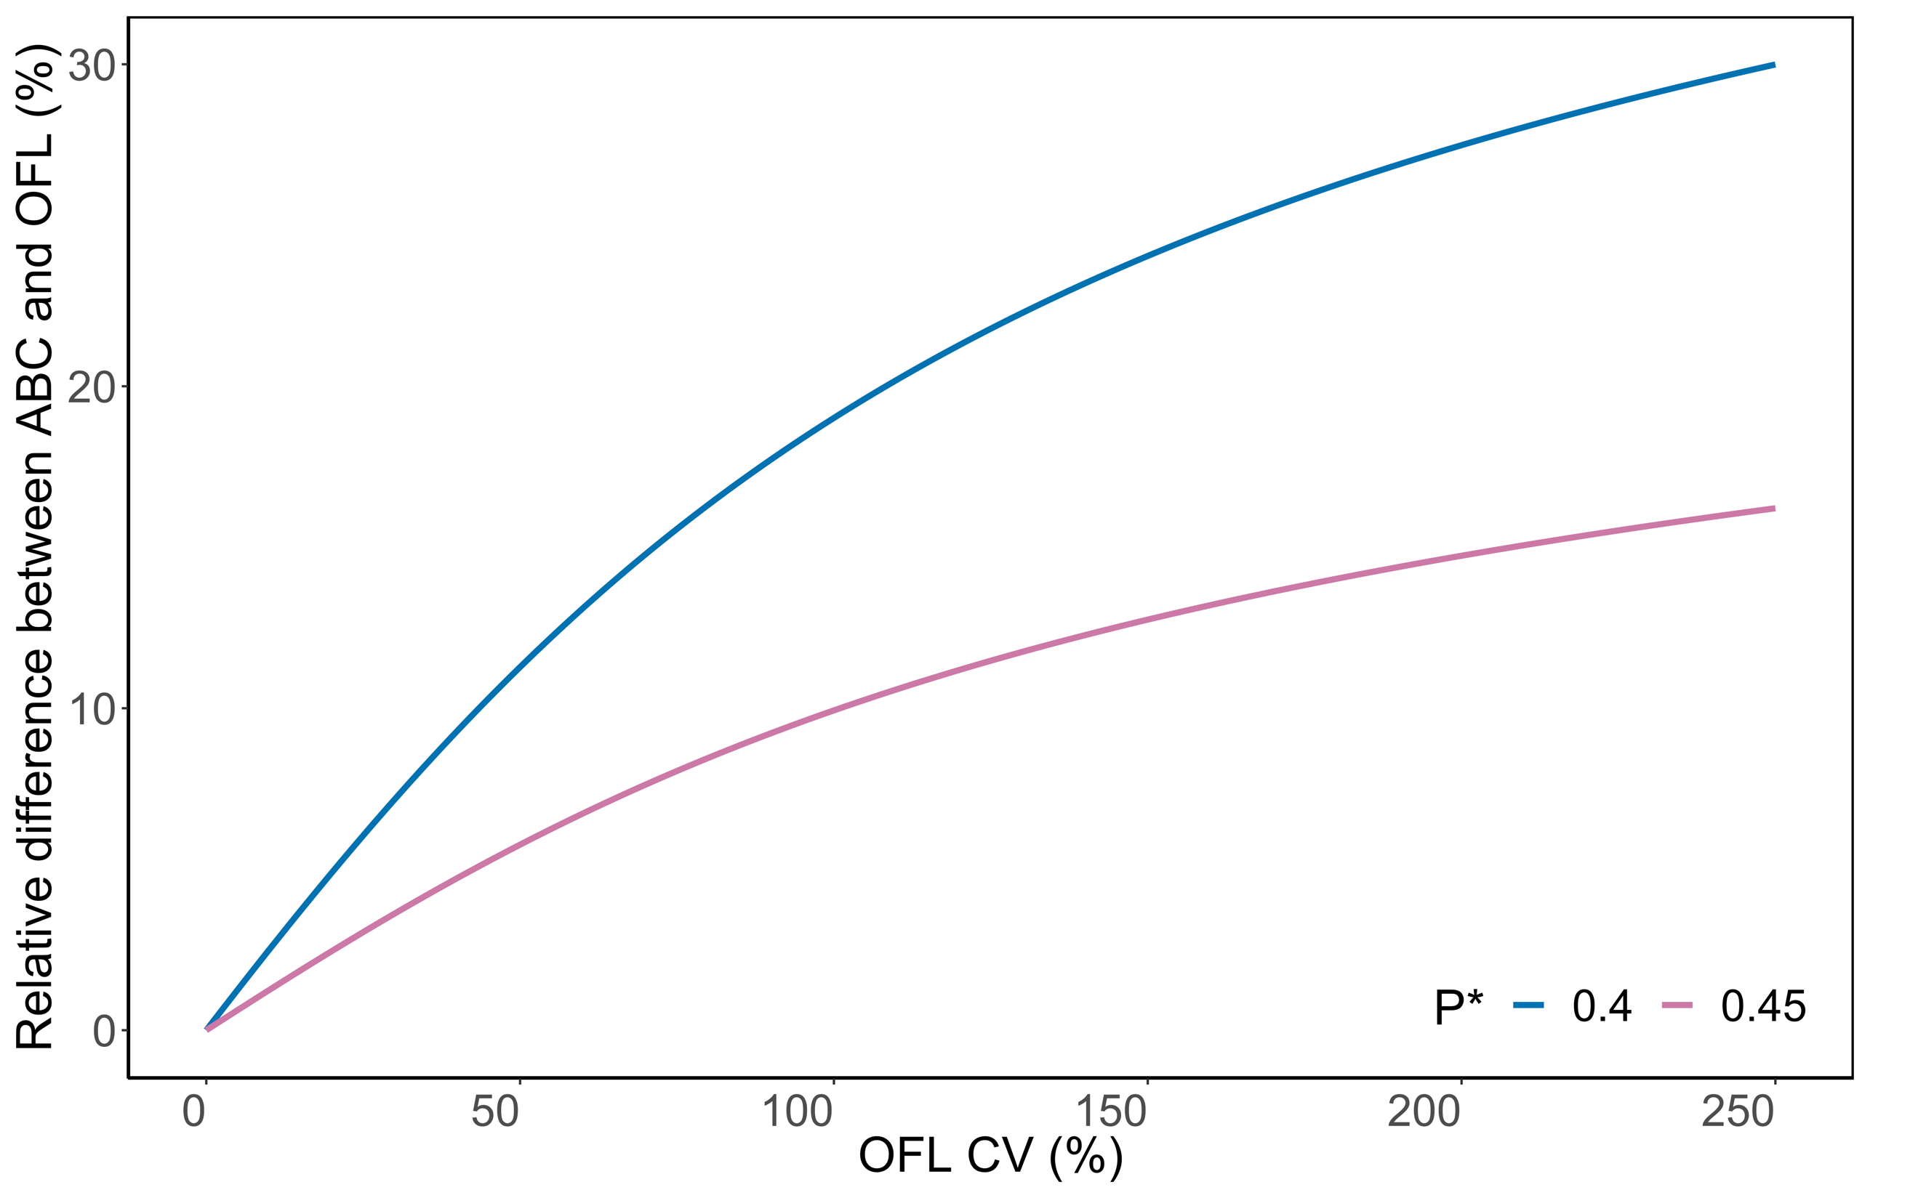
Figure S3. Relative difference between ABC and OFL (i.e., ) under different OFL CVs. The P* is the target probability of overfishing, which is selected to set the ABC by fisheries managers. For example, with a P* = 0.4, the 40th percentile of the OFL distribution, corresponding with a 40% chance of overfishing, is selected as the ABC.

