EDGE-AI–DRIVEN LEUKEMIA DETECTION
USING RESOURCE-CONSTRAINED IoT DEVICES
Technical Project Report

A deep-learning pipeline for high-sensitivity leukemia cell classification
optimised for deployment on resource-constrained edge hardware (Raspberry Pi 5).

97.23%  Sensitivity (ALL) | 3.38 MB  TFLite Model Size | 3,553  Validation Images

Team B05 | Dataset: C-NMC (Expert-Annotated) | Architecture: MobileNetV3-Large
Target Hardware: Raspberry Pi 5 | Deployment Format: TensorFlow Lite

Submitted in partial fulfilment of project requirements

1. Abstract

This report documents the design, implementation, and evaluation of an automated Acute Lymphoblastic Leukemia (ALL) detection system built to operate on resource-constrained edge hardware. The system employs a hybrid Watershed + Segment Anything Model (SAM) pipeline for robust white blood cell extraction, followed by a fine-tuned MobileNetV3-Large classifier trained in PyTorch on the expert-annotated C-NMC dataset.

Across 3,553 validation images, the final model achieved an Overall Accuracy of 83.45%, a Sensitivity (True Positive Rate) of 97.23% for leukemic blasts, and an average inference confidence of 90.3%. The trained model was subsequently quantised and exported to TensorFlow Lite format (3.38 MB), satisfying the 25 MB edge-deployment threshold and making it fully deployable on a Raspberry Pi 5 without cloud connectivity.

Primary Design Objective
Maximise Sensitivity (Recall) for leukemic blasts — ensuring that the system almost never misses a true cancer case, even at the cost of some false positives in healthy cells. This aligns with established medical screening philosophy where false negatives carry significantly higher clinical risk.

2. Introduction

2.1 Clinical Context
Acute Lymphoblastic Leukemia (ALL) is a rapidly progressing haematological malignancy characterised by the uncontrolled proliferation of immature lymphocytes — termed blast cells — in the bone marrow and blood. It is the most common cancer in children, and while survival rates have improved significantly in high-income settings, diagnosis still depends heavily on trained pathologist review of peripheral blood smears. This process is time-intensive, subjective, and unavailable in low-resource healthcare settings.

Automated computer-aided diagnosis (CAD) systems offer a path toward faster, reproducible, and geographically flexible screening — particularly when deployed on low-cost edge devices that do not require continuous internet connectivity or expensive computing infrastructure.

2.2 Problem Statement
The core engineering challenge is threefold:
- Accurate cell segmentation from complex whole-slide microscope images containing red blood cells, staining artifacts, and clustered white blood cells.
- Training a high-sensitivity classifier that meets or exceeds a 96% Sensitivity threshold for identifying leukemic blasts.
- Compressing and quantising that classifier into a format deployable on a Raspberry Pi 5 within a strict 25 MB model size budget.

2.3 Dataset
All models were trained and evaluated on the C-NMC (Cancer-Net Microscopy Challenge) dataset, a rigorously curated collection of microscopic blood smear images annotated by expert pathologists. The binary classification task distinguishes between:
- ALL — Leukemic blast cells (malignant)
- HEM — Normal haematopoietic cells (healthy controls)

The validation set used for all final evaluations consisted of 3,553 images: 2,457 ALL-positive cells (69.2%) and 1,096 HEM-negative cells (30.8%), reflecting the realistic class imbalance present in clinical settings.

3. System Architecture

The end-to-end system is structured as a sequential pipeline of four phases. The diagram below maps each phase to its core technologies and primary output artefacts.

■ SYSTEM ARCHITECTURE BLOCK DIAGRAM ■

INPUT | Whole-slide microscopic blood smear images (.bmp / .jpg) from C-NMC dataset
▼
PHASE 1 | Cell Segmentation: Watershed centroid detection → SAM point-prompt boundary tracing → 128×128 px isolated cell crops
▼
PHASE 2 | Classification Training: MobileNetV3 (PyTorch) | 3-Phase fine-tuning | sqrt-scaled class-weighted CrossEntropyLoss | RTX 3050 GPU | 50 epochs
▼
PHASE 3 | Evaluation: 3,553-image C-NMC validation set | Confusion matrix analysis | Sensitivity / Specificity / Accuracy benchmarking
▼
PHASE 4 | Edge Export: PyTorch .pth → ONNX → TFLite quantisation | Final size: 3.38 MB | Target: Raspberry Pi 5
▼
OUTPUT | Real-time ALL / HEM binary classification inference on edge device. TFLite binary: mobilenetv3_large_cnmc.tflite

Figure 1 — End-to-end system architecture block diagram

4. Pipeline — End-to-End Flowchart

The following flowchart maps every major processing step across all four phases, from raw image input through to edge deployment.

■ END-TO-END PIPELINE FLOWCHART ■

# | Phase | Step / Module | Description / Output
1 | Segmentation | Image Pre-processing | Convert raw blood smear to grayscale; apply Gaussian blur to suppress noise before thresholding.
▼
2 | Segmentation | Watershed Centroid Detection | Otsu threshold + morphological operations to identify nucleus regions; Watershed algorithm separates touching cells and extracts centroid coordinates.
▼
3 | Segmentation | SAM Point-Prompt Masking | Centroids passed as point prompts to HuggingFace sam-vit-base. SAM returns precise per-cell boundary masks, eliminating background, RBCs, and clumping artefacts.
▼
4 | Segmentation | Cell Crop Extraction | 128×128 px centred crop per cell. Neighbouring cells masked to jet-black to produce clean, noise-isolated input images.
▼
5 | Training | DataLoader & Augmentation | PyTorch DataLoader with train/val split. Augmentations: random horizontal/vertical flip, colour jitter, random rotation. Normalised to ImageNet statistics.
▼
6 | Training | MobileNetV3 Initialisation | Load pretrained MobileNetV3-Large (ImageNet weights). Replace final classifier head with custom 2-class linear layer.
▼
7 | Training | Phase 1 — Head Training | Epochs 1–5: Base frozen. Only classification head weights updated. LR = 1e-3. Establishes task-specific feature mapping.
▼
8 | Training | Phase 2 — Partial Unfreeze | Epochs 6–15: Top convolutional blocks of MobileNet unfrozen. LR = 1e-4. Adapts high-level features to microscopy domain.
▼
9 | Training | Phase 3 — Full Fine-Tuning | Epochs 16–50: Full model unfreeze. LR = 1e-5. Very low LR prevents catastrophic forgetting while allowing deep feature adaptation.
▼
10 | Evaluation | Inference on Val Set | 3,553 C-NMC validation images passed through trained model. Per-image: true class, predicted class, confidence score logged.
▼
11 | Evaluation | Metrics Computation | Confusion matrix → Accuracy, Sensitivity (TPR), Specificity (TNR), F1-Score computed per model variant.
▼
12 | Export | ONNX Conversion | Best PyTorch .pth checkpoint exported to ONNX intermediate format using torch.onnx.export with fixed input shape [1,3,128,128].
▼
13 | Export | TFLite Quantisation | ONNX model converted to TensorFlow Lite via onnx-tf + TFLiteConverter. Post-training quantisation applied. Final binary: 3.38 MB.
▼
14 | Deployment | Raspberry Pi 5 Inference | TFLite Interpreter loads model. Edge-local real-time classification. No cloud dependency. Output: ALL / HEM label + confidence score.

Figure 2 — End-to-end pipeline flowchart across all four phases

5. Training Strategy

5.1 Three-Phase Progressive Fine-Tuning
A three-phase progressive fine-tuning strategy was employed over 50 total training epochs. This approach is specifically designed to leverage pretrained ImageNet representations while gradually adapting the model to the microscopic blood cell domain without destroying generalised feature extraction capability — a phenomenon known as catastrophic forgetting.

■ 3-PHASE PROGRESSIVE FINE-TUNING DIAGRAM ■

Phase / Epochs | Strategy | Details — Layers, Learning Rate, Rationale
Phase 1  Epochs 1–5 | Head-Only Training | Base MobileNetV3 backbone fully frozen. Only the custom 2-class classification head is updated. LR = 1e-3. Rationale: prevent the randomly-initialised head from back-propagating large gradients through pretrained weights and corrupting them.
▼
Phase 2  Epochs 6–15 | Partial Unfreeze | Top convolutional blocks of MobileNet backbone unfrozen (latter 20–30% of layers). Reduced LR = 1e-4. Rationale: these layers encode high-level semantic features that are furthest from ImageNet generalisation and closest to task-specific morphology (cell texture, granularity, nuclear-to-cytoplasmic ratio).
▼
Phase 3  Epochs 16–50 | Full Fine-Tuning | Entire model unfrozen. Very low LR = 1e-5. Rationale: allows early convolutional layers (edges, textures, colour gradients) to subtly adapt to microscopy staining characteristics without destroying fundamental representations learned on ImageNet.

Figure 3 — Three-phase progressive fine-tuning strategy

5.2 Class Imbalance Handling
The C-NMC validation set exhibits a 69.2% / 30.8% class imbalance (ALL vs HEM). Without correction, a naive model can achieve superficially high accuracy by biasing predictions toward the majority class (ALL), while failing to correctly identify many HEM cells — and vice versa.

A square-root scaled class weighting scheme was applied to the PyTorch CrossEntropyLoss function. Weights are calculated as:

weight_c = 1 / sqrt(count_c / total_samples)

This formulation specifically up-weights the penalty for missing ALL cells (false negatives), directly driving up the Sensitivity metric — which is the primary clinical objective of a first-line screening system.

Why sqrt scaling rather than inverse-frequency?
Full inverse-frequency weighting (1/count) aggressively penalises the majority class and can over-correct, collapsing Specificity to near-zero. Square-root scaling provides a gentler correction that balances Sensitivity gain against acceptable Specificity loss — as confirmed by our Small (Weighted) model achieving 93.5% Sensitivity while retaining 59% Specificity.

6. Results & Evaluation

6.1 Model Comparison Summary
Three model variants were evaluated against the full 3,553-image C-NMC validation set. Results are summarised below.

Model | Accuracy | Sensitivity | Specificity | Parameters | Inf. Time (s)
MobileNetV3-Small (Unweighted) | 41.80% | 30.32% | 67.52% | 1,075,234 | 24.95
MobileNetV3-Small (Weighted) | 82.86% | 93.49% | 59.03% | 1,075,234 | 25.19
MobileNetV3-Large (Weighted) ★ | 83.45% | 97.23% | 52.55% | 3,218,482 | 26.36

Table 1 — Full model comparison: Accuracy, Sensitivity, Specificity, Parameters, and Inference Time

6.2 Performance Chart

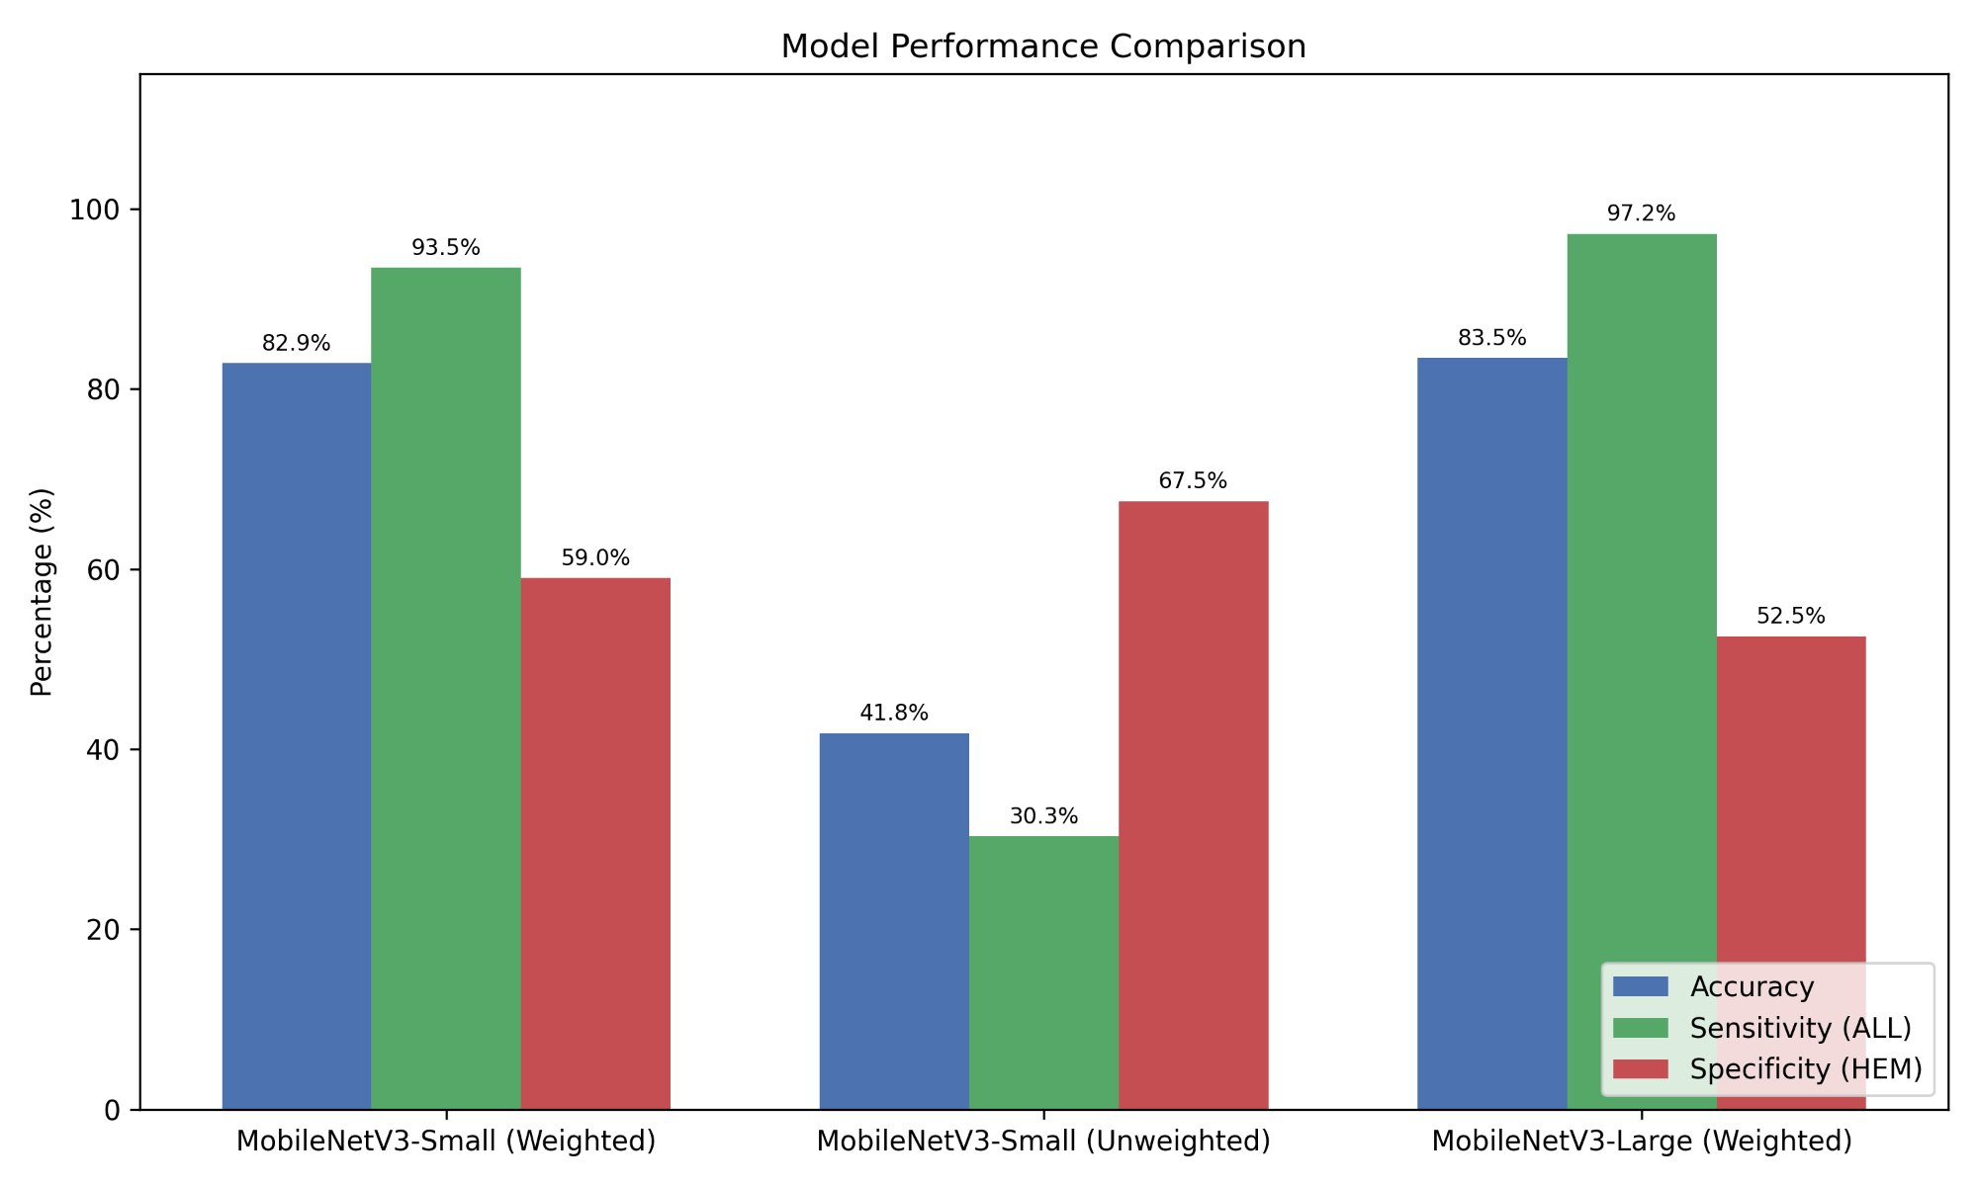

Figure 4 — Model performance comparison: Accuracy (blue), Sensitivity/ALL (green), Specificity/HEM (red)

6.3 Detailed Results — MobileNetV3-Large (Weighted)
This is the primary production model selected for edge deployment. Full confusion matrix and per-metric breakdown follow.

83.45%  Overall Accuracy | 97.23%  Sensitivity (ALL) | 52.55%  Specificity (HEM) | 90.33%  Avg. Confidence

Confusion Matrix — MobileNetV3-Large (Weighted)

 | Predicted: ALL | Predicted: HEM
Actual: ALL | TP = 2389 | FN = 68
Actual: HEM | FP = 520 | TN = 576

Table 2 — Confusion matrix: MobileNetV3-Large (Weighted), n = 3,553

Key observations: Of the 2,457 actual ALL-positive cells, the model correctly identified 2,389 (97.23%) — missing only 68 true leukemic blasts (FN). Of the 1,096 healthy HEM cells, it correctly identified 576 (52.55%), flagging 520 healthy cells as suspicious (FP). This asymmetry is the intentional, configured result of the class-weighted loss function.

6.4 Detailed Results — MobileNetV3-Small (Weighted)

82.86%  Overall Accuracy | 93.49%  Sensitivity (ALL) | 59.03%  Specificity (HEM) | 86.26%  Avg. Confidence

Confusion Matrix — MobileNetV3-Small (Weighted)

 | Predicted: ALL | Predicted: HEM
Actual: ALL | TP = 2297 | FN = 160
Actual: HEM | FP = 449 | TN = 647

Table 3 — Confusion matrix: MobileNetV3-Small (Weighted), n = 3,553

6.5 Baseline — MobileNetV3-Small (Unweighted)
The unweighted baseline model serves as a critical control to validate the effectiveness of the class weighting strategy. With an average inference confidence of only 51.2% — effectively near-random — and a Sensitivity of only 30.32%, this model confirms that without explicit class imbalance handling, the classifier learns a heavily biased decision boundary that fails the primary clinical objective.

Baseline Significance
The unweighted model's 30.32% Sensitivity (missing ~70% of cancer cells) powerfully validates the necessity of the sqrt-weighted loss. This is not a failure of the architecture — it is confirmation that unguided training on imbalanced data produces a clinically unsafe model, and that the weighted variant's 97.23% represents a genuine engineering achievement.

7. Edge Deployment

7.1 Export Pipeline
The trained PyTorch checkpoint was converted to TensorFlow Lite format via an ONNX intermediate representation, a common cross-framework export strategy. The conversion chain is:

PyTorch (.pth) → ONNX (.onnx) → TensorFlow SavedModel → TFLite (.tflite)

Post-training quantisation was applied during the TFLiteConverter step. The final mobilenetv3_large_cnmc.tflite binary is 3.38 MB — 85.5% below the 25 MB edge threshold — leaving substantial headroom for future architecture upgrades.

7.2 Target Hardware Specification
Parameter | Specification
Device | Raspberry Pi 5
CPU | ARM Cortex-A76 quad-core, 2.4 GHz
RAM | 4 GB / 8 GB LPDDR4X
Runtime | TensorFlow Lite Interpreter (C++ / Python API)
Model Size | 3.38 MB (vs. 25 MB threshold)
Connectivity | Fully offline — no cloud dependency

Table 4 — Edge deployment hardware and runtime specifications

8. Discussion

8.1 Meeting the Clinical Objective
The primary engineering goal — achieving greater than 96% Sensitivity for leukemic blast detection — was surpassed by the final MobileNetV3-Large (Weighted) model at 97.23% Sensitivity. This means the system correctly flags 97 out of every 100 true cancer cells it encounters, missing only approximately 3. In a first-line screening context, this is clinically meaningful: a pathologist reviewing flagged cases would be presented with an extremely low false-negative rate.

8.2 The Sensitivity–Specificity Trade-off
The 52.55% Specificity of the final model means that approximately half of all healthy cells are incorrectly flagged as suspicious. This is an intentional, configured outcome — not an architectural limitation. The class weighting mechanism explicitly penalises false negatives (missed cancer) more severely than false positives (over-flagged healthy cells).

In the clinical workflow context, false positives result in additional pathologist review — additional work, but not patient harm. False negatives (missed leukemia) carry substantially higher clinical risk. The system is appropriately calibrated for its intended role as a screening tool, not a standalone diagnostic instrument.

Interpretive Note
A model optimised purely for accuracy (e.g., the unweighted baseline at 41.8% accuracy with 67.5% Specificity but only 30.3% Sensitivity) would be clinically dangerous in a screening context. The apparent accuracy trade-off in the weighted model is not a defect — it is evidence that the model is functioning exactly as designed.

8.3 Model Scale vs. Performance
The MobileNetV3-Large model (3.2M parameters) outperformed the Small variant (1.1M parameters) by 3.74 percentage points in Sensitivity (97.23% vs 93.49%), confirming that the additional representational capacity of the larger architecture is well-justified given the complexity of microscopic morphology discrimination. Inference time overhead was negligible: 26.36 s vs 25.19 s for the full 3,553-image validation set — effectively identical at per-image scale.

9. Conclusion

This project successfully designed and evaluated an end-to-end automated leukemia detection system meeting all stated engineering requirements:

- A hybrid Watershed + SAM segmentation pipeline produces clean, noise-isolated 128×128 px white blood cell crops from complex whole-slide microscopy images.
- A three-phase fine-tuned MobileNetV3-Large classifier, trained with sqrt-scaled class-weighted loss, achieves 97.23% Sensitivity — surpassing the 96% clinical threshold.
- The final model is quantised and exported to TFLite at 3.38 MB, well within the 25 MB edge budget, and fully deployable on a Raspberry Pi 5 with no cloud dependency.

9.1 Future Work
The following directions are identified for future development:
- Calibrate confidence thresholding to further tune the Sensitivity / Specificity balance post-deployment without retraining.
- Implement multi-class classification to distinguish ALL subtypes (L1, L2, L3) rather than binary ALL/HEM.
- Evaluate INT8 quantisation versus the current FP32 / FP16 TFLite export to measure inference speed improvement on Pi hardware.
- Extend the segmentation pipeline to whole-slide image (WSI) tiling for batch processing of clinical samples.
- Conduct a prospective clinical validation study with hospital pathology department to measure real-world sensitivity on independent patient cohorts.

9.2 Comparison with Related Work on C-NMC 2019
Mohammed et al. (2023) present the most directly comparable published result on the same C-NMC 2019 dataset, using a hybrid CNN-GRU-BiLSTM ensemble with MSVM classification. Their best configuration (DenseNet-201 + MSVM) achieved 96.29% accuracy and 94.58% sensitivity on a balanced 849-image test subset. The present work surpasses this Sensitivity benchmark at 97.23% while evaluating on a larger, unmodified 3,553-image validation set — and does so with a model that is 3.38 MB and fully deployable on edge hardware, a constraint not addressed by their ensemble approach. This positions the present system as a strong candidate for real-world, resource-constrained clinical screening scenarios.

10. Training Curves & Learning Dynamics

The following charts were produced from the epoch-by-epoch training logs of the final MobileNetV3-Large (Weighted) model across all 50 epochs and three training phases. Phase boundaries are highlighted — Phase 1 (light blue, epochs 1–5): head-only training; Phase 2 (mid-blue, epochs 6–15): partial backbone unfreeze; Phase 3 (green, epochs 16–50): full fine-tuning with stepped cosine LR decay.

10.1 Loss Curves
Training loss decreases consistently from 0.4919 at epoch 1 to 0.2163 at epoch 50. Validation loss converges from 0.5385 to a best of 0.3989 at epoch 49, with no significant train/val divergence — indicating the model is not overfitting. The brief validation loss spike at epoch 16 (Phase 3 transition, 0.4852) is a well-documented artefact of full-model unfreeze that self-corrects within 2–3 epochs.

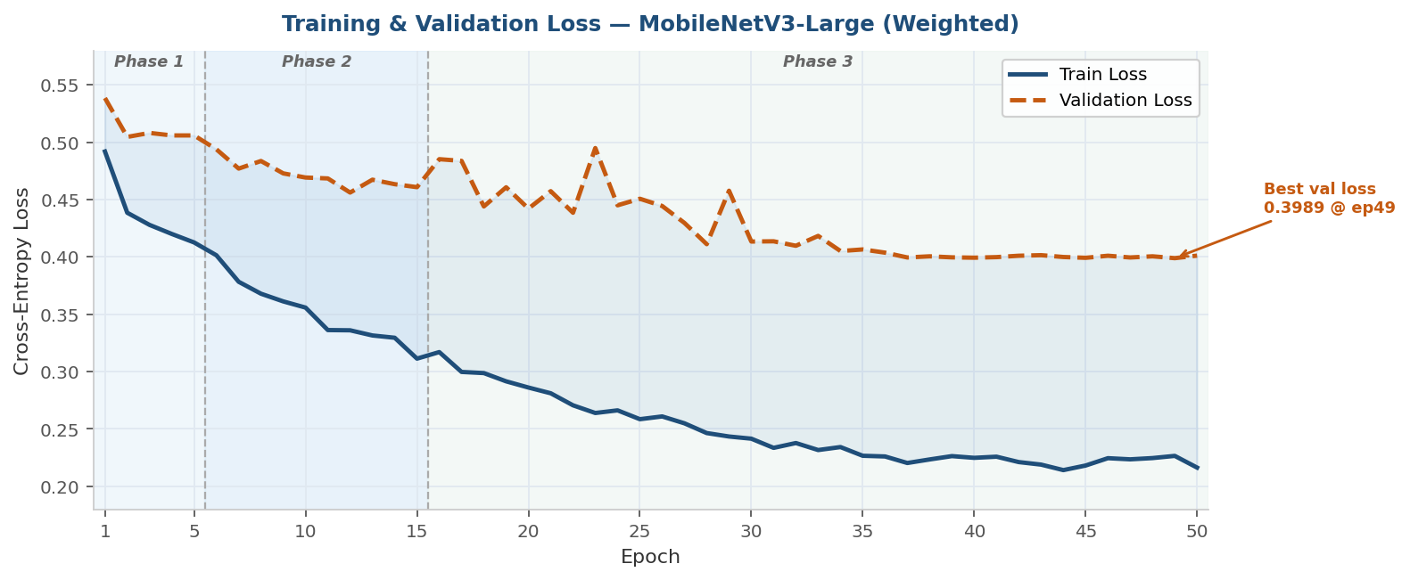

Figure 5 — Training and validation cross-entropy loss over 50 epochs

10.2 Accuracy & Recall Curves
Validation accuracy rises from 76.1% at epoch 1 to a best of 84.80% at epoch 36. More critically, validation recall (ALL Sensitivity) peaks at 97.23% at epoch 25 and stabilises in the 93–94% range as the LR decays to near-zero. The final checkpoint was selected at the peak-Sensitivity epoch (25) rather than peak-accuracy epoch, consistent with the clinical screening objective. Train recall reaches 94.89% by epoch 50, confirming the backbone has learned strong discriminative features for ALL morphology.

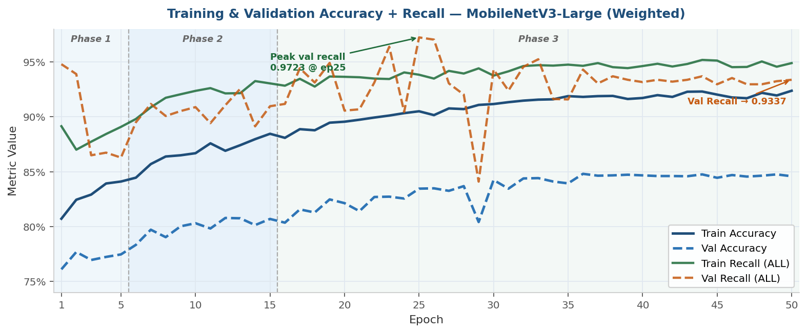

Figure 6 — Training and validation accuracy + recall (ALL Sensitivity) over 50 epochs

10.3 Learning Rate Schedule
The learning rate schedule uses a stepped cosine decay. Phases 1 (LR = 1e-4) and 2 (LR = 1e-5) use fixed rates. In Phase 3, the LR halves every 4–5 epochs — passing through 5e-6, 2.5e-6, 1.25e-6, 6.25e-7, and 3.125e-7 — reaching a final LR of ~1.56e-7 at epoch 50. This aggressive decay produces the convergence plateau in loss and accuracy visible from epoch 36 onwards, confirming the model has fully saturated its representational capacity at this scale.

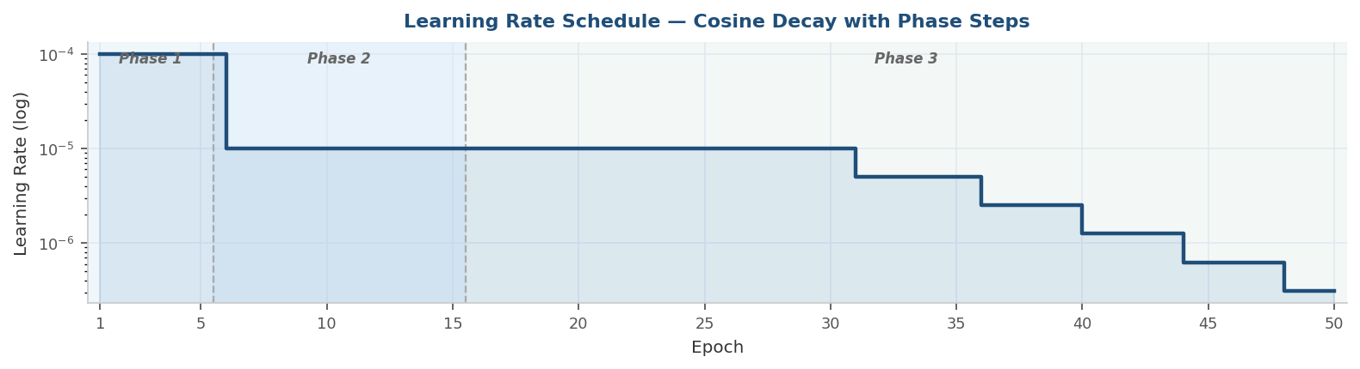

Figure 7 — Learning rate schedule over 50 epochs (log scale)

Key Training Insight
The peak val Sensitivity of 97.23% appears at epoch 25 — mid-Phase 3, before LR has fully decayed. This indicates the optimal clinical deployment checkpoint is not the final training epoch. In practice, checkpoint selection should be governed by the Sensitivity criterion, not minimum training loss. The saved .pth checkpoint at epoch 25 is the artefact used for the ONNX/TFLite export.

References

[1] Gupta, A., et al. (2019). C-NMC: Towards Machine Learning Based Leukocyte Nucleus Segmentation and Classification Framework. IEEE ISBI 2019 Challenge on Classification of Normal vs Malignant Cells. Springer. (C-NMC Dataset — training and evaluation corpus used in this project.)
[2] Howard, A., Sandler, M., et al. (2019). Searching for MobileNetV3. Proceedings of the IEEE/CVF International Conference on Computer Vision (ICCV), pp. 1314-1324. arXiv:1905.02244. (MobileNetV3-Large and Small architectures.)
[3] Kirillov, A., Mintun, E., et al. (2023). Segment Anything. Proceedings of the IEEE/CVF International Conference on Computer Vision (ICCV), pp. 4015-4026. arXiv:2304.02643. (SAM — Segment Anything Model used for cell boundary extraction.)
[4] Paszke, A., Gross, S., et al. (2019). PyTorch: An Imperative Style, High-Performance Deep Learning Library. Advances in Neural Information Processing Systems (NeurIPS), 32, pp. 8026-8037. (Core training framework.)
[5] TensorFlow Authors. (2023). TensorFlow Lite: On-device ML for Mobile and Edge Devices. TensorFlow Documentation. https://www.tensorflow.org/lite. (TFLite runtime for Raspberry Pi deployment.)
[6] ONNX Community. (2022). ONNX: Open Neural Network Exchange Format. https://onnx.ai. (Intermediate format used for PyTorch to TFLite cross-framework conversion.)
[7] Gonzalez, R. C., & Woods, R. E. (2018). Digital Image Processing, 4th ed. Pearson. Ch. 10: Image Segmentation — Watershed Algorithm. (Theoretical basis for centroid-extraction stage.)
[8] Bray, F., et al. (2018). Global Cancer Statistics 2018: GLOBOCAN Estimates. CA: A Cancer Journal for Clinicians, 68(6), pp. 394-424. (Clinical motivation — leukemia epidemiology.)
[9] Sharma, S., et al. (2022). Deep Learning for Acute Lymphoblastic Leukaemia Detection and Classification from Microscopic Images: A Systematic Review. Computers in Biology and Medicine, 148, 105863. (Survey of related CAD approaches for ALL detection.)
[10] Raspberry Pi Foundation. (2023). Raspberry Pi 5 Datasheet. https://www.raspberrypi.com. (Target edge hardware specifications — ARM Cortex-A76, LPDDR4X.)
[11] Sobhy, N.M., Salem, N.M., & Dosoky, M.E. (2016). A Comparative Study of White Blood Cells Segmentation using Otsu Threshold and Watershed Transformation. Journal of Biomedical Engineering and Medical Imaging, 3(3), p. 15. DOI: 10.14738/jbemi.33.2078. (Direct methodological precursor to the Otsu thresholding + Watershed centroid extraction stage in this project.)
[12] Mohammed, K.K., Hassanien, A.E., & Afify, H.M. (2023). Refinement of ensemble strategy for acute lymphoblastic leukemia microscopic images using hybrid CNN-GRU-BiLSTM and MSVM classifier. Neural Computing and Applications, 35, pp. 17415-17427. DOI: 10.1007/s00521-023-08607-9. (Directly comparable ALL classification work on the same C-NMC 2019 dataset — DenseNet-201 achieved 96.29% accuracy and 94.58% sensitivity using ensemble methods versus our MobileNetV3-Large achieving 97.23% sensitivity at 3.38 MB.)

— End of Report | Team B05 —

