**Image enhancement:** Improve the detectability of important image details or objects

**Contrast stretching**: point operator uses a piecewise smooth function f if the input gray level to enhance important details of the image



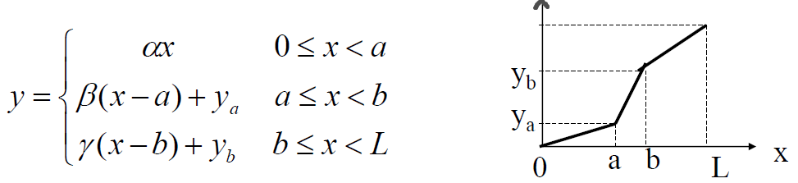

Correlation: process of moving a filter mask over the image and computing the sum of products at each location

Convolution: the filter is first rotated by 180°.

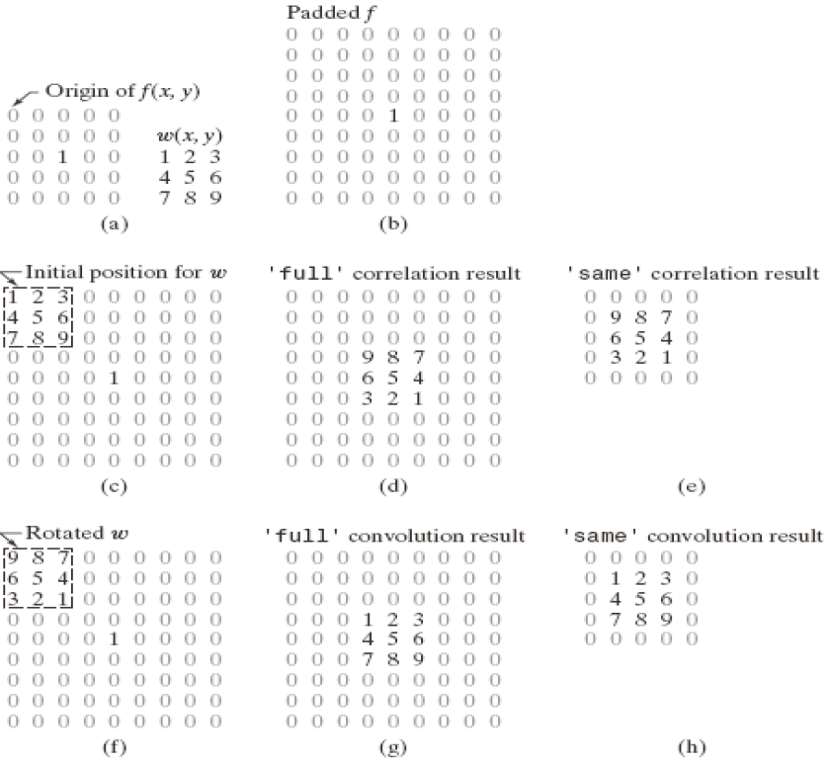

Gaussian mask: 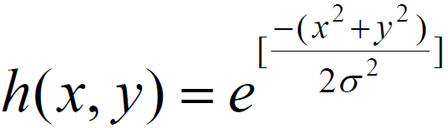

Noise: imnoise(image, ‘salt & pepper’);

Denoise: median filter

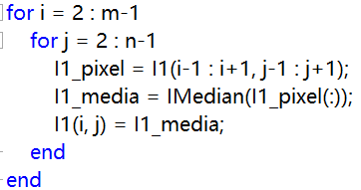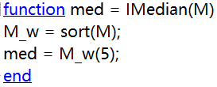

**Sharpening**: emphasize the fine details of an image

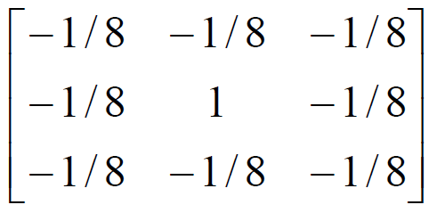 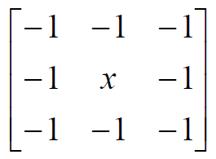

If x = 8: pure high pass filter

If x < 8: results in a negative of the original

If x > 8: retain some low frequency information

**Derivative operator** 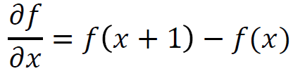

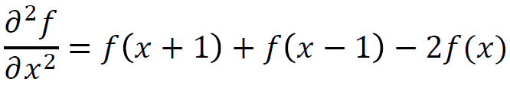

**Unsharp**: subtracting an unsharp version of an image

**Gaussian noise**: statistical noise that has its probability density function equal to the normal distribution

**White Gaussian noise**: the values at any pairs of times are statistically independent

**Grain**: signal-dependent noise

**Edge detection**

**Gradient method**: detects the edge by looking for the maximum and minimum in the first derivative of the image

**Laplacian method**: search for zero crossing in the second derivative of the image

**Gradient**

Gradient equation: 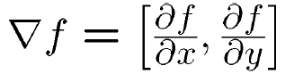

Gradient direction: 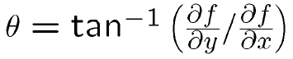

Edge strength: 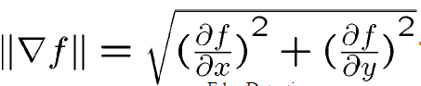

**Sobel edge detection Alogorithm**

1. Calculating the thresholding 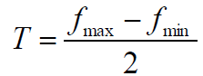

2. Apply Sobel masks to the whole image, respectively

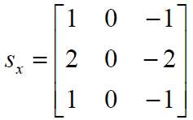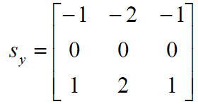

3. There are two result images Gx and Gy. Calculate

|G| = |Gx| + |Gy|

4. If |G| > T, then (x, y) is edge, otherwise, not.

**Laplacian Edge Detector**

1. Apply Laplacian mask to the whole image

2. Zero-crossing process

·Find the maximum and minimum among all pixels at the neighborhood of a pixel

·Using either 1 or 2 for the zero-crossing process

1. If the maximum is greater than zero and the minimum is smaller than zero

2. If the difference the maximum and the minimum is greater than a threshold value

**Canny edge detector**

1. Filter out any noise in the original image (Gaussian)

2. Find the edge strength by taking the gradient of the image 

3. Find the edge direction 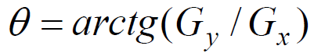

4. Relate the edge direction to a direction that can be traced in an image

5. Non-maximum suppression; trace along the edge in gradient direction and set 0 to pixel that is not considered to be an edge

Non-maximum suppression

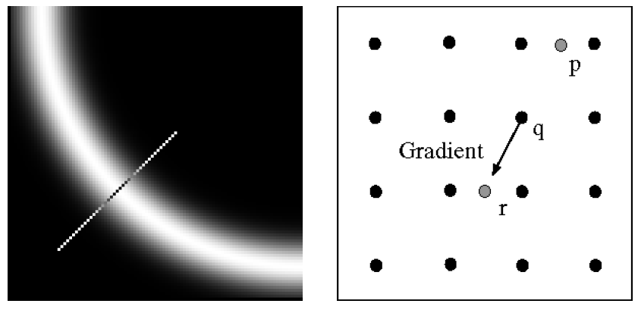

If magn(iq, jq) < magn(ip, jp) or magn(iq, jq) < magn(rp, jp) I(x, y) = 0; otherwise I(x, y) = magn(iq, jq)

**Color models**

The purpose of a color model is to facilitate the specification of colors in some standard.

RGB: monitor, video camera

CMY, CMYK: model for color printing

HSI: closely way with humans describe and interpret color

HSI color space:

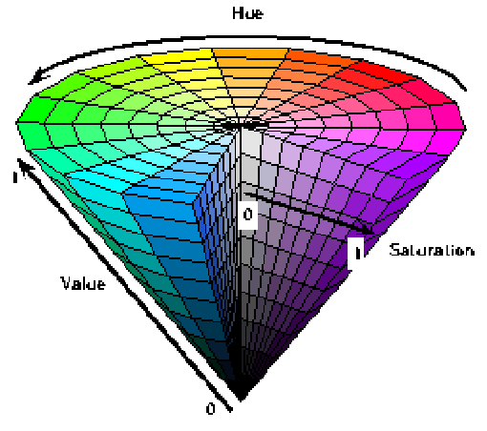

**RGB → HSI**

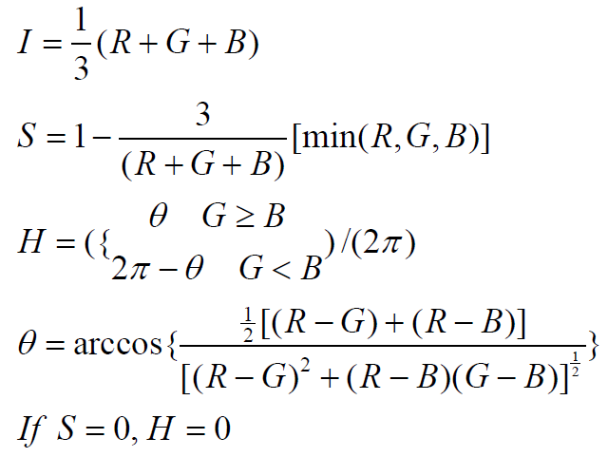

**HSI → RGB**

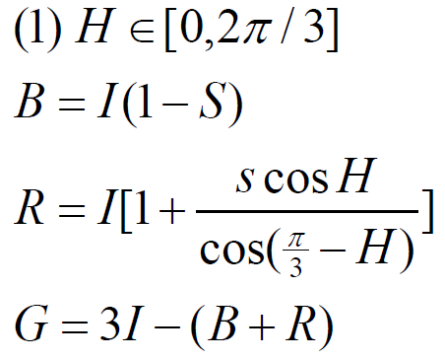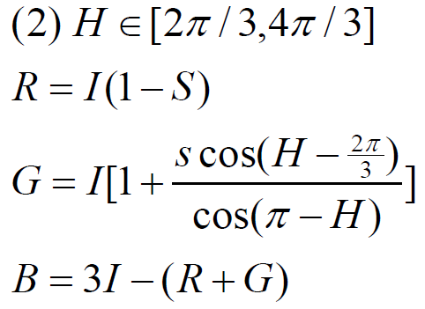

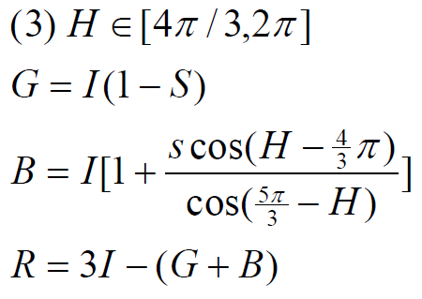

**Difference usage of RGB and HSI color models**

HSI: useful for image processing on the isolated intensity component

RGB: typically used for computer graphics

**Histogram equalization algorithm**

·convert from RGB to HSI model

·get intensity

·Histogram equalization

·convert from HSI to RGB model

·output RGB file

**Segmentation in HIS space**

S: as a template, determine the value of the threshold

S(i, j) = 1, if S(i, j) > threshold

S(i, j) = 0, if S(i, j) < threshold

H: do the threshold in H: S*H

I: there is no color information

Segmentation in RGB space

·Find the color we would like to segment

·For every pixel if



I(R, G, B) = 1, otherwise, I(R, G, B) = 0

**Full-Color Image Processing**

Color Image Smoothing Color Image Sharpening

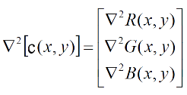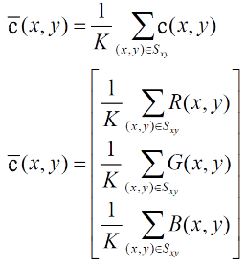 Laplacian of Vector c:

Fourier Transform and Applications

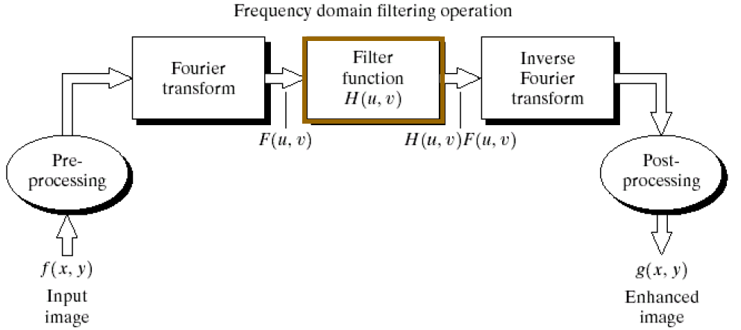

·Edges and sharp transitions in an image contribute significantly to high-frequency content of FT

·Low frequency contents in the FT are responsible to the general appearance of the image over smooth areas

·Blurring is achieved by attenuating range of high frequency components of FT

