Program 1:

import java.io.*;

import java.util.*;

public class w1p1{

public static void main(String args[]){

Scanner sc=new Scanner(System.in);

int t=sc.nextInt();

for(int i=0;i<t;i++){

long n=sc.nextLong();

System.out.println(n+" can be fitted in");

if(n>=-128 && n<=128)

System.out.println("*byte");

if(n>-32768 && n<=32767)

System.out.println("*Short");

if(n>=Integer.MIN_VALUE && n<=Integer.MAX_VALUE)

System.out.println("*Int");

if(n>=Long.MIN_VALUE && n<=Long.MAX_VALUE)

System.out.println("*Long");

}

}

}

output :

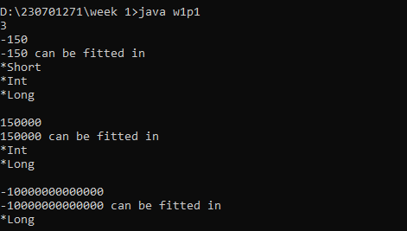

Program 2:

import java.io.*;

import java.util.*;

public class w1p2{

public static void main(String args[]){

Scanner sc=new Scanner(System.in);

int n=sc.nextInt();

double dollar=n/100.00;

System.out.format("$%.2f",dollar);

}

}

Output :

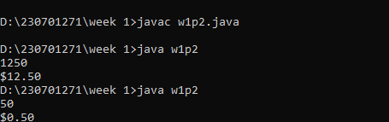

Program 3:

import java.util.*;

public class w1p3 {

public static void main (String args[])

{

Scanner sc=new Scanner(System.in);

double score =sc.nextDouble();

int soc =(int) score;

System.out.println(soc);

}

}

Output :

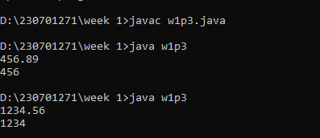

Program 4:

import java.io.*;  
import java.util.*;  
public class w1p4{  
public static void main(String args[]){  
Scanner sc=new Scanner(System.in);  
int n=sc.nextInt();  
double d=sc.nextDouble();  
System.out.format("%.2f",((n*d)/100.00)+n);  
}  
}

output :

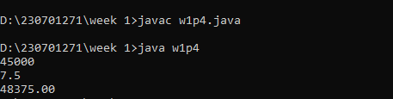

Program 5:

import java.util.*;

public class w1p5 {

public static void main(String args[]) {

Scanner sc=new Scanner(System.in);

int n=sc.nextInt();

int i=n;

int rev,rem,sum=0;

while(i!=0) {

rem=i%10;

sum=rem+sum*10;

i=i/10;

}

if(sum==n) {

System.out.println("the reversed number is "+n+" it is same as the original");

}

else {

System.out.println("it cannot be reversed");

}

}

}

Output :

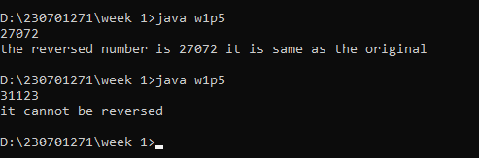

Program 6:

import java.util.*;  
public class w1p6{  
public static void main(String arg[]){  
Scanner sc = new Scanner(System.in);  
System.out.print("Enter n: ");  
int n=sc.nextInt();  
for(int i=0;i<=n;i++){  
for(int j=1;j<=n-i;j++){  
System.out.print(" ");  
}  
for(int j=1;j<=2*i-1;j++){  
System.out.print("*");  
}  
System.out.println();  
}  
for(int i=n-1;i>=1;i--){  
for(int j=1;j<=n-i;j++){  
System.out.print(" ");  
}  
for(int j=1;j<=2*i-1;j++){  
System.out.print("*");  
}  
System.out.println();  
}  
}  
}

output :

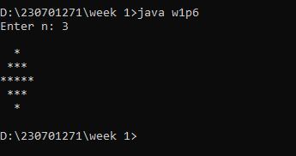

Program 7:

import java.util.*;  
public class w1p7 {  
    public static void main(String[] args) {  
        Scanner scanner = new Scanner(System.in);  
        System.out.print("Enter the number of rows: ");  
        int n = scanner.nextInt();  
        int[][] pascal = new int[n][n];  
        for (int i = 0; i < n; i++) {  
            for (int j = 0; j <= i; j++) {  
                if (j == 0 || j == i) {  
                    pascal[i][j] = 1;  
                } else {  
                    pascal[i][j] = pascal[i - 1][j - 1] + pascal[i - 1][j];  
                }  
            }  
        }  
        for (int i = 0; i < n; i++) {  
            for (int j = 0; j < n - i - 1; j++) {  
                System.out.print(" ");  
            }  
            for (int j = 0; j <= i; j++) {  
                System.out.print(pascal[i][j] + " ");  
            }  
            System.out.println();  
        }  
        for (int i = n - 2; i >= 0; i--) {  
            for (int j = 0; j < n - i - 1; j++) {  
                System.out.print(" ");  
            }  
            for (int j = 0; j <= i; j++) {  
                System.out.print(pascal[i][j] + " ");  
            }  
            System.out.println();  
        }  
    }  
}

output :

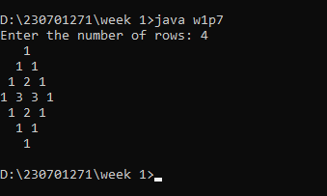

Program 8:

import java.util.*;

public class w1p8 {

public static void main(String[] args) {

Scanner sc = new Scanner(System.in);

int q = sc.nextInt();

for (int i = 0; i < q; i++) {

int a = sc.nextInt();

int b = sc.nextInt();

int n = sc.nextInt();

int sum = a;

for (int j = 0; j < n; j++){

sum += (int)(Math.pow(2, j) * b);

System.out.print(sum + " ");

}

}

}

}

Output :

