**PURBANCHAL UNIVERSITY**



**KIST COLLEGE OF**

**INFORMATION TECHNOLOGY**

**SECOND SEMESTER PROJECT**

**ON**

**“STUDENT FEE PAYMENT SYSTEM”**

In the partial fulfillment for the requirement of the 2nd Semester Project-II (Subject Code-BIT 179CO) in the Completion of Bachelor of Information Technology (BIT) degree at KIST College of information and Technology, under Purbanchal University.

**SUBMITTED BY SUBMITTED TO**

Binod Dangal S.N: - 324075 PURBANCHAL UNIVERSITY

Keshab Bhadel S.N: -324079

Rukesh Basukala S.N: -324088

Sadikshya Shrestha S.N: -324089

**Acknowledgement**

We take this opportunity to express our profound appreciation and unfathomable regards to the Information Technology (IT) department for this commendable guidance, monitoring and constant encouragement throughout the course of this project. The help and guidance given by shall carry us a long way, in the journey on which we are about to embark.

We also take this opportunity to express a deep sense of gratefulness to Mr. Anaya Upadhyay for his amiable support, valuable information and guidance, which helped us in completing this task throughout its various stages. We also want to thank our coordinator Mr. Deepak Khadka who helped us a lot during the complete project by giving us his precious time. We are also indebted to all members of KIST College, for the valuable suggestions and help provided by them in their respective fields. We are grateful for their cooperation during the period of our project.

Finally,we would also like to express lots of thanks to PURBANCHAL UNIVERSITY for designing such a wonderful course structure. It will help us to get more knowledge in the field of Information Technology & help us to have a bright future in the field of technology.

We hope our University will accept this attempt as a successful project.

**Student’s Declaration**

We following students, hereby declare that the Project Report titled

"**STUDENT FEE PAYMENT SYSTEM"**is a result of our own work and our in datedness to other work publications, references, if any, have been dully acknowledged. If we are found guilty of copying any other report or published information and showing as our original work, we understand that we shall be liable and punishable by Purbanchal University, which may include fail in examination, ‘Repeat study and re-submission of the report' or any other punishment that Purbanchal University may decide.

We further certify that this Project submitted in partial fulfillment of the requirement for the award of Bachelor in Information Technology (BIT) of the Purbanchal University is our original work and has not been submitted for award of any other degree or other similar title or prizes.

|  |  |  |  |
| --- | --- | --- | --- |
| S.N | NAME | Symbol No. | Signature |
| 1 | Binod Dangal | 324075 |  |
| 2 | Keshab Bhadel | 324079 |  |
| 3 | Rukesh Basukala | 324088 |  |
| 4 | Sadikshya Shrestha | 324089 |  |

**Examiner’s Certification**

This is to certify that the project entitled "**STUDENT FEE PAYMENT SYSTEM** " has been successfully completed by

|  |  |  |  |
| --- | --- | --- | --- |
| S.N | NAME | Symbol No. | Signature |
| 1 | Binod Dangal | 324075 |  |
| 2 | Keshab Bhadel | 324079 |  |
| 3 | Rukesh Basukala | 324088 |  |
| 4 | Sadikshya Shrestha | 324089 |  |

in partial fulfillment of Degree of Bachelor of Information Technology of Purbanchal University during the academic year 2017 under the guidance of Mr. Deepak khadka.

………………………………………………….

Department of Science and Technology

**KIST College of Information Technology**

PURBANCHAL UNIVERSITY

**To Whom It May Concern**

This is to certify that Mr. Binod Dangal, Mr. Keshab Bhadel, Mr. Rukesh Basukala and Ms. Sadikshya Shrestha of Bachelor in Information Technology (BIT) has studied as per the curriculum of BIT 2nd semester and completed the project entitled “STUDENT FEE PAYMENT SYSTEM”. This project is the original work of Mr. Binod Dangal, Mr. Keshab Bhadel, Mr. Rukesh Basukala and Ms. Sadikshya Shrestha that was carried out under the supervision as per guidelines provided by Purbanchal University and certified as per the student’s declaration that project School Fee Payment System has not been presented anywhere as a part of any other academic work.

The details of the student are as follows: -

|  |  |  |  |
| --- | --- | --- | --- |
| S.N | NAME | Symbol No. | Signature |
| 1 | Binod Dangal | 324075 |  |
| 2 | Keshab Bhadel | 324079 |  |
| 3 | Rukesh Basukala | 324088 |  |
| 4 | Sadikshya Shrestha | 324089 |  |

……………………………………..

Deepak Khadka

Program Coordinator, BIT

KIST College of Information Technology

**Table of Contents**

**Topic Page no.**

1. Background
   1. Abstract of the project 1
   2. Introduction 2
   3. Objective of the project 2
   4. Future of the project 3
   5. Process in the project 3
   6. Introduction to language used 4
2. System Requirements
   1. Hardware Requirement 5
   2. Software Requirement 5
3. System Design
   1. Algorithm 6
   2. Flowchart 7
4. Snapshots 8-12
5. Limitations 13
6. Conclusion 14
7. Bibliography 15

**1.BACKGROUND**

* 1. **Abstract of the project**

The “STUDENT FEE PAYMENT SYSTEM” undertaken as a project based on relevant technologies. The main purpose of this project is to develop software for school to provide fee payment system digitally. This project has been developed to carry out the processes easily and quickly, which is not possible with the manual system. This project is developed using C++ language, and is meant for recording fee’s payments, providing digital bills, getting instant information on students and update. We have made this project interactive and easy to use. We have mainly focused on different types of problem that occur in normal fee record system. This project improves the performance of a school by reducing time and improving the quality of services and related processes. Thus it provides the complete solution for the current traditional system.

As we are beginners and have no practical experience in the field of software development and moreover the Fee Record system is very wide. So, we limit the scope of our project by computerizing the following field of the fee record system:

* Available student record
* Providing digital bills
* Update student record
  1. **Introduction**

One of the most important sector for any country is its education system. It is where the path of development and progress lay its foundation stone. A high standard education system plays vital role for the future of the students. Meanwhile, within a couple of years after birth, almost all the children are sent to schools and in country millions of students like us join schools and college for education. Hence, Student fee payment system was developed to manage the student details which include the adding of new student, listing student records, modifying the student details, searching the particular student.

The term “Student Fee Payment System” includes each and every details of every student admitted i.e. Name, Class, Phone number, Roll No. and many more and also assist for easy fee paying for the user and the payer. After completion of annual class, many students join new schools and some leave their schools. In addition to that students admit for new session make piles of line for paying their fees. It has been systematic till now. It gets much more difficult as the year passes to keep each and every record. But after this system has been implemented it will be a piece of cake for the users to maintain these problems smoothly and more efficiently.

* 1. **Objectives**

The major objectives of student fee record system are: -

* To build integrated information database of the student.
* To make recording process standard, much easier and more effective in order to meet the satisfaction level of the student make the task much efficient.
* To get easiness in task and reduce the paper work by computerization.
* To enhance accuracy in work and save time
* To remove data redundancy and will be fast in operation.
* Guarantee the security and confidentiality of information.
* To make fee paying easier for the payer and receiver.
* To save time for the user to display and search for details of every student.
  1. **Future Implementation for the Project**

All these result of future of project are in high satisfaction. A future application of this system lies in fact that the proposed system would remain relevant in future. Though we have not included a full fee payment system in this project but we will be trying to make it more advance by including all those material required for a full fee payment system. It is necessary to see and visualizes the future scope. Future enhancement is necessary for the system as the limitations that cannot be denied today, can be overcome by better technologies. The project has a very fast scope in future.

**The following are the future scope for the project:**

* Build an integrated information database of the student.
* Making software as a Web application such that the program can be used anywhere and anytime.
* Efficiency can be further enhanced and boosted up to a great extent by introducing the database and provide security feature in the future.
* We can also make the project more attractive by introducing Graphical User Interface.
* Automatic and error free report generation with ease.
  1. **Process in the Project Use**

This software is made to be used by Front desk officer like fee record officer and management team. The user cannot use the software unless he/she provides the username and password. Once the admin login he/she can see all the records and their detail information and can easily access all the records. There are different records each holding different data and information such as student’s information.

* 1. **Introduction to software**

C++ programming language was developed by Bjarne Stroustrup at Bell Lab in New Jersey in early 1980 s as extension of C. He named ‘C with classes’. In 1983 it was renamed to C++. C++ is a general-purpose programming language. C++ is regarded as mid-level language, as it comprises a combination of both high-level and low-level language features. It is a statically typed, free-form, multi-paradigm, usually compiled language supporting procedural programming, data abstraction, object-oriented programming, and generic programming. The C++ language corrects most of the deficiencies of C by offering improved compile time type checking and support for modular and object oriented programming. C++ supports multiple inheritance and does not have garbage collector dynamically created object must be destroyed explicitly.

**2. SYSTEM RECOMMMENDATION**

The minimum requirements for system are:

* 1. **HARDWARE**

|  |
| --- |
| * PC with intel i3 core processor or latest * 32 MB of RAM or more * Color monitor * Hard disk with at least 50 MB of free space |

* 1. **SOFTWARE**

|  |  |
| --- | --- |
| Operating software | Windows XP, Windows 7,8,10, Linux |
| Compiler | Visual Studio ,Code Block |
| Programming language | C++ language |
| Data base | MySQL server version: 10.1.28-MariaDB |

**3. SYSTEM DESIGN**

**3.1. Algorithm**

The system consists of different sets of algorithm:

Step 1: START

Step 2: Enter username and password. (Eg: user name: kist password: kist). If username and password matches go to step 3 otherwise repeat step 2.

Step 3: Program asks for options as Add Records, List Records, Edit Records, Search Records, Payment, Delete Record, Change Password, and Exit Program. On the main menu

Step 4: Add Record, Condition 1 program shows the option as:

Student ID, Class, Roll. No, First name, Last name, Phone number and Total number.

Step 5: List Record, condition 2 programs shows the option as:

Enter the Class.

Step 6: Edit Record, Condition 3 program shows the option as:

Enter the student Id.

1. Edit Student ID
2. Edit Class
3. Edit Roll. no
4. Edit First name
5. Edit Last name
6. Edit Phone Number
7. Edit Total Amount

Step 7: Search Record, condition 4 programs shows the option as:

Enter the Student ID.

Step 8: Fee Payment, Condition 5 program shows the option as:

Enter the Student ID.

Enter the amount that you want to pay.

Step 9: Delete Record, Condition 6 program shows the option as:

Enter the student ID that you want to delete.

Step 10: Change Password, Condition 7:

Enter the old password first and enter the new one.

Step 11: The last Condition is the Exit.

Step 12: STOP

**Although the steps are taken as simplest way there are further deeper algorithms for the separate functions shown in the Options.**

**3.2. FLOWCHART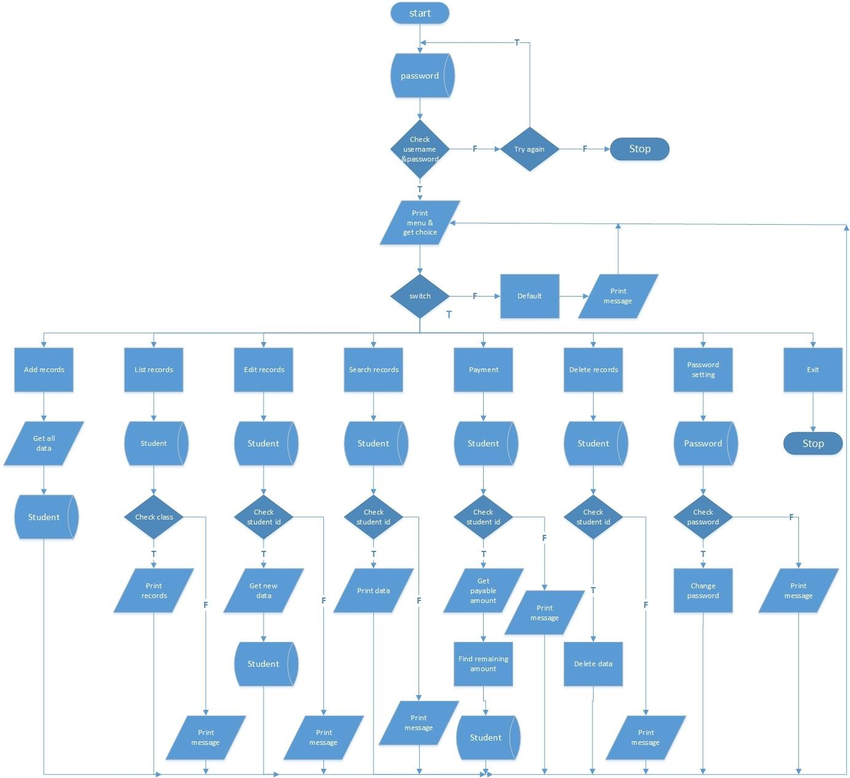5. SNAPSHOTS OF THE SYSTEM**

**Admin login:**

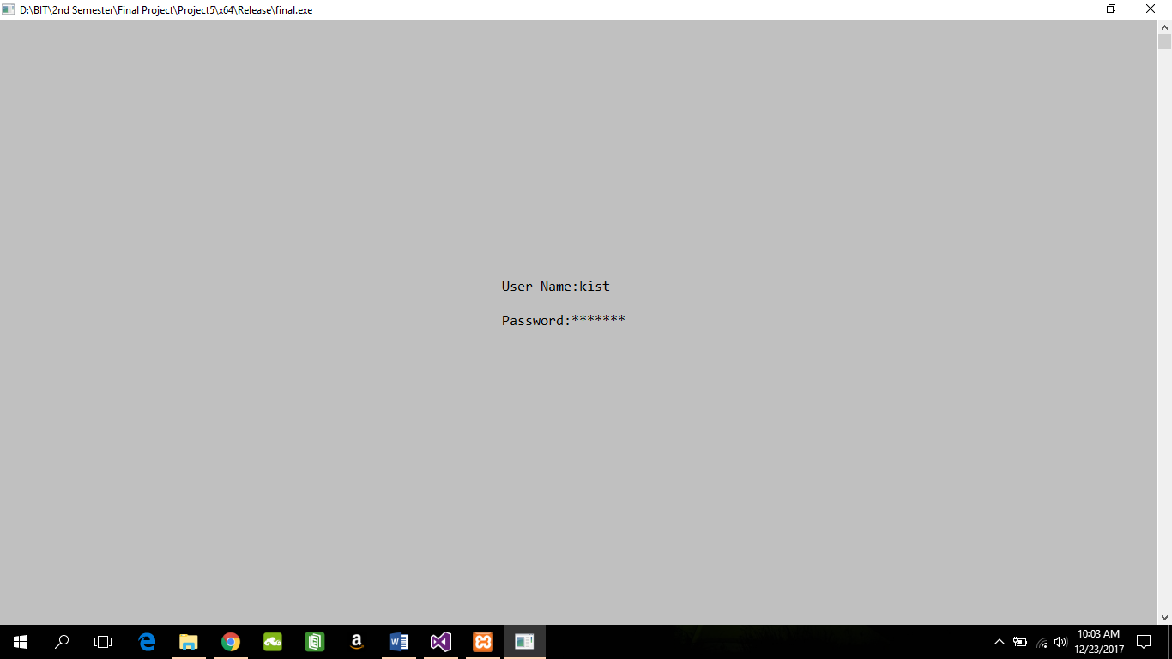

**Main menu:**

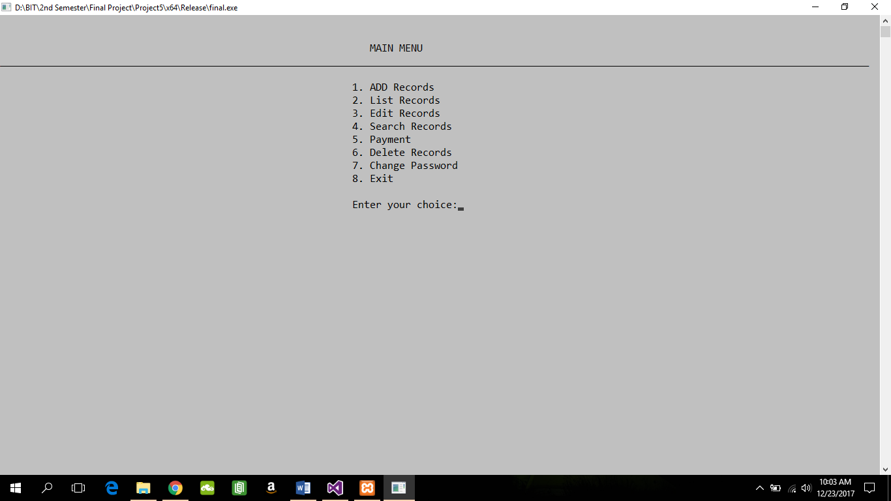

**Add Record:**

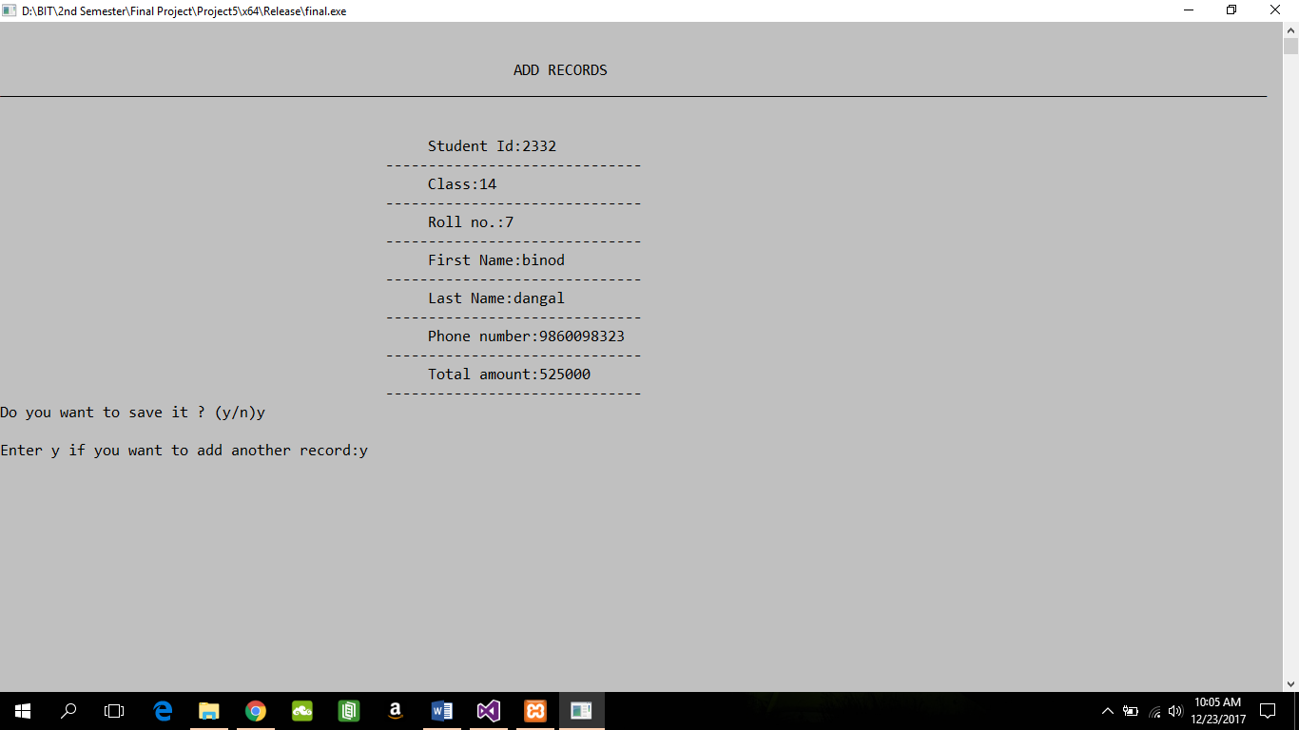

**List Record:**

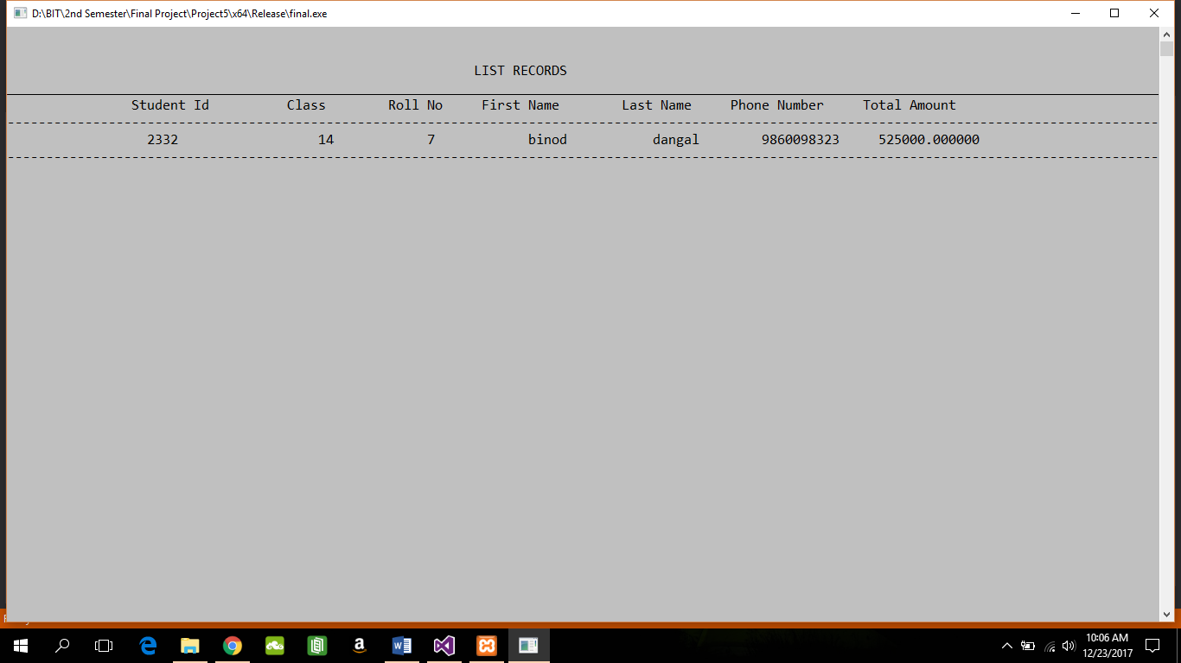

**Edit Record:**

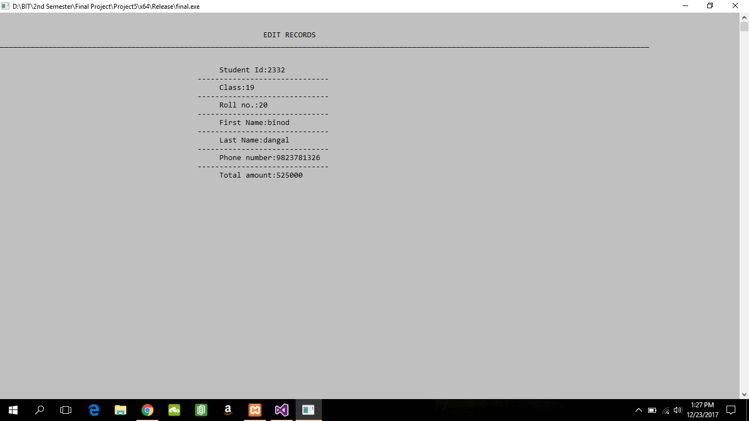

**Search Record:**

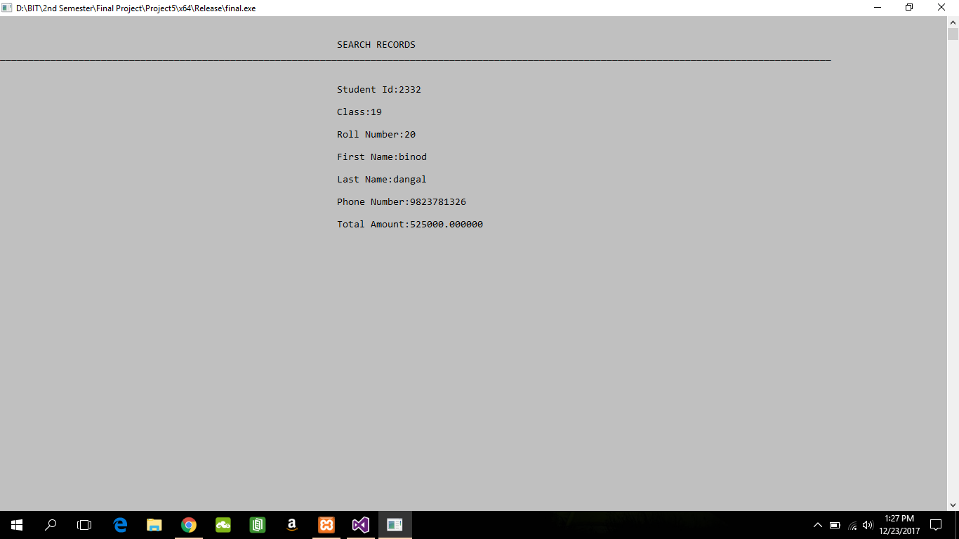

**Payment:**

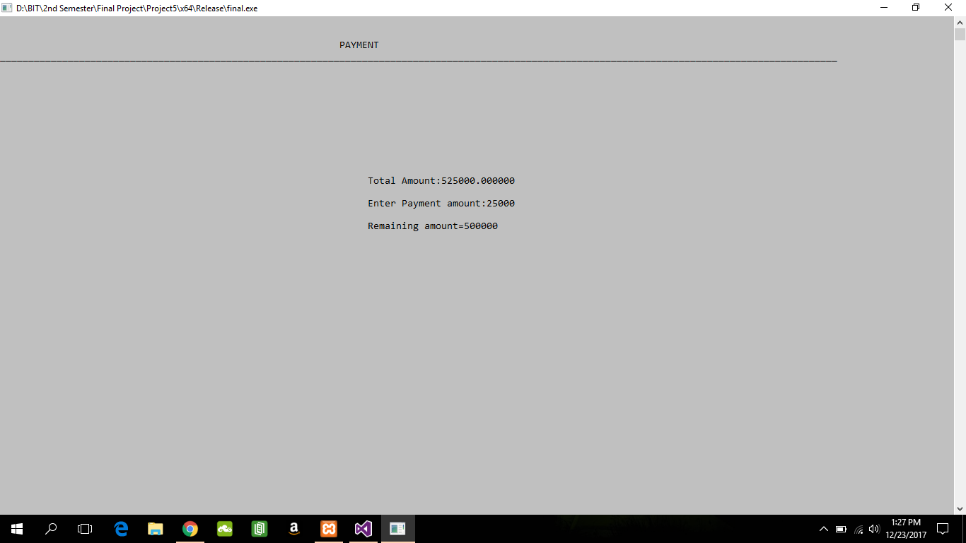

**Delete Record:**

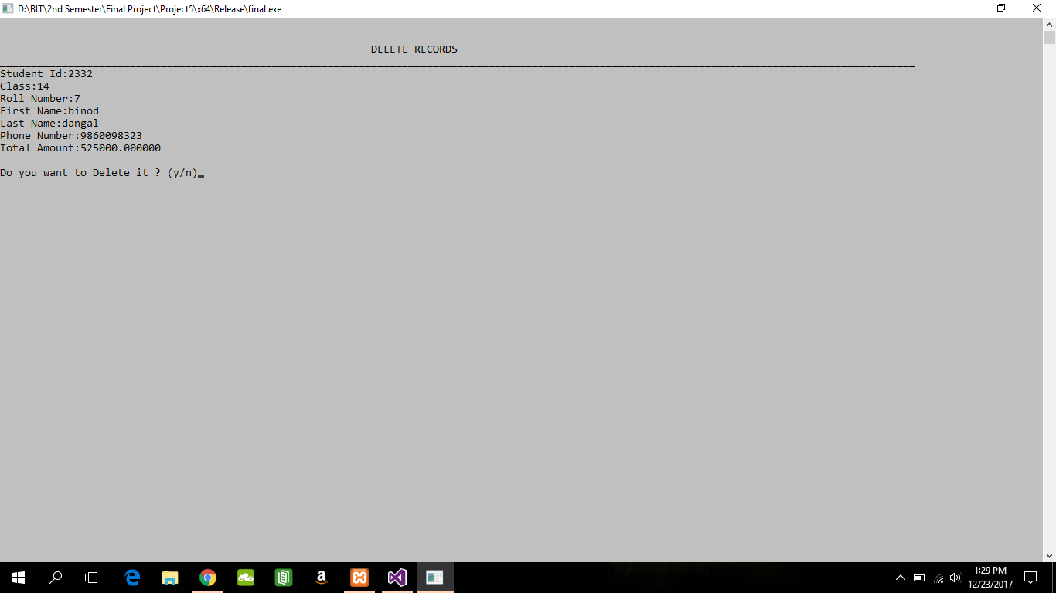

**Change Password:**

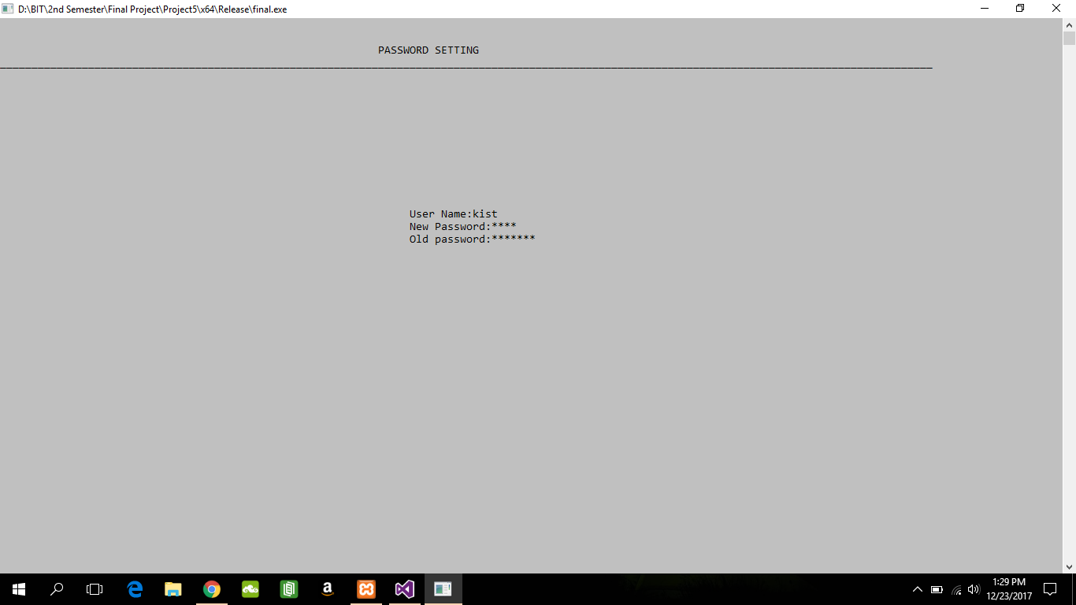

**Exit:**

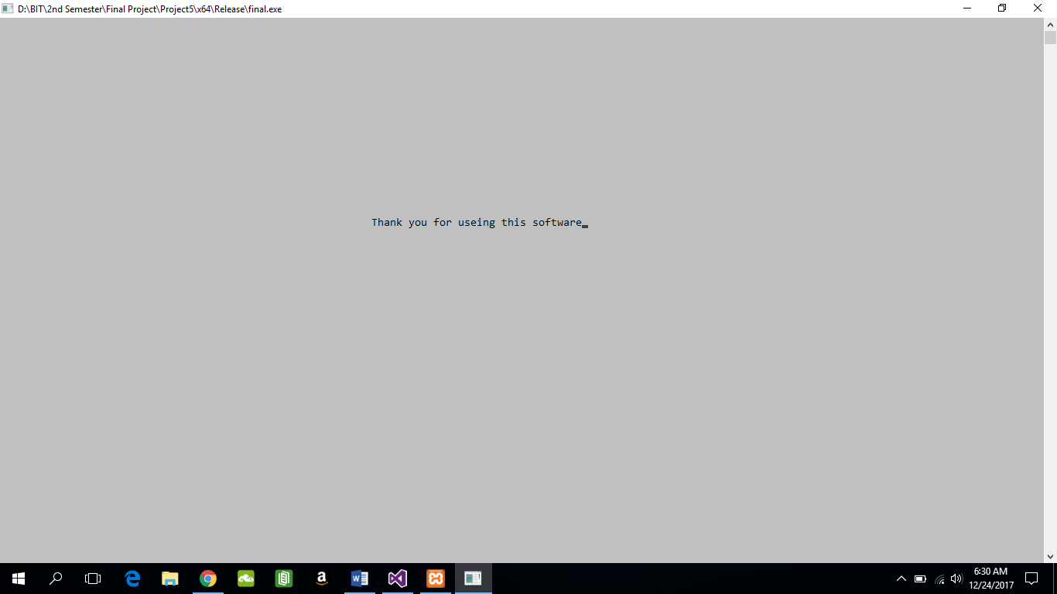

**6. Limitations:**

* Paper prints not supported
* Program might crash if not integers values are given to integer.
* Program only provides text-based interface
* Online based application not supported
* Lack of Secured data and Security

**7. CONCLUSION:**

* Using this software recording process can be made standard, much easier and more effective in order to meet the satisfaction level of the people and make the task much efficient.
* Provide facility for identification and verification services through a digital fee payment system.

**8. BIBLIOGRAPHY**

* Robert Lafore, Object-Oriented Programming in C++, Galgotia, Publication, India
* Project instructor and mentor Mr. Anaya Upadhyay help and guidance.
* https://r3dux.org/2010/11/how-to-use-mysql-connectorc-to-connect-to-a-mysql-database-in-windows/