COFFEE SALES DATA ANALYSIS REPORT

Domain: Data Science & Business Analytics
Dataset: Coffee Sales Transactions (Mar 2024 – Mar 2025)
Tools Used: Python, Pandas, Matplotlib, Seaborn

Executive Summary
This report presents a comprehensive analysis of coffee shop sales data covering the period from March 2024 to March 2025. The objective of the analysis was to identify sales trends, customer behavior, revenue growth patterns, peak business hours, and product performance. The report also includes visualizations and business recommendations that can help improve decision-making, customer engagement, staffing efficiency, and menu strategy.
Key findings indicate strong revenue growth over time, higher demand during morning and evening hours, and significant differences in drink preferences across weekdays, weekends, and seasonal periods.

Dataset Overview
Metric | Value
Total Transactions | 3,547
Total Revenue | $112,246
Menu Items | 8 Drinks
Date Range | March 2024 – March 2025
Analysis Tools | Python, Pandas, Matplotlib, Seaborn
The dataset contains detailed coffee shop transactions including drink type, transaction value, order time, weekdays, and customer demand patterns.

Major Findings & Analysis
- Monthly Revenue Analysis: Monthly revenue trends revealed steady growth with March 2025 showing significant improvement compared to March 2024.
- Top Selling Products: Americano with Milk was identified as the most frequently ordered drink, while premium beverages generated higher average revenue per order.
- Peak Business Hours: The busiest hours were concentrated during morning (8–10 AM) and evening periods, suggesting strong commuter and leisure customer activity.
- Weekend vs Weekday Behavior: Weekends generated lower total revenue compared to weekdays, but average daily revenue remained highly competitive.
- Customer Preference Shifts: Drink preferences varied throughout the year, with specialty drinks performing better during weekends and colder months.

Visual Analysis & Figures
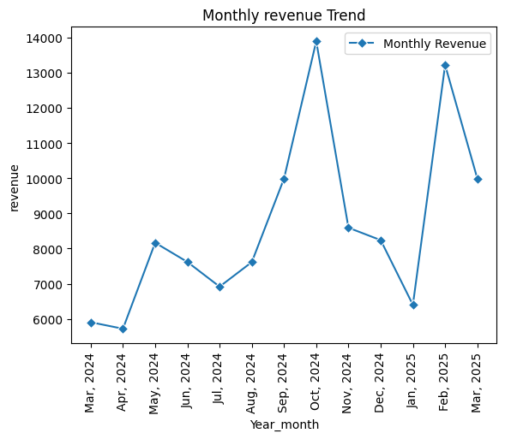
Figure 1: Sales Analysis Visualization
The above figure highlights important sales trends and business insights derived from the coffee sales dataset. These visualizations help management quickly understand customer behavior, sales fluctuations, and operational patterns.
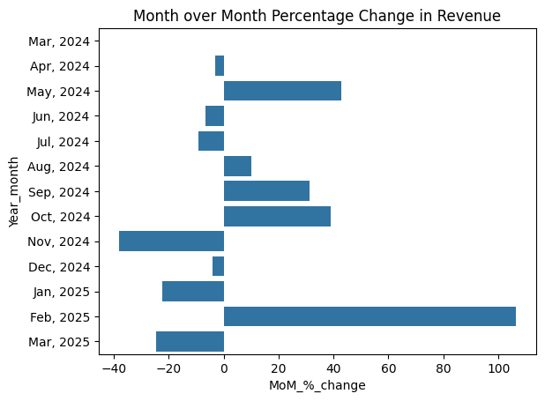
Figure 2: Sales Analysis Visualization
The above figure highlights important sales trends and business insights derived from the coffee sales dataset. These visualizations help management quickly understand customer behavior, sales fluctuations, and operational patterns.
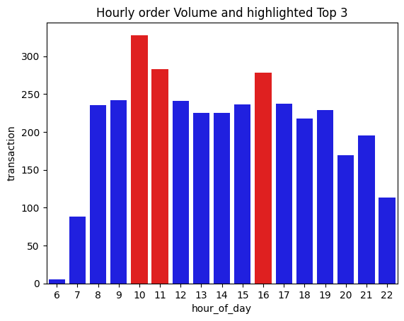
Figure 3: Sales Analysis Visualization
The above figure highlights important sales trends and business insights derived from the coffee sales dataset. These visualizations help management quickly understand customer behavior, sales fluctuations, and operational patterns.
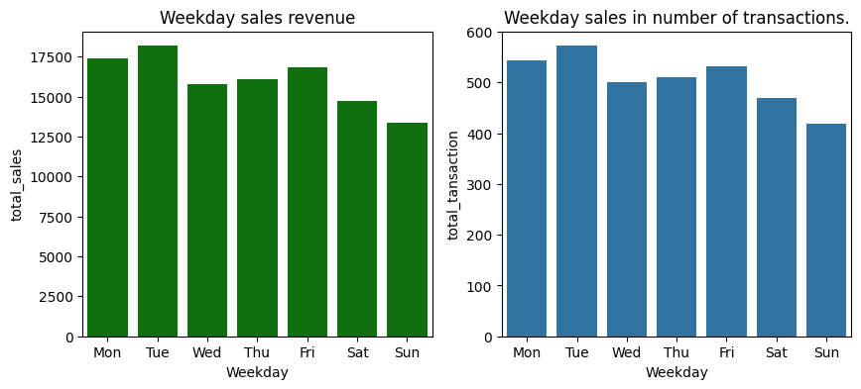
Figure 4: Sales Analysis Visualization
The above figure highlights important sales trends and business insights derived from the coffee sales dataset. These visualizations help management quickly understand customer behavior, sales fluctuations, and operational patterns.
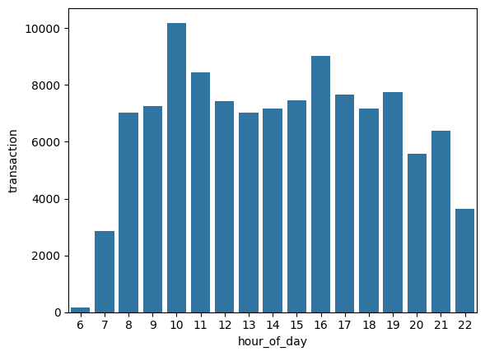
Figure 5: Sales Analysis Visualization
The above figure highlights important sales trends and business insights derived from the coffee sales dataset. These visualizations help management quickly understand customer behavior, sales fluctuations, and operational patterns.
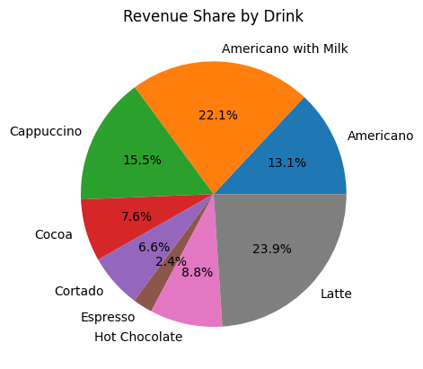
Figure 6: Sales Analysis Visualization
The above figure highlights important sales trends and business insights derived from the coffee sales dataset. These visualizations help management quickly understand customer behavior, sales fluctuations, and operational patterns.
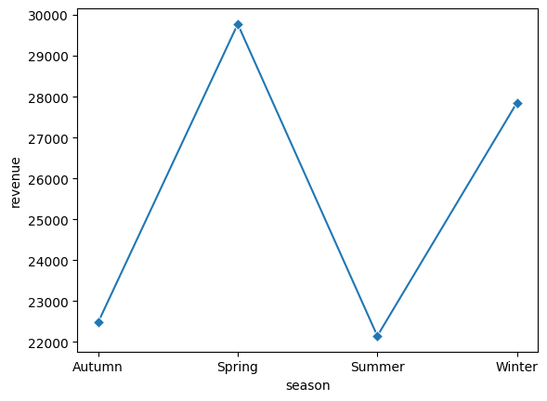
Figure 7: Sales Analysis Visualization
The above figure highlights important sales trends and business insights derived from the coffee sales dataset. These visualizations help management quickly understand customer behavior, sales fluctuations, and operational patterns.
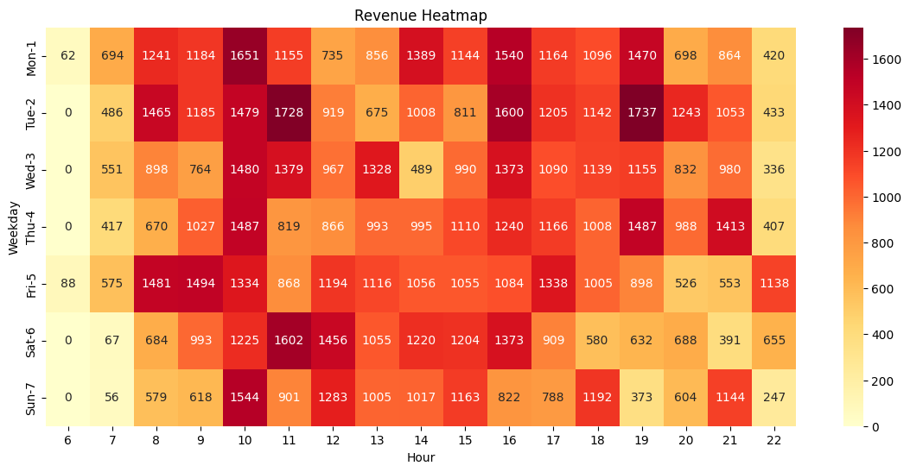
Figure 8: Sales Analysis Visualization
The above figure highlights important sales trends and business insights derived from the coffee sales dataset. These visualizations help management quickly understand customer behavior, sales fluctuations, and operational patterns.
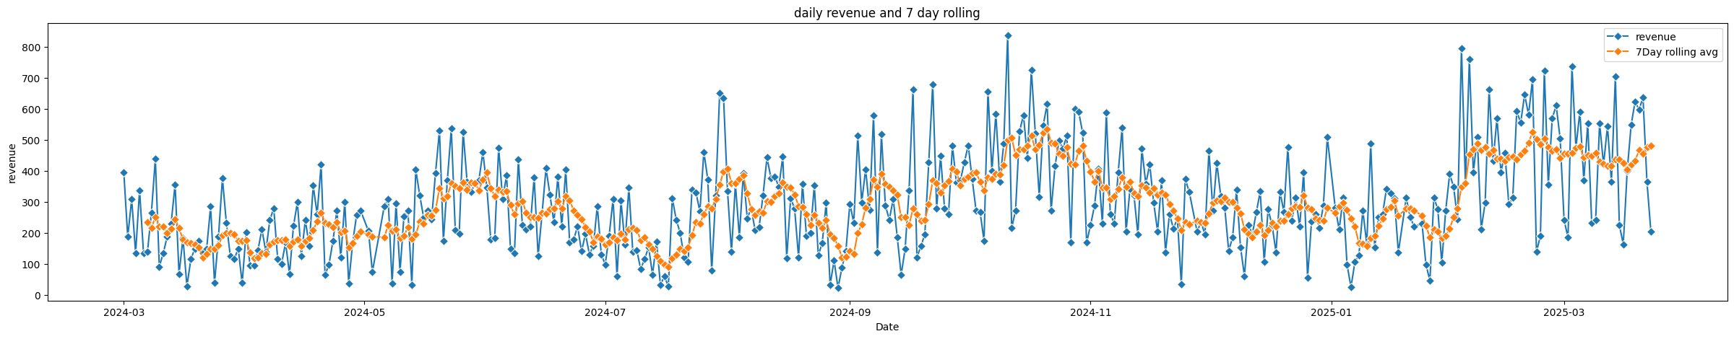
Figure 9: Sales Analysis Visualization
The above figure highlights important sales trends and business insights derived from the coffee sales dataset. These visualizations help management quickly understand customer behavior, sales fluctuations, and operational patterns.
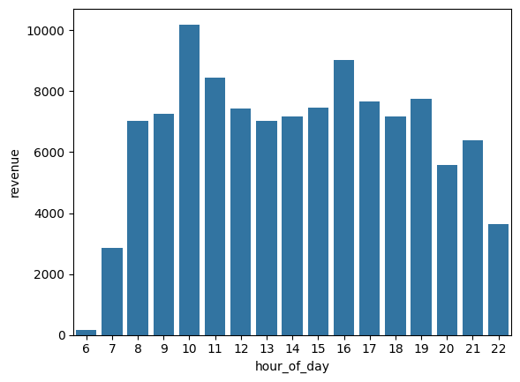
Figure 10: Sales Analysis Visualization
The above figure highlights important sales trends and business insights derived from the coffee sales dataset. These visualizations help management quickly understand customer behavior, sales fluctuations, and operational patterns.
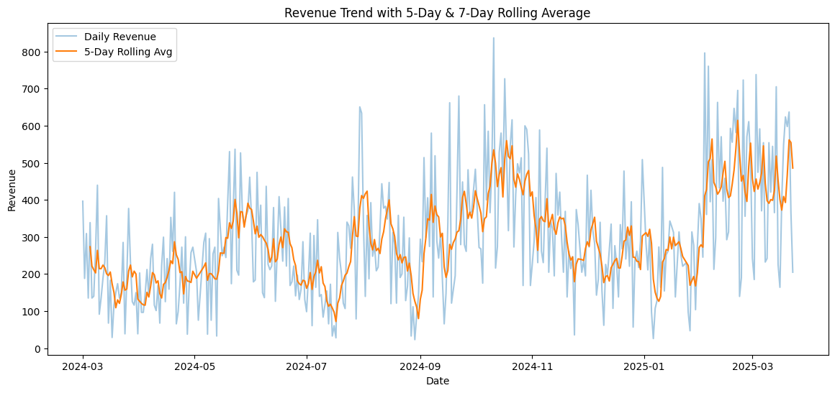
Figure 11: Sales Analysis Visualization
The above figure highlights important sales trends and business insights derived from the coffee sales dataset. These visualizations help management quickly understand customer behavior, sales fluctuations, and operational patterns.
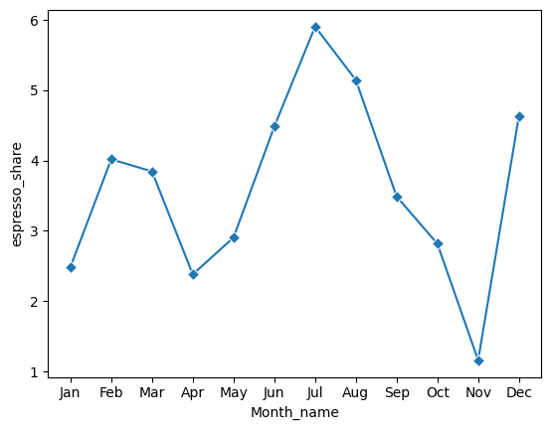
Figure 12: Sales Analysis Visualization
The above figure highlights important sales trends and business insights derived from the coffee sales dataset. These visualizations help management quickly understand customer behavior, sales fluctuations, and operational patterns.

Business Recommendations
Area | Recommendation
Staffing | Increase staffing during peak morning and evening hours to reduce waiting times.
Menu Strategy | Promote low-performing drinks through combo offers or seasonal marketing campaigns.
Revenue Growth | Focus on high-margin beverages and upselling premium products.
Customer Engagement | Introduce weekend offers targeting specialty drink consumers.
Operational Planning | Prepare inventory based on seasonal demand and peak-hour analysis.

Conclusion
The Coffee Sales Internship project successfully demonstrated the use of data science and business analytics techniques to generate meaningful business insights from raw transactional data. Through the use of visualizations, statistical analysis, and trend evaluation, the project provided valuable recommendations for improving operational efficiency, revenue generation, and customer satisfaction.
This report serves as a professional summary of the internship work and can support management in making informed business decisions.

