Category | Details
Patient Name | Elias Vance
Hospital Name | St. Jude's General Hospital
Diagnosis | Community-Acquired Pneumonia
Treatment | Antibiotics (e.g., Azithromycin)

Test | Result | Reference Range | Interpretation
WBC | $12.5 \times 10^3/\mu L$ | $4.5 - 11.0 \times 10^3/\mu L$ | High (Suggests infection)
Hemoglobin | $14.8 \ g/dL$ | $13.5 - 17.5 \ g/dL$ | Normal
Platelets | $305 \times 10^3/\mu L$ | $150 - 450 \times 10^3/\mu L$ | Normal
Glucose | $102 \ mg/dL$ | $70 - 100 \ mg/dL$ | Borderline High
Creatinine | $1.1 \ mg/dL$ | $0.6 - 1.3 \ mg/dL$ | Normal

Scan Report & Image
Scan: Chest X-ray (CXR)
Findings: Subtle lobar infiltrate noted in the lower right lung field, consistent with bacterial pneumonia.
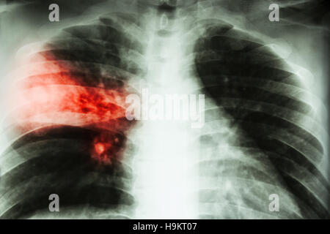
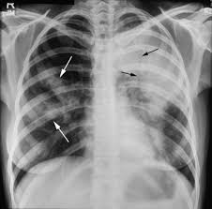
Findings:
- Subtle lobar infiltrate in the right lower lung field.
- No pleural effusion or pneumothorax noted.
- Cardiac silhouette within normal limits.
- No other focal consolidation seen.
Impression / Conclusion:
- Mild atherosclerotic changes in the left carotid artery.
- No significant stenosis (<20%), currently not hemodynamically significant.

