Category | Details
Patient Name | Serena Chen
Hospital Name | Unity Medical Center
Diagnosis | Hypercholesterolemia and Early Atherosclerosis
Treatment | Statin therapy, diet, and exercise counseling

Test | Result | Target/Reference Range | Interpretation
Total Cholesterol | $245 \ mg/dL$ | $<200 \ mg/dL$ | High
LDL Cholesterol | $168 \ mg/dL$ | $<100 \ mg/dL$ | High
HDL Cholesterol | $42 \ mg/dL$ | $>50 \ mg/dL$ | Low
Triglycerides | $130 \ mg/dL$ | $<150 \ mg/dL$ | Normal
HbA1c | $5.4\%$ | $<5.7\%$ | Normal

Scan Report & Image
Scan: Carotid Ultrasound
Findings: Mild plaque formation (atherosclerosis) noted in the left carotid artery bulb, resulting in $<20\%$ stenosis.

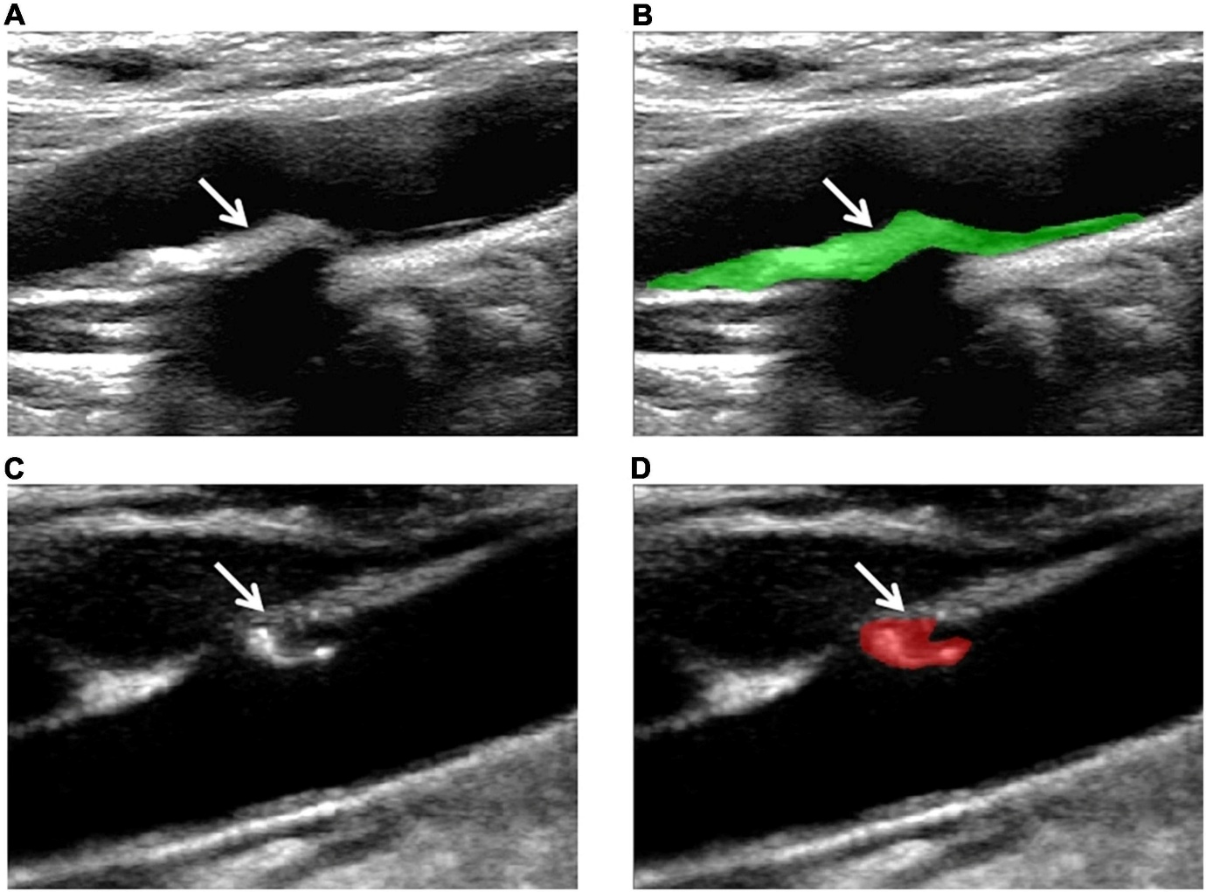

Findings:
- Mild plaque formation (atherosclerosis) in the left carotid artery bulb.
- Resulting in <20% luminal stenosis.
- Flow appears normal with no hemodynamically significant obstruction.
- Right carotid artery: No plaque or stenosis noted.
Impression / Conclusion:
- Mild atherosclerotic changes in the left carotid artery.
- No significant stenosis (<20%), currently not hemodynamically significant.

