Analysis

LLM is responding to the user input

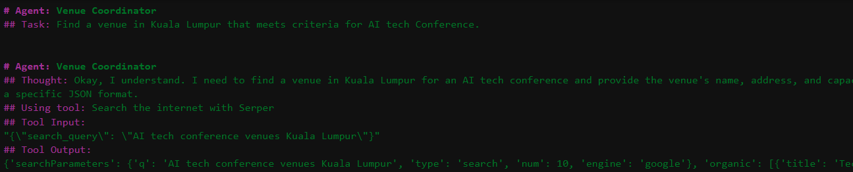

It is using serper API and doing internet search on your behalf

Eg-AI tech conference venues Kuala Lumpur', 'type': 'search', 'num': 10, 'engine': 'google

-this to narrow down later to which venue to pic

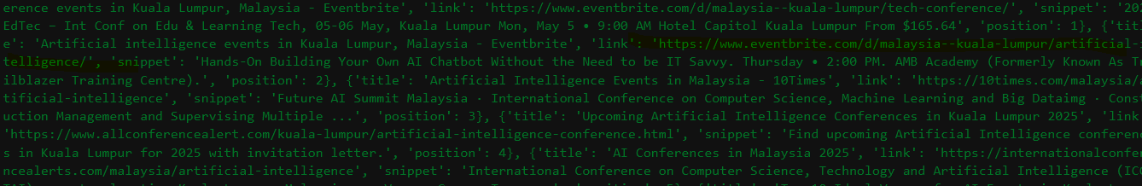

It found couple of events specific to AI eg

'<https://www.eventbrite.com/d/malaysia--kuala-lumpur/tech-conference/>

Now it needs to go inside the website links to see which venue they use. Its trying to scrape the website using crawler

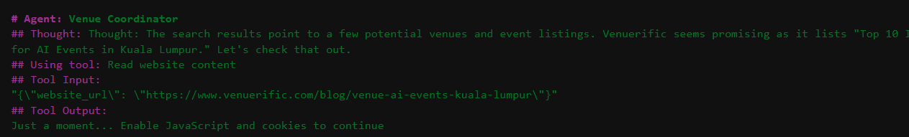

Funny somewebsite blocks its access, some requestion it accept cookies 😉

So it reiterates until find some information which any website gives

Finally it came with the best option in json format.

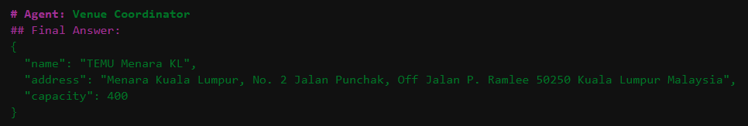

Now the second agent kicksoff ->seems asynchronously finding flight

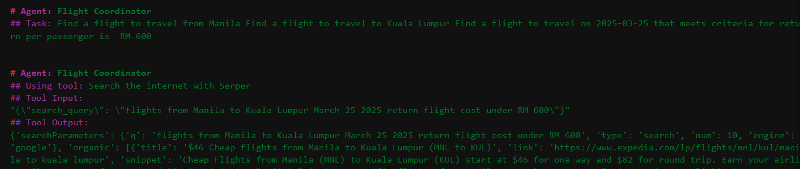

Wow look at list of airports its analyzing

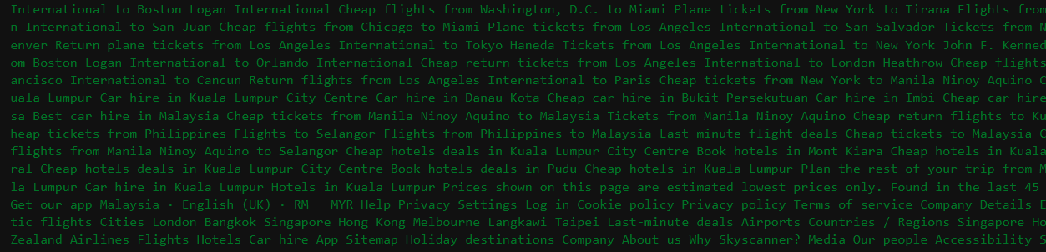

Some don’t allow bots to search 😊



It did not able to match exact requirement hence used hypothetical statement 😊

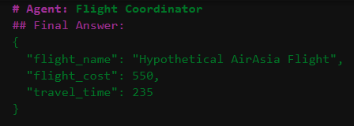

Now Last agent barathan kicks in



After researching it gave a mardown file

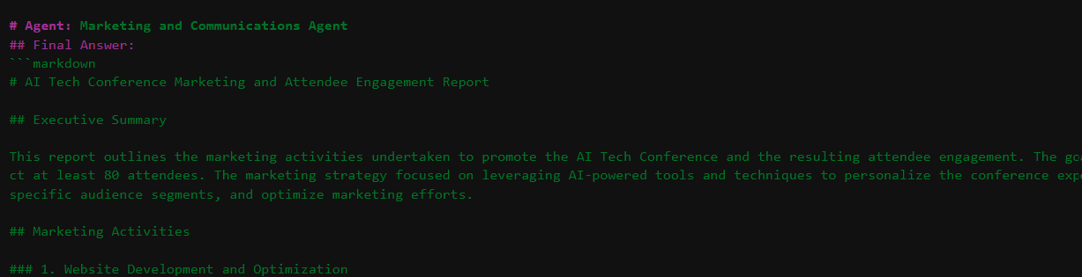

This can be used for ppt, email communications. Time spent on analysis tooks around 5 minutes. Could be nicer if add an UI using simple flask so that it can be an interface later.