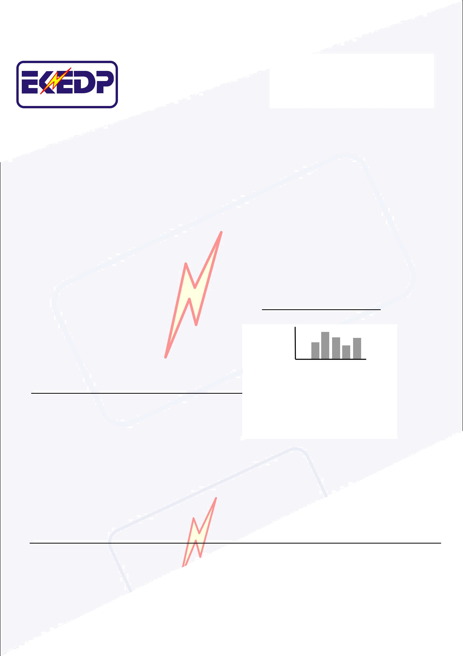 |  |  |  |  |  |  |  | Customers whose complaints are not satisfactorily addressed by
 |  |  | EKO ELECTRICITY DISTRIBUTION PLC |  |  |  |  | EKEDP may approach the Forum established for customer complaints
 |  |  |  |  |  |  |  | 61 Odunlami Street, Off Marina, Lagos.
 |  |  |  |  |  |  |  |  |  |  |  | KEY CUSTOMER GROUP
 | NERC ACCOUNT NO: |  | HEADQUARTERS OFFICE |  |  |  |  | Tel: 08106807261. Email: ekoforum@nercng.org
 |  |  |  |  |  |  |  |  |  |  |  | Account No: 01/24/90/2861-01
EKO ELECTRICITY DISTRIBUTION PLC^{24/25 MARINA, LAGOS} |  |  |  |  |  |  |  | EKEDP dedicated customer care lines: 0708 065 5555
 |  |  |  |  |  |  |  | Email: service.kcg@ekedp.com
 | NAME: |  | CHIEF OLU OKEOWO
 | NAME: |  |  |  |  | ELECTRICITY BILL FOR |  |  |  |  |  | February 2019
 | SERVICE ADD: |  | GBENGA ASHAFA ST 9 BY AJAYI BEMBE ST |  |  | THIS BILL IS FOR ENERGY USED IN |  |  |  |  |  |  | January 2019
 | EMAIL |  | IKOYI |  |  | YOUR BILL AMOUNT PAYABLE:
 | MOBILE |  |  |  |  | PAYMENT DUE DATE
 | Bill Distribution No: |  |  |  |  | AMOUNT AFTER DUE DATE
 | BOOK NO |  | 01/24/90
 |  |  | 01/24/90 |  |  |  |  | SNAPSHOT OF YOUR BILL AMOUNT
 | BILL NO: |  | 359 |  |  | CURRENT MONTH
 | BILL DATE
 | BILL DATE |  |  |  |  | NET PREVIOUS BALANCE
 | CYCLE NO: |  | 2
 | TARIFF CODE |  | R3 |  |  | VAT
 | SUPPLY TYPE |  | Residential LV Maximum Demand |  |  | TOTAL AMOUNT
 | CATEGORY |  | Residential Account
 | TARIFF RATE |  | 29:00
 | TARIFF RATE |  | 29:00 |  |  |  |  |  | UNIT CONSUMED
 | ADC |  | 561 23
 | OLD ACCOUNT NO |  |  |  |  | PRESENT KWH |  |  |  |  |  |  |  |  |  |  | C
 |  |  |  |  |  | PREVIOUS KWH |  |  |  |  |  |  |  |  |  |  | C
 | CALL [24/7] |  |  |  |  |  |  |  |  |  |  |  |  | PL
 | FIRE/ACCIDENT |  |  |  |  |  |  |  |  | UTION
 |  | 07080655555
 |  |  |  |  |  |  | DISTRIB30000
 | EKEDP IS HERE TO SERVE YOU BETTER SHOULD YOU ENCOUNTER ANY |  |  |  |  |  |  | Consumption Analyses
 | CHALLENGE PLEASE CONTACT |  |  |  |  |  | 50000
 | Phone: |  |  |  |  |  | 40000
 | EKEDP Email: | service.kcg@ekedp.com |  | ELECTRICITY |  |  | 20000
 | EKEDP Email: |  |  |  |  |  | 10000
 |  |  |  |  |  |  | 0 |  | FEBRUARY | JANUARY | DECEMBER | NOVEMBER | OCTOBER | SEPTEMBER
 |  |  | O
 |  |  | EK |  |  |  |  |  |  | Months

 |  |  |  | TIPS TO SAVE ELECTRICITY
EKEDPACCOUNT NO: 01/24/90/2851-01 |  |  |  | CUSTOMER NAME: CHIEF OLU OKEOWO
For payment by crossed cheque/DD to be drawn in favour of EKO ELECTRICITY DISTRIBUTION COMPANY PLC
All cheque(s) payable | .................................................................................................................................................
Cheque No:....................................... | Drawn No:.............................................................. |  |  | Date of Cheque.................................................. | C
Receipt subject to realization of cheque. |  |  |  |  | C
 |  |  |  | UTION | PL
 |  | DISTRIB
 | O | ELECTRICITY
 | EK

