**CHAPTER ONE**

**INTRODUCTION**

* 1. **BACKGROUND TO THE STUDY**

In today’s world, where information is at one’s fingertip and the internet is the answer to every question, the issue of online banking cannot be over emphasized. Online banking can be considered as the electronic solution to banking like (online transactions, data plans e.t.c) .

There is no definite definition for online banking as most of the definitions do not adequately convey the gravity of its problems and solutions . According to vaidya (2011) : “Mobile banking is a service provided by a bank or financial institutions that allows its customers to conduct financial transaction remotely using a mobile device such as a smart phone or tablet”. Unlike the related internet banking it uses software usually called an app, provided by the financial institution for the purpose. Mobile banking is usually available on a 24 hours basis, some financial institution have restrictions on which accounts may be accessed through mobile banking as well as a limit on the amount that can be transacted.

Mobile banking may include obtaining account balances and list of latest transactions, electronic bill payment and fund transfer between a customer’s or another’s account. Some app enable copies of statements to be downloaded and sometimes printed at the customer’s premises; and some banks charge a fee for mailing hardcopies of bank statements.

The easy accessibility to mobile banking reduced the cost of handling transaction by saving the need or stress for customers to visit a bank branch for non-cash withdrawal and deposit transactions. Mobile banking does not handle transactions involving cash, and a customer needs to visit an Atm or bank branch for cash withdrawals or deposits. Many apps now have a remote deposit option using the device’s camera to digitally transmit cheques to their financial institution. Several trends will drive this growth. First, more banks are rolling out mobile banking solutions, paralleling a move by major cellular carriers to upgrade their networks to deliver faster data speeds. At the same time, people are investing in more advanced, Web-ready phones and  personal digital assistant (PDAs), although we’ll see that even basic cell phones are perfectly capable of delivering mobile banking services. And, finally, awareness and consumer confidence are on the rise.

Mobile banking differs from mobile payment, which involves the use of a device to pay for goods or devices either at the point of sale or remotely analogously to use of a debit or credit card to effect an EFTPOS payment.

.

* 1. **PROBLEM STATEMENT**

This project would be futile if it does not address a problem in its intermediate surrounding. The usage of Online banking has been widely spread across the continent i.e. developed and most developing countries used in businesses, by schools (payment of school fees), eateries via POS e.t.c.

Also, the issues affecting mobile banking is quite challenging e.g. handset accessibility, security, scalability and reliability, application distribution, personalization e.t.c.

At present, there large number of different mobile phones device and it s a big challenge for banks to offer a mobile banking solution on any type of device, some of devices support java ME and others support SIM Application Toolkit, a WAP browser, or only SMS .

* 1. **AIM AND OBJECTIVES**

The main aim of this project is to find if mobile banking world would achieve superior customer experience with bi-directional communication. Among digital channels, mobile banking is clear IT investment priority in 2013 as retail attempt to capitalize on the features unique to mobile, such as location based services. Specifically, the objectives based functionality enrichment in mobile banking include:

1. Communication enrichment: video interaction with agents, advisors.
2. Pervasive transaction capabilities is comprehensive “mobile wallet”.
3. Customer education: “text drive” for devices of bank services.
4. Connect with new customer segment: connect with GenY- Gen Z using games and social network ambushed to surrogate bank’s offerings.
5. Content monetization: micro level revenue themes such as music, e-book download.
6. Vertical positioning: positioning offerings over mobile banking specific industries.
7. Horizontal positioning: positioning offerings over mobile banking across all the industries.
8. Build Brand: built the bank’s brand while enhancing the “mobile real estate”.
   1. **SIGNIFICANCE OF THE STUDY**

Mobile banking has become quite a common trend in our temporary world. All regions of the world where technology is notably progressing have swiftly accepted this development, that’s why nearly all banks have taken their services to the virtual world. To swiftly transact online, interactive software’s are a necessity. A well developed Banking Software helps you engage with a bank more directly, compared to your physical presence at the bank. It makes the banking process way much easy and conveniently fast. .

* 1. **SCOPE AND LIMITATION OF THE STUDY**

The proposed banking system project was analyzed for an easy banking in order to meet customer’s needs. Electronic banking was built as a segment for electronic business which in turn encompasses a type of business performed through electronic networks. Electronic channels are usesd for both business-business and business-customer’s transaction such as ordering goods, delivering software or paying for such transaction. E-banking is not a banking product, rather it describes the way transactions are conducted. There are forms of electronic banking like tele-banking, pc- banking, mobile banking and internet banking all these forms in its own use helps customers to be able to access their banks without having to be physically present at the banks branch .

* 1. **DEFINITION OF TERMS**

1. **Online banking:** A method of banking in which transactions are conducted electronically over the internet. “some customers have concerns about the security of online banking”
2. **Mobile banking:** It is a service provided by a bank or other financial institution that allows its customers to conduct financial transactions remotely using a mobile device such as smart phone or tablet.
3. **Electronic banking:** . also known as electronic funds transfer (EFT), is simply the use of electronic means to transfer funds directly from one account to another, rather than by check or cash. You can use electronic funds transfer to: have your paycheck deposited directly into your bank or credit union checking account.
4. **Tele - banking :**  is a service provided by a [bank](https://en.wikipedia.org/wiki/Bank) or other [financial institution](https://en.wikipedia.org/wiki/Financial_institution), that enables [customers](https://en.wikipedia.org/wiki/Customer) to perform over the [telephone](https://en.wikipedia.org/wiki/Telephone) a range of [financial transactions](https://en.wikipedia.org/wiki/Financial_transaction) which do not involve for cash or documents (such as [cheques](https://en.wikipedia.org/wiki/Cheques)), without the need to visit a [bank branch](https://en.wikipedia.org/wiki/Branch_(banking)) or [ATM](https://en.wikipedia.org/wiki/Automated_teller_machine).
5. **Pc banking:** A banking service that enables bankcustomers to access their account information and perform certain banktransactions using a personal computer and a modem..
6. **POS:** It is a point of sale purchase where a transaction is finalized or the moment where a customer tenders payment in exchange for goods and services. Any form of payment can be used, such as cash, debit cards, credit cards, mobile payments and even Bitcoin.
7. **EFTPOS payment:** Electronic funds transfer at point of sale (**EFTPOS** /ˈɛftpɒs/) is an electronic payment system involving electronic funds transfers based on the use of payment cards, such as debit or credit cards, at payment terminals located at points of sale.
   1. **ORGANIZATION OF THE REPORT**

This project which deals with a online/mobile banking system that checks for the security, similarity and differences between them which consists of five chapters which are summarized below:

Chapter one contains the background, problem statement, aim and objectives, significance, scope and limitations as related to this project work.

Chapter two further explains and reviews the different types of online and mobile banking and their differences.

Chapter three entails the system analysis and the design of the application and the programming language used for the design.

Chapter four presents the system implementation and the results of the application developed.

Chapter five finally gives a brief of the summary of the whole project work and conclusion which are gathered from the work.

**CHAPTER TWO**

**LITERATURE REVIEW**

**2.1** **Introduction**

With the extensive technology innovation and telecommunications, we have seen new financial distribution channels increasing rapidly both in numbers and form, from ATMs, telephone banking to PC banking (Easingwood & Storey, 1996), and Internet Banking is the latest in the series of technological wonders of the recent past (Mols, 1999). Following the boom of Internet, the Internet can no longer be considered a “fad” or the preserve of “techies” and “computer nerds”. Commercial uses of the Net have become the fastest growing part of the World Wide Web (WWW) (Hamid et al, 2007). About the same time, Internet Banking was thought to signal a revolution in banking distribution. Banks invested heavily in the development of the Internet channels (Accenture, 2005). Internet Banking has experienced explosive growth in many countries and has transformed traditional banking practice (Mols, 1999). Inevitability, Internet Banking will continue to revolutionize the current traditional banking industry and offers more opportunity to meet better consumer services through enhanced interaction, data mining and customization in the Internet Banking services (Hamid et al, 2007). Online banking was first introduced in the early 1980s (Kalakota and Whinston, 1997), in which consumers were provided with an application software program that operates on personal computer (PC) which can be 9 dialed into the bank via a modem, telephone line and operated the programs remotely on the consumer PC. However, the lack of Internet users, and costs associated with using online banking, stunted its growth. It was only in the late 1990s that Internet Banking really caught on as the Internet explosion had made consumers more comfortable with making transactions over the web. During dotcom fallout, it became apparent that Internet Banking was not the panacea banks had thought it to be. Between 2001 and 2004 Internet Banking investment growth experienced a significant slowdown. Nevertheless the customer base for Internet Banking was growing steadily from 2000 to 2005 (Accenture, 2005). Based on Forrester Research, Internet was the dominant channels besides the branch in 2007. See Figure 2.1

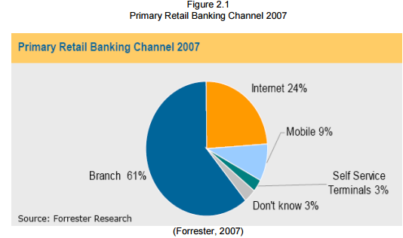

With respect to Internet Banking, a common confusion exists between the terms of online banking, Internet Banking as well as PC banking. The terms Internet Banking and online banking are often used in the literature to refer the same things. According to Hamid et al (2007), online banking is another 10 term used for Internet Banking. Both share the similar meaning. Internet Banking or online banking can be defined as the service that allows consumers to perform banking transactions using a computer with an Internet connection (Lloyd, 2007). Thulani et al (2009) refer Internet Banking as systems that enable bank customers to get access to their accounts and general information on bank products and services through the use of bank’s website, without the intervention or inconvenience of sending letters, faxes, original signatures and telephone confirmations. It is the types of services through which bank customers can request information and carry out most traditional retail banking services such as opening an account or transferring funds to different accounts, and new banking services, such as electronic online payments via a telecommunication network without leaving their homes or organizations (Aladwani, 2001; Daniel, 1999; Mols, 1998; Sathye, 1999). It provides universal connection from any location worldwide and is universally accessible from any Internet linked computer (Thulani et al, 2009; Perumal and Shanmugan, 2004; Bradley and Stewart, 2003 and Rotchanakitumnuai and Speece, 2003). At an advanced level, Internet Banking is called transactional online banking (Sathye, 1999). On the other hand, PC banking is defined as a home banking whereby consumers supplied with a financial software package on disks, allowing consumers to fill in details offline and then to send them into the bank over the bank’s private network. Unlike PC banking, Internet Banking or online banking does not require proprietary software or access to a private network (Hamid et al, 2007).

**2.2 Online Banking Transformation**

ISACA (Information Systems Audit and Control Association) recorded that more and more banks are transforming their businesses by using Internet technology to develop or expand relationships with their customers. The extent to which the Internet is used in a bank depends on the relative maturity of the bank in regard to Internet technology. Banks offer Internet Banking in two main ways. An existing bank with physical offices, ordinarily termed a brick-and-mortar bank, can establish a website and offer Internet Banking to its customers as an addition to its traditional delivery channels. An alternative is to establish either a virtual, branchless or Internet-only bank. The computer server or bank database that lies at the heart of a virtual bank may be housed in an office that serves as the legal address of such a bank or at some other location. Virtual banks provide customers with the ability to make deposits and withdrawals via automated teller machines (ATMs) or through other remote delivery channels owned by other institutions (www.isaca.org). Thulani et al (2009), Yibin (2003) and Diniz (1998) identify three functional types of Internet Banking that are currently employed in the market place i.e. Informational, Communicative and Transactional.

**2.2,1 Functional types of Online banking**

**2.2.1.1** Informational - This is the basic level of Internet Banking. Typically, the bank has marketing information about the bank's products and services on a stand-alone server.

**2.2.1.2** Communicative - This type of Internet Banking system allows some interaction between the bank's systems and the customer. The interaction may be limited to electronic mail, account inquiry, loan applications or static file updates (name and address changes).

**2.2.1.3** Transactional - This level of Internet Banking allows customers to directly execute transactions with financial implications. The basic transactional site only allows a transfer of funds between the accounts of one customer and the bank. The advanced transactional site provides a means for generating payments directly to third parties outside of the bank.

This can take thin a previous study, Durkin et al. (2007) examined the impact of the complexity related to the products offered by Internet banking service. They separated the offered products into three groups according to their complexity, as it was perceived by the interviewed individuals. The simple complexity level contains all the products that the certainty of the outcome was high among the users; the procedure is simple, consists few steps and it is easily understandable by the users. The next group (medium complexity) incorporates all the Internet banking attributes that were either confusing for the Internet banking users or their characterisation was controversial (some of the interviewed claimed that the feature was understandable, while others claimed the opposite). The last group of high complexity products contains these with low certainty of outcome, where the stages are varying and the product is difficult to understand the form of bill payments via a bank official check or electronic funds transfer/automated clearing house entries.

Internet Banking has been regarded as the most important way to reduce cost and maintain or enhance services for consumers (Hua, 2009). By offering Internet Banking services, traditional financial institutions seek to lower operational costs, improve consumer banking services, retain consumers and expand share of customer. Internet is the cheapest delivery channel for banking products as it allows the entity to reduce their branch networks and downsize the number of service staff. The navigability of the website is a very important part of Internet Banking because it can become one of the biggest competitive advantages of a financial entity (Ortega et al., 2007).

**2.3 Online banking accessibility**

Online Banking is a process of innovation whereby customers handle their own banking transactions without visiting bank tellers (Qureshi et al., 2008). Recent evidence suggests that an Internet-based consumer banking strategy may be effective, with reports of more profitable, loyal and committed consumers compared with traditional banking consumers (ABA, 2004; Fox, 2005). Thus, contemporary banks now regard the Internet channel as equally important to traditional channels of branches, automated teller machines (ATM), telephone banking and call centers (Gartner, 2003). In the new 13 banking environment, Internet Banking is increasingly managed as an operational activity and an important element of a multi-channel strategy (Black et al., 2002).

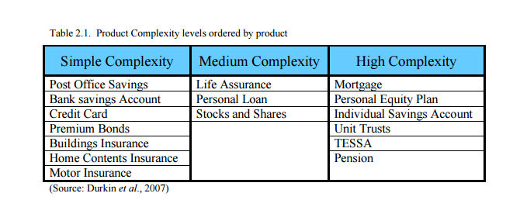Most commonly, relative studies categorise the factors influencing the adoption of Internet Banking application in whether they provide positive or negative attributes. However, some scholars (Jaruwachirathanakul and Fink, 2005) choose to distinguish the benefits caused by and the problems sourcing from Internet Banking via different perspective: the customer and provider perspective. In this study, it is obvious that customer is the bank’s client whereas the provider is the banking institution. The cause of this separation is that there is a clear differentiation on the benefits and problems that both sides deal with.

**2.4 Evolvement of Online banking**

Providers’ perspective Even though the banks worldwide have invested billions in developing Internet banking services, it was clear from the beginning that it could become a perfect substitute distribution channel (Sayar and Wolfe, 2007); there is still need for ATMs to withdraw cash and it is required to visit a bank branch to sign contracts and mortgages. Nevertheless, it is an intermediary that offers many actual, social and psychological advantages to the institution which has invested on Internet banking technology (Sayar and Wolfe, 2007). The most important factor that has led banks to turn to the particular distribution channel is the savings in transaction cost and maintenance, especially when it is compared to the traditional branch network (Shih and Fang, 2004). Cost saving is available because of the diminished transaction cost, reduction of paperwork, facilitation of transactions and human error avoidance (Tan and Teo, 2000; Gurau, 2002; Shih and Fang, 2004; Lymperopoulos et al., 2004; Pikkarainen et al., 2004). Moreover, with the construction of an appealing, effective and useful web site, banks are in position to attract prospect “Web-based” customers and existing Internet users (Rotchanakitumnuai and Speece, 2003) and retain their existing clientele (Sarel and Marmorstein, 2003) by offering alternative and more specialised services. Furthermore, the tense competitiveness in the banking market domestically and globally pulls banks into constant development and upgrade of their Internet Banking services in order to acquire innovation advantage (Lymperopoulos et al., 2004) and further promoting the competition in the market. Other adjacent effects of the usage of Internet Banking regarding banks’ perception are the minimisation of the queue inside the branches (Lymperopoulos et al., 2004), the enhancement of the bank’s image (Lymperopoulos et al., 2004) and an additional opportunity for crossselling. Even though the benefits of using Internet Banking are facilitating and indisputable, surveys conducted during the last period have indicated that the actual users of Internet Banking are still a tiny proportion of the aggregation of bank customers (Sarel and Marmorstein, 2003; Gerrard et al., 2006), excluding Scandinavian economies (Pikkarainen et al., 2004). The reasons will be analysed in the next paragraph of the study. In any case, it is profound that banking institutions should back up and promote the actual usage of Internet banking with different marketing techniques, such as advertisement and solicitation (Sarel and Marmorstein, 2003). Customers’ perspective It was mentioned before that Internet Banking as an alternative distribution channel compared to the other channels has been found to be less expensive for the institution. Actually, several surveys have discovered that Internet Banking is as well the most costless distribution channel regarding the customers’ point of view (Rotchanakitumnuai and Speece, 2003; Shih and Fang, 2004; Pikkarainen et al., 2004). Internet Banking is a convenient and effective application which allows any individual customer – retail or corporate – manage his / her accounts 24 hours a day, it is accessible from any location, as long there is access to Internet and the information provided is current and immediate without any intermediary situation needed (Tan and Teo, 2000). The fact that there is an increasing amount of bank customers who recourse to Internet Banking indicates the tendency to a more self – service mode because traditional branch banking demands more time and effort (Pikkarainen et al., 9 2004; Jaruwachirathanakul and Fink, 2005) and accommodates the procedures (DeYoung, 2007). On the other hand, a sounder question about the customers’ perception on Internet Banking would be: “What are the main factors that discourage individuals use and benefit from Internet Banking”? In the recent years, there is a wide bibliography which studied on the specific question. Gerrard et al. (2006) studied the barriers to the adoption of Internet banking from bank customers and concluded that the most important factors are: lack of trust in Internet and Internet transactions (also in Rotchanakitumnuai and Speece, 2003; Wang et al., 2003), no perceived need to. adopt Internet Banking (inertia) (also in Calisir and Gumussoy, 2008), lack of knowledge about the specific service, lack of experience (also in Rotchanakitumnuai and Speece, 2003), inaccessibility to Internet, pricing concerns (access to internet requires PC as well as appropriate software and hardware) (also in Rotchanakitumnuai and Speece, 2003), and IT fatigue (due to the every day contact with PC in work). Other studies indicate as dominant factors of Internet banking user acceptance the individual’s social influence, computer self–efficacy and demographic characteristics (Durkin and Howcroft, 2003) and awareness of Internet banking services and its benefits (AlSomali et al., 2008). Previous Studies In the past, Internet Banking has been the focus of numerous academic papers as provision to increase consumer Internet Banking demand. Adoption, perception and usage of Internet Banking by consumers are the popular topics heavily examined in Internet Banking literature. Several converging reference domains and theories suggest numerous potential influences on consumer adoption of Internet Banking, including theories of consumer behavior in mass media choice and use, gratification theories, innovation diffusion, technology acceptance, online consumer behavior, online service adoption, service switching costs and the adoption of Internet Banking. Lichtenstein and Williamson (2006) summarized the approaches in Table 2.4

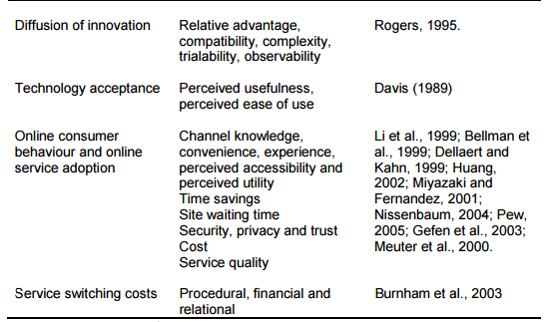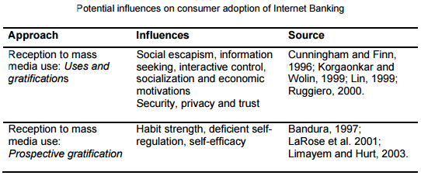

**2.5 Convenience of Online banking**

Complementing the above, Centeno (2004) argued that speed, the convenience of remote access, 7/24 availability and price incentives are the main motivation factors for the consumers to use Internet Banking. Guerrero et al. (2007) examined the usage of Internet Banking by Europeans and their results indicate that ownership of diverse financial products and services, attitude towards finances and trust in the Internet as a banking channel influence clients’ usage of Internet Banking. Durkin et al. (2008) made note on the simplicity of the products offered via Internet Banking facilitates the adoption of Internet Banking by consumers. While the adoption of Internet Banking by consumers is heavily researched there are researches on the supply side of Internet Banking. The Woolwich Bank case study conducted by Shah and Siddiqui (2006) reveals that understanding clients, organizational flexibility, availability of resources, While the adoption of Internet Banking by consumers is heavily researched there are researches on the supply side of Internet Banking. The Woolwich Bank case study conducted by Shah and Siddiqui (2006) reveals that understanding clients, organizational flexibility, availability of resources, systems security, established brand name, having multiple integrated channels, systems integration, systematic change management, support from top management, and good client services are the factors critical to success in Internet Banking. Howcroft et al. (2002) found that in order to be cost effective and successful in implementing Internet Banking, banks will need to provide value for money, error free, convenient and user-friendly services, Berger (2007) argues that a sound understanding of client is required for improvement of e-banking. Thus, all relevant information about the clients should be taken into account and a client-centric strategy should be developed. Confirming Berger (2007), Bontis and Fits-enz (2007) hypothesized customer capital as a driving force behind organizational performance. To sustain in long-term relationships, banking institutions have to embrace the concept of customer satisfaction. Sciglimpaglia and Ely (2002) suggested that banks are vulnerable to loss of customers to rivals with extensive online services. Customer account relationships are found to be predictive of electronic services use in general. And, interest in the use of specific online services is related to differing customer relationships. As supported by McMahon (1996), for banks to survive in the e-banking era, the retail banks will have to earn consumer loyalty through product features and services excellence. The satisfaction of customers is often associated with higher customer loyalty rates and increased economic returns that drive strategic business valuation (Anderson and Srinivasan, 2003). For successful delivery of financial services though Internet, Mols (1999) discovered that financial institutions have to satisfy a vast range of complex customers.

**CHAPTERTHREE  
METHODOLOGY**

No good software can be designed without first understanding the process intended for improvement. Thus, this chapter contains the analysis of current or existing system, the proposed system, data sources, Software development process, technologies applied, software development tools utilized, programming paradigm utilized, database, system requirement, user interaction – using use case diagram as well as the online banking application structural design.

**3.1 ANALYSIS OF EXISTING SYSTEM**

The investigation carried out shows that the current system of learning for autistic patients requires much supervision from their various financial institution. Most of them find it difficult mixing with others.

Furthermore, There are many factors influencing the adoption of online banking and it is important to take these factors into consideration when studying customer attitude and behavior towards online banking. technology. At present, many banks and financial institutions are actively developing new electronic banking products for their customers, throughout the world. Security is essential for the authentication and privacy. .

**3.2 THE PROPOSED SYSTEM**

The requirement for the new or proposed system is to allow learning with lesser supervision.This however will be achieved by implementing a reminder which can prompt the online banking application user to revise their library and memorize stored information. **(The Human Memory, 2017).**

One can divide the proposed system into the following modules:

**3.2.1** INPUT MODULE – using the students details to get information.

**3.2.2** OUTPUT MODULE – involves browsing through the other e-banking applications, categorizing information into named categories, favorites and archive.

**3.2.3** HELP MODULE – provides help in steps for the user to know just how to easily use the online banking application.

**3.2.4** SETTINGS MODULE – for configuring the online banking application to taste.

**3.3 DATA SOURCES**

Basically, the data collection scheme adopted in this research work is a secondary method. Data was gotten through:

1. Search Engines
   1. CORE Search Engine – [https://core.ac.uk](https://core.ac.uk/)
   2. Google Scholar – [https://scholar.google.com](https://scholar.google.com/)
   3. Google Search Engine – <https://www.google.com>
2. Journals
3. Articles
4. Text books
5. Websites

**3.4 SOFTWARE DEVELOPMENT PROCESS**

Software Development Process *or* Software Development Life Cycle (SDLC) is a process used by the software industry to design, develop and test high quality software. The SDLC aims to produce a high-quality software that meets or exceeds customer expectations, reaches completion within times and cost estimates. **(Tutorials Point, 2017)**

The SDLC consists of a detailed plan describing how to develop, maintain, replace and alter or enhance specific software. The life cycle defines a methodology for improving the quality of software and the overall development process.

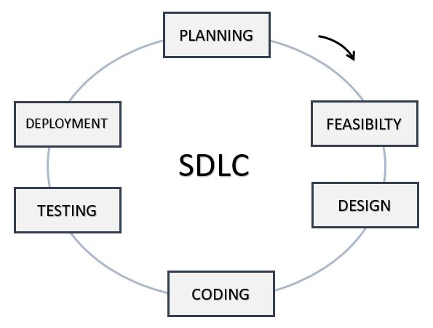**TYPICAL SOFTWARE DEVELOPMENT LIFE CYCLE STAGES**

**\*** The arrows depict the direction of stage steps.

***Fig 3.4.1*** *– Typical Software Development Life Cycle Stages*

STAGE 1 – PLANNING AND REQUIREMENT ANALYSIS

Requirement analysis is the most important and fundamental stage in SDLC. It involves gathering requirements for the project which may be FUNCTIONAL OR NON-FUNCTIONAL. Planning for the quality assurance requirements and identification of the risks associated with the project is also done in the planning stage.

STAGE 2 – FEASIBILITY STUDIES

Feasibility study involves evaluating the workability of the software product. Once the feasibility studies are done the next step is to clearly define and document the product requirements and get them approved from the customer or the market analysts. This is done through an **SRS (Software Requirement Specification)** document which consists of all the product requirements to be designed and developed during the project life cycle.

STAGE 3 – DESIGNING OF SOFTWARE PRODUCT ARCHITECTURE

SRS is the reference for product architects to come out with the best architecture for the product to be developed.

STAGE 4 – CODING OR DEVELOPMENT OF THE SOFTWARE

In this stage of SDLC the actual implementation or development starts and the product is built. The programming code is generated by following the **SRS** document during this stage. If the design is performed in a detailed and organized manner, code generation will be accomplished without much hassle.

STAGE 5 – TESTING THE PRODUCT

Testing activities are mostly involved in all the stages of SDLC. However, this stage refers to the testing only stage of the product where product defects are reported, tracked, fixed and retested, until the product reaches the quality standards defined in the SRS.

STAGE 6 – DEPLOYMENT IN MARKET AND MAINTENANCE

Once the product is tested and ready to be deployed it is released formally in the appropriate market. The product may first be released in a limited segment and tested in the real business environment (UAT – User acceptance testing).

Then based on the feedback, the product may be released as it is or with suggested enhancements in the targeting market segment. After the product is released in the market, its maintenance is done for the existing customer base.

**3.4.1 Software Development Life Cycle Model Utilized**

There are many types of SDLC Models for example:

* Waterfall Model
* Iterative Model
* Spiral Model
* V-Model
* Big Bang Model
* Agile
* RAD (Rapid Application Development)
* Prototyping

The **PROTOTYPING MODEL** is utilized or employed in this project as it allows one to develop or build a working model with limited functionalities called a **PROTOTYPE.** The prototype does not always hold the exact logic used in the actual software application and is an extra effort to be considered under effort estimation. **(Tutorials Point, 2017)**

**3.4.2 The need for Prototyping Model**

1. It enables to understand customer requirements at an early stage of development.
2. It helps get valuable feedback from the customer and helps software designers and developers understand about what exactly is expected from the product under development.
3. Allows the users evaluate developer proposals and try them out before implementation.
4. It also helps understand the requirements which are user specific and may not have been considered by the developer during product design.
5. Allows increased user involvement in the product even before its implementation.
6. Since a working model of the system is displayed, the users gets a better understanding of the system being developed.
7. Reduces time and cost as the defects can be detected much earlier.
8. Quicker user feedback is available leading to better solutions.
9. Missing functionality can be identified easily and quickly.
10. Confusing or difficult functions can be identified.

**3.5 TECHNOLOGIES APPLIED**

To achieve the purpose of this project **(**i.e. creating a mobile application that will serve as a *means of learning* **OR** *a learning tool* for anybody suffering from autism or autistic related challenges through memorization**),** the following technologies will be utilized:

1. **Php**
2. **Web Development Technologies (HTML5, CSS3 and JavaScript)**
3. **Xampp**
4. **Sulime text**

**3.5.1 Php**

PHP is a recursive acronym for "PHP: Hypertext Preprocessor". It is a server side scripting language that is embedded in HTML. It is used to manage dynamic content, databases, session tracking, even build entire e-commerce sites. It is integrated with a number of popular databases, including MySQL, PostgreSQL, Oracle, Sybase, Informix, and Microsoft SQL Server. It is pleasingly zippy in its execution, especially when compiled as an Apache module on the Unix side. The MySQL server, once started, executes even very complex queries with huge result sets in record-setting time. Also it supports a large number of major protocols such as POP3, IMAP, and LDAP. PHP4 added support for Java and distributed object architectures (COM and CORBA), making n-tier development a possibility for the first time.

**3.5.2 Web Development Technologies (HTML5, CSS3 and JavaScript)**

As mentioned above that web technologies such as HTML5, CSS3 and JavaScript are utilized by Adobe PhoneGap to create mobile applications that are platform dependent, these web technologies will be used as the fundamental programming languages for this project. No matter what function or even user interface design is to be done, with the use of these web technologies, they can be implemented.

**HTML5 and CSS3:** These 2 will be used to define the user interface structure of the mobile application similar to how they are famously used to design the user interface of websites.

**JavaScript:** This scripting language will be the main programming language that will be used to write the mobile application functions (that is the actions and reactions) of the mobile application to be developed. It provides many programming options such as variables, functions, arrays, events, objects etc.

**Xampp**  is a [free and open source](https://en.wikipedia.org/wiki/Free_software) [cross-platform](https://en.wikipedia.org/wiki/Cross-platform) [web server](https://en.wikipedia.org/wiki/Web_server) [solution stack](https://en.wikipedia.org/wiki/Solution_stack) package developed by Apache Friends,[[2]](https://en.wikipedia.org/wiki/XAMPP#cite_note-kaiseidlerinterview-2) consisting mainly of the [Apache HTTP Server](https://en.wikipedia.org/wiki/Apache_HTTP_Server), [MariaDB](https://en.wikipedia.org/wiki/MariaDB) [database](https://en.wikipedia.org/wiki/Database), and [interpreters](https://en.wikipedia.org/wiki/Interpreter_(computing)) for scripts written in the [PHP](https://en.wikipedia.org/wiki/PHP) and [Perl](https://en.wikipedia.org/wiki/Perl) [programming languages](https://en.wikipedia.org/wiki/Programming_language).[[3]](https://en.wikipedia.org/wiki/XAMPP#cite_note-x_mariadb-3)[[4]](https://en.wikipedia.org/wiki/XAMPP#cite_note-4) XAMPP stands for Cross-Platform (X), Apache (A), MariaDB (M), PHP (P) and Perl (P). It is a simple, lightweight Apache distribution that makes it extremely easy for developers to create a local web server for testing and deployment purposes. Everything needed to set up a web server – server application (Apache), database (MariaDB), and scripting language (PHP) – is included in an extractable file. XAMPP is also cross-platform, which means it works equally well on Linux, Mac and Windows. Since most actual web server deployments use the same components as XAMPP, it makes transitioning from a local test server to a live server extremely easy as well.

**Sublime text**s a [proprietary](https://en.wikipedia.org/wiki/Proprietary_software) [cross-platform](https://en.wikipedia.org/wiki/Cross-platform) [source code editor](https://en.wikipedia.org/wiki/Source_code_editor) with a [Python](https://en.wikipedia.org/wiki/Python_(programming_language)) [application programming interface](https://en.wikipedia.org/wiki/Application_programming_interface) (API). It natively supports many [programming languages](https://en.wikipedia.org/wiki/Programming_languages) and [markup languages](https://en.wikipedia.org/wiki/Markup_languages), and functions can be added by users with [plugins](https://en.wikipedia.org/wiki/Plugins), typically community-built and maintained under [free-software licenses](https://en.wikipedia.org/wiki/Free_software_licenses).

**3.6 SOFTWARE DEVELOPMENT TOOLS UTILIZED**

A **software development tool** or **programming tool** is a computer program that software developers use to create, debug, maintain, or otherwise support other programs and applications. The term usually refers to relatively simple programs, that can be combined together to accomplish a task.

The most basic tools are a *source code editor and a compiler or interpreter*, which are used ubiquitously and continuously. Other examples of software tools include *debugger, profiler, Integrated Development Environment* (IDE) etc.

The following software development tools are utilized in the development and implementation of the mobile application:

1. **Sublime Text 3 –** as source code editor.
2. **Firefox browser –** as web browser to view and debug the User interface (UI) and navigation of code written before compilation.
3. **Command Line (CMD) –** to perform some tasks such as addition of plugins into the PhoneGap or Cordova project.

**3.7 PROGRAMMING PARADIGM UTILIZED**

JavaScript (JS) is the major programming language used to build the software application. JS is known to be a multi-paradigm programming language as it supports several programming paradigms or styles like *structured programming, functional programming and even a prototype-based (Object Oriented Programming).*

However, FUNCTIONAL PRGRAMMING is the programming paradigm used in the implementation of the online banking application.

**3.8 DATABASE**

A database is a collection of information that is organized so that it can be easily accessed, managed and updated.

Data is organized into rows, columns and tables, and it is indexed to make it easier to find relevant information. Data gets inserted, updated and deleted as new information is added.

**3.9 SYSTEM REQUIREMENTS**

System requirements is a term that refers to important features or components required by the system to function properly. The requirements of the built mobile application are

1. **Available browser updates**
2. **Standard Pc**
3. **Cable**

**3.10 USER INTERFACE DESIGN**

User interface design or user interface engineering is the design of computers, appliances, machines, mobile communication devices, software applications, and websites with the focus on the user's experience and interaction. Where traditional graphic design seeks to make the object or application physically attractive, the goal of user interface design is to make the user's interaction as simple and efficient as possible, in terms of accomplishing user goals—what is often called user centered design. Where good graphic/industrial design is bold and eye catching, good user interface design is to facilitate finishing the task at hand over drawing attention to itself .Graphic design may be utilized to apply a theme or style to the interface without compromising its usability.The design process of an interface must balance the meaning of its visual elements that conform the mental model of operation, and the functionality from a technical engineering perspective, in order to create a system that is both usable and easy to adapt to the changing user needs. In order to provide user-friendly and an intuition interface, several standards will be maintained in the areas of screen navigation, data-entry procedures and button activation

**USE CASE DIAGRAM DEPICTING POSSIBLE USER INTERACTIONS**

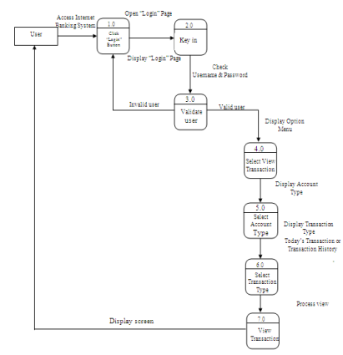

**\*** The arrows depict the direction of interaction.

***Fig 3.10.1*** *–* *Use case depicting possible User Interactions*

**CHAPTERFOUR  
IMPLEMENTATION AND RESULTS**

This chapter describes the design process employed in developing the mobile application. It specifies work done in each software development process stage with emphasis on CODING OR IMPLEMENTATION STAGE and THE TESTING STAGE. Results of the mobile application in form of images are also provided and finally the response of people in form of testers.

**4.1 PLANNING STAGE**

In this stage, the problem of learning for autistic patients is identified and research is made on how to assist or help them with learning. The scope of this project then is to develop a mobile application that can be used for learning through memorization for autistic patients and people who need it.

The search for information on the problem and how to help made up whole of this stage and this information was gotten through the use of search engines, journals, articles and textbooks.

**4.2 FEASIBILITY STUDIES**

After the identification of how to help with learning that is creating a mobile application which is handy, the possibility of successfully developing such a mobile application is estimated and the requirements where properly identified and documented.

**4.3 DESIGNING STAGE**

The mobile application is then designed in such a way as to provide a solution to the problem being tackled. The design involves listing functions to implement and how best to request and present information on the application (UI).

**4.4 CODING OR IMPLEMENTATION STAGE**

Cross development platform, Web Technologies (HTML5, CSS3 and JavaScript) alongside a is used in the implementation of the mobile application.

**4.5 THE MOBILE APPLICATION PAGES**

1. **The Main Pages:** these are pages which are directly accessible to the user.
2. **The Other Pages:** are pages which are not directly accessible to the user.
3. **The Processing Pages:** are pages that performs quick processing and they only alert the user of the success of the process they are to perform.

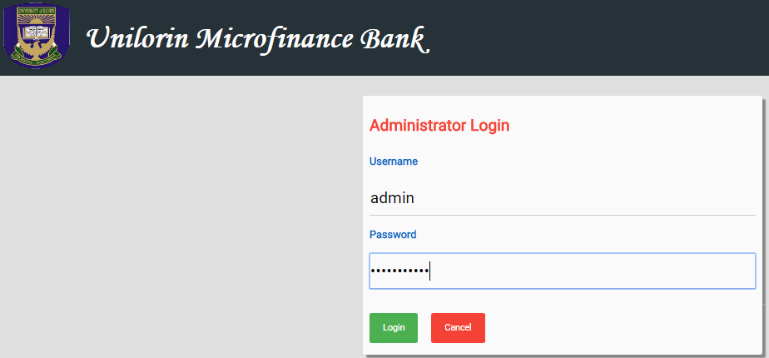  ***Fig 4.5.1*** *– The Admin Login Page Image*

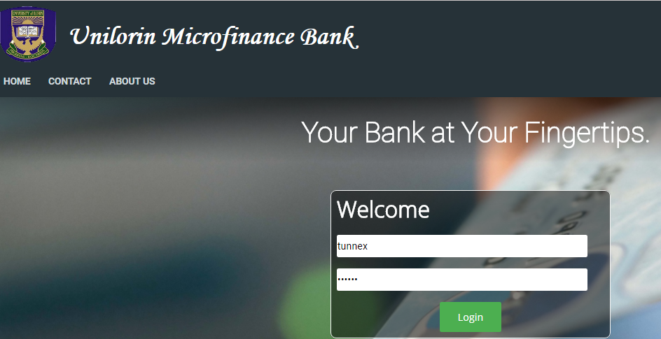

***Fig 4.5.2*** *– The User Login Page Image*

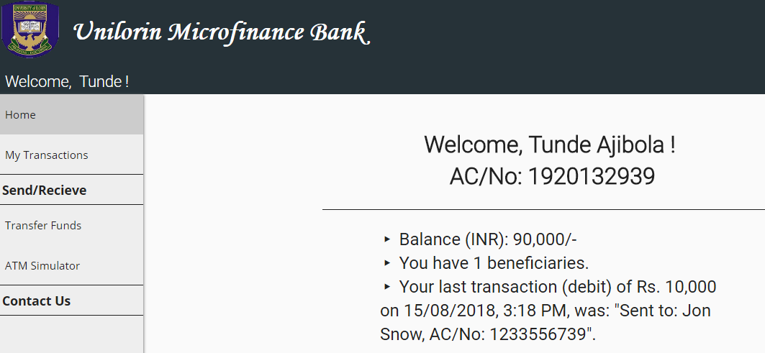 ***Fig 4.5.3*** *– The User Welcome Page Image*

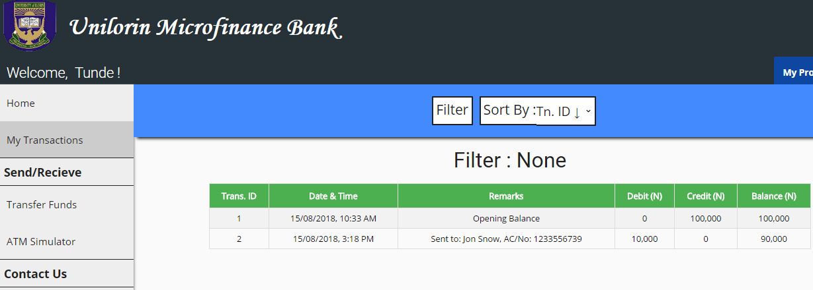 ***Fig 4.5.4*** *– The User Transaction History Page Image*

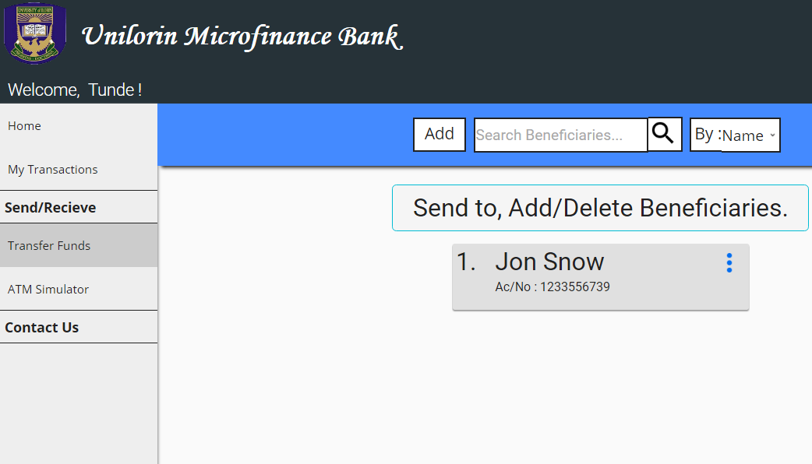

***Fig 4.5.5*** *– The User Transfer Page Image*

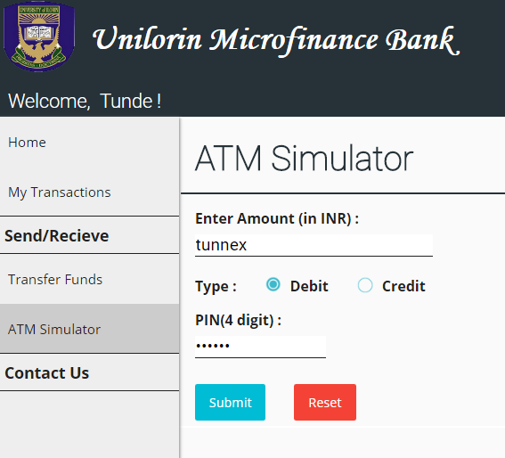

***Fig 4.5.6*** *– The User ATM Simulator Page Image*

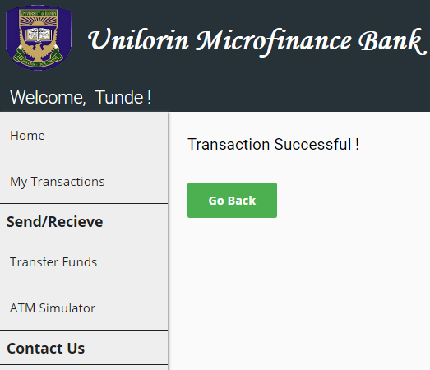

***Fig 4.5.7*** *– The User Transaction Result Page Image*

**The Admin Login page:** In this page it entails the adminstrator’s login details page in which after all its details have been filled it can view all transactions going on and off.

The User Login Page: in this page it entails the user or customer’s login page requirements before he or she can start any transaction.

The User Welcome Page: in this page it comprises of the user’s account balance, no of beneficiaries he has and also its last transaction.

The User Transaction History Page: in this page it entails the user’s balance, no of transactions that has been transacted both Credit, Debit and Transfers.

The User Transfer Page: in this page it comprises of options if you want to add more beneficiaries e.g by their name, whether you still want to make another transfer or delete his or her beneficiary, no of beneficiaries you have had transferred to.

The User ATM Stimulator Page: In this page it entails the amount of money and the card detail either a credit or debit and lastly the user’s pin.

The User Transaction Result Page: In this pae it only shows the outcome of the recent transaction just made whether it’s a success or failure as it shows on image 4.5.1.7 the transaction was successful.

**CHAPTERFIVE  
CONCLUSION AND RECOMMENDATIONS**

**5.1 CONCLUSION**

This aim of this project is to create an internet banking prototype for unilorin microfinance bank, the need of technology based services and acceptance among student in the competitive environment and IT era, in other to increase the speed of rendering service set it apart from other microfinance’s banks. Customers prefer e-channels because of time and cost utility and it is a efficient service to students and lecturers and non lecturers. The future outlook of this e- delivery prototype channel is get bright, and need to only to change the mind set of vision

It also evaluates some related works such as ISACA (ISACA (Information Systems Audit and Control Association) and methodology fully documented.

Finally, the implementation of the online banking application developed, application interface provided through screenshots and the results of testing (both developer and user testers) are inserted.

**\5.2 RECOMMENDATIONS**

There are more functionalities that can be implemented to improve the application usage. Such functionalities should be added.

The fully built application can be published on the mobile market such as Google Play Store so that it can be easily available to people all around the country.

All suggestions made by user testers should also be evaluated and proper corrections should be made such as debugging.