Manual Cleansing of Windows 11

By rukoblood, 2024

1. Introduction
2. Cope-ilot
3. Recall
4. Standart Bloatware
5. ???

Introduction

As you know, windows 11 is bloated. And there is a shit ton of programs, that removes all bloatware, telemetry, ai slop, spying, etc. But I don’t trust him. These apps doing some weird stuff and removes a lot of software, making windows 11 half usable OS.

So, in this manifest I will show, how to manually clean windows 11, instead of running some weird ps1 scripts.

Cope-Ilot

Microsoft Copilot (I like to call it COPE-ilot, or Cope-a-lot) is a local AI By Microsoft, that integrated in windows 11 (If you got NPU chips (RIP, for that price you can get a gaming laptop with good gpu, that runs AI even better) it runs locally). Nobody uses it, because ChatGPT exists (Or if you are Russian like me, copilot just not available).

So, there is a easy way to kill it.

1. In taskbar settings disable this stuff.
2. Windows + R, then type gpedit.msc
3. Navigate to User Configuration > Administrative Templates > Windows Components > Windows Copilot.
4. Enable “Turn off Windows Copilot”
5. Restart PC.
6. Gone!

P.S: It also works for Windows 10.

Recall

Piece of useless AI-ware, that eats a lot of space and literally spies on you. Good enough for non-npu CPUs, it works only on AI Chips But it still installs. So here we are going to “Recall Recall”. You can only have recall in 24H2 windows (I have 23H2, kinda best version).

1. Check if you have recall.  
   Run Terminal as admin.  
   Type: Dism /Online /Get-Featureinfo /Featurename:Recall  
   If your PC does not have a recall, then you see this, and that’s good.

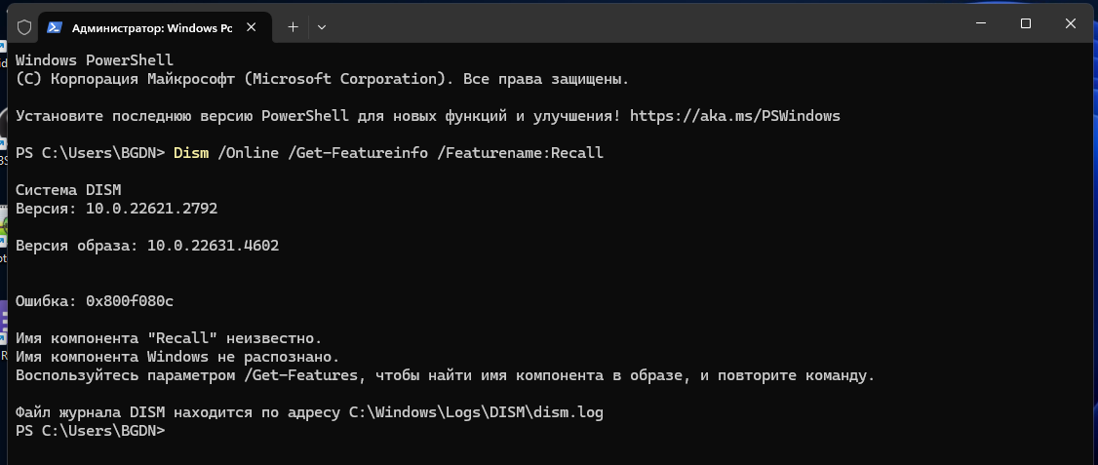

1. If you have a recall  
   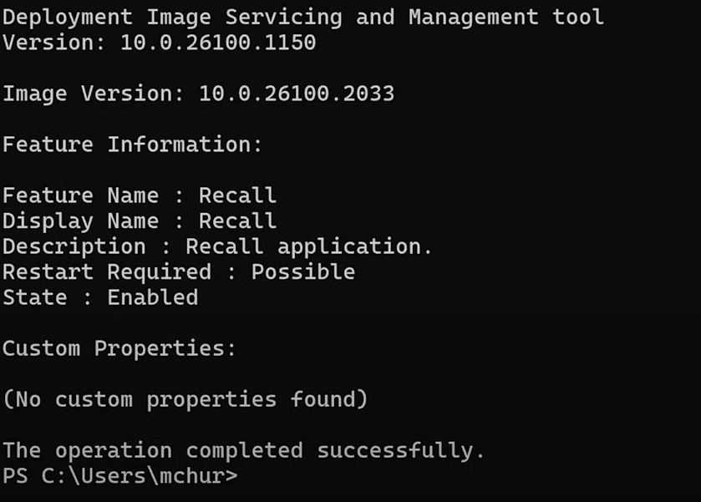

Then do this:

Type: Dism /Online /Disable-Feature /Featurename:Recall

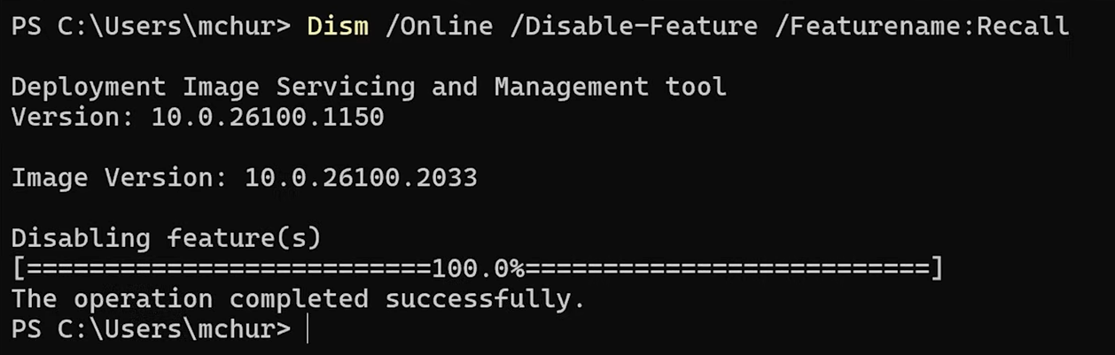

Voila, Gone!

1. Disable Leftovers.

Navigate to User Configuration > Administrative Templates > Windows Components > Windows AI.

Enable “Turn off Saving Snapshots for Windows”.

Standart Bloatware.

The most simple way to remove bloatware is to uninstall some apps.

Just go to Settings, then Apps, then installed apps, then uninstall all of useless sfuff.

Some apps:

* Preinstalled office, outlook, and other pseudooffice. Then you can download LibreOffice or Cracked Office LTSC
* Feedback center stuff  
  
* Movies And TV. Just use Mediaplayer lol.  
  (Fuck I forgot to screenshot)
* People.



* Outlook (new) (Not necessary, bou if you have outlook account, then you can delete)
* Microsoft To Do

???

About telemetry and spying: that’s all cope. If Microsoft collects data,it collects only for future updates. Also This Telemetry doesn’t eat a lot of ram. It all allocated by windows processes, drivers, etc. If you have a slow pc, then get a new pc. All of that extra shutup10 and tweakers only made for UltraCrapPC with Celeron, where everything lags system. Only useless parts are copilot, recall, and some ms-trash.

Source list:

How to remove Copilot: <https://www.reddit.com/r/WindowsHelp/comments/1c1k1o9/disable_windows_copilot_ai_windows_10_and_11/>

How to remove Recall: <https://youtu.be/M5p0a4-fnsM>