**Topics: Descriptive Statistics and Probability**

1. Look at the data given below. Plot the data, find the outliers and find out $μ, σ, σ^{2}$

|  |  |
| --- | --- |
| **Name of company** | **Measure X** |
| Allied Signal | 24.23% |
| Bankers Trust | 25.53% |
| General Mills | 25.41% |
| ITT Industries | 24.14% |
| J.P.Morgan& Co. | 29.62% |
| Lehman Brothers | 28.25% |
| Marriott | 25.81% |
| MCI | 24.39% |
| Merrill Lynch | 40.26% |
| Microsoft | 32.95% |
| Morgan Stanley | 91.36% |
| Sun Microsystems | 25.99% |
| Travelers | 39.42% |
| US Airways | 26.71% |
| Warner-Lambert | 35.00% |

*Solution:*

* *Plotting the data:*

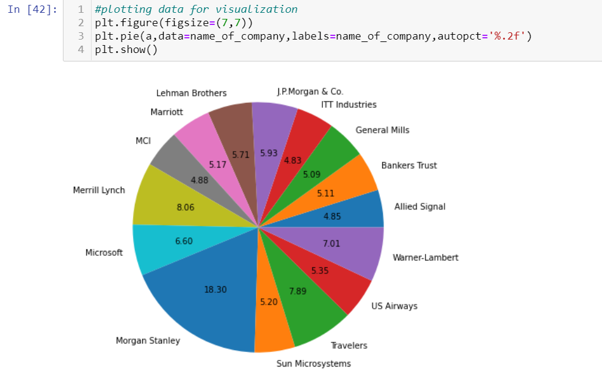

* *Box plot for finding outliers:*

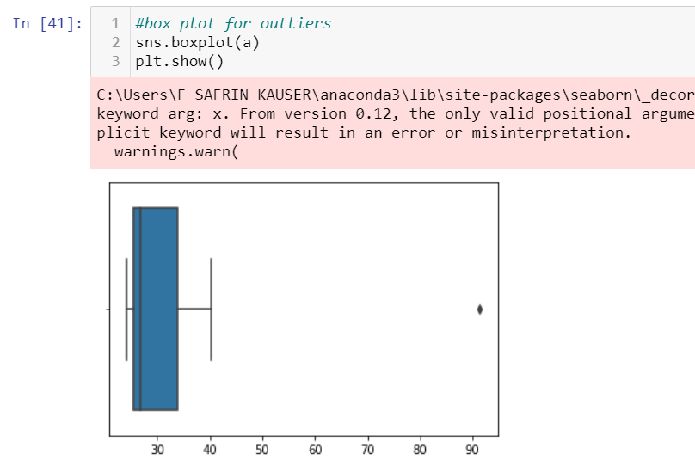

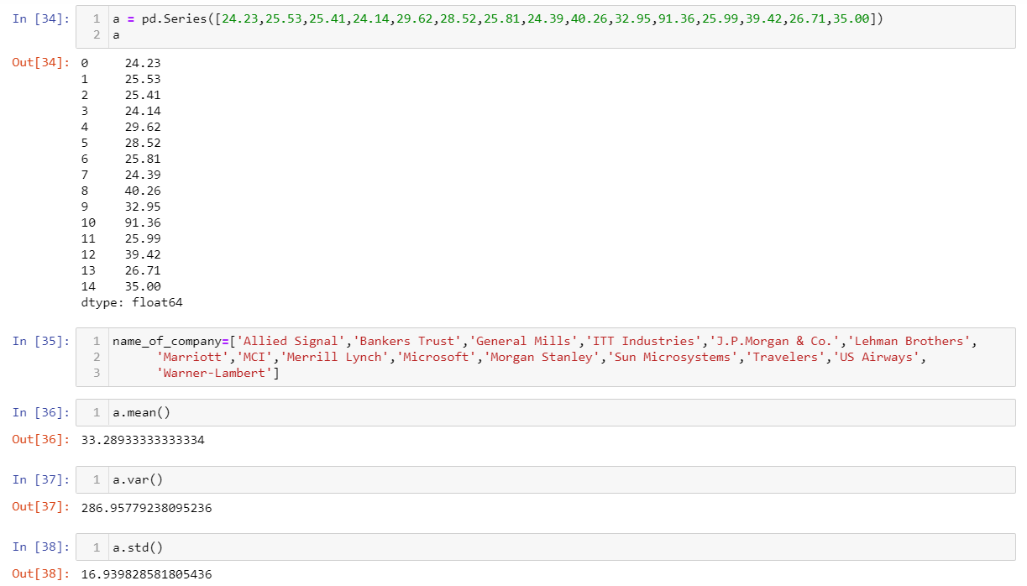



Answer the following three questions based on the box-plot above.

1. What is inter-quartile range of this dataset? (please approximate the numbers) In one line, explain what this value implies.

*Ans: Inter-quartile range of this dataset is Q3=12, Q1=5. So, Q3-Q1 = 7*

1. What can we say about the skewness of this dataset?

*Ans: As most of the data lies right side of median, this is negative skewness*

1. If it was found that the data point with the value 25 is actually 2.5, how would the new box-plot be affected?

*Ans: The outlier at 25 is high outlier, if the outlier is at 2.5, it would be low outlier.*



Answer the following three questions based on the histogram above.

1. Where would the mode of this dataset lie?

*The mode lies between 4 to 8 in the values of ‘Y’*

1. Comment on the skewness of the dataset.

*It* *is left skewness*

1. Suppose that the above histogram and the box-plot in question 2 are plotted for the same dataset. Explain how these graphs complement each other in providing information about any dataset.

*The box plot of Question 2 cannot be differentiated with any statistics with histogram plot of Question 3.*

1. AT&T was running commercials in 1990 aimed at luring back customers who had switched to one of the other long-distance phone service providers. One such commercial shows a businessman trying to reach Phoenix and mistakenly getting Fiji, where a half-naked native on a beach responds incomprehensibly in Polynesian. When asked about this advertisement, AT&T admitted that the portrayed incident did not actually take place but added that this was an enactment of something that “could happen.” Suppose that one in 200 long-distance telephone calls is misdirected. What is the probability that at least one in five attempted telephone calls reaches the wrong number? (Assume independence of attempts.)

*1/200 * 5 = 0.025*

1. Returns on a certain business venture, to the nearest $1,000, are known to follow the following probability distribution

|  |  |
| --- | --- |
| x | P(x) |
| -2,000 | 0.1 |
| -1,000 | 0.1 |
| 0 | 0.2 |
| 1000 | 0.2 |
| 2000 | 0.3 |
| 3000 | 0.1 |

1. What is the most likely monetary outcome of the business venture?

*The returns of $2000 providing the highest probability of 0.3.*

1. Is the venture likely to be successful? Explain

*The positive return’s probability 0.2+0.3+0.1 = 0.6 is probably successful.*

1. What is the long-term average earning of business ventures of this kind? Explain

*0.1(-2000)+0.1(-1000)+0.2(0)+0.2(1000)+0.3(2000)+0.1(3000) = 800*

1. What is the good measure of the risk involved in a venture of this kind? Compute this measure

*The good measure of risk can be calculated by standard deviation and its value is 1707.*