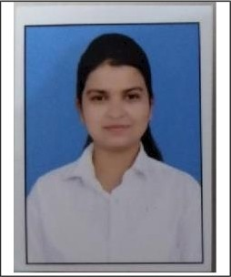

Rukshar Ahmad

22/32 Tashkand Marg, Civil lines,Allahabad 21100l,

Uttar Pradesh

9026603977

D.O.B- 25TH June,1999

ahmadrukshar321@gmail.com

## Objective:

Looking for an opportunity to secure the position of a Teacher in an organization that will give me an opportunity to give my knowledge to the students in an inventive way.

## Profile:

* Currently pursuing BCA from University of Allahabad (Main Campus).
* Always known for the leadership quality and the spirit to learn new things.
* 3 years’ experience of teaching ICSE & CBSE board students from nursery to class 8 as a private tutor.

## Education:

* Bachelor of Computer Application (B.C A) from Institute of Professional Studies, University of Allahabad (Main Campus) batch 2018-2021.
* Intermediate from Girl’s High School & College, Allahabad (1.S.C) in 2018 with 54%.
* High School from Girl’s High School & College, Allahabad (I.C.S.E) in 2016 with 79%.

## Skills:

* Ability to work with children of different amplitude and skills.
* Excellent communication skills and ability to mix with children effortlessly.
* Ability to create an effective teaching method for children.
* Ability to handle the behaviour of children.

## Achievements & Extracurricular:

* Certified for participating in Machine Learning Workshop, WAC 2019 at HIT Allahabad.
* Certified for training in Core Java training at Intern-Shala Trainings (Scored 92% in theoretical paper & 98% in practical.
* Certified for training in Java, C & web development Tutorial course at Solo learn.

## Subject interested in:

* Computer science
* Mathematics
* History & Geography
* Englis

# Declaration:

I hereby declare that the above information is correct to the best of my knowledge and belief.

Place: Allahabad. Date: 19th July,2021 .

(Rukshar Ahmad)