Code File Structure :
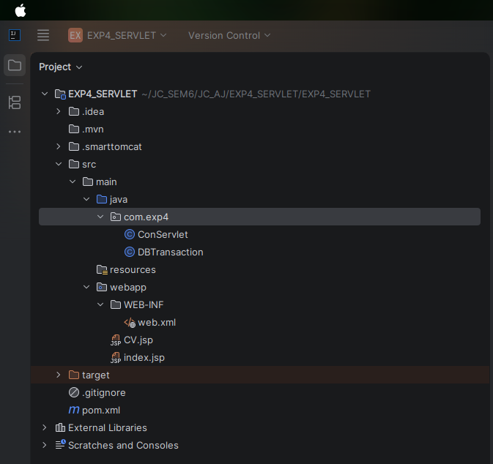
ConServlet.java :
package com.exp4;
import java.io.*;
import jakarta.servlet.*;
import jakarta.servlet.http.*;
public class ConServlet extends HttpServlet {
protected void doPost(HttpServletRequest request, HttpServletResponse response)
throws ServletException, IOException {
// Get form data String name = request.getParameter("name");
String email = request.getParameter("email");
String phone = request.getParameter("phone");
String address = request.getParameter("address");
String gender = request.getParameter("gender");
String qualification = request.getParameter("qualification");
// Handle multiple checkbox values (skills) String[] skillsArray = request.getParameterValues("skills");
String skills = "";
if (skillsArray != null) {
skills = String.join(",", skillsArray);
}
// Using ServletContext (as required) ServletContext context = getServletContext();
// Create DB object DBTransaction db = new DBTransaction();
// Insert data into database db.InsertData(name, email, phone, address, gender, qualification, skills);
// Response response.setContentType("text/html");
PrintWriter out = response.getWriter();
out.println("<h2>Data Inserted Successfully!</h2>");
}
}

DBTransaction.java :

package com.exp4;
import java.sql.*;
import java.sql.*;
public class DBTransaction {
// Method to get DB connection public Connection getConnection() {
Connection con = null;
try {
Class.forName("com.mysql.cj.jdbc.Driver");
con = DriverManager.getConnection(
"jdbc:mysql://localhost:3306/cv",
"jc",
"Jc@25302022" );
} catch (Exception e) {
e.printStackTrace();
}
return con;
}
// Method to insert data public void InsertData(String name, String email, String phone,
String address, String gender,
String qualification, String skills) {
try {
Connection con = getConnection();
String query = "INSERT INTO cv_data(name, email, phone, address, gender, qualification, skills) VALUES (?, ?, ?, ?, ?, ?, ?)";
PreparedStatement ps = con.prepareStatement(query);
ps.setString(1, name);
ps.setString(2, email);
ps.setString(3, phone);
ps.setString(4, address);
ps.setString(5, gender);
ps.setString(6, qualification);
ps.setString(7, skills);
ps.executeUpdate();
con.close();
} catch (Exception e) {
e.printStackTrace();
}
}
}

Web.xml :

<!DOCTYPE web-app PUBLIC "-//Sun Microsystems, Inc.//DTD Web Application 2.3//EN" "http://java.sun.com/dtd/web-app_2_3.dtd" ><web-app> <servlet> <servlet-name>ConServlet</servlet-name> <servlet-class>com.exp4.ConServlet</servlet-class> </servlet> <servlet-mapping> <servlet-name>ConServlet</servlet-name> <url-pattern>/ConServlet</url-pattern> </servlet-mapping></web-app>

CV.jsp :
<html>
<head> <title>CV Form</title></head>
<body>
<h2>Enter Your Details</h2>
<form action="ConServlet" method="post">
Name:
<input type="text" name="name" required>
<br><br> Email:
<input type="email" name="email" required>
<br><br>
Phone:
<input type="text" name="phone" required>
<br><br> Address: <textarea name="address" required>
</textarea>
<br><br> Gender:
<input type="radio" name="gender" value="Male"> Male
<input type="radio" name="gender" value="Female"> Female
<br><br> Qualification:
<select name="qualification">
<option value="BSc">BSc</option>
<option value="BCA">BCA</option>
<option value="BTech">BTech</option>
<option value="MCA">MCA</option>
</select>
<br><br> Skills:
<input type="checkbox" name="skills" value="Java"> Java
<input type="checkbox" name="skills" value="Python"> Python
<input type="checkbox" name="skills" value="Web"> Web
<br><br>
<input type="submit" value="Submit">
</form>
</body>
</html>

Index.jsp :

<html>
<body>
<h2>Welcome</h2>
<a href="CV.jsp">Go to CV Form</a>
</body></html>

Index.jsp output:
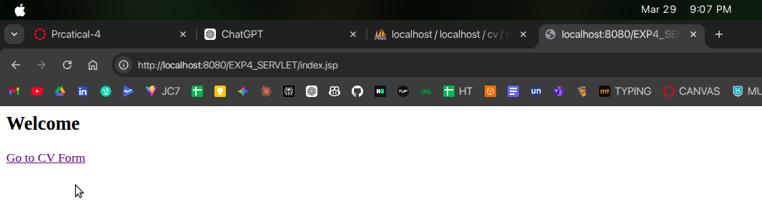

CV.jsp output :
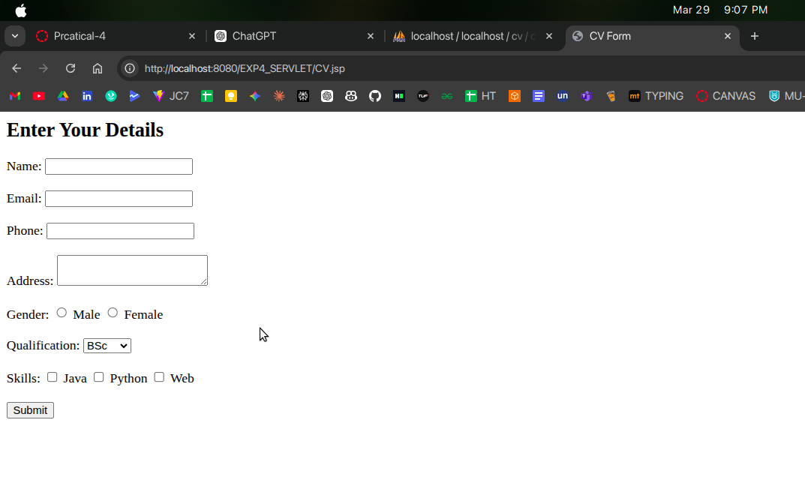
After form submission Db output :