**SYNTHESIS AND CHARACTERIZATION OF OXIDATIVELY DEGRADABLE POLYUREA CONTAINING DIACYLHYDRAZINE MOIETY**

**Course Title: Research Project**

**Applied Course : Computer Fundamental & Office Applications**

**Course Level : Basic**

SUBMITTED TO

Tania Islam

Assistant Professor

Computer Science and Engineering

University of Barishal

SUBMITTED BY

Mst. Rukaya Kusum

Batch:48

Chemistry Department

University of Barishal

Contents

Abstract 3

Introduction 3

Definition of Polymer 4

Figure 1.1: Polymer formation 4

Table 1.1: Examples of polymer 4

Polymers in daily life 4

Figure 1.2 : Use of polymer 5

Polymeric materials and environment 5

Figure 1.3 : Ocean water pollution by synthetic polymer 5

Degradation of polymer 6

Types of Degradation 6

Oxidatively degradable polyurea 7

Review of Literature 8

Objectives of the Work 8

Methodology 9

Polymer Synthesis 10

Characterization of Synthesized Polymer 11

5. Socio-Economic Contributions 11

4.Result and Discussion 11

Table 1.2 : percentage of yield for BU-CHE-RK-(1-2) 12

Conclusion 12

Reference 13

# Abstract

Step growth polymerization of 4-aminobenzohydrazide and tolylene-2,4-diisocyanate is successfully performed to form polyurea containing diacylhydrazine(PDAH) moiety in every repeating unit ,which is an oxidatively degradable polymer .On treatment of PDAH with sodium hypochlorite solution ,the PDAH is rapidly oxidized and degraded to the corresponding dicarboxylic acid with the evolution of the bubble of N2 gas . Because of the properties of oxidative degradability and thermal stability, this type of polymer can be used in different purposes including film formation and can gather interest in scientific research.

# Introduction

Today, the world is facing serious problems related to environmental pollution and the preservation of the ecological system. A large fraction of these problems is attributed to nondegradable polymeric materials. Currently, various petrochemical and pharmaceutical industries produce distinct synthetic polymers that are nondegradable, after use, these materials are wasted, and this leads to environmental toxicity because of the nondegradable nature of the polymers. The biggest challenge is the disposal of nondegradable plastic bags that are adversely affecting wild and marine life. Major hurdles are faced in the disposal of the long-lived materials employed in, for example, packaging, engineering purposes, and medical usage, and this has resulted in the disturbance of the ecological system. Nondegradable materials, such as plastics, are even creating problems in incineration and recycling because of issues related to pollution and energy consumption [1].

Oxidatively degradable polymer can be disposed of easily, safely and in an environmentally-sound way after use. Using diacylhydrazine, the researchers have developed a novel polymer with attractive properties as well as vast benefits and potential applications. The polymer can be used in plastic, adhesive or paint, with further possible uses. Despite its thermal and chemical stability, diacylhydrazine can be degraded easily and quickly using an oxidising agent such as bleach [2] .

# Definition of Polymer

A polymer is a large molecule built up by the repetition of small, simple chemical units. In some cases, the repetition is linear, much as a chain is built up from its links. In other cases, the chains are branched or interconnected to form three dimensional networks. The repeat unit of the polymer is usually equivalent or nearly equivalent to the monomer, or starting material from which, the polymer is means many and ˈmerousˈ means units. Thus, A polymer means many units [3].

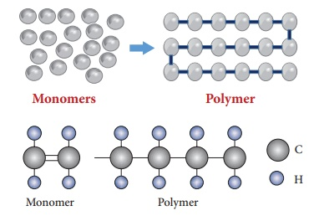

## Figure 1.1: Polymer formation

## Table 1.1: Examples of polymer

|  |  |  |
| --- | --- | --- |
| Polymer | Monomer | Repeat Unit |
| Polyethylene | CH2=CH2 | -CH2-CH2- |
| Poly (vinyl chloride) | CH2=CHCl | -CH2-CHCl- |

# Polymers in daily life

The polymers, a word that we hear about it a lot, is very vital and one cannot imagine the life without it. There were relatively few materials available for the manufacture of the article needed for a civilized life. Steel, glass, wood, stone, brick, and concrete for most of the construction and cotton, wood, jute, and a few other agricultural products for clothing or fabric manufacture were used. The rapid increase in demand for the manufactured products introduce the new materials. These new materials are polymers and their impact on the present way of life is almost 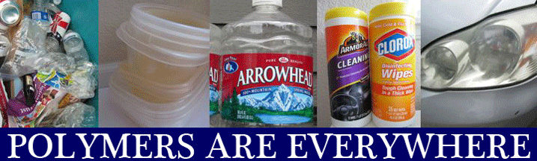includable.

## Figure 1.2 : Use of polymer

## Polymeric materials and environment

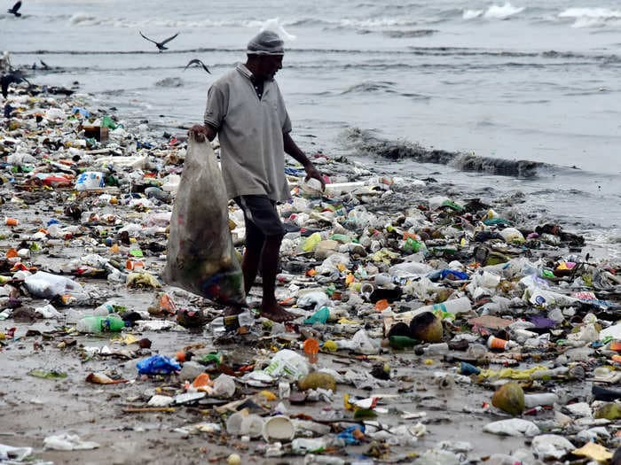The traditional polymer materials available today, especially the plastics, are the result of decades of evolution.

## Figure 1.3 : Ocean water pollution by synthetic polymer

Their production is extremely efficient in terms of utilization of raw materials and energy, as well as of waste release. The products present a series of excellent properties such as impermeability to water and microorganisms, high mechanical strength, low density (useful for transporting goods), and low cost due to manufacturing scale and process optimization.

On 2 March,2022, at the UN Environment Assembly in Nairobi, Kenya, senior representatives from 175 countries backed a ground-breaking resolution to stop plastic pollution. This will result in a legally binding, international agreement by the end of 2024, aiming to make all plastics sustainable.

Plastics, especially single-use plastics, have often made international headlines. And with good reason. According to the United Nations, the world and its oceans are being overrun by plastics. So much so, the Ellen MacArthur Foundation reports, that by 2050 there will be more plastic in the oceans than fish. Although plastic-strewn oceans get most attention, the UN Food and Agricultural Organization (FAO) points out that plastics in soil threaten human health and food security. Last December, the FAO published a striking report, Assessment of agricultural plastics and their sustainability: a call for action, which described in detail how a multitude of agricultural plastics, especially microplastics, find their way into the food chain [4] .

# Degradation of polymer

Synthetic polymers are recognized as major solid waste environmental pollutants.

Another problem is disposal of plastic wastes. Since 1990, the plastic industry has invested US$1 billion to support increased recycling, and to educate communities. Land filling is the most common method for disposing of municipal solid waste. Increasing amounts of synthetic polymers produced results in increasing interest in polymer degradation.

# Types of Degradation

Environmental factors such as light, heat, moisture, chemical conditions, and biological activity result in bond scission. The formation of structural homogeneities and formation of new functional groups also occurs during polymer degradation.

348 Environmental Waste Management

Depending upon the nature of the causing agents, polymer degradation has been classified as the following types:

Polymer degradation

Bio-

degradation

physical

degradation

Chemical

degradation

348 Environmental Waste Management

# Oxidatively degradable polyurea

Polyurea are polyamides of carbonic acid and are made of -NH-CO-NH- repeat units.



Polyurea

The polyurea is a synthetic elastomer obtained from the reaction of a amines or polyamines with di-isocyanates or poly (isocyanate)s, polymerization reaction is very similar to polyurethane one, but in case of polyurea, resulting link is a "urea", so it is called polyurea.

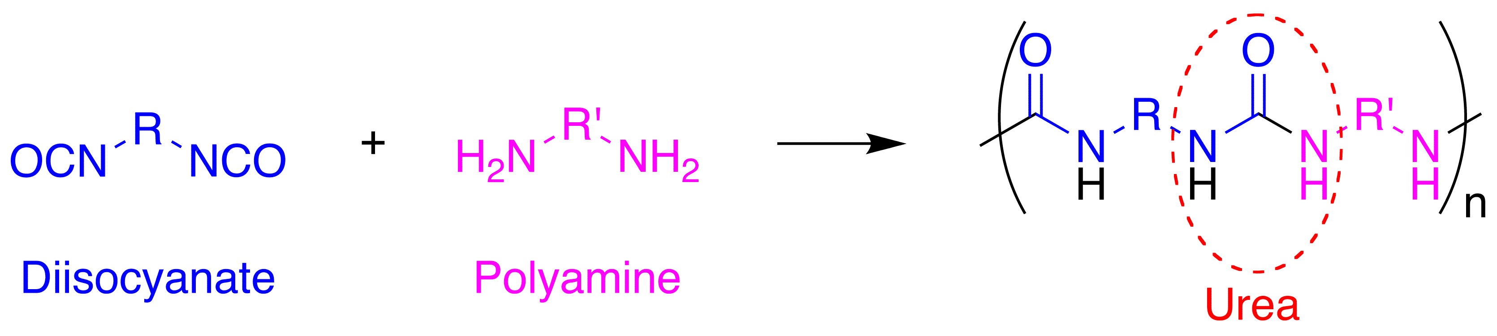

# Review of Literature

Polyurea is a class of polymers synthesized through the polymerization of 4-aminobenzylhydrazide monomer and hexa-methylene di-isocyanate monomer. The polymerization of hydrazide with diisocyanate is successfully performed to form polyurea, which is an oxidatively degradable polymer. When these polymers are treated with sodium hypochlorite solution, they are oxidized and degraded to corresponding dicarboxylic acid with the evolution of the bubble of N2 gas [5].



#### Scheme 1: Oxidative degradation of diacylhydrazine group in presence NaClO.

# Objectives of the Work

a) To explore innovative synthesis methods for producing degradable polymers.

b) To prepare an environmentally friendly polymer.

c) To analyze the physical, chemical, and mechanical properties of synthesized degradable polymer.

d) To synthesize oxidatively degradable polyurea polymer (Introducing diacylhydrazine) group to the polymeric chain).

e) To check the oxidative degradability of the synthesized polymer in presence of NaClO.

# Methodology

1.For synthesis of chemically degradable polyurea, 4-aminobenzohydrazide (0.30234 g, 2 mmol) was taken in a small conical flask and was dissolved in N, N-Dimethylformamide (DMF) and was stirred for few minutes for the proper dissolution of the monomer in the solvent in order to form saturated solution.

2. Then tolylene-2,4-diisocyanate (0.34832 g, 2 mmol) was measured and was added in that flask and again DMF was added for proper dissolution.

3. A magnetic stir bar was taken in that flask and the reaction mixture was stirred continuously for 24 hours at room temperature by using hot plate magnetic stirrer.

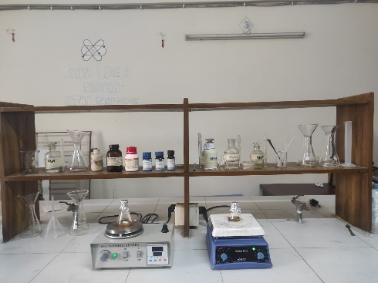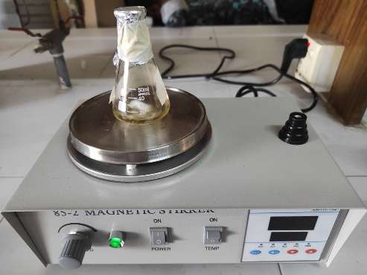

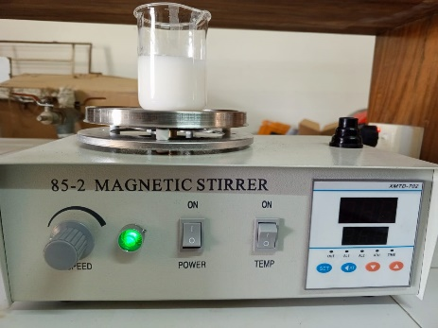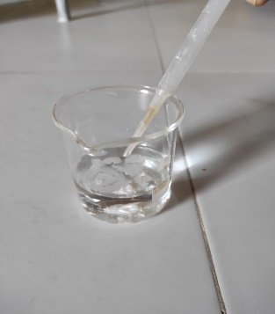4.After stirring the reaction mixture for 24 hours, that mixture was added drop wise in 50 ml of nonsolvent water in a beaker.

5.Then the mixture was again shaken for 30 minutes again.

6. The solution was then filtered and the residue was kept in oven for drying to obtain crystalline powder.

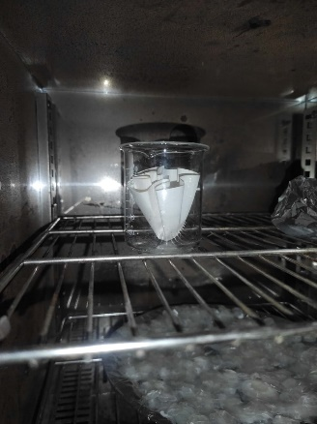7. After drying the crystalline powder was measured and then percentage of product was calculated.

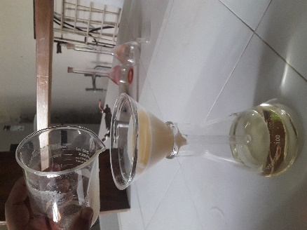

# Polymer Synthesis

Polymerization of 4-aminobenzohydrazide and tolylene-2,4-diisocyanate will yield polyurea.



Scheme 2: Degradable polyurea containing diacylhydrazine groups.

# Characterization of Synthesized Polymer

a) The synthesized polymer will be characterized by IR and NMR spectroscopic techniques.

b) Molecular weight: Molecular weight of the synthesized polymer will be determined by using Gel permeation chromatography (GPC).

c) Thermal stability of the synthesized polymer will be determined by thermo gravimetric analysis (TGA).

d) Crystallinity of the polymer will be analyzed by differential scanning calorimetry (DSC).

e) If the synthesized polymer forms film, its tensile strength, yield strength will be measured.

# 5. Socio-Economic Contributions

This research project will help to know about the behavior of polyurea containing diacylhydrazine groups and diisocyanate group. It also helps to know the innovative researcher in polymer chemistry and environmental science as well as the development of more trained graduate researcher. In addition, the research may offer wide opportunity in environmental science. Production of oxidatively degradable polymer will reduce municipal garbage and trashes which will help to make our environment free from wastage.

# 4.Result and Discussion

From the survey data ,it can be seen that 90% people use polymers in their daily life.

Polyurea containing poly(diacylhydrazine) was synthesized by the reaction of two monomers (4-aminobenzohydrazide and Tolylene-2,4-diisocyanate). Polymer with different percentage of yield and thermal properties were formed. The percentages of yield for the different polymerization reaction are as follows:

### Table 1.2 : percentage of yield for BU-CHE-RK-(1-2)

|  |  |  |  |  |  |  |  |  |
| --- | --- | --- | --- | --- | --- | --- | --- | --- |
| Name  of  Polymer | 4-amino  benzo  hydrazide | Tolylene-  2,4-diiso  cyanate | DMF | NMP | Duration  Of  Reaction  (hours) | Ratio  Of  Monomers | Weight  Of the  product | %  Of  product |
| BU-CHE  -RK-1 | 2 mmol  0.30234g | 2 mmol  0.34832g | 4 mmol | - | 24  hours | 2:2 | 0.70g | 54.33% |
| BU-CHE  -RK-2 | 1 mmol  0.15117g | 1 mmol  0.174160g | - | 3 mmol | 24 hours | 1:1 | 0.308g | 47.34% |

Polymer synthesized by the reaction between 4-aminobenzohydrazide and tolylene-2,4-diisocyanate showed different value of percentage yield with different time duration. For BU-CHE-RK-1, the reaction was carried out at 2:2 ratio for 24 hours and DMF solvent was used. 54.33% product was obtained. Further for BU-CHE-RK_2, the ratio of monomers was changed. It was carried out at 1:1 ratio, in presence of NMP. The percentage of product was 47.34.

# Conclusion

Oxidatively degradable polymers have been synthesized by the step growth polymerization reaction using 4-aminobenzohydrazide and tolylene-2,4-diisocyanate in presence of polar aprotic solvent like DMF or NMP in normal temperature. These synthesized polymers contain diacylhydrazine moiety in their main chain which are thermally stable and oxidatively degradable. These reactions have been carried out by the combination of monomers with different ratio and different time duration. The degradation tests have been done using sodium hypochlorite solution and 1% bleaching solution. Oxidative degradation has implied the nonselective auto oxidation by air. Thus, the polymer containing diacylhydrazine moiety can be controlled by the addition of sodium hypochlorite as a decomposition switch. Another important feature of this type of synthesized polymer containing diacylhydrazine is that the degradation product is the corresponding carboxylic acid which is the starting material for the preparation of poly(diacylhydrazine). Therefore, poly(diacylhydrazine) can be recycled via the oxidative degradation. As sodium hypochlorite is one of the most inexpensive and common oxidants, various applications are expected to be widely accessible with poly(diacylhydrazine)s. This type of polymer has the possibility of film formation. To better understand thermal stability and the rate of the oxidative degradation of the synthesized polymers, it is necessary to know the molecular weight of the polymers.

# Reference

1. M. U. Islam, “Structure,Chemistry and Pharmaceutical Applications of Biodegradable Polymers,” *ResearchGate,* vol. 3, pp. 517-540, September 2015.

2. P. N. Kihara, “A fantastic plastics”.

3. Billmeyer, W. (1984). Textbook of polymer science, New York.

*4.Rethinking the future of plastics*. (2022b, March 31). ISO. https://www.iso.org/news/ref2792-1.html

5.Kihara, N., Iino, Y., & Misawa, T. (2008). Oxidative degradation of poly (isophthaloylhydrazine‐1, 2‐diyl) s. Journal of Polymer Science Part A: Polymer Chemistry, 46(18), 6255-6262.