/*建视图*/

/*建立学生学号，姓名，请假原因，请假日期，宿舍楼号，宿舍号的视图*/

create view s1
as
select student.StuNo,student.stuname,leave.LeaveDate,leave.LeaveRea,
Dormitry.DorNo,Dormitry.RNo from student,leave,Relationship,Dormitry
where student.stuno=leave.stuno and Relationship.stuno=student.stuno
and Relationship.RNo=Dormitry.RNo

select * from s1
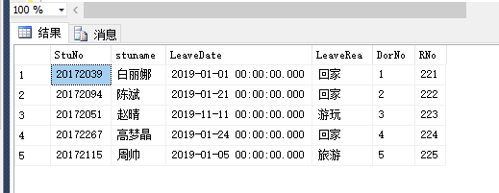

/*建立学生学号，姓名，学院，班级，宿舍楼号，宿舍号，晚归原因，晚归日期，的视图*/
create view s2
as
select student.StuNo,student.stuname,student.stuclass,college.StuDep,
late.lateDate,late.lateRea,Dormitry.DorNo,Dormitry.RNo
from student,late,Relationship,Dormitry,College
where student.stuno=late.stuno and Relationship.stuno=student.stuno
and Relationship.RNo=Dormitry.RNo and student.StuDepNo=college.StuDepNo

select * from s2
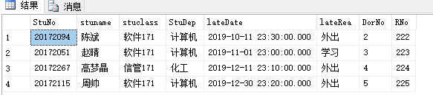

/*视图查询*/

/*查询住在1号公寓221的学号为20172039的学生的请假原因。*/

select stuname,rno,leaverea from s1 where stuno='20172039'
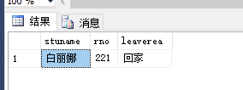
/*查询学号为20172051的学生的姓名，学院，晚归日期，宿舍楼号及宿舍号*/

select stuname,studep,latedate,dorno,rno from s2 where stuno='20172051'
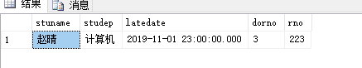

/*查询软件171班晚归学生的学号，姓名，晚归日期，原因，*/

select stuno,stuname,latedate,laterea from s2 where stuclass='软件171'
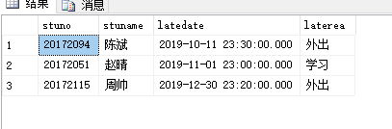

/*更新视图*/

/*将学号为20172039的学生的请假原因改为旅游*/

update s1 set leaverea='旅游' where stuno='20172039'
