Special Late-Breaking Int. News Event

Reaction RuleML

http://ibis.in.tum.de/research/ReactionRuleML

Nov. 9th, 17.30 – 18.30
(after ISWC closing ceremony)

Location: Room A (2nd floor)

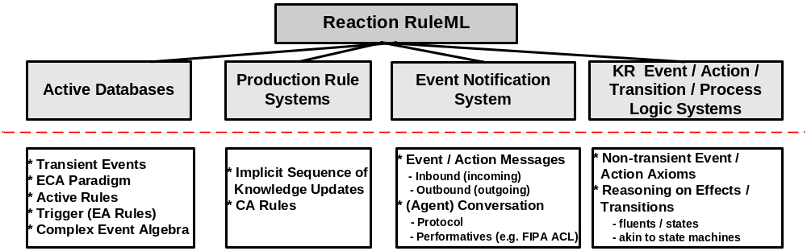

Reaction RuleML is a general, practical, compact and user-friendly XML-serialized language for the family of reaction rules. It incorporates different kinds of production, action, reaction, and KR temporal/event/action logic rules into the native RuleML syntax using a system of step-wise extensions. In particular, the approach covers different kinds of reaction rules from various domains such as active-database ECA rules and triggers, forward-directed production rules, backward-reasoning temporal-KR event/action logics, event notification & messaging and active update, transition, process and transaction logics.

