P R O J E C T R E P O R T

Term Project CS6905: TX RuleML Tab

Instructors: Dr. E. Bruce Spencer

Dr. Harold Boley

Submitted by
Onut Iosif-Viorel (3168236)
Sandeep Singh (3161493)

Contents

Contents 2
Introduction 3
Taxonomic RuleML 3
Protégé 4
TX RuleML Tab 6
What it is 6
What it does 6
Importing 6
Exporting 8
Validating 9
Modules 11
Ontology Connection Class 11
TX RuleML Connection Class 12
Parser Class 12
TX RuleML Tab Class 13
Installing and Running the TX RuleML Tab 14
Installing Protégé 14
Copying the Jar File 14
Choosing the Plugin 15
Limitations and Future Work 16
Support for Multiple Inheritance 16
TX RuleML Editor 16
Auto-correcting the TX RuleML Files 16
Figures 17
References 17

Introduction

Taxonomic RuleML

Taxonomic RuleML (TX RuleML) introduces a set of experimental RuleML tags that are used to represent subsumption (type of) relationships. Some of the important tags are the role tags _shead for the superclass and _sbody for the subclass. Class disjunctions (like ‘class a OR class b’) are represented by <sor> tag and class conjunctions (like ‘class a AND class b’) are represented by <sand> tag. For example –

the relationship: “a mammal may be a cat or a dog” can be represented as:

<sub>
<_shead><rel>mammal</rel></_shead>
<_sbody>
<sor>
<rel>cat</rel>
<rel>dog</rel>
</sor>
</_sbody>
</sub>

the relationship: “a cat is both a carnivore and a mammal” can be represented as:

<sub>
<_shead>
<sand>
<rel>Carnivore</rel>
<rel>Mammal</rel>
</sand>
</_shead>
<_sbody>
<rel>Cat</rel>
</_sbody>
</sub>

For an industry related example, see [2] and for the translation from subsumptions to implications, see [1]

Protégé

Protégé is an integrated software tool originally developed by the Stanford Medical Informatics group at Stanford University for medical purposes, and later developed into a general Semantic web tool.

The Protégé-2000 tool has an extendible GUI (graphical user interface) whose
top-level part consists of overlapping tabs for compact presentation and manipulation of the component parts and for convenient co-editing between them. It is available under the terms of the Mozilla license.

The top-level GUI design permits an integration of [3]:
- modeling of an ontology of classes describing a particular subject,
- creation of a knowledge-acquisition tool for collecting knowledge,
- entering of specific instances of data and creation of a knowledge base, and
- execution of applications.

The ontology defines a set of classes (a taxonomy) with slots that can be again typed by classes. Protégé-2000 has become to be a domain independent knowledge-acquisition tool allowing users to easily and naturally enter knowledge of their area. Moreover it has a Java API (application user interface) that allows programs to directly create, manipulate and interact with the knowledge base (ontology). The ontology can then be used with problem-solving methods to answer questions and solve problems regarding the domain.
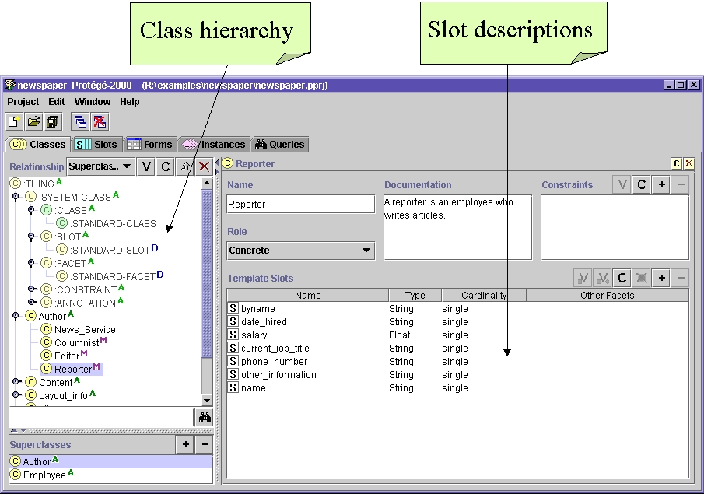
- Protégé-2000 graphical interface general view. The taxonomy
of the current ontology is displayed on the left hand side, while the right hand side
displays contextual information about the current class such as their slots.
Protégé-2000 is also a platform that can be extended with graphical plugins (widgets) for tables, diagrams, animation components. Plugins can be constructed independently and added later as emerging parts. Through these extensions the tool proves to be highly adaptable to any type of ontology that it might be used for.

The two major types of plugins for our purpose are:
- tab-widget plugin. Through this type of plugin users can define their own modules graphically independent from those modules that exist in Protégé.

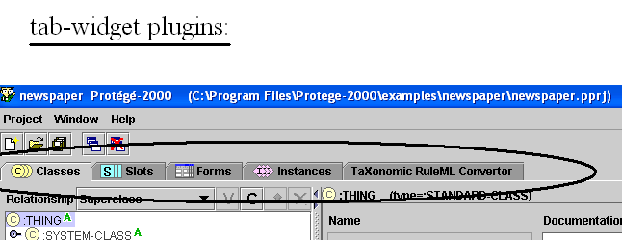
- Protégé-2000: Tab-Widget Plugin Examples

- slot-widget plugin. In general a slot widget plugin can be viewed as a sub-element of a tab-widget plugin :

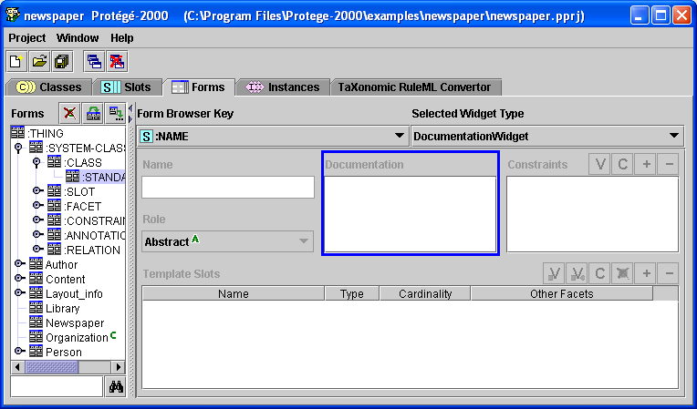
Slot-widget Tab:
- Protégé-2000: Slot-Widget Plugin Example

TX RuleML Tab

What it is

Taxonomic RuleML Tab (TX RuleML Tab) is a plugin to Protégé that converts TX RuleML files to taxonomic class hierarchies in Protégé and vice versa. It also acts as a validator to the Taxonomic RuleML files, recognizing and reporting errors such as incomplete or misplaced tags or invalid symbols.

What it does

Importing

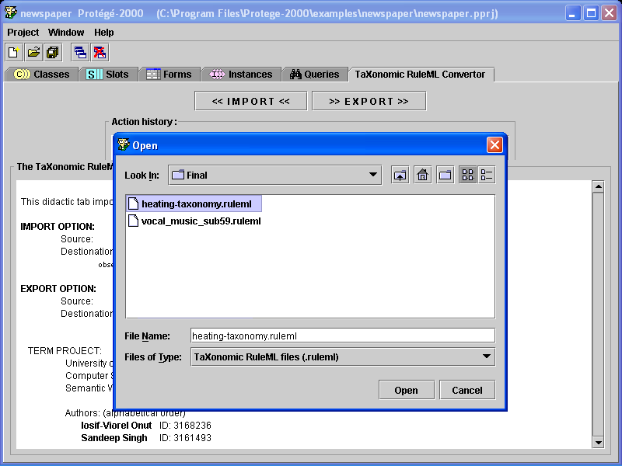

- Importing a TX RuleML file to Taxonomy in Protégé

The TX RuleML Tab allows the user to choose any TX RuleML or Text file which it converts to Taxonomic Hierarchies in Protégé. In figure 4 the file ‘heating-taxonomy.ruleml’ is chosen using the file open dialoge box provided by the Tab. This file, modeling electrothermic devices [2] is parsed by the Tab and the result is shown in figure 5 and figure 6.

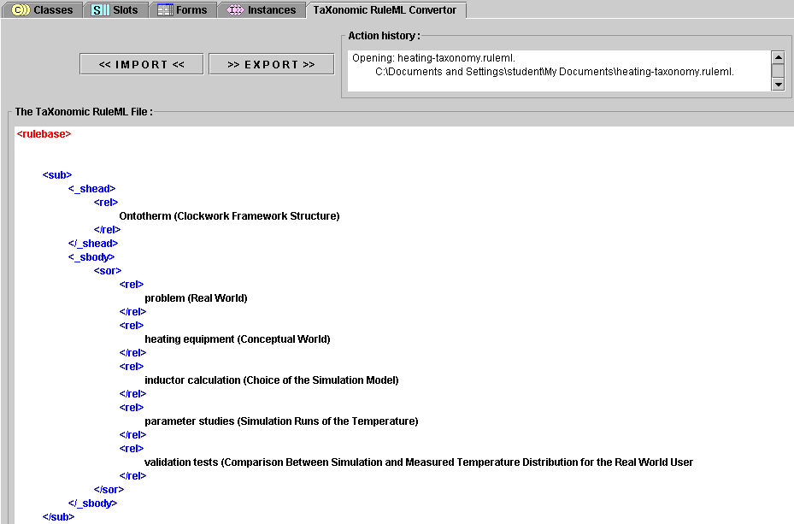

- TX RuleML markup listing, as shown by the TX RuleML Tab
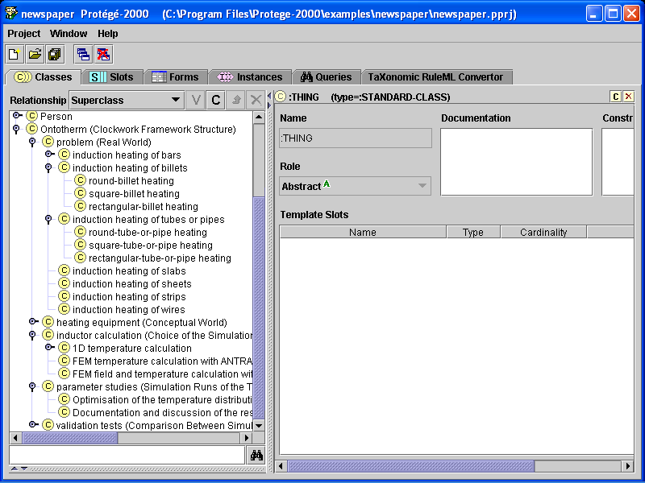

- Protégé-2000 Class Taxonomy generated by the TX RuleML Tab

As shown in figure 5, the TX RuleML Tab first shows the TX RuleML file using different colors for different tags. The Taxonomic class structure represented in the file can be seen by choosing the Classes tab of Protégé (figure 6). The class structure is shown graphically with different levels for representing different levels of subclasses.

Exporting
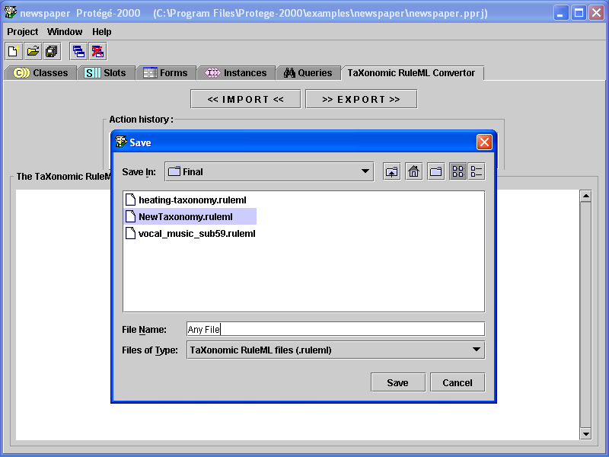

- Exporting Protégé-2000 Taxonomic Hierarchy to TX RuleML markup listing

The TX RuleML Tab allows the user to convert the current taxonomic structure in Protégé to TX RuleML markup. This can be done by using the save file dialog box, which is provided by the Tab. In figure 7 the current taxonomy is saved by the name of
‘Any File.ruleml’.
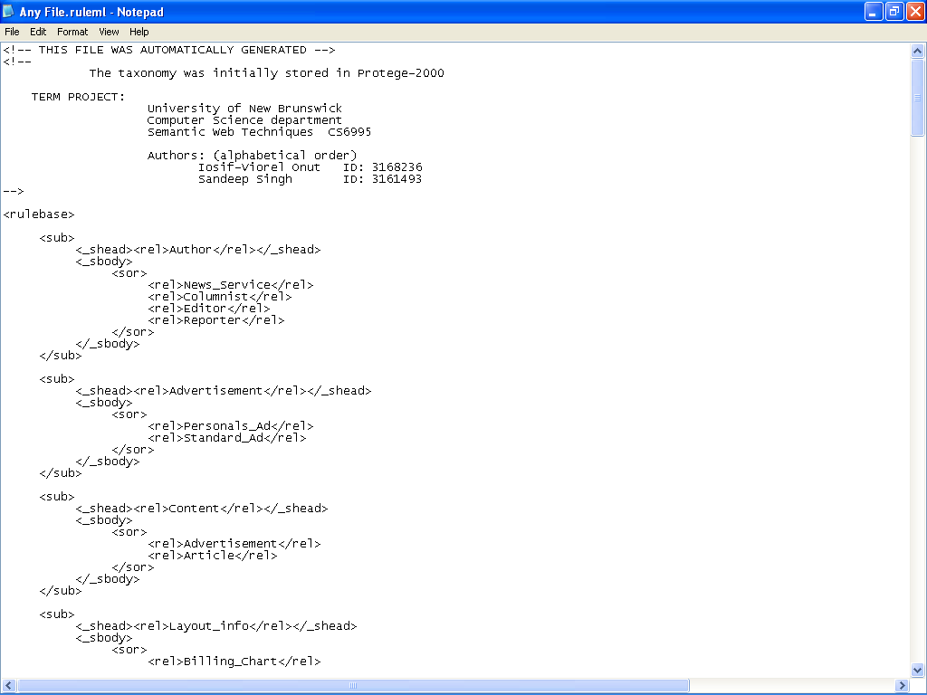

- TX RuleML markup generated by the TX RuleML Tab
Figure 8 shows the newly generated TX RuleML file that contains the markup for the taxonomy that was earlier generated from the ‘heating-taxonomy.ruleml’ file (figure 4).

Validating

The TX RuleML Tab does not accept ill-formed TX RuleML files. Before importing any TX RuleML file, the Tab checks if the file contains any missing tags, misplaced tags or invalid text in it. If the file contains any of these three ill-formedness features, the Tab raises an error and an error message is displayed in the Action History box.

Figure 9 shows various possible errors in a TX RuleML file. Figure 10 shows the result when we tried to import this ill-formed file.

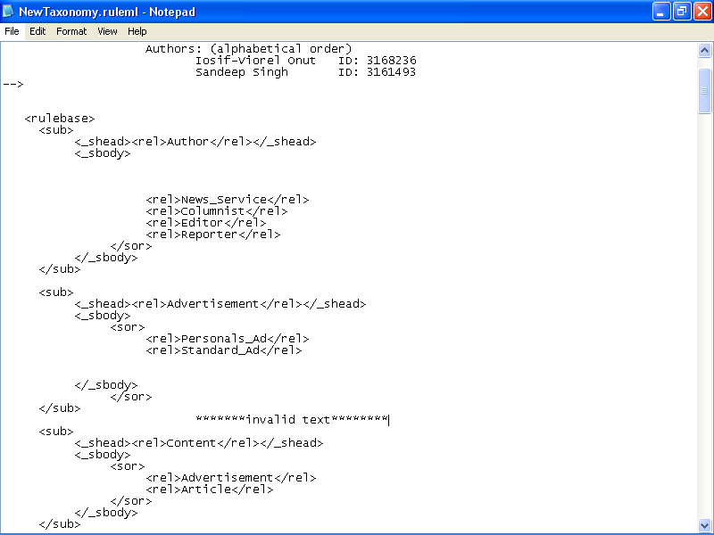
Missing Tag
Incorrect Order
Invalid Text

- An ill-formed TX RuleML file

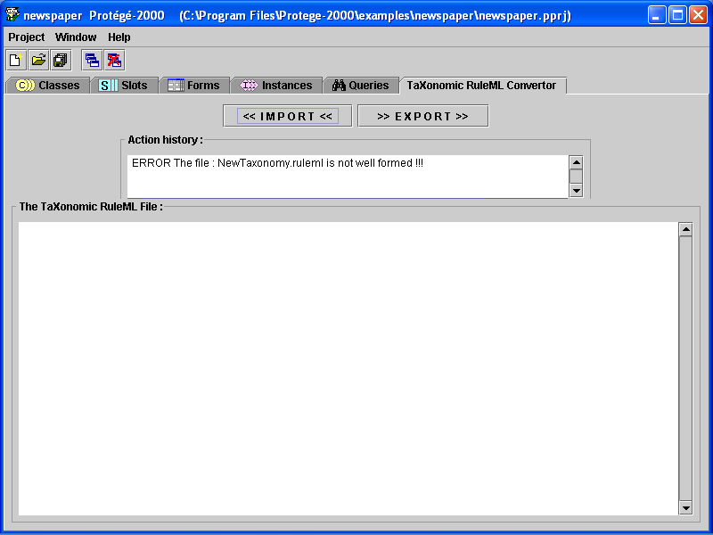

- Result of importing an ill-formed TX RuleML file

Modules

Protégé-2000 provides a Java API for the purpose of creating and manipulating ontologies, at the same time being itself developed in Java. As a consequence the TX RuleML Tab is implemented using a single programming platform.

The Tab has four main classes:
  - Ontology Connection
  - TX RuleML Connection
  - Parser
  - TX RuleML Tab

Ontology Connection Class

The main purpose of this class is to connect the TX RuleML tab to the currently opened ontology through Protégé’s API.

The TX RuleML tab plugin is not concerned with the storage or creation of the current ontology due to the fact that in Protégé-2000, in order to access a plugin, one has to be in a project (whether that project is a new one or an existing one).

Consequently, the whole class hierarchy will be imported or exported in the currently opened ontology.
The main functions of this class are: to create new classes, assign super classes and return stored classes from the current ontology.
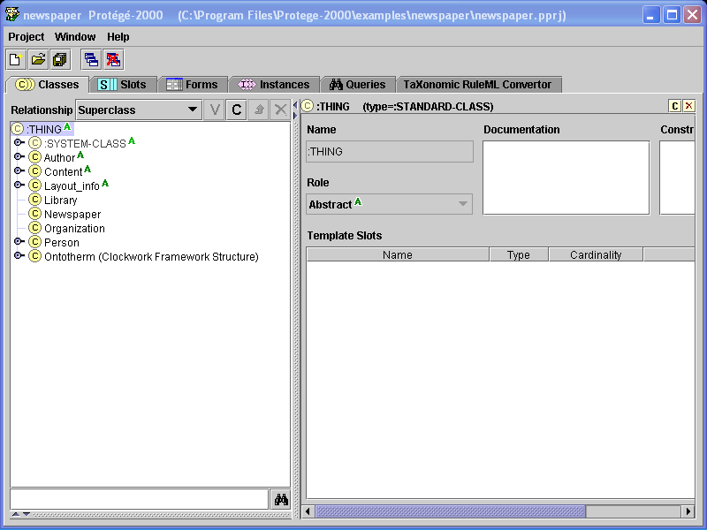
OntologyConnection

Create Class

Get Class

API
- Connection between the TX RuleML tab and the current Protégé-2000 Ontology.

TX RuleML Connection Class

The TX RuleML connection class represents the core of the plugin. At the importing phase the working TX RuleML file is selected by the user through a file open dialog box. After that, the entire file is scanned and all the key tags are detected, analyzed and classes are identified. Similarly, at the exporting phase, based on the current ontology, the file selected by the user is constructed and populated with the class taxonomy.

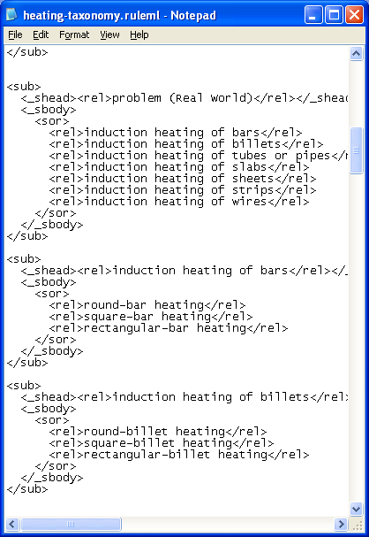
TX RuleMLConnection

Process the file
- Connection between the TX RuleML tab and the Taxonomic file.

Parser Class
A validation phase was introduced at the beginning of the importing action. During this phase the file object is passed to the Parser class. The latter will check for invalid tags, invalid order and missing tags. Once an error is found the document will be rejected by the TX RuleML Tab as an invalid one.
After this preprocessing stage is passed, the document is considered to be a valid one with respect to the TX RuleML format.
TX RuleMLConnection

Process the file
Parser

Validation
- Connection between the Parser class and the TX RuleMLConnection class

TX RuleML Tab Class

The TX RuleML Tab class is extended from Protégé’s AbstractTabWidget class. The main purpose of this class is to deal with the GUI (Graphical User Interface) interaction. All the actions that the user takes are done through this class. The user is presented with feedback from the system through this class only.

At the importing/exporting, the TX RuleML file is displayed in a pretty print format: key tags have different colors and styles, comments are displayed in gray, and, for better visualization, the whole document is indented with respect to the key tags and their
semantic structure.
OntologyConnection

Create Class

Get Class
TX RuleMLConnection

Process the file
TX RuleMLTab

Initialize Tab Design
- The general connection between classes.

Installing and Running the TX RuleML Tab

The TX RuleML Tab can be installed in three easy steps – installing Protégé, copying the Jar file and Configuring Protégé to accept the Tab.

Installing Protégé

Protégé is available as free software under the open-source Mozilla Public License. It can be downloaded for free from http://protege.stanford.edu/

Protégé gives you an option of using the JRE which comes bundled with it or using your already installed JRE.

Copying the Jar File

The TX RuleML Tab comes packaged in a Jar file that has to be copied to the plugins folder in Protégé’s installation folder. Figure 15 shows the jar file of the Tab, which has been copied into Protégé’s plugins folder.

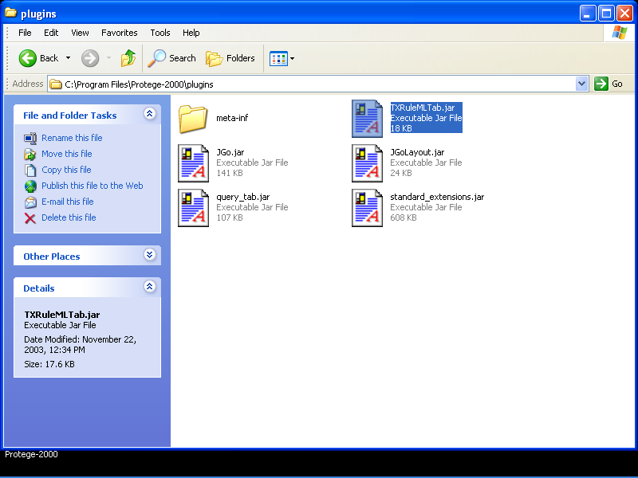

- Copying the Jar file

Choosing the Plugin

The last step in installing the TX RuleML Tab is to configure Protégé to use the Tab. This can be done by selecting Protégé’s Project – Configure – Tab Widgets option and then checking the checkbox against TX RuleML Tab. Once you have done that, the TX RuleML Tab should appear in Protégé’s main window. Figure 16 and figure 17 show the configuration step and the end result, respectively.

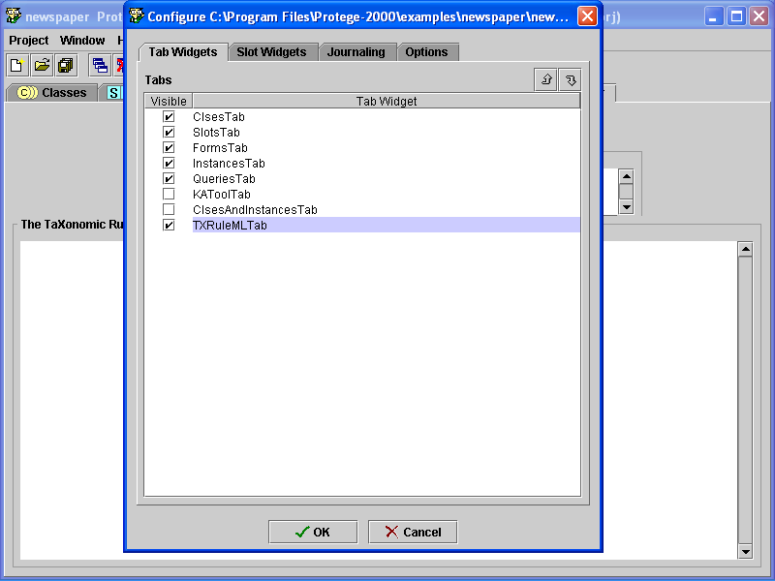

- Choosing the Tab Plugin

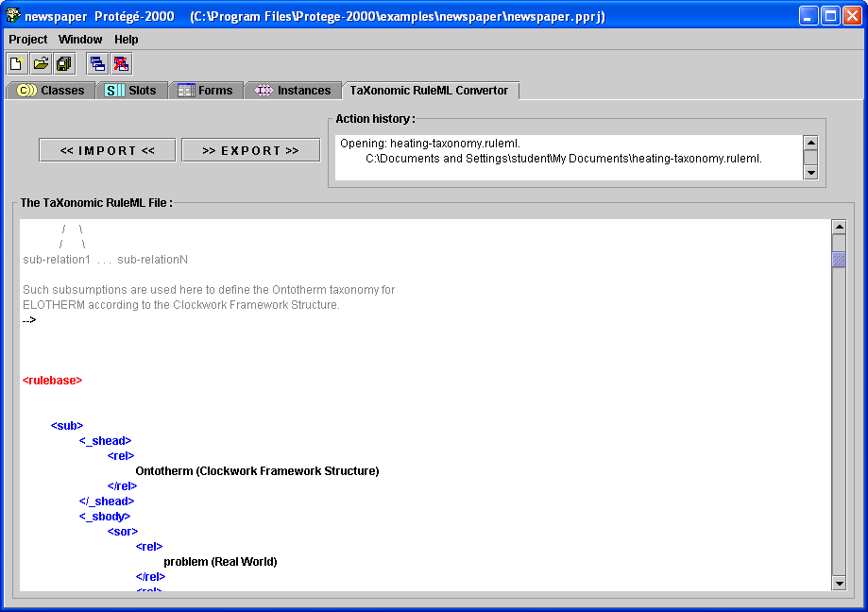

- Protégé’s main window with the TX RuleML Tab

Limitations and Future Work

The developers perceive the following limitations and possible areas of future work -

Support for Multiple Inheritance

As for now, the TX RuleML Tab does not support multiple inheritance. In other words, it currently does not support relationships that have a single class subsumed by two or more super classes. For example, the relationship “a cat is a carnivore as well as a mammal” can not be represented by the TX RuleML Tab.

TX RuleML Editor

The TX RuleML Tab can be further enhanced to incorporate a TX RuleML Editor, which will allow the user to import a TX RuleML file, make changes to it at his/her will, and then generate Class Taxonomies in Protégé from this changed file. The editor can be further enhanced to instantly reflect any changes made to the Taxonomy in Protégé. On the other hand, Protégé’s, drag-and-drop class editor can already be used after Importing and followed by Exporting.

Auto-correcting the TX RuleML Files

The Parser, which is an integral part of the Tab, can be easily extended to provide a comprehensive summary of errors present in an ill-formed TX RuleML file. The Parser/Validator can also suggest possible changes, which may be useful for removing the errors. As a slightly higher aspiration, the parser/validator can go one step further to automatically correct an ill-formed TX RuleML file.

Figures

Figure 1. Protégé-2000 graphical interface general view. The taxonomy of the current ontology is displayed on the left hand side, while the right hand side displays contextual information about the current class such as their slots. 4
Figure 2. Protégé-2000: Tab-Widget Plugin Examples 5
Figure 3. Protégé-2000: Slot-Widget Plugin Example 5
Figure 4. Importing a TX RuleML file to Taxonomy in Protégé 6
Figure 5. TX RuleML markup listing, as shown by the TX RuleML Tab 7
Figure 6. Protégé-2000 Class Taxonomy generated by the TX RuleML Tab 7
Figure 7. Exporting Protégé-2000 Taxonomic Hierarchy to TX RuleML markup listing 8
Figure 8. TX RuleML markup generated by the TX RuleML Tab 8
Figure 9. An ill-formed TX RuleML file 9
Figure 10. Result of importing an ill-formed TX RuleML file 10
Figure 11. Connection between the TX RuleML tab and the current Protégé-2000 Ontology. 11
Figure 12. Connection between the TX RuleML tab and the Taxonomic file. 12
Figure 13. Connection between the Parser class and the TX RuleMLConnection class 12
Figure 14. The general connection between classes. 13
Figure 15. Copying the Jar file 14
Figure 16. Choosing the Tab Plugin 15
Figure 17. Protégé’s main window with the TX RuleML Tab 15

References

[1] | Harold Boley, ‘Taxonomies in RuleML’ 2002-04-18: Version 0.2 (http://www.dfki.uni-kl.de/ruleml/insub)
[2] | Harold Boley, Robert Jürgens, Detlev Stahl, ‘OntoTherm: The ELOTHERM Ontology for Heating Design’ (http://www.dfki.uni-kl.de/~boley/ontotherm/) (http://www.dfki.uni-kl.de/~boley/heating-design/heating-taxonomy.ruleml)
[3] | Protégé-2000 official web site (protege.stanford.edu)
[4] | Harold Boley: ‘Transforming RuleML Sub Elements to RDFS via XSLT’ 2002-08-19 (http://www.dfki.uni-kl.de/~boley/heating-design/ruleml2rdfs.xsl)
[5] | Noy N. F. and McGuinness D. L. : ‘Ontology Development 101: A Guide to Creating Your First Ontology‘, Stanford University, Stanford, CA,USA.
[6] | Noy N.F., Sintek M., Decker S., Crubézy M., Fergerson R.W.,and Musen M.A. ‘Creating Semantic Web Contents with Protégé-2000’, Stanford University, USA, 2001.

