**Pi:Relay IOT Application using Cayenne**

Pi:Relay is a Relay Shield for Raspberry pi. It is the best suitable device for making Home Automation and for controlling high power devices like motors, lights etc.

**Features of Pi:Relay:**

* 4 - High quality Relay and loads up to 7A/240VAC
* LED’s for indicating status of each relay
* 40-Pin Stacking Header for accessing GPIO of RPi.
* GPIO 4, GPIO 17, GPIO 27 and GPIO 22 are used for controlling Relay. But user can remove Relay Jumper and select custom GPIO pin.

**Cayenne Application:**

* Login and connect Cayenne with your Raspberry Pi.

<https://mydevices.com/>

* After connecting Raspberry Pi you will see the Dashboard like this:

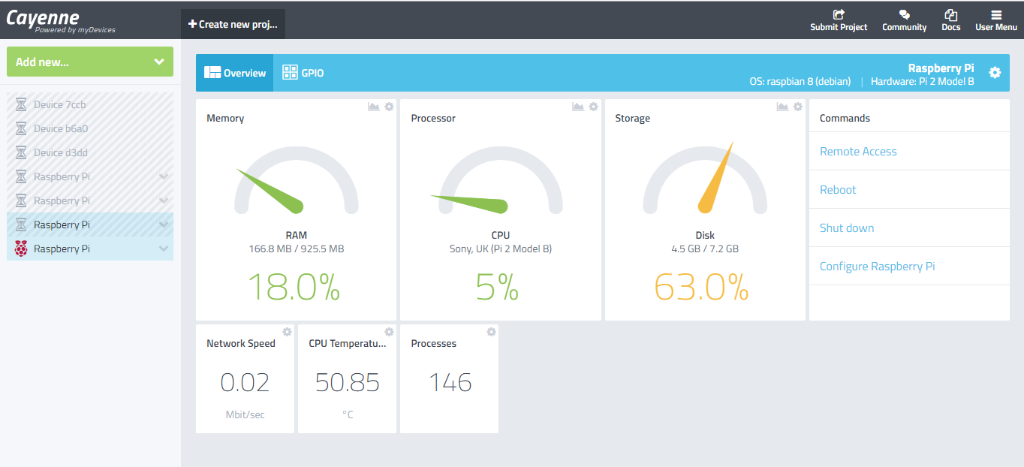

* Click on **‘Create new project’** and write project name:

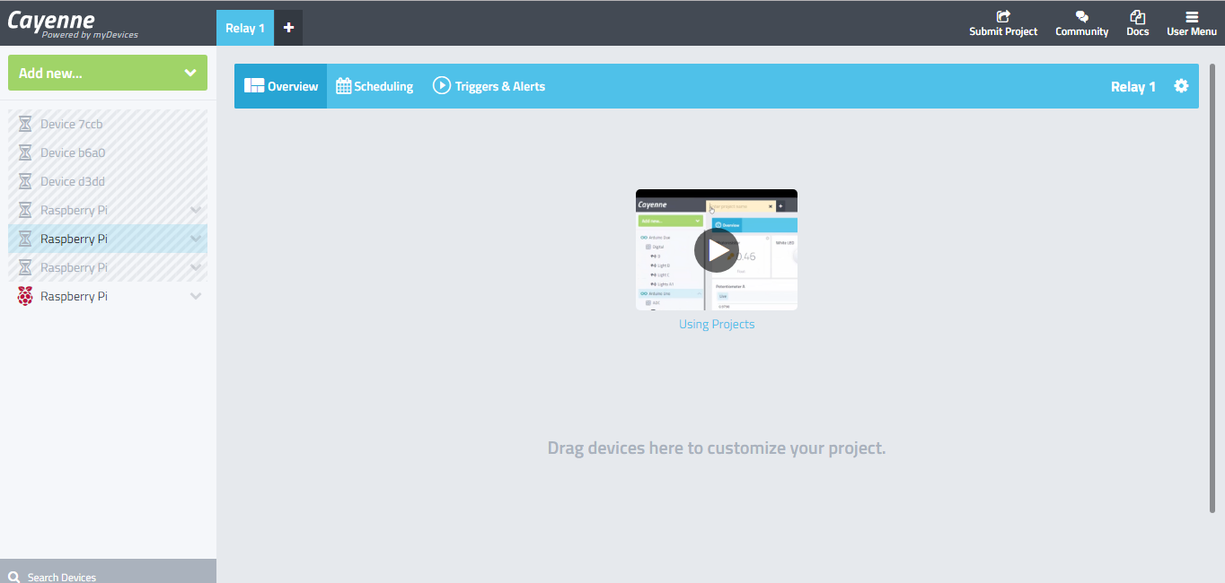

* On left hand side, click on **‘Add new…’** --> **‘Device/Widget’**

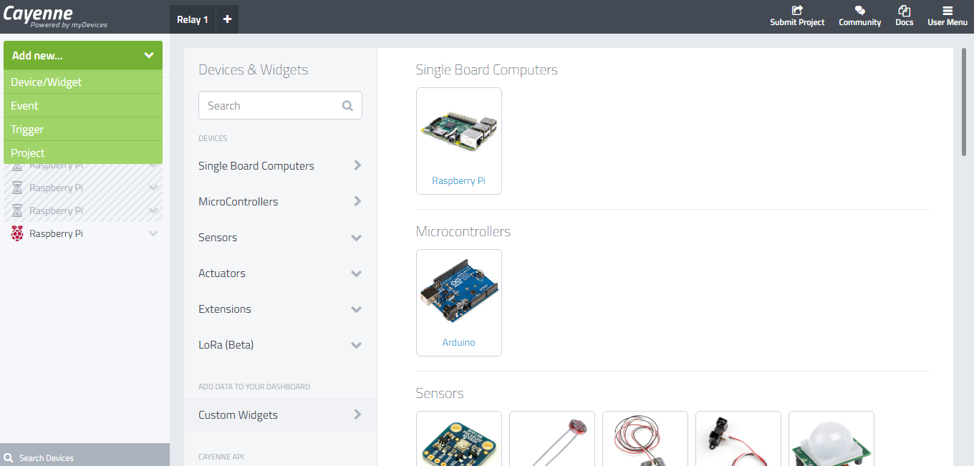

* Select **‘Actuators’** and select **‘Relay’** or **‘Generic’** ->’**Digital Output**’. Fill all the settings :

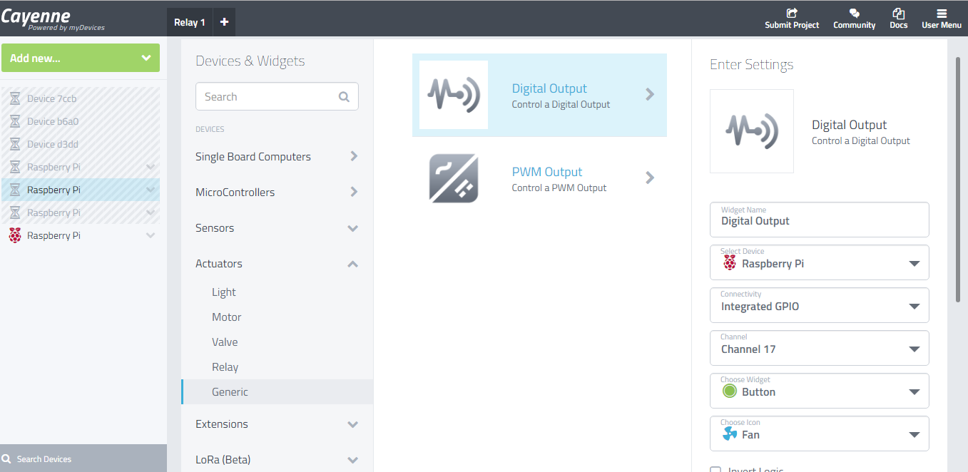

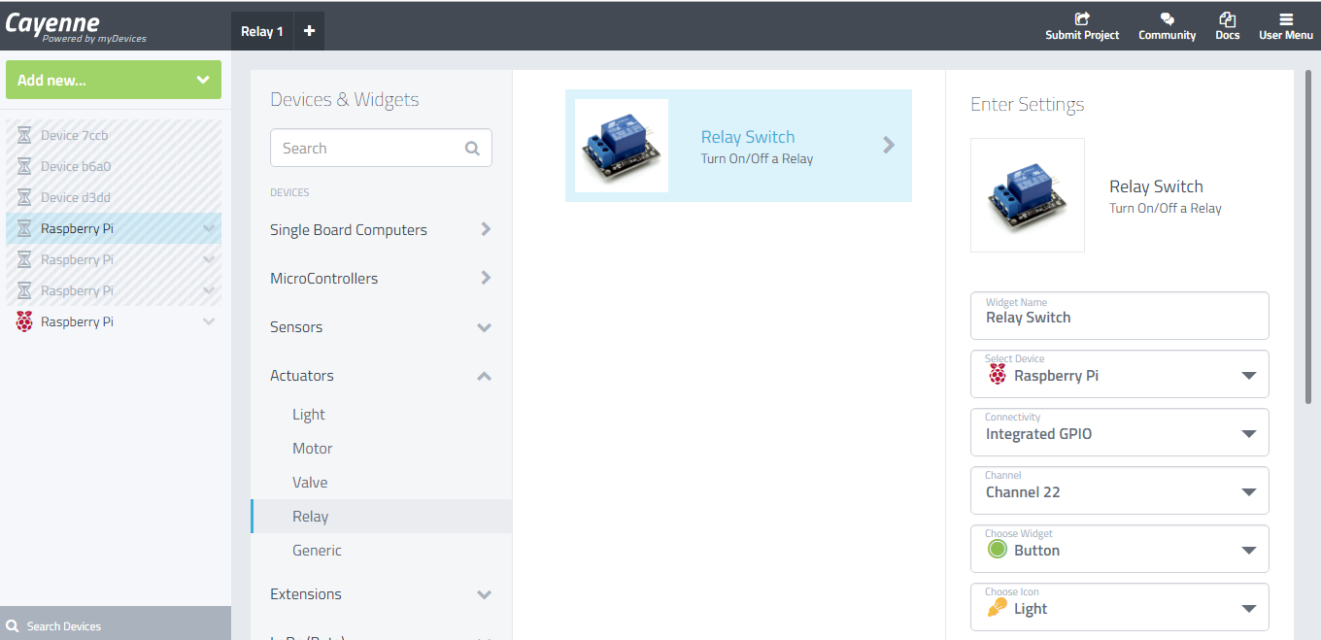

* Now you will see your widget on Dashboard. Click on widget to control Relay.

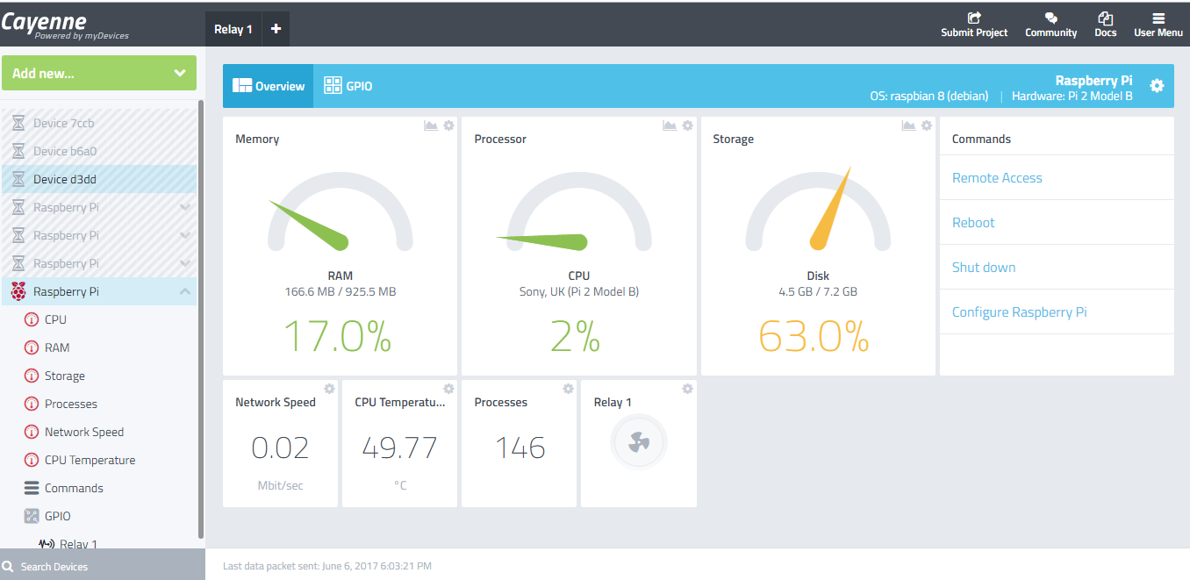

* Connect any power component/device to Pi:Relay (like Motor or any home appliance) and make it intelligent. Using Cayenne you can also schedule your device and you can also control your device from anywhere.

**Note: ‘Common (COM)’ pin is default connected to ‘Normally Closed (NC)’ pin and when relay is ON then ‘Common (COM)’ pin will connect to ‘Normally Open (NO)’.**