Day - 15

**PyCharm & Coffee Machine**

PyCharm Installation and Coffee Machine project

**15.1 PyCharm Features**

1. Spell-check in PyCharm.

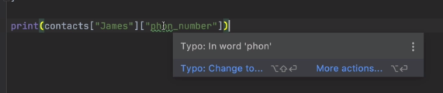

1. Multi-screen support.

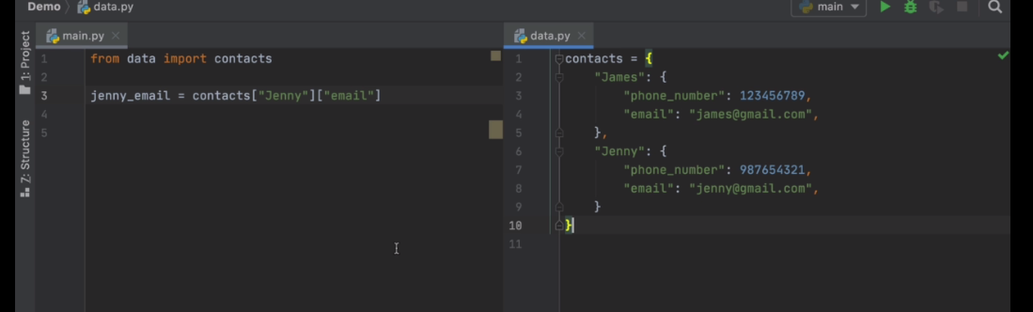

1. Linter: Automatic PEP-8 style guide and suggestions.

|  |  |
| --- | --- |
|  |  |

1. Local History: Last 12 hours records for code changes of a source-file.

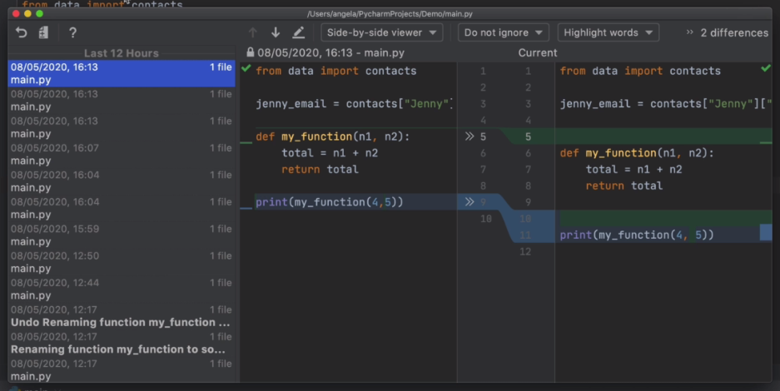

1. Code-structure view and Intelligent Refactor.

* Function tracking and selecting an element (right-click) Refactor/change intelligently (can differ string and functions)

|  |  |
| --- | --- |
|  | * Notice string doesn't changes while my_function() to add()     To |

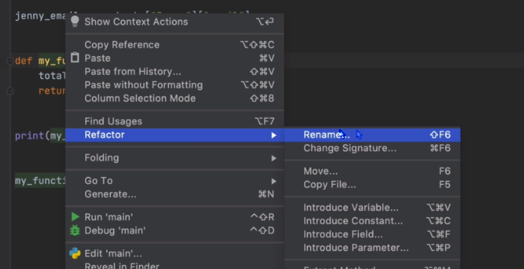

**15.2 Coffee Machine challenge**

First attempt: Practice version

user_input = **input**("What would you like? (espresso/latte/cappuccino):")**.lower**()

#*use dictionary  ??*

water = 1000

milk = 500

coffee = 500

money = 0

**def** **esprso**():

**global** water, coffee, money

    water -= 50

    coffee -= 18

    money += 1.5

**if** (water **<** 0) **or** (coffee **<** 0) :

        water += 50

        coffee += 18

        money -= 1.5

**print**("sorry Resource is low")

**def** **late**():

**global** water, milk, coffee, money

    water -= 200

    coffee -= 24

    milk -= 150

    money += 2.5

**if** (water **<** 0) **or** (coffee **<** 0) **or** (milk **<** 0):

        water += 200

        coffee += 24

        milk += 150

        money -= 2.5

**print**("sorry Resource is low")

**def** **caPcino**():

**global** water, milk, coffee, money

    water -= 250

    coffee -= 24

    milk -= 200

    money += 3.0

**if** (water **<** 0) **or** (coffee **<** 0) **or** (milk **<** 0):

        water += 250

        coffee += 24

        milk += 200

        money -= 3.0

**print**("sorry Resource is low")

**def** **show_resrc**():

**print**(f"""

            water= {water} \n

            milk = {milk} \n

            coffee = {coffee} \n

            money = {money}""")

**def** **coin_enter**():

    pNy = **float**(input("Enter number of Peny : "))

    niKl = **float**(input("Enter number of Nickl : "))

    dIme = **float**(input("Enter number of Dime : "))

    qrTr = **float**(input("Enter number of Quarter : "))

    total = (0.01*pNy) + (0.05*niKl) + (0.1*dIme) + (0.25*qrTr)

**if** (total **<** 1.5) **and** (user_input **==** "espresso"):

**print**("Not Enough money. Coins are returned")

**elif** (total **<** 2.5) **and** (user_input **==** "latte"):

**print**("Not Enough money. Coins are returned")

**elif** (total **<** 3.0) **and** (user_input **==** "cappuccino"):

**print**("Not Enough money. Coins are returned")

**return** total

**while** user_input **!=** "off":

**if** user_input **==** "resource":

**show_resrc**()

**elif** user_input **==** "espresso":

        coIn = **coin_enter**()

**if** coIn **>=** 1.5:

**esprso**()

**print**(f"Here is change : {coIn - 1.5}")

**show_resrc**()

**elif** user_input **==** "latte":

        coIn = **coin_enter**()

**if** coIn **>=** 2.5:

**late**()

**print**(f"Here is change : {coIn - 2.5}")

**show_resrc**()

**elif** user_input **==** "cappuccino":

        coIn = **coin_enter**()

**if** coIn **>=** 3.0:

**caPcino**()

**print**(f"Here is change : {coIn - 3.0}")

**show_resrc**()

**else**:

**print**("Not a valid Code")

    user_input = **input**("What would you like? (espresso/latte/cappuccino):")**.lower**()

#*def resRc():*

#*water= 100*

#*milk= 50*

#*coffee= 76*

#*money= 2.5*

#*python coffie_machine.py*

Second attempt: Practice version

user_input = **input**("What would you like? (espresso/latte/cappuccino):")**.lower**()

#*use dictionary*

resource = {

    "water" : 1000,

    "milk" : 500,

    "coffee" : 500,

    "money" : 0

}

**def** **esprso**():

**global** resource

    resource["water"] -= 50

    resource["coffee"] -= 18

    resource["money"] += 1.5

**for** i **in** resource:

**if** resource[i] **<** 0 :

            resource["water"] += 50

            resource["coffee"] += 18

            resource["money"] -= 1.5

**print**(f"sorry {i} is low")

**return**

**def** **late**():

**global** resource

    resource["water"] -= 200

    resource["coffee"] -= 24

    resource["milk"] -= 150

    resource["money"] += 2.5

**for** i **in** resource:

**if** resource[i] **<** 0 :

            resource["water"] += 200

            resource["coffee"] += 24

            resource["milk"] += 150

            resource["money"] -= 2.5

**print**(f"sorry {i} is low")

**return**

**def** **caPcino**():

**global** resource

    resource["water"] -= 250

    resource["coffee"] -= 24

    resource["milk"] -= 200

    resource["money"] += 3.0

**for** i **in** resource:

**if** resource[i] **<** 0 :

            resource["water"] += 250

            resource["coffee"] += 24

            resource["milk"] += 200

            resource["money"] -= 3.0

**print**(f"sorry {i} is low")

**return**

**def** **show_resrc**():

**print**(f"""

            water= {resource["water"]} \n

            milk = {resource["milk"]} \n

            coffee = {resource["coffee"]} \n

            money = {resource["money"]}""")

**def** **coin_enter**():

    pNy = **float**(input("Enter number of Peny : "))

    niKl = **float**(input("Enter number of Nickl : "))

    dIme = **float**(input("Enter number of Dime : "))

    qrTr = **float**(input("Enter number of Quarter : "))

    total = (0.01*pNy) + (0.05*niKl) + (0.1*dIme) + (0.25*qrTr)

**if** (total **<** 1.5) **and** (user_input **==** "espresso"):

**print**("Not Enough money. Coins are returned")

**elif** (total **<** 2.5) **and** (user_input **==** "latte"):

**print**("Not Enough money. Coins are returned")

**elif** (total **<** 3.0) **and** (user_input **==** "cappuccino"):

**print**("Not Enough money. Coins are returned")

**return** total

**while** user_input **!=** "off":

**if** user_input **==** "resource":

**show_resrc**()

**elif** user_input **==** "espresso":

        coIn = **coin_enter**()

**if** coIn **>=** 1.5:

**esprso**()

**print**(f"Here is change : {coIn - 1.5}")

**show_resrc**()

**elif** user_input **==** "latte":

        coIn = **coin_enter**()

**if** coIn **>=** 2.5:

**late**()

**print**(f"Here is change : {coIn - 2.5}")

**show_resrc**()

**elif** user_input **==** "cappuccino":

        coIn = **coin_enter**()

**if** coIn **>=** 3.0:

**caPcino**()

**print**(f"Here is change : {coIn - 3.0}")

**show_resrc**()

**else**:

**print**("Not a valid Code")

    user_input = **input**("What would you like? (espresso/latte/cappuccino):")**.lower**()

#*def resRc():*

#*water= 100*

#*milk= 50*

#*coffee= 76*

#*money= 2.5*

#*python coffie_machine.py*

Instructor Solution

MENU = {

    "espresso": {

        "ingredients": {

            "water": 50,

            "coffee": 18,

            "milk": 0,

        },

        "cost": 1.5,

    },

    "latte": {

        "ingredients": {

            "water": 200,

            "milk": 150,

            "coffee": 24,

        },

        "cost": 2.5,

    },

    "cappuccino": {

        "ingredients": {

            "water": 250,

            "milk": 100,

            "coffee": 24,

        },

        "cost": 3.0,

    }

}

profit = 0

resources = {

    "water": 300,

    "milk": 200,

    "coffee": 100,

}

**def** **is_resource_sufficient**(order_ingredients):

    """Returns True when order can be made, False if ingredients are insufficient."""

**for** item **in** order_ingredients:

**if** order_ingredients[item] **>=** resources[item]:

**print**(f"Sorry there is not enough {item}.")

**return** **False**

**return** **True**

**def** **process_coins**():

    """Returns Total of the inserted coins"""

**print**("Please insert the coins")

    pNy = **float**(input("Enter number of Peny : "))

    niKl = **float**(input("Enter number of Nickl : "))

    dIme = **float**(input("Enter number of Dime : "))

    qrTr = **float**(input("Enter number of Quarter : "))

    total = (0.01 * pNy) + (0.05 * niKl) + (0.1 * dIme) + (0.25 * qrTr)

**return** total

**def** **is_transection_sucess**(money_recived, drink_cost):

    """True when accepted or False if insufficient"""

**if** money_recived **>=** drink_cost:

**global** profit

        change = **round**(money_recived - drink_cost, 2)

**print**(f"Here is ${change} in change")

        profit += drink_cost

**return** **True**

**else**:

**print**("Sorry that's not enough money. Money refunded.")

**return** **False**

**def** **make_coffiee**(drink_name, order_ingredients):

    """Deduct the ingredients from resources """

**for** itM **in** order_ingredients:

        resources[itM] -= order_ingredients[itM]

**print**(f"Here is your {drink_name}")

is_on = **True**

**while** is_on:

    choice = **input**("What would you like? (espresso/latte/cappuccino):")**.lower**()

**if** choice **==** "off":

        is_on = **False**

**elif** choice **==** "report":

**print**(f"Water {resources['water']}")

**print**(f"Milk {resources['milk']}")

**print**(f"Coffee {resources['coffee']}")

**print**(f"Money ${profit}")

**else**:

        drink = MENU[choice]

**if** **is_resource_sufficient**(drink["ingredients"]):

            payment = **process_coins**()

**if** **is_transection_sucess**(payment, drink["cost"]):

**make_coffiee**(choice, drink["ingredients"])