Day - 31

**Flash Card App Capstone Project**

Milestone Project using previous Knowledge. Lean French through this app.

**31.1 Learning a LANGUAGE using Frequency dictionary**

* Learning a Language: If you basically just want to get by in life, you can pretty much rely on the 3000 words that an average teenager would know. And finally, if you actually just want to be able to watch some simple movies, read some simple books, then you could use the average kid vocabulary of about that the 1000 characters.
* Frequency dictionary: And at this point, I think to myself, 1000. That's quite doable. But it's not just 1000 random characters either. There's such a thing as a frequency dictionary. This dictionary not listed here by A, B, C, D, but it actually listed by the frequency that a particular word occurs in common usage.
* For example, if you take the first 1000 characters that are most commonly used, then you can pretty much read most of the Newspapers, you can watch most of the TV shows because these are the words that are the bread and butter of the language. It's like in English, the a, the, of, from, why, yes, no, these are words that we use every day, again and again.

**31. 2 Get the most frequent words**

Now, if you're wondering, how did you get the most frequent words for the flashcard app in the first place?

* Wikitonary: There's a Wiki for the frequency list of different languages, and it lists most of the common languages. If we go to French, you can see that there are loads of different lists that people have compiled that list the top, most frequently occurring words.
* Words are based on subtitles: And one of the ones that I thought was really relevant is the words are based on subtitles. These subtitles come from all sorts of shows and movies that are relevant to modern culture.
* It's basically just all the words that are spoken in the movie or in the show and it's been transcribed into subtitles. Now then if we take all of these words that are from the most commonly watched movies and shows, we end up with these frequency lists.

|  |  |
| --- | --- |
|  |  |

* Hermit Dave's list of frequent words in GItHub: These frequency lists are compiled by a user called ***HermitD***. and ***Hermitd*** is a ***Hermit*** ***Dave***. And he has a GitHub repository where he's compiled all of the frequency words.
* Now he's got all of the frequency words for many languages and it's listed by the language code, so French would be ***fr*** for example. And here you can see the top 50,000 most frequent lists or the full entire list. We're probably not gonna learn more than 1000, and I'm certainly not going to get to 50,000. But this data here lists all the words that he found in these subtitles and the frequency that they occurred. And once they've been sorted in order of frequency,
* So if I take a hundred words from this frequency dictionary and I put it into a Google sheet.

|  |  |
| --- | --- |
|  |  |

**31.3 Finding out the meaning: Using Google Spreadsheet and Translate**

* Finding out the meaning of each of these words: There's actually a really neat trick in Google sheets that I want to show you. If you hit equals to '**=**' start a new formula and you type in ***GOOGLETRANSLATE()*** you can see it expects some inputs.
* First is the piece of text that you want to translate, so I'm going to click on this cell, and then it's the source language. It is the language-code. So for example, Spanish is ***es*** and French is ***fr***.
* And then the final input. it expects is the language-code that you want to translate it to. So in this case, I want to translate it to English. So I'm going to use ***en***.
* And then we can close off the parentheses, hit enter and after a little while with good internet, you'll see the English translation for this word. And of course, because we're an Excel, we can simply just drag this cross all the way down to all of our words. And after a little while, bam! It's translated all of those words into English.

|  |
| --- |
|  |

**31.4 App Description**

We're going to be building a flashcard program to help you study. And it's especially great with studying for languages. It shows you the front and the back of the card. So for example, French, ***demande***. In English means ***request***. After three seconds, the card flips and I can check whether if I knew the right answer. If I got it right I'll press the tick and if I got it wrong I'll press the cross.

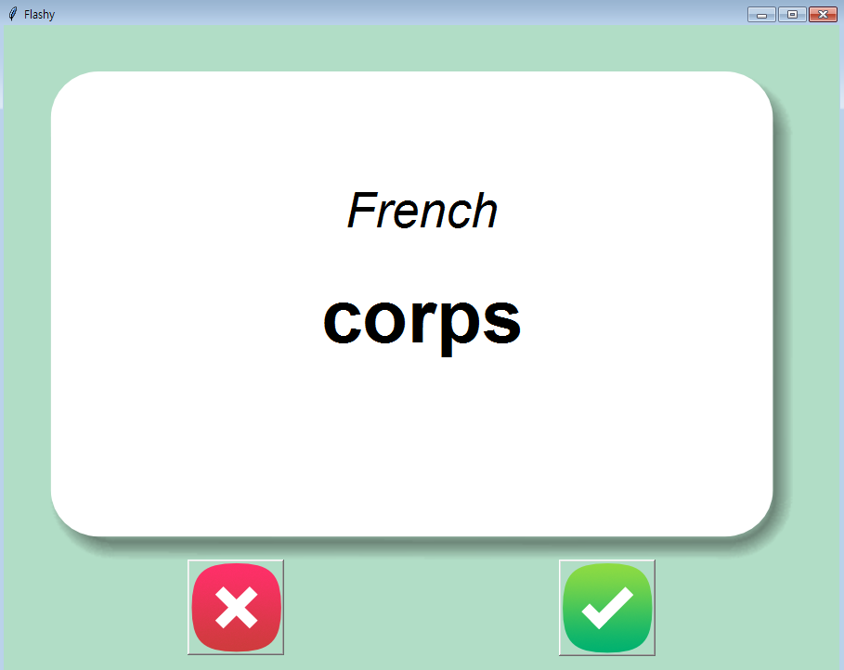 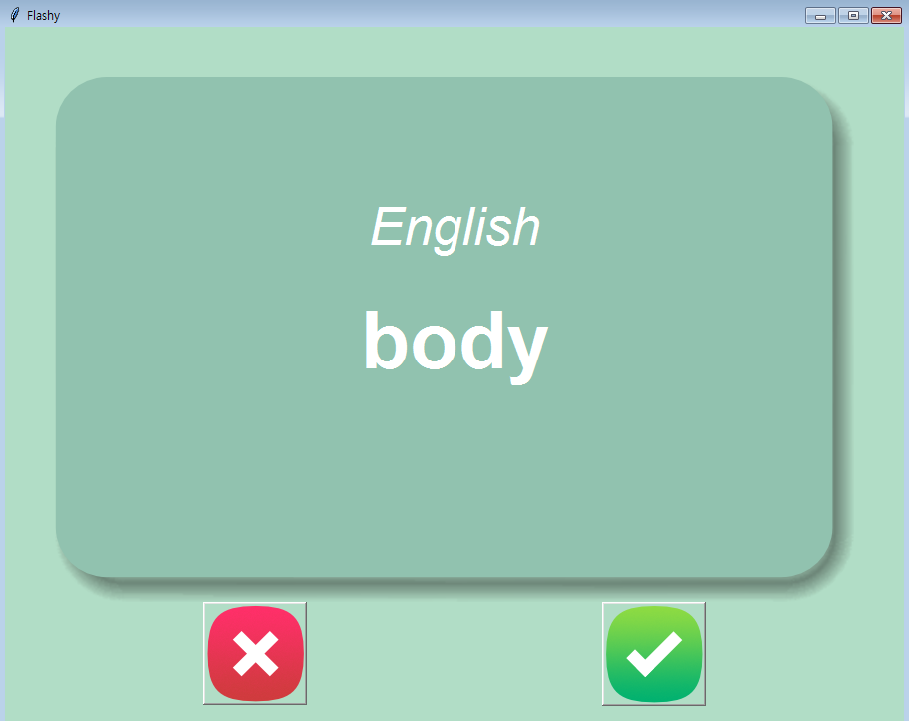

**31.5 The Project**

Practice version

**import** tkinter

**import** random

BACKGROUND_COLOR = "#B1DDC6"

RED = "#e7305b"

ini_word = ()

#*Open CSV file and store it to a dictionary*

**import** pandas

data = pandas**.read_csv**("./data/french_words.csv")

**print**(data)

        #*create dictionary*

data_dict = data**.to_dict**()

**print**(data_dict)

#*----------------  Random-Choice of French word ---------------------*

**def** **random_word**():

    ran_num = random**.randint**(0, 100)

**print**(ran_num)

    french = data_dict["French"][ran_num]

    english = data_dict["English"][ran_num]

**return** (french, english)

#*ask = input(f"Know the Feench word '{french}' ? y/n :").lower()*

#*if ask == "n":*

#*print(f"The english word is : '{english}'")*

#*random_word()*

#*elif ask == "y":*

#*random_word()*

#*else:*

#*print("wrong key")*

#*random_word()*

#*------------------- button clicks : Card flip ----------------------*

**def** **flip**():

**global** ini_word

    cAnVas**.itemconfig**(back_ground, image = small_front)

    #*create new text*

    cAnVas**.itemconfig**(lang, text = "English", fill = "black", font = ("Arial", 18, "italic"))

    cAnVas**.itemconfig**(word, text = f"\n {ini_word[1]}", fill = "black", font = ("Arial", 28, "bold"))

**def** **genrt_word**():

**global** ini_word

    ini_word = **random_word**()

    cAnVas**.itemconfig**(back_ground, image = small_back)

    cAnVas**.itemconfig**(lang, text = "French", fill = "white", font = ("Arial", 18, "italic"))

    cAnVas**.itemconfig**(word, text = f"\n {ini_word[0]}", fill = "white", font = ("Arial", 28, "bold"))

#*------------------------ window and Canvas ----------------------*

winDoW = tkinter**.Tk**()

winDoW**.title**("Flash Card : Learn French")

winDoW**.config**(bg = BACKGROUND_COLOR, padx = 50, pady = 50)

#*Must use required keyword*

iMaGe_back = tkinter**.PhotoImage**(file = "./images/card_back.png")

iMaGe_front = tkinter**.PhotoImage**(file = "./images/card_front.png")

#*Image resize with subsample(): +ve higher value smaller*

small_back = iMaGe_back**.subsample**(2, 2) #*Image resize*

small_front = iMaGe_front**.subsample**(2, 2) #*Image resize*

cAnVas = tkinter**.Canvas**(width = 400, height = 263, bg = BACKGROUND_COLOR, highlightthickness=0)

back_ground= cAnVas**.create_image**(200, 132, image = small_back)

cAnVas**.grid**(row = 0, column = 1)

#*------------------- Buttons -------------------*

right_btn_img = tkinter**.PhotoImage**(file = "./images/right.png")

rightButtonResizedImage = right_btn_img**.subsample**(2, 2)

right_btn = tkinter**.Button**(image = rightButtonResizedImage, bd = 0, highlightthickness=0)

right_btn**.config**(command = genrt_word)

right_btn**.grid**(row = 2, column = 1, sticky = 'w', padx = 100, pady = 20)

wrong_btn_img = tkinter**.PhotoImage**(file = "./images/wrong.png")

wrongButtonResizedImage = wrong_btn_img**.subsample**(2, 2)

wrong_btn = tkinter**.Button**(image = wrongButtonResizedImage, bd = 0, highlightthickness=0)

wrong_btn**.config**(command = flip)

wrong_btn**.grid**(row = 2, column = 1, sticky = 'e', padx = 100, pady = 20)

#*-------------- Labels: Show the words ----------*

ini_word = **random_word**()

lang = cAnVas**.create_text**(200, 100, text = "French", fill = "white", font = ("Arial", 18, "italic"))

word = cAnVas**.create_text**(200, 132, text = f"\n {ini_word[0]}", fill = "white", font = ("Arial", 28, "bold"))

#*auto genetate a word after 3secs or 3000 mili-secs*

**def** **auto_generate**(coUnt):

**if** coUnt **>** 0:

**genrt_word**()

        winDoW**.after**(3000, auto_generate, coUnt-1)

**auto_generate**(100)

#*meaning_label = tkinter.Label(text = , font = ("Arial", 30, "bold"), fg = RED )*

#*meaning_label.grid(row = 1, column = 1)*

winDoW**.mainloop**()

#*python Flash_card_practice.py*

#*Image resize*

#*scale_w = new_width/old_width*

#*scale_h = new_height/old_height*

#*photoImg.zoom(scale_w, scale_h)*

#*or use*

#*iMaGe.subsample()*

Instructor version

|  |
| --- |
|  |

**import** tkinter

**import** random

BACKGROUND_COLOR = "#B1DDC6"

current_card = {}

data_dict_list = []

#*Open CSV file and store it to a dictionary*

**import** pandas

**try**:

    data = pandas**.read_csv**("./data/learned.csv")

    data_dict_list = data**.to_dict**(orient = "records")

**except** FileNotFoundError:

    original_data = pandas**.read_csv**("./data/french_words.csv")

    #*create dictionary-list and ORIENT-Data-dictionary*

    data_dict_list = original_data**.to_dict**(orient = "records")

#*------------------------ window and Canvas ----------------------*

winDoW = tkinter**.Tk**()

winDoW**.title**("Flashy")

winDoW**.config**(bg = BACKGROUND_COLOR, padx = 50, pady = 50)

#*Must use required keyword*

iMaGe_back = tkinter**.PhotoImage**(file = "./images/card_back.png")

iMaGe_front = tkinter**.PhotoImage**(file = "./images/card_front.png")

cAnVas = tkinter**.Canvas**(width = 800, height = 526, bg = BACKGROUND_COLOR, highlightthickness=0)

back_ground= cAnVas**.create_image**(400, 263, image = iMaGe_front)

cAnVas**.grid**(row = 0, column = 0, columnspan = 2)

#*------------------------ Button commands ----------------------*

**def** **flip_card**():

    cAnVas**.itemconfig**(lang, text = "English", fill = "white")

    cAnVas**.itemconfig**(word, text = current_card["English"], fill = "white")

    cAnVas**.itemconfig**(back_ground, image = iMaGe_back)

flip_timer = winDoW**.after**(3000, flip_card)

**def** **next_card**():

**global** current_card, flip_timer

    winDoW**.after_cancel**(flip_timer)

    current_card = random**.choice**(data_dict_list)

    cAnVas**.itemconfig**(lang, text = "French", fill = "black", font = ("Arial", 18, "italic"))

    cAnVas**.itemconfig**(word, text = current_card["French"], fill = "black", font = ("Arial", 28, "bold"))

    cAnVas**.itemconfig**(back_ground, image = iMaGe_front)

    flip_timer = winDoW**.after**(3000, flip_card)

**def** **is_known**():

    data_dict_list**.remove**(current_card)

    data_frm = pandas**.DataFrame**(data_dict_list)

    #*To get rid of indexing each time during save use "index=False"*

    data_frm**.to_csv**("./data/learned.csv", index=**False**)

**next_card**()

#*------------------- Buttons -------------------*

known_btn_img = tkinter**.PhotoImage**(file = "./images/right.png")

known_btn = tkinter**.Button**(image = known_btn_img, bd = 0, highlightthickness=0)

known_btn**.config**(command = is_known)

known_btn**.grid**(row = 1, column = 1, padx = 100, pady = 20)

unknown_btn_img = tkinter**.PhotoImage**(file = "./images/wrong.png")

unknown_btn = tkinter**.Button**(image = unknown_btn_img, bd = 0, highlightthickness=0)

unknown_btn**.config**(command = next_card)

unknown_btn**.grid**(row = 1, column = 0, padx = 100, pady = 20)

#*-------------- Labels: Show the words ----------*

lang = cAnVas**.create_text**(400, 150, font = ("Arial", 40, "italic"))

word = cAnVas**.create_text**(400, 263, font = ("Arial", 60, "bold"))

**next_card**()

winDoW**.mainloop**()

#*python flashy_instrctr.py*