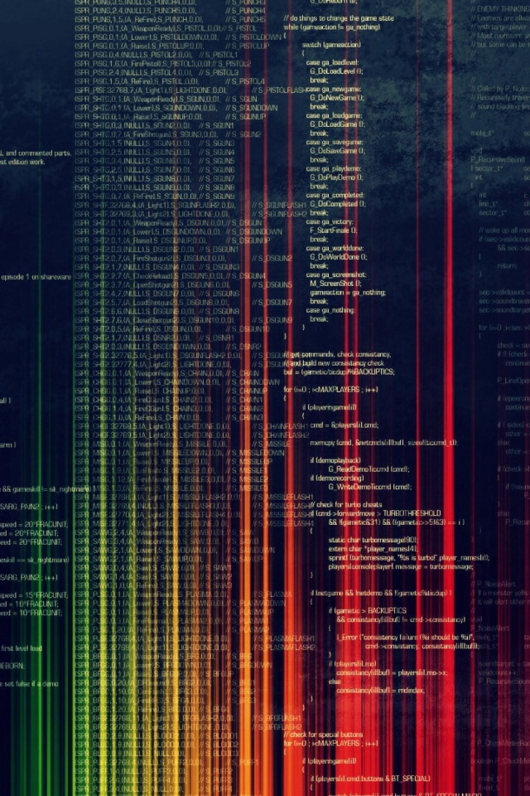

CODEX

C++

A compact note on C and C++

**Edited**

**By**

ANonyMoUs