Chapter – 2 (implementation – Part 3 - Homework)

**Computer Vision**

**SSD: Object Detector**

Horse Detector

Implementation

**2.11 Object Detect – Problem Description**

Description: We want to build a computer vision application that can detect smile from our face. It can be very useful to understand customer's reactions when for example they're watching a m

* In the next chapter we're going to implement a GAN (Generative Adversarial Networks) from scratch and it's one of the most powerful models in computer vision.
* That time it's not going to be detection it's going to be actually creation/generation.
* We'll also implement the training process and therefore we need to fuel ourselves with energy, inspiration and excitement.
* In this section, we'll detect the Horses from a beautiful video where some horses are running.
* We just need to copy our previous object detection code, and we do one or two changes there. It's mostly the same codes as before except the object detection.
* Just change the name of the video: We only have one change to make and it is just the "name of the video" (LOL).
* Remember, it will process each of the images of the video and on each of these images it detects the objects. Previously we had 2 seconds of video, now we have 10 seconds, so it will be 300 frames. So it requires more time.

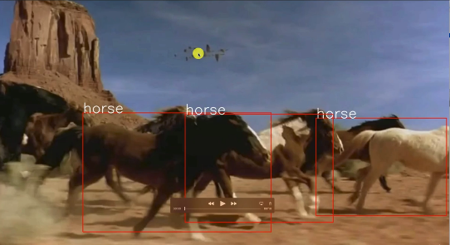

* There is some false positive. Because there is some features that are identical to a cow. And sometimes we (humans) can get confused with a cow.

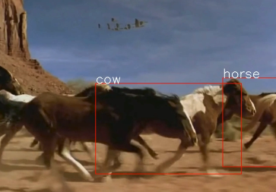

* Since there is no front of the horse here the model detected following as a cow. And two horses behind other got mixed and the model detected two dogs.

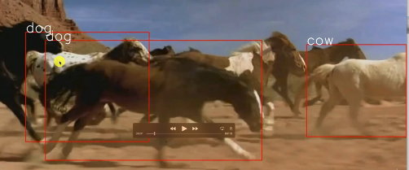

The model detected pretty good at the last portion of the video.