Chapter 8

**ChatBot: Running a Pre-trained ChatBot**

Required TF version 1.4.0 and TF==0.12.1 (suriadipan)

**8.1 Cloning a conda environment for TF==1.4.0**

**(base) C:\Users\ >conda env list**

# conda environments:

#

base * C:\Users\anaconda3

py354 C:\Users\anaconda3\envs\py354

**(base) C:\Users\>conda deactivate**

**C:\Users\>conda create --name py354TF1_4 --clone py354**

Source: C:\Users\anaconda3\envs\py354

Destination: C:\Users\anaconda3\envs\py354TF1_4

Packages: 98

Files: 4002

Preparing transaction: done

Verifying transaction: done

**C:\Users\>conda activate py354TF1_4**

**(py354TF1_4) C:\Users\>pip install --upgrade tensorflow==1.4.0**

Collecting tensorflow==1.4.0

Downloading

**(py354TF1_4) C:\Users\>pip show tensorflow**

Name: tensorflow

Version: 1.4.0

.

.

.

* **Note**: Spyder is already installed to cloned environment.

Also this environment supports following TF versions

(TF versions: 0.12.0, 0.12.1, 1.0.0, 1.0.1, 1.1.0, 1.2.0, 1.2.1, 1.3.0, 1.4.0, 1.5.0, 1.5.1, 1.6.0, 1.7.0, 1.7.1, 1.8.0, 1.9.0, 1.10.0, 1.11.0, 1.12.0, 1.12.2, 1.12.3, 1.13.1, 1.13.2, 1.14.0, 1.15.0, 1.15.2, 1.15.3, 1.15.4, 2.0.0, 2.0.1, 2.0.2, 2.0.3, 2.1.0, 2.1.1, 2.1.2, 2.2.0, 2.2.1, 2.3.0, 2.3.1)

**8.2 Creating Anaconda environment for TF==0.12.1**

Remove already existing environment, for example

conda env remove -n env_name

* Anaconda environment for TF==0.12.1:

conda env remove -n bestCTBT

conda deactivate

conda create --name bestCTBT --clone py354

conda activate bestCTBT

pip uninstall tensorflow

pip install tensorflow==0.12.1

pip install nltk==3.2.5

pip install pipwin

pip install nltk

Error:

Collecting nltk

….

….

Running setup.py bdist_wheel for regex ... error

….

….

error: Microsoft Visual C++ 14.0 is required. Get it with "Microsoft Visual C++ Build Tools": https://visualstudio.microsoft.com/downloads/

----------------------------------------

Failed building wheel for regex

Running setup.py clean for regex

NB: above error arise for nltk==3.6.2

Install visual studio installer (if NLTK doesn't install).

Select **MVC 140** from Individual Components > compiler

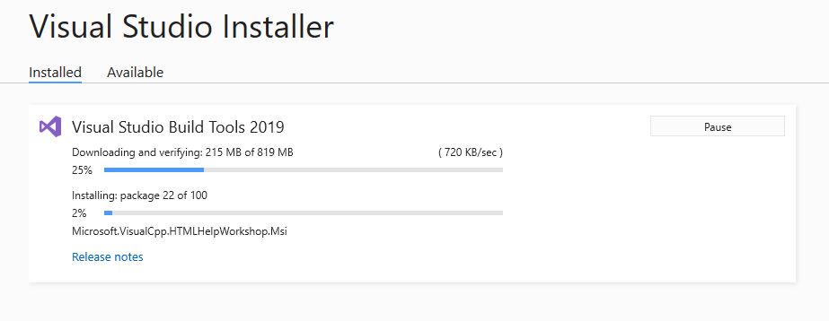

* However nltk==3.2.5 successfully installed

pip install nltk==3.2.5

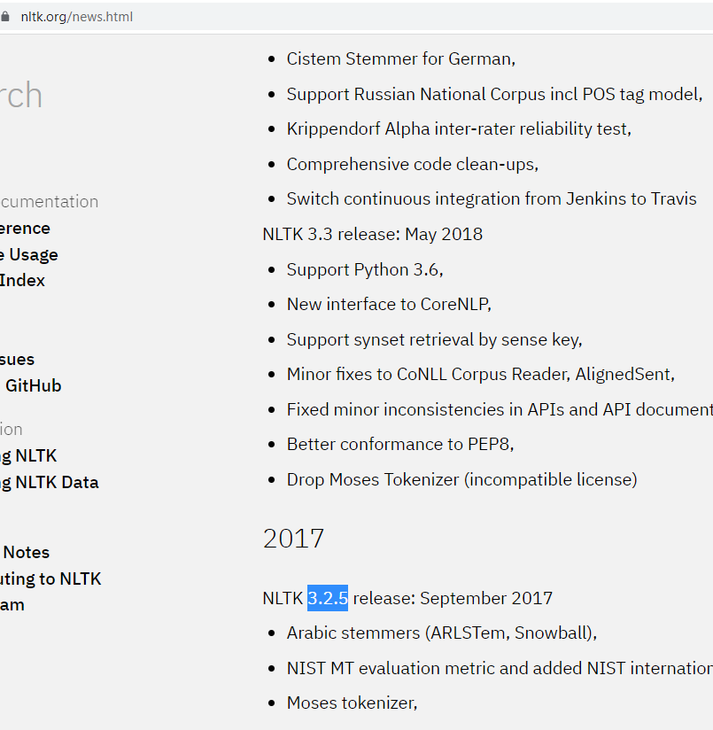

**8.3 Best Chatbot**

This Chatbot is from : **Suriaeepan**.

<https://github.com/suriyadeepan>

Easy seq2seq:

<https://blog.suriya.app/2016-06-28-easy-seq2seq/>

<https://github.com/suriyadeepan/easy_seq2seq>

Practical seq2seq

<https://blog.suriya.app/2016-12-31-practical-seq2seq/>

<https://github.com/suriyadeepan/practical_seq2seq>

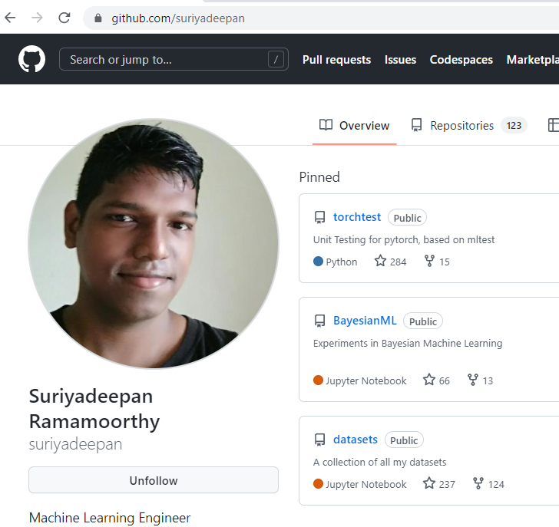

File Description:

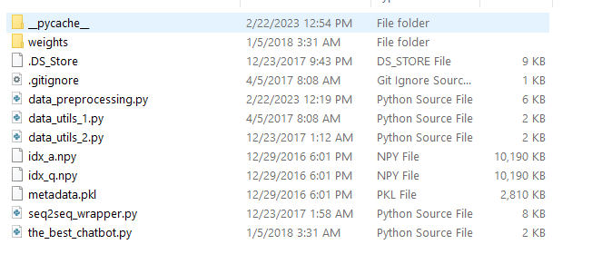

* Weights: Contains the checkpoint of the saved weights.
* Preprocess: Following three files preprocess the data.

data_preprocessing.py

data_utils_1.py

data_utils_2.py

* Dataset: Following are the dataset. It’s the "Twitter Dataset" and much better than "Movie dataset". This "Twitter Dataset" is best for general conversation.

idx_a.npy

idx_q.npy

metadata.pkl

* Train the model with following file: It contains the architecture of the seq2seq and the training mechanisms.

seq2seq_wrapper.py

* Chat with the Chabot: If we just want to talk with the chatbot, we can use following file. (No training happens).

the_best_chatbot.py

* Open Spyder from anaconda prompt on **bestCTBT** active environment.

**Running the Trained Chatbot**

# *Building The Best ChatBot with Deep NLP*

# *Importing the libraries*

**import** seq2seq_wrapper

**import** importlib

**importlib.reload**(seq2seq_wrapper)

**import** data_preprocessing

**import** data_utils_1

**import** data_utils_2

#*######### PART 1 - DATA PREPROCESSING ##########*

# *Importing the dataset*

metadata, idx_q, idx_a = **data_preprocessing.load_data**(PATH = './')

# *Splitting the dataset into the Training set and the Test set*

(trainX, trainY), (testX, testY), (validX, validY) = **data_utils_1.split_dataset**(idx_q, idx_a)

# *Embedding*

xseq_len = trainX.shape[-1]

yseq_len = trainY.shape[-1]

batch_size = 16

vocab_twit = metadata['idx2w']

xvocab_size = **len**(metadata['idx2w'])

yvocab_size = xvocab_size

emb_dim = 1024

idx2w, w2idx, limit = **data_utils_2.get_metadata**()

#*######### PART 2 - BUILDING THE SEQ2SEQ MODEL ##########*

# *Building the seq2seq model*

model = **seq2seq_wrapper.Seq2Seq**(xseq_len = xseq_len,

                                yseq_len = yseq_len,

                                xvocab_size = xvocab_size,

                                yvocab_size = yvocab_size,

                                ckpt_path = './weights',

                                emb_dim = emb_dim,

                                num_layers = 3)

#*######### PART 3 - TRAINING THE SEQ2SEQ MODEL ##########*

# *See the Training in seq2seq_wrapper.py*

#*######### PART 4 - TESTING THE SEQ2SEQ MODEL ##########*

# *Loading the weights and Running the session*

session = **model.restore_last_session**()

# *Getting the ChatBot predicted answer*

**def** **respond**(question):

    encoded_question = **data_utils_2.encode**(question, w2idx, limit['maxq'])

    answer = **model.predict**(session, encoded_question)[0]

**return** **data_utils_2.decode**(answer, idx2w)

# *Setting up the chat*

**while** **True** :

  question = **input**("You: ")

**if** question **==** "End_Chat_Now":

**break**

**else**:

      answer = **respond**(question)

**print** ("ChatBot: "+answer)

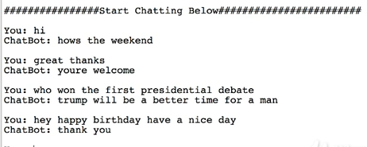

**8.4 Running Cornel movie dataset trained in TF 1.4**

* This chatbot from Abraham Sanders

<https://github.com/AbrahamSanders/seq2seq-chatbot>

<https://github.com/AbrahamSanders/seq2seq-chatbot/blob/master/seq2seq-chatbot/models/cornell_movie_dialog/README.md>

* To chat with a trained model from the model directory:

(Batch files are only available for windows as of now. For mac and linux users see instructions below for python console.)

* Make sure a model exists in the models directory (to get started, download and unzip trained_model_v2 into the seq2seq-chatbot/models/cornell_movie_dialog folder)
* For console chat:

From the model directory run chat_console_best_weights_training.bat

or chat_console_best_weights_validation.bat

* Install following packages:

pip install --upgrade jsonpickle

pip install click==6.7

pip install flask==0.12.4

pip install --upgrade flask-restful

* Open conda environment " py354TF1_4" of python 3.5.4 and TF==1.4.0

python chat.py "models\cornell_movie_dialog\trained_model_v2\best_weights_training.ckpt"

(py354TF1_4) E:\1_Development_2.0\ML_phase_4_prj_1_CtBt_NLP\seq2seq-chatbot-master\seq2seq-chatbot>python chat.py "models\cornell_movie_dialog\trained_model_v2\best_weights_training.ckpt"

