Chapter 13: Part 2

**Deep Learning**

**SOM: Revisit K-means Clustering**

Python Implementation

**13.2.1 Why Revisit K-means Clustering**

Knowing K-Means clustering will be helpful when you want to understand SOMs. *K-Means clustering* is relevant to *SOMs*. It's not exactly *identical*. But it will prepare you for understanding *SOMs*.

* In the next section we will see the process of SOM jumping around, like, *pushing* and *pulling* is happening as those *nodes*, or as those *centroids* are traveling across the *map*.
* And how they're being *pulled* and *pushed* around by the actual data points. That kind of similar process that we saw in Chapter 4.1: K-means Clustering.
* So revisiting Chapter 4.1: K-means Clustering will prepare you for the mood of what's going to be happening in SOMs,
* Also note that, K-Means clustering is a unsupervised type of algorithm. But it's not a neural network. It's just an unsupervised DL algorithm.

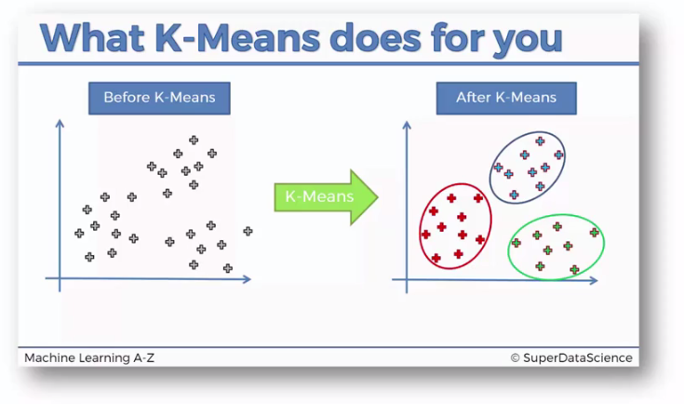

* We don’t need the python implementation (application). Just revisit the following topics.

**4.1.1 K-Means Clustering:** What is K-Means Clustering and its Steps.

**4.1.2 K-Means Clustering Example**

**4.1.3 K-Means Random Initialization Trap**

**4.1.4 Elbow-Method: Choosing K (Right Number Of Clusters)**