Chapter 4 : Part 1

**K-Means Clustering**

**4.1.1 K-Means Clustering**

*K-Means Clustering* is an algorithm that allows you to Cluster your data. *K-Means Clustering* is an *unsupervised* *learning* algorithm that is used to solve the clustering problems in *machine learning* or *data* *science*.

* *K-Means Clustering* is an *Unsupervised* *Learning* algorithm, which groups the unlabeled dataset into different clusters. Here K defines the number of pre-defined clusters that need to be created in the process, as if ***K=2***, there will be ***two*** ***clusters***, and for ***K=3***, there will be ***three*** ***clusters***, and so on.
* It is an iterative algorithm that divides the unlabeled dataset into k different clusters in such a way that each dataset belongs only one group that has similar properties.
* It allows us to cluster the data into different groups and a convenient way to discover the categories of groups in the unlabeled dataset on its own without the need for any training.
* It is a ***centroid-based algorithm***, where each cluster is associated with a centroid. The main aim of this algorithm is to minimize the sum of distances between the data-point and their corresponding clusters (centroid).
* The algorithm takes the unlabeled dataset as input, divides the dataset into k-number of clusters, and repeats the process until it does not find the best clusters. The value of k should be predetermined in this algorithm.
* The k-means clustering algorithm mainly performs following tasks:
* Determines the ***best value*** for ***K*** ***center*** ***points*** or ***centroids*** by an iterative process.
* Assigns each *data-point* to its closest *k-center*. Those *data points* which are near to the particular *k-center*, create a *cluster*.
* Hence each cluster has data-points with some commonalities, and it is away from other clusters.
* The below diagram explains the working of the K-means Clustering Algorithm:

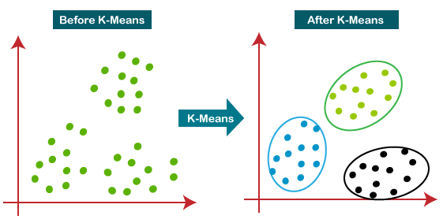

* It is a very convenient tool for discovering *categories* or *groups* in your data-set.

|  |  |
| --- | --- |
| * Let's imagine that we've got two variables in our data set and we decided to plot those two variables on ***X*** and ***Y*** axis. The question is: * How our observations are configured according to these two variables? * Can we identify certain groups among all variables? * What the *K-Means* does for you is: it takes out the complexity from this decision making process and allows you to very easily identify those clusters (actually called clusters of data points) in your data-set. |  |

* Of course this is a very simplified example, in this case we have three classes and we only have two dimensions (two variables) here. so K-means can work with multidimensional objects, there can be as many as 10 or 100 any number of variables.
* Steps of K-means Algorithm: The working of the K-Means algorithm is explained in the below steps:

1. Step-1 (Choose the number K of clusters): Select the number K to decide the number of clusters. Let's imagine that we've agreed on a *number* of *clusters* for a certain challenge, say *3* or *2* or *5* *clusters*. Once you've done that then you proceed to *step 2*.

* We'll talk more about how to select the *Optimal Number Of Clusters*.

1. Step-2: Select random K points or CENTROIDS. (It can be other from the input dataset). The random k points will be the centroid of your clusters and ***not necessarily*** these ***points have to be from your dataset***.

* As you saw we had a Scatterplot, we could select any points in that Scatterplot. The points *don't have to be part of the observations*, they can be any random ***x*** and ***y*** values on your *Scatterplot*. (As long as you just selects a ***certain number of centroids*** that are going to equate to the number of clusters that you have decided upon).

1. Step-3: Assign each data point to their Closest Centroid, which will form the ***predefined*** ***K*** ***clusters***.

* So you're starting clusters and then there's going to be an Iterative process to Refine those clusters.
* Basically so you just check for every point in a data set, which of them is the closest.
* Closest is a kind of vague term here, because it depends on what kind of distance you're measuring (is it Euclidean distances? Or some other sort of distance?).
* For the purposes of simplicity, we're going to talk about Euclidean distances (that's basically geometrical distances).

1. Step-4: Calculate the Variance and *place* a *new centroid* of each *cluster*.
2. Step-5: Repeat the 3rd steps, which means *reassign* each *datapoint* to the New Closest Centroid of each CLUSTER.
3. Step-6: If any reassignment occurs, then go to step-4 else go to FINISH.
4. Step-7: The model is ready.

**4.1.2 K-Means Clustering Example**

Now we do these steps manually to Understand the whole process:

|  |  |
| --- | --- |
| * This is our *scatterplot*. We can't just visually *identify* the final *clusters*, although it is *two-dimension* but it's pretty tough. * Now imagine how complex a situation would be if we had three or more variables !! We wouldn't even be able to plot a five dimensional scatterplot like that. * So that's where it came in is clustering comes into play and that's where this algorithm will help us simplify the process. * In this case we're actually going to manually perform the same k-means clustering algorithm (later we will do these in python/R). | K-Means Clustering Algorithm |
| 1. Let's take number ***k*** of clusters, i.e., ***K=2***, to identify the dataset and to put them into different clusters. It means here we will try to group these datasets into ***two*** different ***clusters***.  * We need to choose some ***random*** ***k*** ***points*** or ***centroid*** to form the cluster. * These points can be either the points from the dataset or any other point. So, here we are selecting the two points as k points (in the right-side figure), which are not the part of our dataset. Consider the right-side image: | K-Means Clustering Algorithm |

1. Now we will assign each data point of the scatter plot to its closest ***K-point*** or ***centroid***. We will compute it by applying some ***mathematics*** that we have studied to calculate the distance between two points. So, we will ***draw*** a ***median*** between both the ***centroids***. Consider following image.

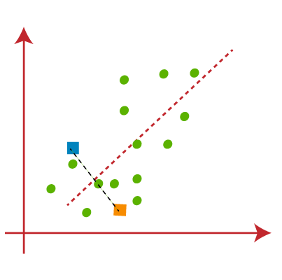

* From the above image, it is clear that points ***left*** side of the ***line*** is near to the ***K1*** or ***blue*** ***centroid***, and points to the ***right*** of the line are close to the ***yellow*** ***centroid***. Let's color them as ***blue*** and ***yellow*** for clear visualization.

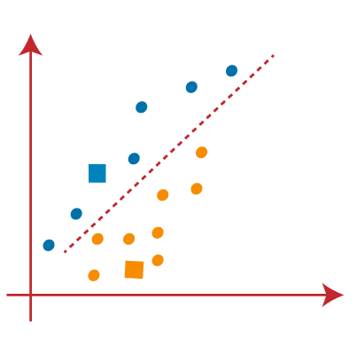

1. As we need to find the closest cluster, so we will repeat the process by choosing a new centroid. To choose the new centroids, we will compute the center of gravity of these centroids, and will find *new* *centroids* as below:

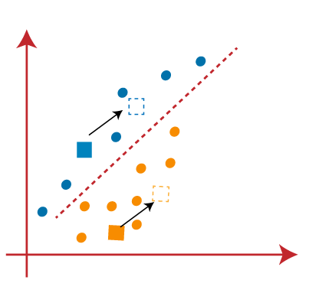

|  |  |
| --- | --- |
| 1. Next, we will ***reassign*** each ***datapoint*** to the ***new*** ***centroid***. For this, we will repeat the same process of finding a ***median*** ***line***. The median will be like right - side image:  * From the beside image, we can see, one yellow point is on the left side of the line, and two blue points are right to the line. So, these three points will be assigned to new centroids. | K-Means Clustering Algorithm |

|  |  |
| --- | --- |
| 1. As reassignment has taken place, so we will again go to the step-4, which is finding new centroids or K-points. | K-Means Clustering Algorithm |
| 1. We will repeat the process by finding the center of gravity of centroids, so the new centroids will be as shown in the right-side image: | K-Means Clustering Algorithm |
| 1. As we got the *new centroids* so again will *draw* the *median* *line* and *reassign* the *data* *points*. So, the image will be: | K-Means Clustering Algorithm |
| 1. We can see in the above image; there are no dissimilar data points on either side of the line, which means our model is formed. Consider the below image: | K-Means Clustering Algorithm |
| 1. As our model is ready, so we can now remove the assumed centroids, and the two final clusters will be as shown in the below image: | K-Means Clustering Algorithm |

**4.1.3 K-Means Random Initialization Trap**

Consider the following scatterplot. We have two variables represented by the *x* and *y* *coordinates*. Let's say we're going to choose three clusters. It does look like you can pretty easily spot them here.

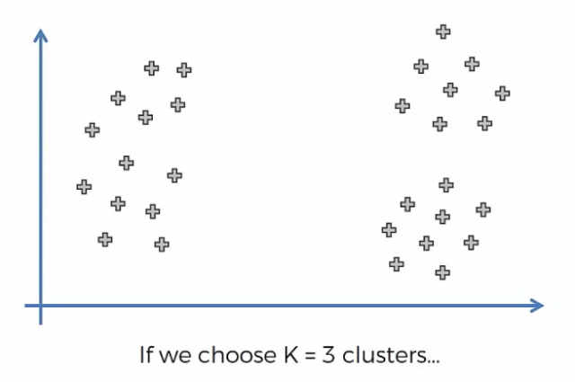

|  |  |  |
| --- | --- | --- |
|  |  |  |

* So this is the end result if we choose the ***correct random initialization*** at ***correct location***.
* However, if we select a centroid in different locations we will end up with different result. By following the steps of the algorithm we will end up as follows:

|  |  |
| --- | --- |
|  |  |
| 1. Draw the median lines | 1. Group the points |
| 1. Find new centroids | 1. Then assign the centroids to the new positions: |

* Wrong End result: Now if we draw the median lines, we can see there are no dissimilar data points. So this is the our end point. And it is the final cluster result.

|  |  |
| --- | --- |
| True Cluster | False Cluster |
|  |  |

* So you can see that the three clusters are different and therefore, the selection of the Centroid is at the very start of the algorithm can potentially dictate the outcome of the algorithm. And that's not a good thing because the centroid are selected at random.
* ***K-means++:*** There is a *modification* to the *K-means algorithm* that allows you to correctly select the Centroid called the ***K-means++*** algorithm.
* Python Scikit-learn library can handle this automatically: From above we can see that it is obviously a trap. However we not need to worry about this because, python implementation of this k-means algorithm can automatically handle this kind of "trap" situation. The good news is that ***K-means++*** algorithm happens in background in either in R or Python or whatever tool you're using. You don't need to actually implement it.

**4.1.4 Elbow-Method: Choosing K (Right Number Of Clusters)**

The performance of the *K-means clustering* *algorithm* depends upon highly efficient clusters that it forms. But ***choosing the optimal number of clusters*** is a big task. There are some *different ways* to find the *optimal number of clusters*, but here we are discussing the most appropriate method to find the number of clusters or value of K. The method is given below:

* Elbow Method: The Elbow method is one of the most popular ways to find the optimal number of clusters. This method uses the concept of WCSS value. WCSS stands for Within Cluster Sum of Squares, which defines the ***total*** ***variations*** within a cluster. The formula to calculate the value of ***WCSS (for 3 clusters)*** is given below:

Where are the data-points in corresponding Clusters and are the centroids.

* In the above formula of WCSS, Following is the *sum of the square of the distances* between each *data point* and its *centroid* within a Cluster1 and the same for the other two terms.
* To measure the distance between data points and centroid, we can use any method such as Euclidean distance or Manhattan distance.
* To find the optimal value of clusters, the elbow method follows the below steps:

1. It executes the ***K-means*** clustering on a given dataset for different ***K values*** (ranges from 1-10).
2. For ***each*** value of ***K***, calculates the ***WCSS*** value.
3. Plots a ***curve*** between calculated ***WCSS*** values and the ***number*** of clusters ***K***.
4. The ***sharp point*** of ***bend*** or a ***point*** of the ***plot*** looks like an ***arm***, then that point is considered as the ***best*** value of ***K***.

|  |  |
| --- | --- |
| * Since the graph shows the sharp bend, which looks like an elbow, hence it is known as the elbow method. The graph for the elbow method looks like the right side image: * Maximum number of Clusters: We can choose the number of clusters equal to the given data points. If we choose the number of clusters equal to the data points, then the value of WCSS becomes zero, and that will be the endpoint of the plot. * Actually we can set the K for which WCSS decrease rapidly and after that certain number the WCSS won't change rapidly. | K-Means Clustering Algorithm |

* WCSS value is a metric: We need a certain metric so that we can understand or evaluate how a certain number of clusters performs compared to a different number of clusters (and preferably that metric should be quantifiable).

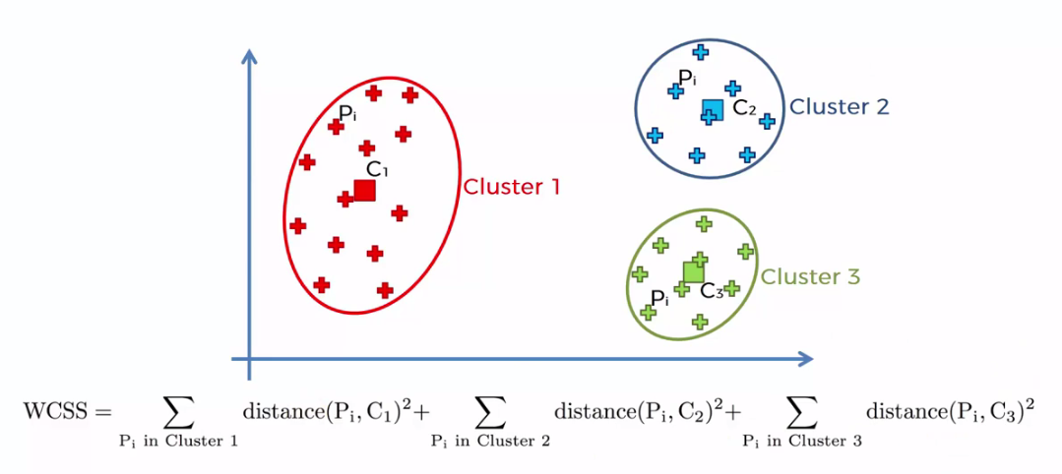

* Actually it's a quite a good metric in terms of understanding or comparing the goodness of fit between two different K-means clusterings.
* Let's see how that metric ***WCSS*** is going to change as we ***increase*** the ***number*** of ***clusters***.
* If we use one centroid in the middle, the distance from each data point is big and the squared distance will be very large.

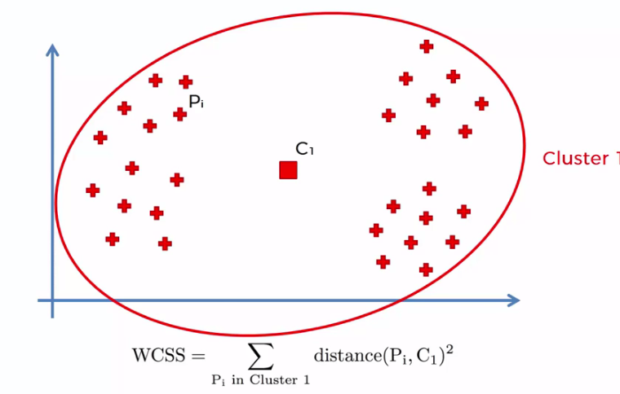

* If we have 2 clusters then the squared distance reduces.

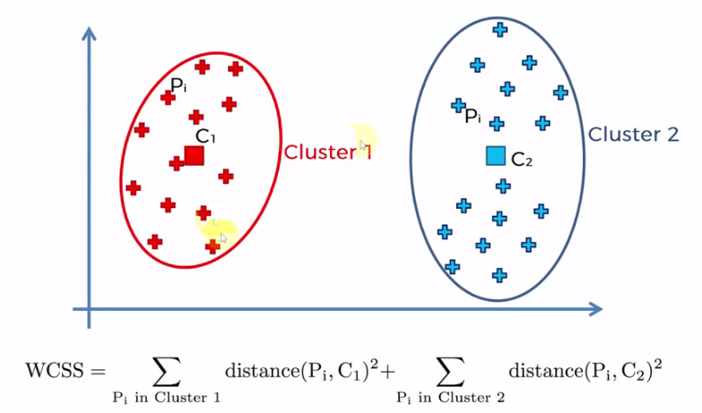

* For 3 clusters we get more reduced ***WCSS***. And for 4, 5, or more ***centroid*** the distance doesn't decrease ***rapidly*** (but it decreases). The WCSS tends to ***0*** as ***K*** reaches to ***number of data points***.



* So the *Elbow-method* is just an approach that can help you to decide the number of k (number of clusters). But at the end of day it is your decision.

**4.1.5 Python Implementation of K-means Clustering**