Chapter – 9

**Neural Networks for Machine Learning**

**Geoffrey Hinton**

with **Nitish Srivastava** & **Kevin Swersky**

**Regularization**

Lectures: Geoffrey Hinton

Overview of ways to *improve generalization*

*Limiting the size* of the *weights*

Using noise as a regularizer

Introduction to the Full Bayesian Approach

The Bayesian interpretation of weight decay

*MacKay's quick and dirty method*

**9.1 Overview of ways to improve generalization**

In this section, we're going to discuss about *improving generalization* by reducing the *overfitting* that occurs when a *network has too* *much capacity* for the amount of data it's given during training.

* We'll discuss various ways of controlling the *capacity* of a network.
* And we'll also discuss how we determine & how to set the *meta parameters* when we use a method for *controlling capacity*. I'll then go on to give an example where we control capacity by *stopping the learning early*.
* **Reminder: Overfitting**
* ***The reason we get over-fitting:*** The training data contains *information about the true regularities* in the *mapping from input to output*. But any finite set of training data also contains *sampling error*.
* There will be *accidental regularities* in the training set, just because of the particular training cases were chosen.
* So when we fit the model to the training set, it can't tell which of the *regularities are real* (it'll exist if we sampled the training set again), and which are caused by the *sampling error*.
* Hence, the model fits both kinds of regularity. And if the model is very flexible, it'll *fit the* ***sampling error*** *really well*, and then it'll ***generalize badly***.
* i.e. if you fitted the model to another training set drawn from the same distribution over cases, it would make different predictions on the test data. This is called “variance”.
* **Use following approaches to prevent OVERFITTING**
* ***Approach 1: Get more data!***
* This method is by far the best. And it's simply to get more data, if *data is cheap* and you have *enough compute power to train* on more data.
* Data has exactly the right characteristics to prevent over fitting. The more of it you have the better.
* ***Approach 2: Use a model that has the right capacity***
* We try to judiciously *limit the capacity of the model* so that it's got *enough capacity* to fit the *true regularities* but *not enough capacity* to fit the *spurious regularities* (if they are weaker) caused by the *sampling error*.
* It's not so easy; there are various approaches to regulate the capacity appropriately.
* ***Approach 3: Average many different models***
* *Use models with different forms:* Another way is to *averaging* together *many different models*. If we average models that have *different forms* and make *different mistakes*, the *average* will do better than the individual models.
* *Train the model on different subsets of the training data:* We could make the models different just by *training* them on *different subsets* of the *training data*. This is a technique called bagging.
* There's also other ways to mess with the training data to make the models as different as possible.
* ***Approach 4: Average the predictions from different weights (Bayesian)***

Use *single neural network architecture*, but average the predictions made by many different weight vectors.

* It is a Bayesian approach; we'll use *single neural network architecture*, but to find many *different sets of weights* that do a good job of predicting the output.
* And then on *test data*, you *average the predictions* made by all those different *weight vectors*.
* **Some ways to limit the capacity of a neural net**

There's many ways to control the capacity of a model.

* ***Architecture:*** Control the capacity of a model by modifying the architecture. We can *limit* the number of *hidden layers*, and the *number of* *units (neurons)* per layer.
* And those control the *number of connections* (i.e. the number of parameters) in the network.
* ***Early stopping:*** Start with *small weights* and *stop* the learning before it *overfits*.
* Assuming that it finds the *true regularities* before it finds the *spurious regularities* in that particular training set we have.
* ***Weight-decay:*** Penalize large weights using penalties or constraints on their squared values or absolute values.
* A very common way to control the capacity of a neural network is to give it a *number of hidden layers or units per layer is a little too large*, but then to *penalize* the *weights* using penalties or constraints using *squared values* (L2 penalty) or *absolute values* (L1 penalty) of the *weights*.
* ***Noise:*** we can control the capacity of a model by adding *noise to the* ***weights***, or by adding *noise to the* ***activities***.

Typically, we use a combination of several of these different capacity control methods.

* **How to choose meta parameters that control capacity**
* Hyperparameters: Hyperparameters *can't be learned using the algorithm* that needs them, but they must be *tuned* before the training (manually or automatically). Hyperparameters are also named as Meta-parameters, Free-parameters or Tuning-parameters.
* To control the model capacity, some Hyperparameters or Meta Parameters for example are the *number of hidden units* or the *size of the weight penalty*.
* For most of the above methods (to limit the capacity of a neural net), there are some *meta-parameters* that we have to set. Like the number of hidden units, or the number of layers, or the size of the weight penalty.
* An obvious **wrong-way** to set those meta-parameters is: to *try lots of different values of one of the meta parameters*, for example, the number of hidden units, and see which gives the *best performance* on the *test set*.
* This is easy to do, but there's something ***deeply wrong*** with that.
* It gives a ***false impression*** of how well the method will work if you give it another test set.
* So the settings that work best for *one particular test set* are ***unlikely to work*** as well on a *new test set* that's drawn from the *same* *distribution* because those *meta-parameters* been *tuned* to that *particular test set*. And that means you get a *false impression* of how well you would do on a *new test set*.
* ***An extreme example:*** Suppose the test set has random answers that *do not depend* on the input or *can't be predicted* from the inputs. (quite a lot of financial data seems to be like that).
* If you choose the model that does best on test set, that will obviously do better than chance on the test set.
* But if we take that model and try it on *new data that's also random*, we can't expect it to do better than chance on that *new test set*.

So by selecting a model, we got a false impression of *how well a model will do on new data* and the question is: *Is there a way around that?*

* **Cross-validation: A better way to choose meta parameters**
* ***Cross validation:*** Cross validation is a better way to *choose* the *meta-parameters*. You start by dividing the total data set into *three subsets*.
* **Training Data:** It is used to train our model, i.e. the *training data* is used for *learning the parameters* of the model.
* **Validation Data:** Validation data is *not* used for *learning (training)* but is used for ***deciding*** what *settings* of the *meta parameters* work best.
* By observing how well the model does on the *validation data*, we decide the *appropriate number* of *hidden units* or an *appropriate size* of *weight penalty*.
* **Test Data:** Test data is used to get a *final, unbiased estimate* of how well the network works. We expect this *estimate* to be *worse than* on the *validation data*.
* After we get our trained model *(with what looks like the best number of hidden units and the best weight penalty)*, we're then going to use the ***test data*** to see how well our ***trained-model*** does.
* We must only *use* that *data once*. And that'll give us an unbiased estimate of how well the network works.
* In general that *estimate* will be a *little worse* than on the *validation data*.

Nowadays in competitions, the people organizing the competitions have learned to hold back *that true test data* and get people to send in predictions so they can see whether they *really can predict* on *true test data*, or whether they're just *over-fitting* to the *validation data* by selecting *meta-parameters* that do particularly *well on the* ***validation data*** but *won't generalize to* ***new test sets***.

* ***N-fold cross-validation:*** One way we can get a better *estimate* of our *weight penalties* or number of *hidden units* or anything else we're trying to fix using the *validation data*, is to ***rotate*** the ***validation set***.
* So, we still use a final *test set* to get our *final unbiased estimate*. But we divide the *other data* into *N equal sized subsets* and we train on all but one (i.e. train on all N-1 subsets) of those N subsets, and use the Nth-subset as a *validation set*.
* The point is: we can *rotate* and a hold back a *different subset* as a *validation set*, and so we can get *many different estimates* of what the *best weight penalty* is, or the *best number of hidden units* is.
* By rotating the validation set, we get *N different estimates* of the *validation error rate*.
* This is called ***N-fold cross-validation***.
* It's important to remember, the N different estimates we get are not independent of one another.

If for example, we were really unlucky and *all the examples of one class* fell into one of those *subsets*, we'd expect to generalize very badly.

* Whether that subset was the *validation subset* or whether it was in the *training data*.
* **Preventing overfitting by early stopping**

If we have ***lots of data*** and a ***big model***, it's very expensive to keep *re-training* it with different sized penalties on the *weights* or different *architectures*.

Early stopping is one particularly easy to use method for *preventing overfitting*.

* It's good when you have a *big model* on a *small computer* and you don't have the time to train a model many different times with different numbers of *hidden units* or different size *weight penalties*.
* What you do is:
* You start with *small weights*, and as the model *trains*, they *grow*.
* You watch the ***performance*** on the ***validation set***. And as soon as it starts getting worse, you *stop training*.
* Now, the *performance* on the *validation set* may fluctuate, particularly if you're *measuring an* ***error rate*** rather than a ***squared error*** or ***cross-entropy error***.
* *It can be hard to decide when performance is getting worse:* So it's hard to decide when to stop and so what you typically do is: keep going until you're sure *things are getting worse* and then go *back* *to the point* at which things *were best*.
* *The capacity of the model is limited because the weights have not had time to grow big:* The reason this controls the capacity of the model, is because *models with small weights* generally don't have as *much capacity*, and the *weights* haven't had time to *grow* big.
* **Why early stopping works**

It's interesting to ask why smaller weights lower the capacity of the network?

|  |  |
| --- | --- |
| * Let's consider a model with some *input units*, some *hidden units*, and some *output units*. * When the weights are very small, if the hidden unit is a logistic units, their total inputs will be close to zero, and they'll be in the middle of their linear range. * With very small weights every hidden unit is in its linear range, i.e. they'll behave very like linear units. |  |

* What that means is, when the weights are small, the whole network is the same as a linear network that maps the inputs straight to the outputs.
* *So even with a large layer of hidden units it’s a linear model:* So, if you multiply that weight matrix **W1** by that weight matrix **W2**, you'll get a *weight matrix* that you can use to *connect* the *inputs* to the *outputs*
* And provided the *weights are small*, a net with a *layer of logistic hidden units* will behave pretty much the same as that *linear net*.
* Provided we also *divide the weights* in the *linear net* by *four*, to take into account the fact that when the *hidden units* there, in that ***linear*** ***region***, and they have a *slope of a quarter*.
* So it's got *no more capacity* than the *linear net*, so even though there's $3×6+6×2$ weights, it's really got no more capacity than a network with $3×2$ weights (in which the inputs are directly connected to the outputs).
* As the weights grow, we start using the *non-linear region* of the sequence (the *hidden units* start using their *non-linear ranges* so the capacity grows). And then we start making use of all those parameters.
* So if the network has *6 weights* at the *beginning* of learning and has *30 weights* at the *end* of learning, then we could think of the *capacity* as *changing smoothly* from *6 perimeters* to *30 perimeters* as the *weights get bigger*.

What's happening in ***early stopping*** is: we're *stopping the learning* when it has the *right number of parameters* to do as well as possible on the *validation data*. That is when it's *optimized* the *trade-off* between *fitting* the *true regularities* in the data and *fitting* the *spurious* *regularities* that are just there because of the particular training examples we chose.

**9.2 Limiting the size of the weights**

In this section, we'll discuss about how we can *control capacity of a neural net* by limiting the ***size*** of the ***weights***.

* The standard way to do this is to introduce a **penalty** that prevents the weights from getting **too large**. With the implicit assumption that: *a network with small weights* is somehow *simpler* than a *network with large weights*.
* There are several different *penalty terms* we can use.
* We can also *constrain the weights*, so that the *incoming weight vector* to each of the *hidden units* is *not allowed* to be *longer* than a *certain length*.
* **Limiting the size of the weights**
* The standard way to *limit* the *size of the weights*, is to use an ***L2 weight penalty***, which means that we ***penalize*** the *squared value of the weights*.
* Sometimes it's called ***weight decay*** in the neural network literature, because the ***derivative*** *of that* ***penalty*** acts like a force pulling the weight towards zero.
* This *weight penalty* keeps the *weight small*, unless they have *big error-derivatives* to *counter-act* it.
* The *standard L2 weight penalty* involves adding an *extra term* to the *cost function* that *penalizes* the *squared weights*.
* So if you look at what the ***penalty term*** looks like, as the *weight* *moves away from zero*, you get following ***parabolic cost***.

|  |  |
| --- | --- |
| * If you look at the equation, the ***cost*** that you're *optimizing* is the ***normal error*** that you're trying to *reduce*, plus a term which is the *sum of the* ***squares of the weights***, with a coefficient in front, ***Lambda***, and we *divide by 2* so that when we *differentiate* the *2 is cancelled*. * That ***coefficient*** in front of the *summed* ***squared weights*** is sometimes called the ***weight cost***. That determines how *strong* the *penalty* is. |  |
| $$C=E+\frac{λ}{2} \sum_{i}{w_{i}^{2}}$$ $$\frac{∂C}{∂w_{i}}=\frac{∂E}{∂w_{i}}+ λw_{i}$$* If you differentiate, you can see the *derivative* of this *cost* is just the *derivative of the error* plus something that's to do with the *size of the weight and the value of Lambda*. |  |

* That *derivative* will be zero (i.e. $\frac{∂C}{∂w_{i}}=0$) when the *magnitude of the weight* is: $w_{i}= -\frac{1}{λ}\frac{∂E}{∂w_{i}}$
* *This keeps the weights small unless they have big error derivatives:* So the only way you can have *big weights*, when you're at a *minimum of the cost function*, is if they also have *big error derivatives*. And this makes the *weights* much *easier to interpret*. You don't have a whole *lot of weights* that are *large* but *aren't doing anything*.
* **The effect of L2 weight cost**

The effect of an ***L2 penalty*** on the *weights* is to *prevent* the network from using *weights that it doesn't need*. This often improves generalization a lot, because it can use those weights that it doesn't really need to fit the sampling error.

* So it helps to stop the network from fitting the sampling error.
* It also makes a smoother model in which the output changes more slowly as the input changes.

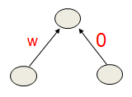 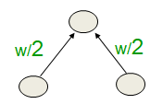

* So if the network has *two* very *similar inputs*, when you put in an L2 weight penalty, it prefers to *put* ***half*** *the* ***weight*** on each of those two *similar inputs* rather than all of the weight on one, as shown on the right here.
* If the two inputs are very similar, those two networks will produce very similar outputs.
* But the one with the *halved-weights* will have *much less extreme changes* in its outputs when you change the inputs.
* **Other kinds of (L1) weight penalty**

There are other kinds of weight penalty. For example, an L1 penalty, where the *cost function* is just like V ***shape***.

|  |  |
| --- | --- |
| * ***V-shaped cost-function:*** In the *V-shaped cost-function*, we're penalizing the *absolute values* of the weights. Sometimes it works better to *penalize the* ***absolute values*** of the ***weights***. * This has the nice effect that it drives *many of the weights* to be exactly *zero* and that helps a lot in interpretation. If there's only a *few non-zero weights* left, it's much *easier to understand* what's going on. |  |
| * ***More extreme weight penalties:*** We can also use weight penalties that are *more extreme than L1* where the *gradient* of the *cost function* actually gets *smaller* when the *weight gets really big*. That kind of weight penalty has ***negligible effect*** on ***large weights***. * This allows the network to *keep large weights* without them being *pulled towards zero*. * It's just the *small weights* that'll get *pulled towards zero*. That's how it'll help us getting a ***few large weights***. |  |

* **Weight penalties vs weight constraints**

Instead of putting penalties on the weights, we could actually use weight constraints. That is instead of *penalizing the squared value of each weight separately*, we put a *constraint* on the *maximum squared length of the incoming weight vector* of each *hidden unit* or *output* *unit*.

* When we update the weights, if the ***length*** of that incoming vector gets longer than allowed by the constraint, we simply *scale the vector* *down* by ***dividing*** all the weights by the same amount until its length *fits the allowed length*.
* We usually **penalize** the squared value of each weight separately.
* Instead, we can put a **constraint** on the maximum squared length of the incoming weight vector of each unit.
* If an update violates this constraint, we scale down the vector of incoming weights to the allowed length.
* Using *weight constraints* has a number of advantages over *weight penalties*.
* *Its easier to set a sensible value:* It's much easier to select the *sensible value* for the *squared length* of the *incoming weight vector* than it is to select the *weight penalty*.
* That's because, logistic units have, a *natural scale* to them so we know what a "weight of 1" means.
* *They prevent hidden units getting stuck near zero:* Using weight constraints also *prevents* hidden units *getting stuck near zero* with all their *weights* being *tiny* and *not doing anything useful*.
* Because when all their *weights are tiny*, there's *no constraint* on the weights. So there's nothing preventing them from *growing*.
* *They prevent weights exploding:* Weight constraints also prevent the weight from *exploding*.
* One of the subtle things that weight constraints do is that: when a unit *hits* its *constraint* (hits it’s limit), the *effective weight penalty* on all of its *weights* is determined by the *big gradients*.
* So if some of the *incoming weights* have very *big gradients*, they'll be trying to ***push*** the length of the incoming weight vector ***up***. And that will ***push down*** on all the other weights.
* In effect, if you *think* of it *like a penalty*, the *penalty scales itself* so as to be *appropriate* for the *big weights* and to *suppress* the *small* *weights*.
* This is more effective than a fixed penalty at pushing irrelevant weights towards zero.
* ***Using Lagrange multipliers:*** For those of you who know about *Lagrange multipliers*, the *penalties* are simply the *Lagrange* *multipliers* required to keep the *constraints satisfied*.
* Lagrange multipliers can be used to *handle weight constraints*. When you want to enforce certain constraints on the weights (like keeping their *norm* below a *specific threshold*), you can formulate this as an *optimization problem*.
* The Lagrange multipliers would then *represent the penalties* applied to the objective function to ensure that the *constraints* are *satisfied* during training.
* This approach helps balance the *trade-off* between *minimizing the loss* and *adhering to the weight constraints*.

**9.3 Using noise as a regularizer**

In this section we'll discuss *another way of restricting* the *capacity* of a *neural network*. The idea is ***"adding noise"***, either to the *weights* or to the *activities*.

* Firstly, if we add noise to the inputs in a *simple linear network*, that's trying to minimize the ***squared error***, that's exactly equivalent to imposing an ***L2 penalty*** on the weights of the network.
* Next we'll discuss the uses of noisy weights in more complicated networks.
* Lastly we'll see a recent discovery that extreme noise in the ***activities*** can also be a very good ***regularizer***.
* **L2 weight-decay via noisy inputs**

So let's look at what happens if we add Gaussian noise to the *inputs* to a *simple neural network*.

* The **variance** of the noise gets amplified by the *squared weights* on the *connections*, before going into the *next hidden layer*.
* If we have a very *simple net*, with just a *linear output unit* that's directly *connected* to the *inputs*, the amplified noise then gets *added* to the *output*.

|  |  |
| --- | --- |
| * So if you look at the diagram, we put in an input $x_{i}$ with additional Gaussian noise $N\left(0, σ_{i}^{2}\right)$ that's sampled from a Gaussian with mean $0$ and variance $σ_{i}^{2}$. * That additional noise has it's *variance* multiplied by the *squared weight*. It then goes through the linear output unit $j$. And so what comes out of $j$ is: the $y_{j}$ (would have come out before) plus Gaussian noise $N\left(0, w_{i}^{2}σ_{i}^{2}\right)$ that has mean $0$ and variance $w_{i}^{2}σ_{i}^{2}$.   Input: $x_{i}+ N\left(0, σ_{i}^{2}\right)$ Output: $y_{j}+ N\left(0, w_{i}^{2}σ_{i}^{2}\right)$  * This *additional variance* makes an *additive contribution* to the *squared error*. You can think of it like **Pythagoras theorem**, that the ***squared error*** is going to be the ***sum*** of the ***squared error*** *caused by $y_{j}$* , and this ***additional noise $N\left(0, w_{i}^{2}σ_{i}^{2}\right)$*** , because the *noise* is independent of $y_{j}$. * So *minimizing the squared error* tends to *minimize the squared weights* when the *inputs* are *noisy*. |  |

* When we *minimize* the *total squared error*, we'll *minimize* the *squared error* that will come out if it was a *noise-free system*. And in addition, we'll be minimizing that second term.
* i.e. we'd be minimizing the *expected squared value* of that *second term* and the expected squared value is just $w_{i}^{2}σ_{i}^{2}$, so that corresponds to an L2 penalty on $w_{i}$ with a penalty strength of $σ_{i}^{2}$.

Derivation

* Following is the derivation of that:
* The *output*, $y^{noisy}$, when we add *noise* to all of the *inputs*, is:
 $$output on one case→ y^{noisy}= \sum_{i}{w_{i}x_{i}}+ \sum_{i}{w_{i}ε_{i}} , where ε_{i} is sampled from N\left(0, σ_{i}^{2}\right)$$

 $\sum_{i}{w_{i}x_{i}}$ + : the *output* would have been with *noise-free system* i.e. the sum of all the inputs $w_{i}x_{i}$,
  + $\sum_{i}{w_{i}ε_{i}}$: is the sum of $w_{i}$ times the noise $ε_{i}$ that we added to each input.
  + And those *noises* are sampled from a *Gaussian* with mean $0$ and variance $σ_{i}^{2}$.
* So if we compute the *Expected Squared Difference* between $y^{noisy}$ and the *target value $t$* , that's the quantity that's shown on the left-hand side of the equation.
$$E\left[{\left(y^{noisy}- t\right)}^{2}\right]= E\left[{\left(y+\sum_{i}{w_{i}ε_{i}}- t\right)}^{2}\right]= E\left[{\left(\left(y- t\right)+\sum_{i}{w_{i}ε_{i}}\right)}^{2}\right]$$

* We're using $E$ followed by $[ ]$, i.e. $E[ ]$ to denote an ***expectation***, so it's not the *error*, it's an *expectation*.
* We're computing the *expectation* of the *things in the square brackets*. In this case, we're computing the *expectation of the squared error* that we'll get with the *noisy system*.
* So if we substitute the equation above for $y^{noisy}$, with $y+\sum_{i}{w_{i}ε_{i}}$, then after calculating the square we get:
$${\left(y- t\right)}^{2}+E\left[\left(2\left(y- t\right)\sum_{i}{w_{i}ε_{i}}\right)\right] + E\left[{\left(\sum_{i}{w_{i}ε_{i}}\right)}^{2}\right]$$

* ${\left(y-t\right)}^{2}$ isn't inside of *expectation bracket* because it doesn't involve any ***noise***.
* The second term is the cross product of $\left(y- t\right)$ and $\sum_{i}{w_{i}ε_{i}}$ the third term is the square of $\sum_{i}{w_{i}ε_{i}}$.
* Now that equation simplifies a lot. In fact, it simplifies down to the *normal squared error* plus the expectation of $\sum_{i}{w_{i}^{2}ε_{i}^{2}}$.

|  |  |
| --- | --- |
| $${\left(y- t\right)}^{2} + E\left[\sum_{i}{w_{i}^{2}ε_{i}^{2}}\right]$$ | The reason it simplifies is because $ε_{i}$ is independent of $ε_{j}$ and $ε_{i}$ is independent of $\left(y-t\right)$. |

* So if you look at the last term, when we *multiply at that square*, all of the *cross terms* have an *expected value of zero*. Because we're *multiplying* together *two independent things* that are zero mean (because $ε_{i}$ is independent of $ε_{j}$).
* If you look at the *middle term*, that also has an *expectation of zero*, because each of the $ε_{i}$ is independent of the residual error $\left(y-t\right)$.
* Now we can rewrite the *expectation* of $\sum_{i}{w_{i}^{2}ε_{i}^{2}}$ i.e. $E\left[\sum_{i}{w_{i}^{2}ε_{i}^{2}}\right]$, as simply $\sum_{i}{w_{i}^{2}σ_{i}^{2}}$, because the *expectation* of $ε_{i}^{2}$ is just $σ_{i}^{2}$, because that's how we generated $ε_{i}$.

$${\left(y- t\right)}^{2} + \sum_{i}{w_{i}^{2}σ_{i}^{2}}$$

And so we see that the *expected squared error* we get is just the *squared error* we get in the *noise free system* plus this additional term $\sum_{i}{w_{i}^{2}σ_{i}^{2}}$. And that looks just like an L2 penalty on the $w_{i}$ with the $σ_{i}^{2}$ being the strength of the penalty.

So, $σ_{i}^{2}$ is equivalent to an L2 penalty.

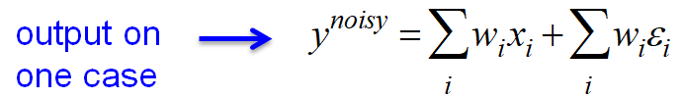

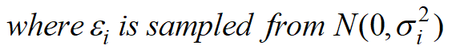

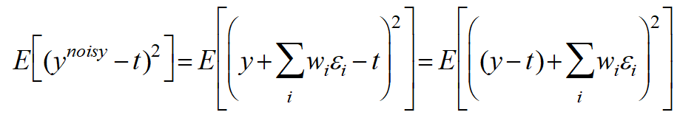

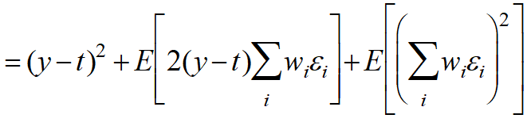

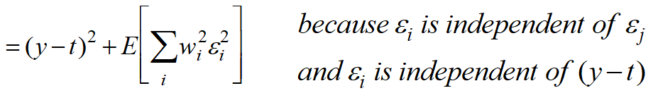

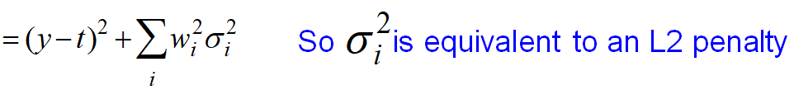

* **Noisy weights in more complex nets**
* In more complex nets, we can *restrict* the *capacity* by adding *Gaussian noise* to the *weights*.
* This is *not exactly equivalent* to *an L2 penalty*. But it seems actually to work better, especially in *Recurrent Networks*.
* *Alex Graves’ recurrent net* that recognizes handwriting, works significantly better if noise is added to the weights.
* **Using noise in the activities as a regularizer**

We can also use *noise* in the *activities* as a *regularizer*. Suppose we use *backpropagation* to train a multilayer neural net composed of *logistic hidden units*.

* What's gonna happen if we make the units *binary & stochastic* on the *forward pass* but then we do the *backward pass* as if we'd done the *normal deterministic forward pass* using the *real values*?
* So we're going to treat a *logistic unit*, in the *forward pass*, as if it's a *stacastic binary neuron*. That is, we compute the output of the **logistic p**, and then we treat that **p** as the probability of outputting a one (i.e. $p\left(s=1\right)$).
* And in the *forward pass*, you make a *random decision* whether to output a *one* or a *zero* using that *probability*.

|  |  |
| --- | --- |
| $$p\left(s=1\right)=\frac{1}{1+e^{-z}}$$* But in the *backward pass*, you use the **real value of p** for *back propagating derivatives* through the *hidden unit*. * This is *not exactly correct*, but it's *close* to being a *correct thing* to do for the stochastic system *if all of the units make small contributions to each unit in the layer above*. |  |
| * When we do this, the ***performance*** on the *training set* is *worse* and *training* is considerably *slower*. It may be several times slower. * But it does significantly *better* on the *test set*. This is currently an unpublished result. |  |

**9.4 Introduction to the Full Bayesian Approach**

In this section, we'll discuss the *Bayesian Approach* to *fitting models*, using a simple *coin tossing* example.

The main idea behind the Bayesian Approach is: instead of looking for the *most likely settings* of the *parameters* of the model, we should consider *all possible settings* of the *parameters* and try to *figure out* for *each of those possible settings*, how *probable* ***it*** is, given the data we observed.

* **The Bayesian framework**

The Bayesian framework assumes that we always have a *prior distribution* for *everything* (we always start with a belief about *how likely* an *event* is).

* This means that for any event, no matter what it is, we have to *assign an initial estimate* of how likely we think it is to happen, even before seeing any data.
* That is, for any *event* we might care to *mention*, we *must have* some *prior probability* that the event might happen.
* The prior might be very vague. So what's happening is, our *data* gives us a *likelihood term*. We combine it with our *prior* and then we get a *posterior*.
* When we see some data, we combine our *prior distribution* with a *likelihood term* to get a *posterior distribution*.
* The *likelihood term* takes into account *how probable* the *observed data* is given the *parameters of the model*.
* The *likelihood term* favors *settings of our parameters* that make the data more likely.
* It can disagree with the prior.
* *With* ***enough data*** *the* ***likelihood terms*** *always wins:* If we get enough data, however unlikely the prior is, the data can overwhelm it. And in the end, with enough data, the *truth will out*. That is, even if your *prior's wrong*, you'll end up with the *right hypothesis*.
* But that may take an *awful lot of data* if you thought that things were very *unlikely* under your *prior*.

Note: Prior vs Posterior

* ***Prior Distribution:*** The prior distribution represents your *initial beliefs* about a parameter or variable *before observing any data*. It reflects what is known or assumed about the parameter based on *previous knowledge or intuition*, without considering *new evidence*.
* Example: If you’re *estimating* the probability of a coin landing *heads*, you might initially assume a 50% chance, reflecting your *prior belief* (assuming the coin is fair).
* ***Posterior Distribution:*** The posterior distribution represents the updated beliefs about a parameter after observing the data. It combines the prior distribution with the new data (likelihood) using Bayes' Theorem to update the understanding of the parameter.
* Example: After *flipping the coin multiple times* and observing more heads than tails, your *posterior distribution* will adjust to reflect the higher likelihood of the coin being *biased toward heads*.

In simple terms, the prior is what you believe before the data, and the posterior is what you believe after seeing the data.

* **A coin tossing example**

Let's use a *coin toss* as an example. Imagine we *don’t know much about coins*, other than the fact that tossing a coin results in either **heads** or **tails**.

* We assume:
* The probability of getting heads is some unknown value **p**.
* The probability of getting tails is **1-p**.
* Each coin toss is an *independent decision*, meaning the *outcome of one toss* doesn’t affect the *outcome of the next*.
* So our coin model has one parameter **p**, which represents the probability of getting heads.
* Now, if we *toss* the coin *100 times* and get *53 heads*, what would be a good *estimate* for p? Most would suggest **p = 0.53** (since 53 out of 100 tosses were heads). But why is that a good estimate?
* The *frequentist approach* (or *maximum likelihood*) suggests choosing the value of p that makes the *observations* most *probable* (53 heads out of 100 tosses). In this case, **p = 0.53** is that value. Let’s go ahead and derive why this is true.

Derivation: coin tossing

* Let's consider $P(D)$ is the probability of a particular sequence that contains *53 heads* and *47 tails* and it could be written out by:
$$P\left(D\right)=p^{53}{\left(1-p\right)}^{47}$$

* p every time you *toss a head* And 1-p every time you *toss a tail*. And then if we *collect* all the p 's together, and all the 1-p's together, we get $p^{53}$, and ${\left(1-p\right)}^{47}$.
* If we now ask, how does the *probability of observing that data depend on* p, we can differentiate $P(D)$ with respect to p, and we get the expression shown below:
$$\frac{dP\left(D\right)}{dp}=53p^{52}{\left(1-p\right)}^{47}-47p^{53}{\left(1-p\right)}^{46}=\left(\frac{53}{p}-\frac{47}{1-p}\right)p^{53}{\left(1-p\right)}^{47}$$

$$=0 if p=0.53$$

* If we then set that derivative to *zero*. We discover that the *probability of the data* is *maximized* by setting p=0.53. So that's *maximum* *likelihood*.

|  |
| --- |
|  |

* **Some problems with picking the parameters that are most likely to generate the data**

There are some problems with using *maximum likelihood* to determine the *parameters* of a model.

* ***Is p=1 a sensible answer?:*** For example, suppose we *tossed* a coin just once and it landed *heads*.
* It doesn't really make sense to conclude: *"We believe the probability of the coin landing* ***heads*** *in the future is 1"*. That would imply we'd be willing to bet at infinite odds that it will *never land* ***tails***, which seems absurd.
* ***Surely p=0.5 is a much better answer:*** It's sort of intuitively obvious that a better answer is 0.5. But how can we justify that?
* More importantly, we can ask, *"Is it reasonable to give a single answer?"*
* If we don't have much data, we don't know much, so we're *uncertain* about the value of *p*. What we really should do is *avoid giving a single answer* and instead provide a *probability distribution* over *possible answers*.
* Our computations of probabilities will work much better if we take this uncertainty into account.
* A answer like 0.5 is fairly likely, while a answer like 1 is still quite unlikely, especially if we have a *"prior belief"* that coins land ***heads*** about *half the time*."
* **Using a distribution over parameter values**

Let’s go through an example where we begin with a *prior distribution (an initial guess)* about the value of a parameter, like p (the probability of heads). We'll choose a *simple prior distribution*, even if it doesn't perfectly match what we believe about coins.

* Then we'll show how that *prior distribution* get *modified by data* if we adopt the Bayesian Approach (i.e. after we look at the data, like the coin toss results).
* We’ll start with a *prior distribution* that assumes *"all the different values of p (the probability of heads) are equally likely"*. This means we believe coins can have *any degree of bias*, and each type of bias is equally possible. For example, some coins might *land heads 50% of the time*, while others might *land heads 100% of the time*, and we think both are equally likely.
* So we start with a *prior distribution over p*. In this case we used a *uniform distribution*.

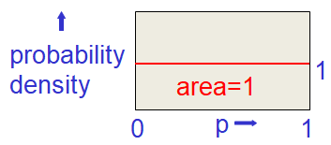

* Multiply the *prior probability of each parameter value* by the *probability of observing a head given that value*: Now let's observe a *coin landing heads*. So what we do now is: *for each possible value of p (the probability of getting heads), we take its* ***prior probability*** *and we multiply by the* ***probability*** *that we would have observed a head, given that, that value of p is the correct one.*
* So, for example, if we take the value of **p=1** which says *coins come down heads every time* then the *probability of observing a head* would be **1** (there would be no alternative). And if we take the value of **p** to be **0** the *probability of observing a head* would be **0**.
* And if we take it to be **p=0.5**, the *probability of observing head* would be **0.5**.
* So we take that ***red line***, that's our ***prior***, and we multiply each point on that by the *probability of observing a head* according to that hypothesis.

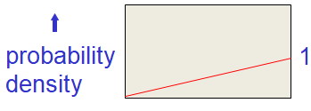

* Now we get the *sloping-line*, that's our ***unnormalized posterior***. It's *unnormalized* because the area under that line doesn't *add up* to **1**. For a probability distribution, the *probabilities of all the alternative events* have to add to **1**.
* ***Re-normalize:*** So the last thing we do is re-normalize it, i.e. *scale up all of the probability densities* so that their integral comes to 1. This gives the *posterior distribution*.

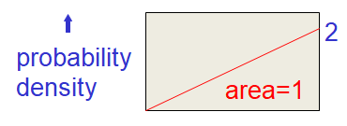

* We *scale everything up*, so the *area under the curve* is 1. And now if we started with the *uniform prior distribution* of a **p**, we end up with this *triangular posterior distribution* of a **p**, having *observed one* ***head***.
* **Let's do it again: Suppose we get a tail**

Now let's do it again. And this time let's suppose we get a ***tail***. So, the *prior distribution* that we start with now is the *posterior* *distribution* we had *after observing* our *one head*.

|  |  |
| --- | --- |
| * *Start with a prior distribution over p:* * And now, the ***green line*** shows the *probability* that we will *get a* ***tail*** according to each of those *hypotheses* that correspond to a value of **p**. * So, for example, if **p=1**, the probability we would observe a *tail* is *zero*. |  |
| * *Multiply the* ***prior probability*** *of each parameter value by the* ***probability of observing a tail*** *given that value:* * So we have to multiply our prior by our likelihood term, and now we get a curve like this. |
| * *Then renormalize to get the posterior distribution:* We have to re-normalize to make the *area to be 1*. And that's now a posterior distribution, after having *observed* *one head* and *one* *tail*. * Notice that it's a pretty *sensible distribution*. After observing one of each, we know that p can't be either *zero* or *one*, and it also seems very sensible that the "*most likely* thing" is now in the *middle*. |

|  |  |
| --- | --- |
| * **Lets do it another 98 times**   If we do this again another 98 times, and keep *applying* the *same strategy* of: *multiplying the posterior we had after the last toss, by the likelihood of* ***observing*** *that event,* ***given*** *the various* ***different settings*** *of the parameter* p.   * And let's suppose we get 53 heads and 47 tails in all. Then we'll end up with a curve that looks like this: * That is, after 53 heads and 47 tails we get a very sensible *posterior distribution* that has its *peak at 0.53* (assuming a uniform prior). * It'll have its *mean* at *0.53* because we started with the *uniform prior*. And it'll be fairly *sharply peaked* by *0.53*. * But it'll allow other values like *0.49* as a perfectly reasonable value under this curve. Not quite as likely as *0.53*, but very reasonable. * Whereas a value of 0.25 is extremely unlikely under this curve. |  |

* **Bayes Theorem**

So we can summarize all that with **Bayes Theorem**. Determine the *middle* of folowing equation is the *joint probability* of a set of parameters W, and some data D.

* For *supervised learning*, the data is gonna consist of the target values. So we assume we are given *inputs* and the *data values consist of* *the target values* that are *associated with those inputs* (that what we observe).

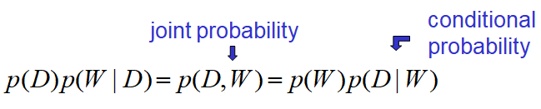

* That joint probability can be re-written as the product of an *individual probability* and a *conditional probability*. So on the right, we're written it as $p\left(W\right)p\left(D|W\right)$, and on the left, w've written it as $p\left(D\right)p\left(W|D\right)$.

|  |  |
| --- | --- |
| * Now we can divide both sides of the equation by $p\left(D\right)$. And this gives us *Bayes Theorem* in it's usual form: * Bayes Theorem says that the *posterior probability* of a *particular value of W, given the data D*, is just the *prior probability* of that *particular* *value of W* times the *probability* given that *particular value of W, that you would have observed the data you observed*. |  |

* And that has to be normalized by $p\left(D\right)$ the probability of the data which is simply the *integral* over all possible values of $W$, of $p\left(W\right)p\left(D|W\right)$, i.e. $\int_{w}{p\left(W\right)p\left(D|W\right)}$.

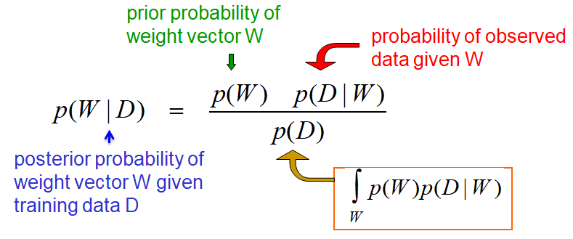

* The *bottom line* needs to be the *sum of the top line* over all possible values $W$ in order for this to be a *probability distribution that adds to 1*. Because that $p\left(D\right)$ has *integrated over all possible values* of $W$, it's *not affected* by picking a *particular value* of $W$ on the left-hand side.
* So when we're looking for the *best value* of $W$, for example, we can ignore $p\left(D\right)$. It doesn't depend on $W$. The other two terms on the right-hand side, however, do depend on $W$.

**9.5 The Bayesian interpretation of weight decay**

In this section, we’ll discuss the *Bayesian interpretation* of *weight penalties*. In the Full Bayesian Approach (previous section), we try to compute the *posterior probability* for *every possible setting of the parameters* of a model.

* But there's a much *reduced form* of the *Bayesian approach*, where we simply going to *"look for the single set of parameters that is the best compromise between fitting our prior beliefs (about what the parameters should be like), and fitting the data we've observed"*.
* This simpler *Bayesian* approach, called ***Maximum a Posteriori (MAP) learning***, and it gives us a nice explanation of what's really going on, when we use *weight decay* to control the *capacity* of a model.
* *Maximum a posteriori (MAP) learning* selects a single most likely hypothesis given the data.
* **Supervised Maximum Likelihood Learning**

Let's briefly discuss what’s really happening when we *minimize* the *squared error* during *Supervised Maximum Likelihood Learning*.

* Finding the *weight vector* that *minimizes* the *squared residuals*, i.e. the differences between the *target value* and the *value predicted* by the net, is equivalent to *finding a weight vector* that *maximizes* the *log probability density* of the *correct answer*.
* In order to see this *equivalence*, we have to assume that the *correct answer* is produced by *adding* *Gaussian noise* to the *output* of the neural net. So the idea is:
* We make a *prediction* by first *running the neural net* on the input to get the output.
* Then *adding* some *Gaussain noise*, we ask: "What's the probability that when we do that, we get the correct answer?"

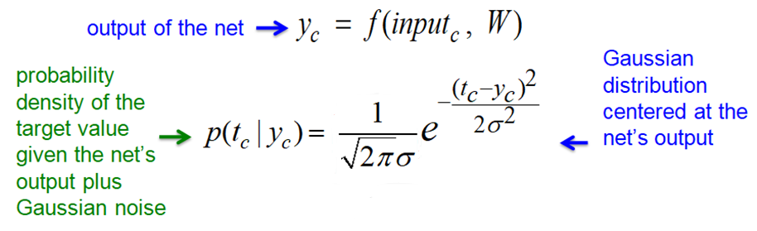

* So the *model's output* is the *center of a Gaussian* and what we're interested in is: having the *target value of high probability* under that *Gaussian*.
* Because the *probability* producing the *value t*, given that the network gives an *output of y* is just the *probability density of t* under a *Gaussian centered at y*.
* Let's suppose that the *output of the neural net* on *training case c* is $y_{c}$ and this output is produced by applying the $weights W$ to the $t_{c}$.
$$output of the net→y_{c}=f\left(input_{c}, W\right)$$

* The *probability* that we'll get the *correct target value* when we add *Gaussian noise* to that output $y_{c}$ is given by a *Gaussian* *centered on $y_{c}$* .

$$p\left(t_{c} | y_{c}\right)=\frac{1}{\sqrt{2πσ^{2}}}e^{- \frac{{\left(t_{c}-y_{c}\right)}^{2}}{2σ^{2}}}$$

$p\left(t_{c} | y_{c}\right)$: Probability density of the target value given the net’s output plus Gaussian noise

$\frac{1}{\sqrt{2πσ^{2}}}e^{- \frac{{\left(t_{c}-y_{c}\right)}^{2}}{2σ^{2}}}$: Gaussian distribution centered at the net's output

* So we're interested in the *probability density of the target value*, under a *Gaussian centered at the output* of the neural net.
* On the right side, we have that *Gaussian distribution centered at the net's output*, with mean $y_{c}$. We also have to assume some *variance*, and that variance will be important later.
* If we now take *logs* and put in a *minus* sign, we see that the *negative log probability density* of the *target value $t_{c}$* *given* that the *network* *outputs $y_{c}$* , is a constant $k$ (that comes from the normalizing term of the Gaussian $\frac{1}{\sqrt{2πσ^{2}}}$) plus $\frac{{\left(t_{c}-y_{c}\right)}^{2}}{2σ^{2}}$ (the log of that exponential).

$$-\log{p\left(t_{c} | y_{c}\right)}=k+\frac{{\left(t_{c}-y_{c}\right)}^{2}}{2σ^{2}}$$

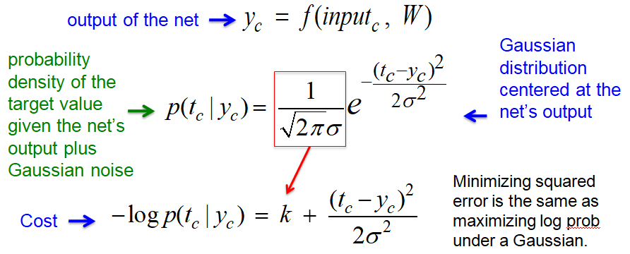

* Therefore, if our *cost function* is the *negative log probability* of getting the *right answer*, that turns into *minimizing* a *squared distance*.
* It's helpful to know that whenever you see a *squared error* being *minimized*, you can make a *probabilistic interpretation* of what's going on, and in that probabilistic interpretation, you'll be ***maximizing*** *the* ***log probability*** *under a* ***Gausian***.

Supervised Maximum Likelihood Learning

*Supervised Maximum Likelihood Learning* is a method where we train a model (like a neural network) to make predictions that match the *observed target values* as closely as possible. In this approach, we assume that the observed *target values* come from a *probability* *distribution* centered around the model’s output with some noise.

* For example, if we assume the target value $y$ is normally distributed around the network’s output $f\left(x\right)$ with *Gaussian noise*, we can express this by saying that the *probability density* of the *target value $y$* , given the network's output $f\left(x\right)$, follows a *Gaussian (normal) distribution*. The *Gaussian distribution* is *centered* at $f\left(x\right)$ with some variance $σ^{2}$.
* ***Probability Density Function (PDF):*** Given the target $y$ and the network’s output $f(x)$, the probability density function $p(y∣f(x))$ can be written as:

$$p\left(y| f\left(x\right)\right)= \frac{1}{\sqrt{2πσ^{2}}}\exp\left(-\frac{{\left(y-f\left(x\right)\right)}^{2}}{2σ^{2}}\right)$$

where:

$f(x)$: the model's output for input $x$

$y$: the observed target value,

$σ^{2}$: the variance of the Gaussian noise (assumed constant).

* ***Maximum Likelihood Estimation (MLE):*** In supervised *maximum likelihood learning*, we aim to maximize the likelihood of the observed data. For a dataset with N examples

$${\left\{\left(x_{i}, y_{i}\right)\right\}}_{i=1}^{N}$$

the *likelihood* of all observations given the network *output $f\left(x_{i}\right)$* , is the product of the *individual probabilities*:

$$L= \prod_{i=1}^{N}{p\left(y_{i}|f\left(x_{i}\right)\right)}$$

Taking the *log-likelihood* makes the computation easier and converts the product into a sum:

$$\log{L=\sum_{i=1}^{N}{\log\left(\frac{1}{\sqrt{2πσ^{2}}}\exp\left(-\frac{{\left(y_{i}-f\left(x_{i}\right)\right)}^{2}}{2σ^{2}}\right)\right)}}$$

Simplifying, we get

$$\log{L}=\sum_{i=1}^{N}{\left(\log{\frac{1}{\sqrt{2πσ^{2}}}}- \frac{{\left(y_{i}-f\left(x_{i}\right)\right)}^{2}}{2σ^{2}}\right)}=\sum_{i=1}^{N}{\left(-\frac{1}{2}\log\left(2πσ^{2}\right)- \frac{{\left(y_{i}-f\left(x_{i}\right)\right)}^{2}}{2σ^{2}}\right)}$$

Since $\log\left(\sqrt[y]{x}\right)= \frac{\log\left(x\right)}{y}$ and $\log\left(\exp\left(x\right)\right)=x$

$$\log{L}=-\frac{N}{2}\log\left(2πσ^{2}\right)- \frac{1}{2σ^{2}} \sum_{i=1}^{N}{{\left(y_{i}-f\left(x_{i}\right)\right)}^{2}}$$

To maximize the likelihood, we can equivalently minimize the negative log-likelihood (since maximizing the likelihood is the same as minimizing the negative log-likelihood):

$$-\log{L}=\frac{1}{2σ^{2}} \sum_{i=1}^{N}{{\left(y_{i}-f\left(x_{i}\right)\right)}^{2}}+ constant$$

This expression shows that minimizing the negative log-likelihood is equivalent to minimizing the mean squared error (MSE), commonly used in supervised learning, when the noise is Gaussian.

Therefore, *Supervised Maximum Likelihood Learning* under *Gaussian noise* is equivalent to *minimizing the squared error* between the *model’s predictions* and the *observed targets*.

* ***Note:*** When dealing with continuous variables (like the target value y in regression), we use probability density. We describe the *likelihood of different outcomes* using *probability density functions (PDFs)*, rather than *discrete probabilities*.
* A *probability density function* tells us the *likelihood* of *observing a value* within *a small range around a point*, rather than an exact probability of a *single point* (since the probability of any specific point in a continuous distribution is technically zero).
* So, $p(y∣f(x))$ is the *probability density* of observing the *target $y$* given the model’s *output $f(x)$* and the assumed *Gaussian noise*.
* For discrete target variables (like classification), we use probability.
* **MAP: Maximum a Posteriori**

The proper *Bayesian approach*, is to find the *full posterior distribution* over *all possible weight vectors*.

* If we have more than a *handful of weights*, that's hopelessly *difficult* when we have a *non-linear net*.
* Bayesians have a lot of ways (clever tricks) of *approximating* this horrendous distribution, often using Monte Carlo methods. But for the time being, let's try and do something simpler.
* Let's just try to find the *most probable weight vector*. So the *single setting of the weights* that's most probable given the *prior* *knowledge* we have and given the *data*. So what we're going to try and do is:
* Find an optimal value of $W$ by starting with some random weight vector, and then adjusting it in the direction that improves the probability of that weight vector given the data i.e. $p\left(W|D\right)$.
* But it will only be a local optimum.

Now, it's going to be easier to work in the *log domain* than in the *probability domain*. So if we want to *minimize a cost*, we better use *negative log probs*.

* **Why we maximize sums of log probabilities**

Just an aside about why we *maximize* sums of *log probabilities*, or *minimize* sums of *negative log probs*, what we really want to do is *maximize the probability* of the data, which is *maximizing the product of the probabilities of producing all the target values* that we *observed on all the different training cases*.

* If we assume that the *output errors* on *different cases $c$* are *independent*, we can write that down as the *product over all the training cases*, of the *probability of producing the target value*, $t_{c}$, given the *weights $W$* .
$$p\left(D|W\right)= \prod_{c}{p\left(t_{c}|W\right)}= \prod_{c}{p\left(t_{c}|f\left(input_{c}, W\right)\right)}$$

* That is the *product of the probability* of producing $t_{c}$, given the *output $f\left(input_{c}, W \right)$* that we're going to get from our network, if we give it *input $c$* and it has *weights $W$* .
* The *log function* is *monotonic*, and so it can't change where the maxima are. So instead of *maximizing* a *product of probabilities*, we can *maximize* the *sums of log probabilities*, and that typically works much better on a computer. It's much more stable.
$$\log\left(p\left(D|W\right)\right)= \sum_{c}{\log\left(p\left(t_{c}|W\right)\right)}$$

* So we *maximize* the *log probability* of the data D given the weights W, which is simply *maximizing the* ***sum*** *over all* ***training cases*** of the *log probability of the output* for that *training case*, given the *input* and given the *weights*.

|  |
| --- |
| Because the log function is monotonic, it does not change where the maxima are. So we can maximize sums of log probabilities |

* **MAP: Maximum a Posteriori (the math)**

In *Maximum A Posteriori Learning*, we're trying to find the *set of weights* that optimizes the *trade-off* between *fitting our prior* and *fitting* *the data*. So that's Bayes's theorem.

* If we take *negative logs* to get a *cost*, we get that the *negative log* of the *probability of the weights* given the *data*, is the *negative log of the* *prior* term, and the *negative log of the data term*, and an *extra term*.

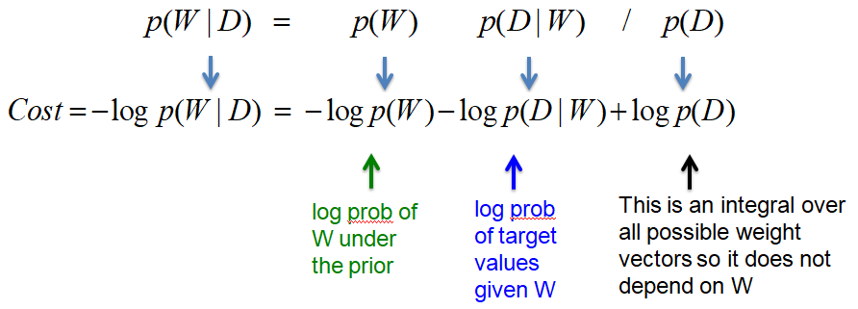

* So, that last extra term $\log{p\left(D\right)}$, is an *integral* over all *possible weight vectors*. And so that doesn't affect $W$. So we can *ignore it* when we're *optimizing $W$* .
* The term that *depends on the data* is the *negative log probability of target values given $W$* , and that's our *normal error term*.
* The term that *only depends on $W$*  is the *negative log probability of $W$ under its prior*.
* **The log probability of a weight under its prior**

Maximizing the *log probability of a weight* is related to minimizing a *squared distance*, in just the same way as *maximizing* the *log probability of producing correct target value* is related to *minimizing* the *squared distance*.

* *Minimizing the squared weights* is equivalent to *maximizing the log probability of the weights* under a *zero-mean Gaussian prior*.
* Here's a *Gaussian*. It's got a *mean zero*, and we want to *maximize* the *probability of the weights*, or the *log probability of the* *weights*. To do that, we obviously want $w$ to be *close to the mean* 0.
* The equation for the Gaussian is just like below, where the *mean is* 0 so we don't have to put it in.

|  |  |
| --- | --- |
|  |  |

|  |  |
| --- | --- |
|  |  |

* So the log probability of $w$ is then the *squared weights* ($w^{2}$) scaled by *twice the variance* ($2σ_{w}^{2}$), plus a constant ($k$) that comes from the *normalizing term of the Gaussian* and isn't affected when we change $w$.
* **The Bayesian interpretation of weight decay**

Finally we can get to the *Bayesian Interpretation* of *weight decay* or *weight penalties*.

$$-\log{p\left(W|D\right)}= -\log{p\left(D|W\right)}-\log{p\left(W\right)}+\log{p\left(D\right)}$$

* We're trying to *minimize* the *negative log probability* of the *weights* given the *data* and that involves minimizing a term that ***depends*** *on both* ***data*** *and the* ***weights*** namely how well they fit the targets and the term that depends only on the weights.

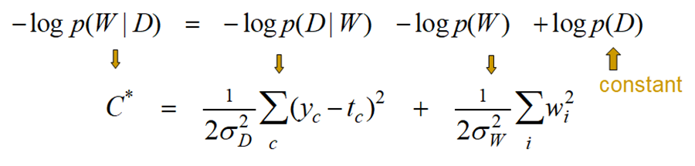

* Cost function $C^{*}$ is derived from the *log probability* of the *data* given the *weights*, which if we *assume Gaussian noise is added to the output of the model to make the prediction*, then that *log probability* is the *squared distance* between the *output of the net* on the *target value* scaled by *twice the variance* of that *Gaussian noise*.

|  |  |
| --- | --- |
| Assuming that the model makes a Gaussian prediction | $$\frac{1}{2σ_{D}^{2}} \sum_{c}{{\left(y_{c}-t_{c}\right)}^{2}}$$ |

* Similarly, if we assume we have a *Gaussian prior* for the *weights*, the *log probability of a weight* under the *prior* is the *squared* value of that *weight* scaled by *twice the variance* of the *Gaussian prior*.

|  |  |
| --- | --- |
| Assuming a Gaussian prior for the weights | $$\frac{1}{2σ_{W}^{2}} \sum_{i}{w_{i}^{2}}$$ |

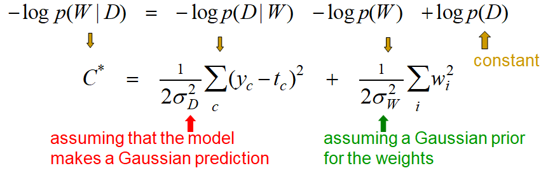

$$C^{*}= \frac{1}{2σ_{D}^{2}} \sum_{c}{{\left(y_{c}-t_{c}\right)}^{2}}+ \frac{1}{2σ_{W}^{2}} \sum_{i}{w_{i}^{2}}$$

* Let's take that equation and multiply through by $2σ_{D}^{2}$. Then we got a *new cost function $C$* . And the *first term*, when we multiply through, turns into simply the *sum over all training cases* of the *squared difference* between the *output* of the net and the *target*. $\sum_{c}{{\left(y_{c}-t_{c}\right)}^{2}}$ that's the ***squared error $E$*** that we typically minimize in the neural net.

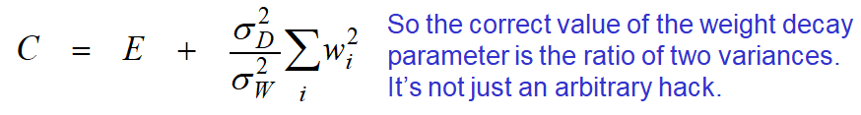

|  |  |
| --- | --- |
| * The *second term* becomes the ratio of $σ_{D}^{2}/ σ_{W}^{2}$ times the sum of the squares of the weights $w_{i}$. And so what you see is, the ratio of those two variances $\frac{σ_{D}^{2}}{σ_{W}^{2}}$ is exactly the *weight penalty*. | $$C=E+ \frac{σ_{D}^{2}}{σ_{W}^{2}} \sum_{i}{w_{i}^{2}}$$ |

* So we initially thought of *weight penalties* as just a number *you make up to try* and make things work better. Where you *fix* the value of the *weight penalty* by using a *validation set*.
* But now we see that if we make this GAUSSIAN INTERPRETATION where we have a *Gaussian prior* and we have a *Gaussian* *model* of the *relation* of the *output* of the net to the *target*.
* Then the *weight penalty* is determined by the *variances* of those Gaussians. It's just the *ratio of those variances*. It's not an arbitrary thing at all within this framework.

**9.6 MacKay's quick and dirty method**

In this section, we're going to describe a method developed by David MacKay in the 1990s for *determining* the *weight penalties* to use in a neural network *without using a validation set*.

It's based on the idea that we can *interpret weight penalties* as doing *map estimation* so that the *magnitude* of the *weight penalty* is related to the *tightness* of the *prior distribution over the weights*.

* Mackay showed we can *empirically fit* both the *weight penalties* and the *assumed noise* in the *output of the neural net* to get a ***method*** for *fitting weight penalties* that does not require a *validation set* and therefore, allows us to have *different weight penalties* for *different* *subsets* of the *connections* in a neural network, something that will be very expensive to do using ***validation sets***.
* **Estimating the variance of the output noise**

Here's a simple and practical method developed by David MacKay for making use of the fact that: we can *interpret weight penalties* as the *ratio* of *two variances*.

* After we've learned a model to *minimize squared error* we can find the *best value* for the *output variance (output noise)*. And the best value is found by simply using the *variance* of the *residual errors*.
* The best value is the one that *maximizes the probability* of producing exactly the *correct answers* after adding *Gaussian noise* to the output produced by the neural net.
* The best value is found by simply using the *variance* of the *residual errors*.
* **Estimating the variance of the Gaussian prior on the weights**
* We can also estimate the *variance* in the Gaussian prior of the weight. We have to:
* Start with some *guess* about what this variance should be.
* Then, we do some learning,
* And then we use a very dirty trick called "empirical Bayes".
* We set the *variance* of our *prior* to be the *variance of the weights of the model learned* because that's the variance that will make those weights most likely.
* This really violates a lot of the *presuppositions* of the *Bayesian approach*. We're using the *data* to *decide* what our *prior beliefs* are.
* i.e. use the data itself to decide what your prior is!
* So, once we've *learned* the *weights*, we *fit a zero mean Gaussian* to the *one-dimensional distribution of the* ***learned weights***. And then, we take the *variance* of that *Gaussian*, and we use that for our *prior*.
* *We could easily learn different variances for different sets of weights:* Now, one nice thing about that is: the *different subsets of weights*, like in *different layers*, for example, we could learn *different variances* for the *different layers*.
* We don't need a *validation set* so we can use all of the non-test data for training.
* Because we don't need *validation sets* to determine the *weight penalties* in different layers, we can actually have many *different weight* *penalties*. This would be very *hard* to do with *validation sets*.
* **MacKay’s quick and dirty method of choosing the ratio of the noise variance to the weight prior variance.**

So, here's MacKay's method:

* You start by guessing the *noise variance* and the *weight prior variance*. Actually, all you have to really do is guess their ratio.
* Then, you do some *Gradient Descent Learning*, trying to improve the weights.
* Then, you *reset* the *noise variance* to be the *variance of the residual errors* and
* You *reset* the *weight prior variance* to be the *variance of the distribution of the actually learned weight*.
* And then, you go back around this loop again.