Chapter – 12

Neural Networks for Machine Learning

Geoffrey Hinton

with Nitish Srivastava & Kevin Swersky
RBM: Restricted Boltzmann Machines
Lectures: Geoffrey Hinton
Boltzmann machine learning
More efficient ways to get the statistics
RBM: Restricted Boltzmann Machines
An example of RBM learning
RBMs for collaborative filtering

12.1 Boltzmann machine learning

In the previous chapter, we've seen how a Boltzmann Machine can be used as a probabilistic model of a set of binary data vectors. In this section we're finally going to get around to the Boltzmann Machine learning algorithm.

- This is a very simple learning rule which has an elegant theoretical justification, but it turned out in practice, it was extremely slow and noisy, and just wasn't practical. And for many years, people thought that Boltzmann Machines would never be practical devices.
- Then we found several different ways of greatly speeding up the learning algorithm. And now the algorithm is much more practical, and has, in fact, been used as part of the winning entry for a million dollar machine learning competition.

- The goal of learning

The Boltzmann Machine Learning Algorithm is an unsupervised learning algorithm. Unlike the typical use of back propagation, (where we have an input vector and we provide it with a desired output or label) in Boltzmann Machine Learning, we just give it the input vector, there are no labels.

- What the algorithm is trying to do is— build a model of a set of input vectors, though it might be better to think of them as output vectors.

- What we want to do is— maximize "the product of the probabilities that the Boltzmann machine assigns to a set of binary vectors in the training set".
- This is equivalent to maximizing "the sum of the log probabilities that the Boltzmann machine assigns to the training vectors".

- It's also equivalent to maximizing the probability that we would obtain exactly the $N$ training cases, if we ran the Boltzmann machine in the following way—
- First, we let the network settle to its stationary distribution $N$ different times, with no external input.
- Then we sample the visible vector once each time.
- Then we let it settle again, and sample the visible vector again. And so on.

- Why the learning could be difficult

Now there are many reasons why the learning could be difficult. This is probably the most important reason—

- If you consider a chain of units (a chain of hidden units here) with visible units attached to the two ends. And if we use a training set that consist of (1, 0) and (0, 1) another words, we want the two visible units to be in opposite states.

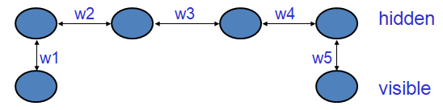

- Then the way to achieve that is by making sure that the product of all those weights is negative.
- For example, if all of the weights are positive, turning on w1 will tend to turn on the first hidden unit. And that will tend to turn on the second hidden unit, and so on. And the fourth hidden unit will tend to turn on the other visible unit w5.
- So, if one of those weights is negative, then we'll get an anti-correlation between the two visible units.

- What this means is, that if we're thinking about learning weight w1, we need to know other weights.
- To know how to change that weight w1, we need to know w3. We need to have information about w3, because if w3 is negative, what we want to do with w3 is the opposite of what we want to do with w1 if w3 is positive.
- So to know how to change w1 or w5 we must know w3.

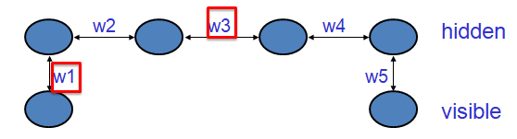

- A very surprising fact

So given that one weight needs to know about other weights in order to be able to change even in the right direction, it's very surprising that there's a very simple learning algorithm, and that learning algorithm only requires local information.

- It turns out that— everything that one weight needs to know about all the other weights and about the data is contained in the difference of two correlations. | $$\frac{∂\log{p\left(v\right)}}{∂w_{ij}}= {〈s_{i}s_{j}〉}_{v}- {〈s_{i}s_{j}〉}_{model}$$

- Another way of saying that, is that— if you take the log probability that the Boltzmann machine assigns to a visible vector $v$ and ask about the derivative of that log probability with respect to a weight, $w_{ij}$. It's equal to the difference of:
- the expected value ${〈s_{i}s_{j}〉}_{v}$ of the products of states of i and j. When the networks settle to thermal equilibrium with $v$ clamped on the visible units (i.e. how often states of i and j are on together when $v$ is clamped in the visible units and the network is at thermal equilibrium).
- the same quantity (expected value) but when $v$ is not clamped on visible units,

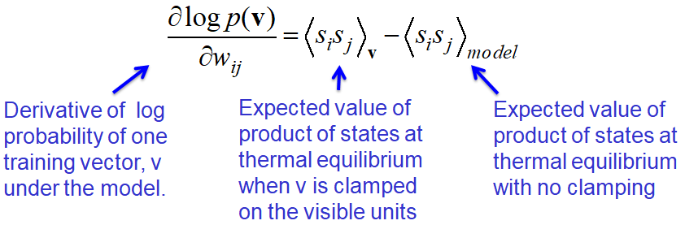

- So because the derivative of the log probability of a visible vector is this simple difference of correlations we can make the change in the weight $Δw_{ij}$be proportional to

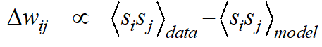

- the expected product of the activities averaged over all visible vectors in the training set (that's what we call $data$), minus the product of the same two activities when your not clamping anything and the network has reached thermal equilibrium with no external interference.

$$Δw_{ij}∝ {〈s_{i}s_{j}〉}_{data}- {〈s_{i}s_{j}〉}_{model}$$

- So this is a very interesting learning rule— the first term in the learning rule says: raise the weights in proportion to the product of the activities the units have when you're presenting data.
- That's the simplest form of what's known as a Hebbian learning rule. Donald Hebb, a long time ago, in the 1940s or 1950s, suggested that synapses in the brain might use a rule like that.

- But if you just use that rule, the synapse strengths will keep getting stronger. The weights will all become very positive, and the whole system will blow up.
- You have to somehow keep things under control, and this learning algorithm is keeping things under control by using that second term.
- It's reducing the weights in proportion to how often those two units are on together, when you're sampling from the model's distribution.

- You can also think of this as— the first term is like the storage term for a Hopfield Net. And the second term is like the term for getting rid of spurious minima. And in fact this is the correct way to think about that. This rule tells you exactly how much unlearning to do.

- Why is the derivative so simple?

One obvious question is— why is the derivative so simple?

- The probability of a global configuration at thermal equilibrium (i.e. once you've let it settle down), is an exponential function of its energy. The probability is related to $e^{-energy}$.
- So when we settle to equilibrium we achieve a linear relationship between the log probability and the energy function.

- Now, the energy function is linear in the weights. So, we have a linear relationship between the weights and the log probability. And since we're trying to manipulate log probabilities by manipulating weights, that's a good thing to have.
- It's a log linear model.

- Since, settling to equilibrium makes the log probability a linear function of the energy. And the energy is a linear function of the weights and states, so:

$$- \frac{∂E}{∂w_{ij}}=s_{i}s_{j}$$

- this relationship is very simple. It's that the derivative of the energy $E$ w.r. to a particular weight $w_{ij}$ is just the product of the two activities $s_{i}$ and $s_{j}$, that the weight connects.

- So what's happening here is— the process of settling to thermal equilibrium is propagating information about the weights.  - We don't need an explicit back propagation (backprop) stage. We do need two stages:  - We need to settle with the data and  - We need to settle with no data. | 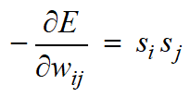

- But notice that the network is behaving in pretty much the same way in those two phases.
- The unit deep within the network is doing the same thing, just with different boundary conditions.
- With backprop the forward pass and the backward pass are really rather different.

- Why do we need the negative phase?

Another question you could ask is— what's that negative phase for? We've already mentioned that it's like the unlearning we do in a Hopfield net to get rid of spurious minima. Let's look at it in more detail.

$$p\left(v\right)=\frac{\sum_{h}{e^{-E\left(v, h\right)}}}{\sum_{u}{\sum_{g}{e^{-E\left(u, g\right)}}}}$$

- The equation for the probability of a visible vector $v$ is a sum overall hidden vectors $h$ of $e^{-E\left(v, h\right)}$, normalized by the same quantity, summed overall visible vectors (i.e. $e^{-E\left(u, g\right)}$ is summed over both hidden and visible vectors $u$ and $g$ ).

- Here, $E\left(v, h\right)$ is the energy of that visible and hidden vector $v, h$ together.

- So if we look at the top term, what the first term in the learning rule is doing is— decreasing the energy of terms in that sum that are already large and it finds those terms by settling to thermal equilibrium with the vector $v$ clamped so that it can find an $h$ that goes nicely with $v$, (i.e. gives a nice low energy with $v$).
- Having sampled those vectors $h$, it then changes the weights to make that energy even lower.
- i.e. the positive phase finds hidden configurations that work well with $v$ and lowers their energies.

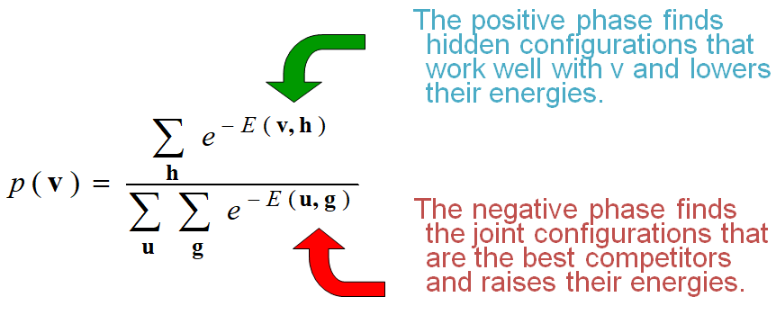

- The second phase in the learning, the negative phase, is doing the same thing, but for the partition function. That is, the normalizing term on the bottom line.
- It's finding global configurations, combinations of visible and hidden states that give low energy, and therefore, are large contributors to the partition function.
- And having find those global configurations, it tries to raise their energy so that they can contribute less.
- i.e. the negative phase finds the joint configurations that are the best competitors and raises their energies.

So the first term is making the top line big, and the second term is making the bottom line small.

- An inefficient way to collect the statistics required for learning
Hinton and Sejnowski (1983)

Now in order to run this learning rule, you need to collect those statistics— you need to collect what we call the positive statistics, those are the ones when you have data clamped on the visible units, and also the negative statistics, those are the ones when you don't have data clamped and that you're going to use for unlearning.

An inefficient way to track these statistics was suggested by me (Hinton) and Terry Sejnowski in 1983. And the idea is—

- Positive phase: In the positive phase we clamp a data vector on the visible units, and we set the hidden units to random binary states.
- Then we keep updating the hidden units in the network, one unit at a time, until the network reaches thermal equilibrium at a temperature of 1.
- We actually did that by starting at a higher temperature and reducing it, but that's not the main point here.
- Sample $<s_{i}, s_{j}>$ for every connected pair of units: Once we reach thermal equilibrium, we sample how often two units are on together. So we're measuring the correlation of i and j with that visible vector clamped.
- We then repeat that, over all the visible vectors (data vectors in the training set), so that, that correlation we're sampling is averaged over all the data.

- Negative phase: In the negative phase, we don't clamp anything. The network is free from external interference.
- Set all the units to random binary states: So, we set all of the units, both visible and hidden, to random binary states.
- Update all the units: Then we update all the units one at a time until the network reaches thermal equilibrium at a temperature of 1 (just like we did in the positive phase).

- Repeat many times and average to get good estimates: Again, we sample the correlation $<s_{i}, s_{j}>$ of every connected pair of units i and j, and we repeat that many times.
- But it's very difficult to know how many times you need to repeat it, but certainly in the negative phase you expect the energy landscape to have many different minima, but are fairly separated and have about the same energy.

- The reason we expect that is— we're going to be using Boltzmann machines to do things like model a set of images. And we expect there to be
  - Reasonable images, all of which have about the same energy and
  - Very unreasonable images, which have much higher energy.

- And so you expect
  - A small fraction of the space to be these low energy states and
  - A very large fraction of the space to be these bad high energy states.

- If you have multiple modes, it's very unclear how many times you need to repeat this process to be able to sample those modes.

12.2 More efficient ways to get the statistics

In this section, we'll go into more detail about how we can speed up the Boltzmann Machine Learning Algorithm by using cleverer ways of keeping Markov chains near the equilibrium distribution, or by using what are called mean field methods.

This is an advanced topic, so you can skip it if you want. It’s here for those who really interested in how to get deep Boltzmann machines work better.

- A better way of collecting the statistics

There are better ways of collecting the statistics than the method that Terry Sejnowski and I (Hinton) originally came up with (discussed in previous section).

- If we start from a random state, it may take a long time to reach thermal equilibrium. Also, it’s very hard to tell when we reach thermal equilibrium, so we don't know how long we need to run for.

- So, the idea is— why not start from whatever state you ended up in last time you saw that particular datavector? So, we remember the interpretation of the data vector in the hidden units, and we start from there.
- This stored state (the interpretation of the data vector), is called a particle.

- Using particles that persist gives us a warm start and it has a big advantage: If we were at equilibrium before (last time) and we only updated the weights a little bit, it'll only take a few updates of the units in a particle to bring it back to equilibrium.
- We can use particles for both the positive phase, where we have a clamp data vector, and for the negative phase, when nothing is clamped.

- Neal’s method for collecting the statistics (Neal 1992)

Here's the method for collecting statistics introduced by Radford Neal in 1992.

Positive phase:

- In the positive phase, we have a set of data specific particles, one (or a few) per training case. And each particle has a current value that is a configuration of the hidden units plus which data vector it goes with.
- We sequentially update all the hidden units a few times in each particle with the relevant datavector clamped.
- And then, for every connected pair of units, we average the probability of the two units being on $s_{i}s_{j}$ over all these particles.

Negative phase:

- In the negative phase, we keep a set of fantasy particles. Each particle has a value that is a global configuration (i.e, these are global configurations).  - And again, after each weight update, we sequentially update all the units in each fantasy particle a few times.  - Now, we're updating the visible units as well. | 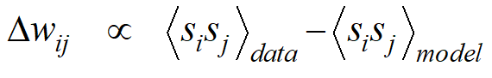

- For every connected pair of units, we average $s_{i}s_{j}$, over all the fantasy particles. The learning rule is then— the change in the weights $Δw_{ij}$ is proportional to the average we got with data, averaged over all training data, and the average you got with the fantasy particles when nothing was clamped.

$$Δw_{ij}∝ {〈s_{i}s_{j}〉}_{data}- {〈s_{i}s_{j}〉}_{model}$$

- This works better than the learning rule that Terry Sejnowski and I (Hinton) introduced, at least for full batch learning.

- Adapting Neal’s approach to handle mini-batches

- It's difficult to apply Neal's approach to mini batches. And the reason is— by the time we get back to the same data vector (again) if we're using mini batch learning, the weights would have been updated many times.
- So the stored data specific particle for that data vector won't be anywhere near thermal equilibrium anymore (because it will not have been updated).
- The hidden units won't be in thermal equilibrium with the visible units of the particle given the new weights.
- And again, we don't know how long we're going to have to run for, before we get close to equilibrium again.

- ASSUMPTION: So, we can overcome this by making a strong assumption about how we understand the world (it's a kind of a epistemological assumption):
- We're going to assume that when a data vector is clamped, the set of good explanations (i.e. states of the hidden units, that act as interpretations of that data vector) is uni-modal.
- That means we're saying that, for a given data vector, there aren't two very different explanations for that data vector. We assume that for sensory input, there is one correct explanation. And if we have a good model of the data, our model will give us one energy minimum for that data point.

- This is a restriction on the kinds of models we're willing to learn. We're going to use a learning algorithm that's incapable of learning models in which a data vector has many very different interpretations.
- i.e. we restrict ourselves to learning models in which one sensory input vector does not have multiple very different explanations.
- Provided we're willing to make this assumption, we can use a very efficient method for approaching thermal equilibrium or an approximation to thermal equilibrium, with the data.

- The simple Mean Field Approximation

The approximation we mentioned above is called a mean field approximation. If we want to get the statistics right, we need to update the units stochastically and sequentially.

- The update rule is:

$$prob\left(s_{i}=1\right)=σ\left(b_{i}+\sum_{j}{s_{j}w_{ij}}\right)$$

- The probability of turning on unit i$prob\left(s_{i}=1\right)$, is the logistic function $σ$ of the total input $\sum_{j}{s_{j}w_{ij}}$ it receives from the other units and its bias $b_{i}$.  - Where $s_{j}$, the state of another unit, is a stochastic binary thing. | 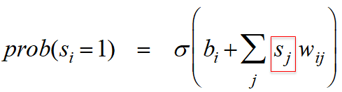
- We can use probabilities instead of binary states: Now, instead of using above rule, we could say— we're not going to keep binary states $s_{i}$ for unit i, we're going to keep a real value between 0 and 1 which we call a probability $p_{i}$.  - That probability $p_{i}^{t+1}$ at time t+1, is going to be the output of the logistic function. | 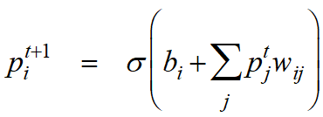

- What we put in— is the bias $b_{i}$, and the sum of all the probabilities at time t times the weights. $\sum_{j}{p_{j}^{t}w_{ij}}$. So, we're replacing this stochastic binary thing by a real value probability.

$$p_{i}^{t+1}=σ\left(b_{i}+\sum_{j}{p_{j}^{t}w_{ij}}\right)$$

- But, that's not quite right because this stochastic binary thing is inside a non-linear function. If it was a linear function, things would be fine.
- Since the logistic is non-linear, we don't get the right answer when we put probabilities instead of fluctuating binary things inside.
- However, it works pretty well. And if we are in a hurry we can use probabilities instead of binary states and update the units in parallel.

- To avoid biphasic oscillations we can use damped mean field: It can go wrong by giving us biphasic oscillations because now we're going to be updating everything in parallel. And we can normally deal with those by using what's called damped mean field where we compute that $p_{i}^{t+1}$.
- But, we don't go all the way there. We go to a point in between where we are now, and where this update wants us to go.

$$p_{i}^{t+1}=λp_{i}^{t}+\left(1-λ\right)σ\left(b_{i}+\sum_{j}{p_{j}^{t}w_{ij}}\right)$$

- So, in damped mean field, we'll go to $λ$ times the place we are now (i.e. $p_{i}^{t}$), plus $\left(1-λ\right)$ times the place the update rule tells us to go to  (i.e. $σ\left(b_{i}+\sum_{j}{p_{j}^{t}w_{ij}}\right)$). And that will kill oscillations. | 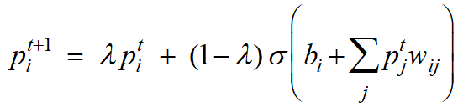

- An efficient mini-batch learning procedure for Boltzmann Machines
(Ruslan Salakhutdinov & Hinton 2012)

Now, we can get an efficient mini batch learning procedure for Boltzmann Machines, and this is what Russ Salakhutdinov realized.

Positive phase:

- In the positive phase, we can initialize all probabilities (hidden) at 0.5.
- We can clamp a data vector on the visible units, and
- We can update all the hidden units in parallel using mean field updates until convergence.

- And for mean field, you can recognize convergence is— when the probability stop changing.
- Once we converged, we record $p_{i}p_{j}$ for every connected pair of units (and average this over all data in the mini-batch).

Negative phase:

- In the negative phase, we do what we were doing before. We keep a set of fantasy particles, each of which has a value that's a global configuration.
- After each weight update, we sequentially update all the units in each fantasy particles a few times.
- Then, for every connected pair of units, we average $s_{i}s_{j}$, these stochastic binary things, over all fantasy particles.

- The difference in those averages is the learning rule, i.e. we change the weights by an amount proportional to that difference.

- Making the updates more parallel

If we want to make the updates for the fantasy particles more parallel, we can change the architecture of the Boltzmann Machine.

- In a general Boltzmann Machine, the stochastic updates of units need to be sequential. So, we're going to have a special architecture that allows alternating parallel updates (more efficient) for the fantasy particles. We have:  - No connections within a layer, and  - No skip-layer connections. But we allow ourselves lots of hidden layers.  - The architecture looks like this:  - This is called a Deep Boltzmann Machine (DBM). It's a general Boltzmann machine with lots of missing connections.  - All those skipped layer connections, if they were present— we wouldn't really have layers at all, it would just be a general Boltzmann machine. But, in this special architecture, there's something nice we can do. | 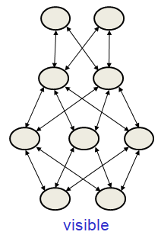

- We can update the states for example the first hidden layer and the third hidden layer, given the current states of the visible units and the second hidden layer.  - Then, we can update the states of the visible units and the second hidden layer. And then, we can go back and update the other states.  - So we can go backwards and forwards like this and update half the states of all the units in parallel and that'll be a correct update. | 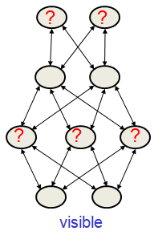 | 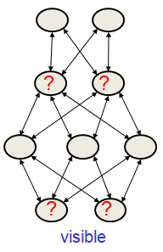

- Can a DBM learn a good model of the MNIST digits?

One question is, if we have a deep Boltzmann machine like that— trained by using mean field for the positive phase and updating fantasy particles by alternating between even layers and odd layers for the negative phase, can we learn good models of things like the MNIST digits, or indeed, a more complicated things?

- So, one way to tell whether you've learned a good model is— after learning, you remove all the input and you just generate samples from your model.
- You run the Markov chain for a long time until it's burned in, and then you look at the samples you get.

- Do samples from the model look like real data?
- Russ Salakhutdinov used a deep Boltzmann machine to model MNIST digits using: mean field for the positive phase, and alternating updates of the layers of the particles for the negative phase.

The real data looks like this:  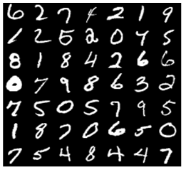 | And the data that Salakhutdinov got from his model looks like this:  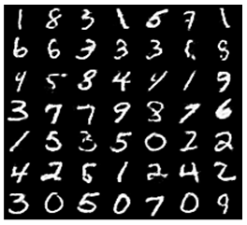

Notice, the similarity, the model is producing very similar things like MNIST digits so it's learned a pretty good model.

- A puzzle

Here's a puzzle. When Salakhutdinov was learning that, he was using mini-batches with 100 data examples and also he was using 100 fantasy particles, the same 100 fantasy particles for every mini-batch.

The puzzle is: how can we estimate the negative statistics well with only 100 negative examples to characterize the whole space?

- Why can we estimate the “negative phase statistics” well with only 100 negative examples to characterize the whole space of possible configurations?
- For all interesting problems, the GLOBAL configurations space is going to be highly multi model.
- And how does it manage to find and represent all the modes with only 100 particles?

- The learning raises the effective mixing rate.

There's an interesting answer to above puzzle.

- The learning interacts with the Markov chain that's being used to gather the negative statistics, (i.e. one that's used to update the fantasy particles— the data-independent statistics), and it interacts with it to make it have a much higher effective mixing rate.
- That means, we cannot analyze the learning by thinking of it being an outer loop— that updates the weights; and an inner loop— that gathers statistics with a fixed set of weights.
- The learning is affecting how effective that inner loop is.

- The reason for this is that— whenever the fantasy particles outnumber the positive data, the energy surface is raised, and this has an effect on the mixing rate of the Markov chain.
- It makes the fantasies rush around hyper-actively, and
- they move around much faster than the mixing rate of the Markov chain defined by the current static weights.

- How fantasy particles move between the model’s modes

So, here's a picture that shows you what's going on.

- If there's a mode in the energy surface that has more fantasy particles than data, the energy surface will be raised until the fantasy particles escape from that mode. For example, consider following case:
- Notice, the mode on the left has four fantasy particles and only two data points. So, the effect of the learning is going to be to raise the energy there.
- And that energy barrier might be much too high for a Markov chain to be able to cross, so the mixing rate will be very slow.

- But, the learning will actually spill those red particles out of that energy minimum by raising the minimum. It'll get filled up and the fantasy particles will escape and go off somewhere else, to some other deep minimum.
- This can overcome energy barriers that would be too high for the Markov chain to jump in a reasonable time. So, we can get out of minima that the Markov chain would not be able to get out of (at least, not in a reasonable time).

- What's going on here is— the energy surface is really being used for two different purposes:  - The energy surface represents our model, but it's also being manipulated by the learning algorithm to make the Markov chain mix faster. (or rather, to have the effect of a faster-mixing Markov chain).  - i.e. the energy surface is being changed to help mixing in addition to defining the model.  - Once the fantasy particles have filled up one hole, they'll rush off to somewhere else and deal with the next problem. An analogy for them is that— they are like investigative journalists who rush into investigate some nasty problem. As soon as the publicity has caused that problem to be fixed, instead of saying: "okay, everything is okay now", they rush off to find the next nasty problem.  - Once the fantasy particles have filled in a hole, they rush off somewhere else to deal with the next problem.  - They are like investigative journalists. | 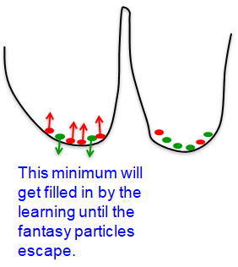

12.3 RBM: Restricted Boltzmann Machines

Now we'll introduce Restricted Boltzmann Machines (RBM). RBMs have a much simplified architecture in which there are no connections between hidden units. This makes it very easy to get the equilibrium distribution of the hidden units if the visible units are given.

- That is, once you've clamped the data-vector on the visible units, the equilibrium distribution of the hidden units can be computed exactly in one step because they're all independent of one another, given the states of the visible units.

- The proper Boltzmann Machine Learning Algorithm is still slow for a Restricted Boltzmann Machine. But in 1998, I (Hinton) discovered a very surprising shortcut that leads to the first efficient learning algorithm for Boltzmann Machines. Even though this algorithm has theoretical problems, it works quite well in practice. And it led to a revival of interest in Boltzmann Machine Learning.

CLAMP: A clamp is a fastening device used to hold or secure objects tightly together to prevent movement or separation through the application of inward pressure.

In the context of Restricted Boltzmann Machines (RBMs) (and more generally in neural networks and probabilistic graphical models), “clamping” means fixing the states of some units (usually the visible/input units) to specific values provided by the data, and not allowing them to change during the sampling process.

A physical analogy:
Think of the network like a system of springs. Clamping is like grabbing one side of the system (the visible units) and holding it in place, forcing the rest of the system (hidden units) to adjust accordingly.

- Restricted Boltzmann Machines

In a Restricted Boltzmann Machine, we restrict the connectivity of the network in order to make both inference and learning easier.
(Statistical inference uses mathematics to draw conclusions in the presence of uncertainty.)

- It only has one layer of hidden units and
- There's no connections between the hidden units.
- There's also no connections between the visible units.

- The architecture looks like the network on the right, it's what computer scientists call a bipartite graph. There's two pieces, and within each piece, there's no connections. (In the mathematical field of graph theory, a bipartite graph or bigraph is a graph whose vertices can be divided into two disjoint and independent sets.) | 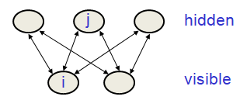
- The good thing about an RBM is that— if you clamp a datavector in the visible units, you can reach thermal equilibrium in one step.  - So, in an RBM it only takes one step to reach thermal equilibrium when the visible units are clamped. So we can quickly get the exact value of $<v_{i}h_{j}>_{v}$. | 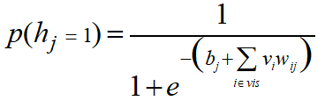

- That means with a datavector clamped, we can quickly compute the expected value of $v_{i}h_{j}$ because we can compute the exact probability with each j will turn on, and that is independent of all the other units in the hidden layer.

- The probability that j will turn on is just the logistic function of the input that it gets from the visible units and quite independent of what other hidden units are doing.  - So, we can compute that probabilities all in parallel and that's a tremendous win.  $$p\left(h_{j}=1\right)=\frac{1}{1+e^{-\left(b_{j}+\sum_{i∈vis}{v_{i}w_{ij}}\right)}}$$  - The terms:  $b_{j}$ is the bias of hidden unit $h_{j}$.  $\sum_{i∈vis}{v_{i}w_{ij}}$ is weighted input from the visible layer
  We can re-write this as:
  $$p\left(h_{j}=1\right)=\frac{1}{1+e^{-x}}$$
  Where
  $$x=b_{j}+\sum_{i∈vis}{v_{i}w_{ij}}$$
  And the logistic sigmoid:
  $$σ\left(x\right) = \frac{1}{1+e^{-x}}$$

Together, $b_{j}+\sum_{i∈vis}{v_{i}w_{ij}}$ is the pre-activation or net input to hidden unit j.

- Note: It’s hidden unit hidden unit j, and we write its state as$h_{j}$. The state (value) of that unit is $h_{j}∈\left\{0, 1\right\}$.

- PCD: An efficient mini-batch learning procedure for RBM
(Tieleman, 2008)

If you want to make a good model of a set of binary vectors, then the right algorithm to use for a Restricted Boltzmann Machine is one introduced by Tieleman in 2008 that's based on earlier work by Neal.

- Positive phase: In the positive phase, you clamp the datavector on the visible units.
- You then compute the exact value of the expectation $<v_{i}h_{j}>$ for all pairs of a visible and a hidden unit. And you could do that because $v_{i}$ is fixed, and you can compute $h_{j}$ exactly.
- Then, for every connected pair of units, you average the expected value $<v_{i}h_{j}>$ (of $v_{i}h_{j}$) over all the data vectors in the mini batch.

- Negative phase: For the negative phase, keep a set of fantasy particles. Each particle has a value that is global configurations.
- Then, you update each fantasy particle a few times by using alternating parallel updates. So, after each weight update, you update the fantasy particles a little bit and that should bring them back to close to equilibrium.
- And then, for every connected pair of units, you average $v_{i}h_{j}$ over all the fantasy particles, and that gives you your negative statistics.

This algorithm actually works very well, and allows RBMs to build good density models of sets of binary vectors.

- A picture of an inefficient version of the Boltzmann Machine learning algorithm for an RBM

Let's discuss our learning algorithm that is not as good at building density model but is much faster. We start with a picture of an inefficient learning algorithm for RBM.

- The idea is— we start with a training vector on the visible units. Then alternate between updating all the hidden units in parallel and updating all the visible units in parallel.

- We're going to start by clamping a data-vector on the visible units, and we're going to call that time t=0. So, we're going to use times now, not to denote weight updates, but to denote steps in a Markov chain. | 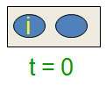
- Given that visible vector, we now update the hidden units (to get the hidden vector). Here we choose binary states for the hidden units and we measure the expected value $<v_{i}h_{j}>$ (of $v_{i}h_{j}$) for all pairs of visible and binary units that are connected.  - And we'll call that $<v_{i}h_{j}>^{0}$ to indicate that it's measured at time t=0, with the hidden units being determined by the visible units.  - We can also update all the hidden units in parallel. | 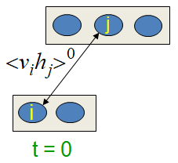

- We then use the hidden vector to update all the visible units in parallel, and again we update all the hidden units in parallel.

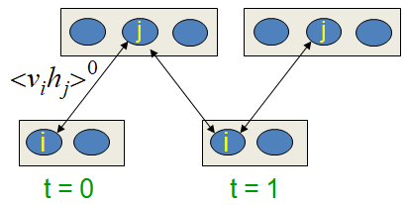

- So, the visible vector at t = 1, we'll call a reconstruction, or a one-step reconstruction, and we can keep going with the alternating chain that way, updating visible units, and then hidden units. Each set being updated in parallel.

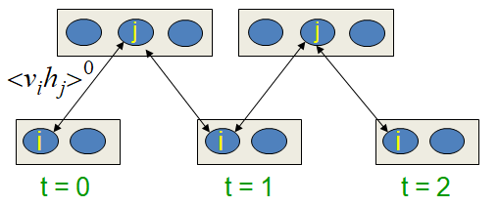 | 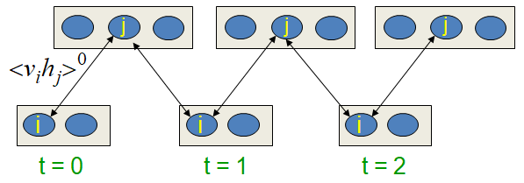

- After we've gone for a long time, we'll get to some state of the visible units that we'll call t = infinity (to indicate it needs to be a long time and the system will be at thermal equilibrium).
- And now, we can measure the correlation of $v_{i}$ and $h_{j}$ after the chains run for a long time and we'll call that $<v_{i}h_{j}>^{∞}$.

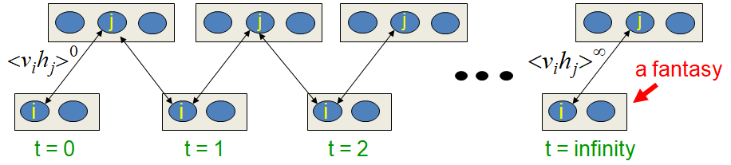

- The visible state we have after a long time, we'll call it a fantasy.

- Learning rule: Now, the learning rule is simply,

$$Δw_{ij}= ε \left(<v_{i}h_{j}>^{0}-<v_{i}h_{j}>^{∞}\right)$$

Where
$Δw_{ij}$ is the change in $w_{ij}$.
$ε$ is the learning rate.
$\left(<v_{i}h_{j}>^{0}-<v_{i}h_{j}>^{∞}\right)$ is the difference between $<v_{i}h_{j}>$ at t=0 and t=infinity.

- The problem with this algorithm is that— we have to run this chain for a long time before it reaches thermal equilibrium, if we don't run it for long enough, the learning may go wrong.
- But the above statement is very misleading. It turns out that even if we only run the chain for a short time, the learning still works.

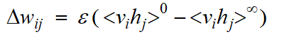

- Contrastive Divergence: A very surprising short-cut

Following is the very surprising shortcut to run the above chain:

- Start with a training vector on the visible units.  - Update all the hidden units in parallel.  - Update the all the visible units in parallel to get a “reconstruction”.  - Update the hidden units again.  We just run the chain up, down, and up again (say up to $<v_{i}h_{j}>^{1}$).  So, from the data (t=0), we generate a hidden state, from that we then generate a reconstruction, and from that, we generate another hidden state. | 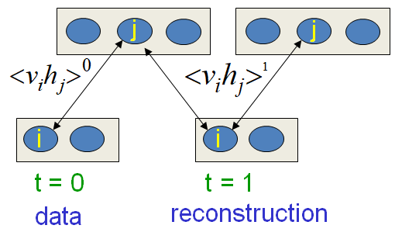

- And you measure the statistics once you've done that. So, instead of using the statistics measured at equilibrium, we're using the statistics measured after doing one full update of the Markov chain.
- The learning rule is the same as before (notice no infinity), except its much quicker to compute, and this is clearly is not doing maximum likelihood learning because the term we are using for negative statistics is wrong.

$$Δw_{ij}= ε \left(<v_{i}h_{j}>^{0}-<v_{i}h_{j}>^{1}\right)$$

- But the learning, nevertheless, works quite well. Next sections, we'll understand a bit more about why it works well. But for now, we'll just see that it does.
- This is not following the gradient of the log likelihood. But it works well.

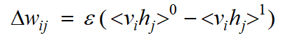

- Why does the shortcut work?

Now, the obvious question is— why does actually this shortcut work at all? Following are the reasoning:

- If we start the chain at the data, the Markov chain will wander away from the data and towards its equilibrium distribution (things that it likes more: i.e. towards things that is initial weights like more than the data).
- We can see what direction it is wandering in after only a few steps.
- When we know the weights are bad: And if we know the initial weights aren't very good, it's a waste of time to let it go all the way to equilibrium. We know how to change them to stop it wandering away from the data without going all the way to equilibrium.

- Lower the probability of the confabulations: All we need to do is lower the probability of the Reconstructions of Confabulations (as a psychologist would call them), it produces after one full step, and then, raise the probability of the data.
- That will stop it wandering away from the data.
- Once the data and the places it goes to after one full step have the same distribution, then the learning will stop.
- i.e. the learning cancels out once the confabulations and the data have the same distribution.

- A picture of contrastive divergence learning

Following is a picture of what's going on.

- Here's the energy surface in the space of global configurations.

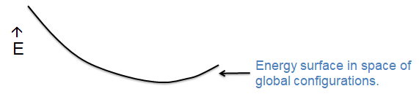

- Notice the data point on the energy surface, and by data point, we mean both the visible vector and the particular hidden vector that we got by stochastically updating the hidden units.
- So, that hidden vector is a function of what the data point is.

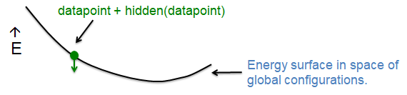

- Starting at that data point, we run the Markov chain for one full step to get a new visible vector and the hidden vector that goes with it (i.e. a reconstruction of the data point plus the hidden vector that goes with that reconstruction).

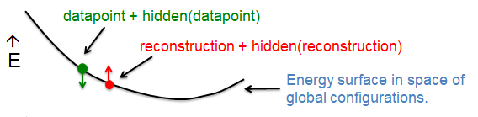

- We then change the weights to pull the energy down at the data point, and pull to the energy up the reconstruction. And the effect of that would be to make the surface look like this.

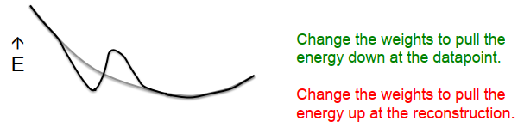

- And you'll notice we're beginning to construct an energy minimum at the data.
- You'll also notice that far away from the data, things have stayed pretty much as they were before.

- When does the shortcut fail?

So, this shortcut of "only doing one full step to get the reconstruction" fails for places that are far away from the data.

- We need to worry about regions of the data-space that the model likes but which are very far from any data point. These low energy holes cause the normalization term to be big, and we can't sense them if we use the shortcut.

- If we use persistent particles, where we remembered their states, and after each update, we updated them a few more times, then they would eventually find these holes. They'd move into the holes, and the learning would cause the holes to fill up.
- i.e. persistent particles would eventually fall into a hole, cause it to fill up then move on to another hole.

- A good compromise between speed and correctness is to start with small weights and to use CD1, (i.e. Contrast Divergence with one full step to get the negative data).
- Once the weights have grown a bit, the Markov chain is mixing more slowly, and now we can use CD3.
- Once the weights have grown more, we can use CD5, or CD9, or CD10 (CD means Contrast Divergence).

So, by increasing the number of steps as the weights grow, we can keep the learning working reasonably well, even though the mixing rate of the Markov chain is going down.

12.4 An example of RBM learning

An example of Contrastive Divergence Learning

Now we'll see a simple example of a RBM, learning a model of images of handwritten 2's. After it's learned the model, we'll look at how good it is at reconstructing 2's. And we'll look at what happens if we give it a different kind of digit and ask it to reconstruct that.

We'll also look at the weights we get if we train a RBM that's considerably larger on all of the digit classes.

- It learns a wide variety of features, which between them are very good at reconstructing all the different classes of digits, and also are quite a good model of those digit classes.
- i.e. if you take a binary vector, there is an image of a handwritten digit, the model will be able to find low energy states, compatible with that image and if you give it an image that's a long way away from being an image of a handwritten digit, the model will not be able to find low energy states compatible with that image.

- How to learn a set of features that are good for reconstructing images of the digit 2

Now we're going to see— how a relatively simple RBM can learn to build a model of images of the digit '2'.

- The image is a 16x16 pixels and it has 50 binary hidden units that are gonna learn to become interesting feature detectors.  - So when it's presented with a data case, the first thing that it does is— use the weights and the connections from pixel to feature detectors, to activate the feature detectors.  - i.e. for each of the binary neurons, it makes a stochastic decision about whether it should deduct the state of 1 or 0. | 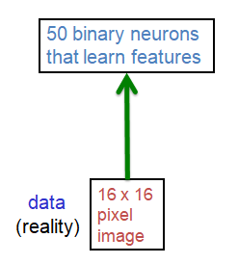
- It then uses these binary patterns of activation to reconstruct the data. That is, for each pixel, it makes a binary decision about whether it should be a 1 or a 0. | 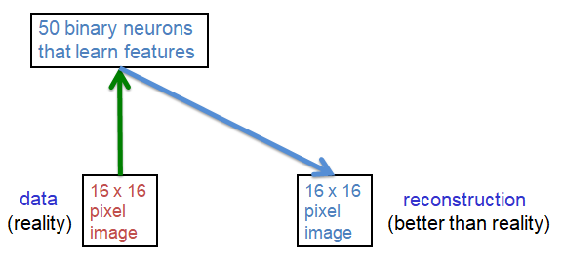
- It then reactivates the binary feature detectors using the reconstruction to activate them rather than the data. | 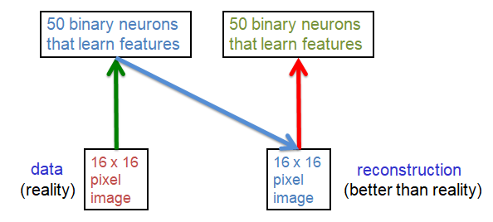
- The weights are changed by  - Incrementing the weights between an active pixel and an active feature detector when the network is looking at data. That will lower the energy of the global configuration of the data, and whatever hidden pattern went with it.  - It decrements the weights, between an active pixel and an active feature detector, when it's looking at a reconstruction, and that would raise the energy of the reconstruction. | 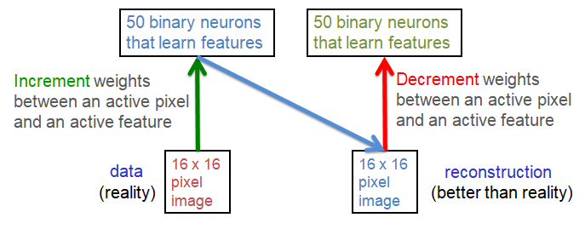

- Near the beginning of learning when the weights are random, the reconstruction would almost certainly have lower energy than the data.
- Because the reconstruction is what the network likes to reproduce on the visible units, given the hidden pattern of activity. And obviously it likes to reproduce patterns that have low energy according to its energy function.

- You can think of what learning does— as changing the weights so the data is low energy and the reconstructions of the data are generally higher energy.

- The weights of the 50 feature detectors

- We start with small random weights to break symmetry: Let's start with some random weights for the 50 feature detectors. We'll use small random weights and each of the squares in the following image shows you the weights to the pixels coming from a particular feature detector.

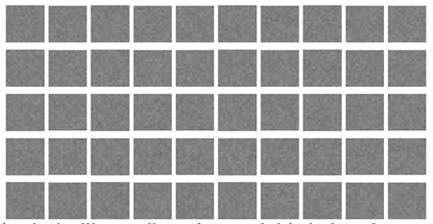

- The small random weights are used to break symmetry. They're because the update rule is stochastic and we don't really need that.

- After seeing a few hundred examples of digits, and digesting the weights a few times, the weights are beginning to form patterns.

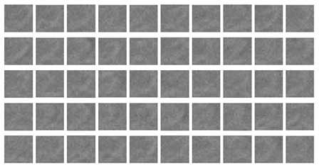

- If we continue to doing that, we can see that many of the feature detectors are detecting the pattern of a whole "2". They're fairly global feature detectors.

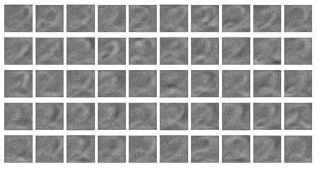

- And those feature detectors are getting stronger and stronger, and now some of them begin to localize, and they're getting more and more local

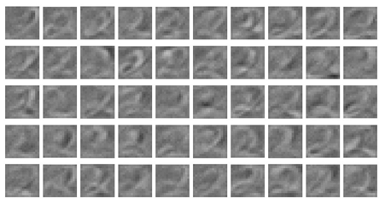 | 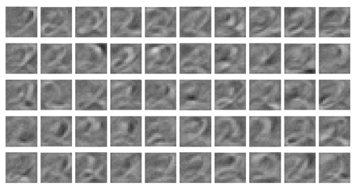 | 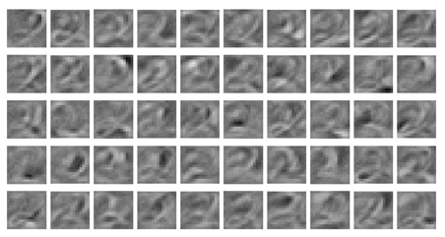
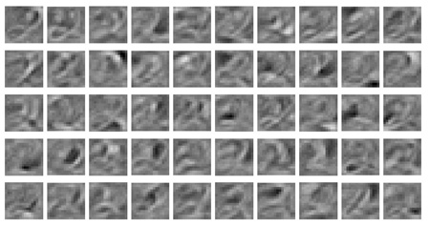 | 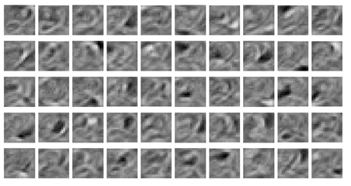 | 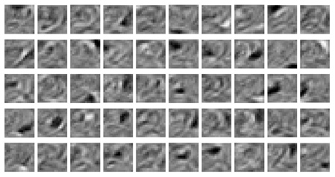

- Following are the final weights and you can see that each neuron has become a different feature detector and most of the feature detectors are fairly local.

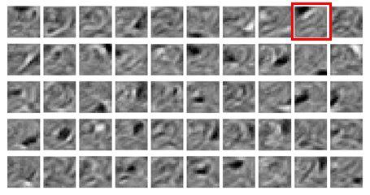

- The final 50 x 256 weights: Each neuron grabs a different feature.
- Now, if we look at the feature detector in the red box, for example, it's detecting the "top" of a "2", and it's happy when the "top of a 2" is where its white pixels are and where there's nothing where the black pixels are.
- So it's representing where the "top of a 2" is.

- How well can we reconstruct digit images from the binary feature activations?

- Test with same digit class: Once we've learned the model, we can look at how well it reconstructs digits and we'll give it some test digits that it hasn't seen before. So we'll start by giving it a test example of a '2'.  - Notice, its reconstruction is pretty faithful to the test example. It's slightly blurry. The test example has a "hook" at the top and that's been blurred after the reconstruction, but it's a pretty good reconstruction.  - Test with different digit class: The more interesting thing we can do is— to give it a test example from a different digit class. So if we give it an example of the '3' to reconstruct:  - What it reconstructs actually looks more like a '2' then like a '3'.  - All of the feature detectors that the model learned, are good for representing '2's, but it doesn't have feature detectors for things like representing that cusp in the middle of the '3'.  So it ends up reconstructing something, but obeys the regularities of a '2', better than it obeys the regularities of a '3'. In fact, the network tries to see everything as a '2'. | 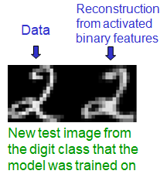
 | 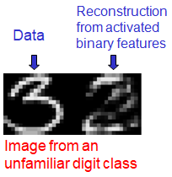

Model of all 10 digit classes:

Here is some feature detectors learned in the first hidden layer of a model of all 10 digit classes using 500 hidden units. And this model has been trained for a long time with contrastive divergence.

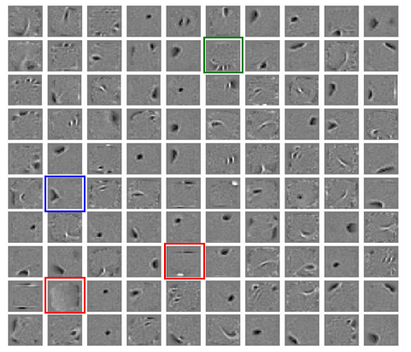

- It has a big variety of feature detectors:
- If you look at the one in the blue box, that's obviously going to be useful for detecting things like '8's.
- If we consider the red box (8th row 6th column), it's a curious kind of feature (it's not what you expect to see). It likes to see pixels on very near the bottom there, and it really doesn't like to see pixels on in a row that there's 21 pixels above the bottom.
- What's going on here is that the data is normalized and so the digits can't have a height of greater than 20 pixels.
- That means if you know that there's a pixel on where those big positive weights are, there can't possibly be a pixel on, where those negative weights are.
- So this is picking up on a long range regularity that was introduced by the way we normalized the data.
- At 9th row and 2nd column there's another one that's doing the same thing for the fact that the data can't be wider than twenty pixels.

- The feature detected in the green box (2nd row 6th column) is very interesting. It's for detecting where the bottom of a vertical stroke comes and it will detect it in a number of different positions and then refuse to detect it in the intermediate positions.

So it's very like one of the least significant digits in a binary number, that as you increase the magnitude of the number goes on-off (on again, and off again), and it shows that this is developing quite complex ways of representing where things are.

12.5 RBMs for collaborative filtering

In this section, we're going to discuss about applying RBMs to collaborative filtering.

- Collaborative filtering means trying to figure out how much a user would like one product based on how much that user liked other products and how much many other users like products.

- The particular case we'll look at is— the Netflix competition, in which a machine learning algorithm has to predict how much a particular user will like a particular movie. The training data for this competition consists of 100 million ratings of 18,000 movies by half a million users.

So it's quite a big data set. It's not the kind of thing anybody at the time imagined a Boltzmann Machine could deal with. As we'll see, there's an important trick to being able to get a RBM to cope with the fact that— nearly all the ratings of nearly all the movies are missing.

But when we use this trick, we're able to train models, that are very useful in practice, and were in fact used in the winning entry.

- Collaborative filtering: The Netflix competition

Let's explain how RBMs were used for collaborative filtering in the Netflix competition.

- In that competition, you're given most of the ratings that 5,00,000 users gave to 18,000 movies, and each movie gets rated on a scale from 1 to 5.
- Each user, of course, only rates a small fraction of the movies. But even so, there's about a hundred million ratings, so it's quite a big data set.
- You have to predict the ratings that the users gave to the held out movies, and if you can do that well you get a big prize.
- You actually win a million dollars if you're the best person at doing that.

- You can draw the ratings in a big matrix like this— where we have movies across the top, and users down the side, for example:
- User two (U2) gave a rating of 5 to movie one (M1), and a rating of 1 to movie three (M3).
- User four (U4) gave a rating of 4 to movie one (M1), and the question is— what rating did he/she give to movie three (M3).
- You might decide he/she (U4) is quite like user two (U2) because he rated movie 1 (M1) the same way. So maybe like user two, he/she (U3) hated movie three (M3).
- On the other hand, user four (U4) liked movie six (M6), and gave rating 5. So maybe U5 likes all the movies.

 | M1 | M2 | M3 | M4 | M5 | M6
U1 |  |  |  | 3
U2 | 5 |  | 1
U3 |  | 3 | 5
U4 | 4 |  | ? |  |  | 5
U5 |  |  | 4
U6 |  |  |  |  | 2

By the time you've done that much reasoning, you realize you better use some statistics.

- Lets use a “language model”

Let's start by trying to use a language model (it sounds bizarre, but as we'll see it's equivalent to a standard method). So we can write the data as a string of triples, much like family trees.

- So, the data is strings of triples. Each triple has a form: User, Movie and Rating.  - Here's some of the data on that table shown on the previous section.  - We just have to predict the third term of a triple. | U2 M1 5  U2 M3 1  U4 M1 4  U4 M3 ?
- So if we built a language model, what we would do is— we'd convert each user into a vector features for that user, (i.e. a vector that we learned) and we converted movie into a vector features for that movie, (a vector that we learned) and from those two feature vectors, we try and predict the rating.  - Now, the obvious way to do this is to put it in a big hidden layer, and make the feature vectors feed into the hidden layer and then have the hidden layer predict the rating. | 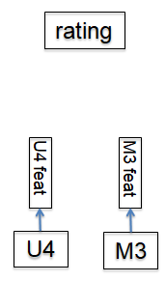

- We tried that, and we couldn't get that to work any better than a very simple method. Which is simply— to take the scalar -product of the feature vector for the user and the feature vector for the movie.  - You just multiply them together point wise, add it up, and output that as your rating.  - So it's not even a soft max, you actually output whatever real number you get form the scalar product.  - Now that's exactly equivalent to doing something else, which is normally called a Matrix Factorization model. | 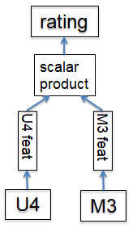
- Matrix Factorization model: If we arrange the user features down the rows and the movie features above the columns, we can see that— if we multiply, that matrix of $users×features$ by the matrix of $features×movies$, then we'll get predictions for the ratings.  - And it will be exactly equivalent to the language model that's beside it.  - So the Matrix Factorization Model is the most commonly used model for Collaborative Filtering like this, and it works pretty well. | 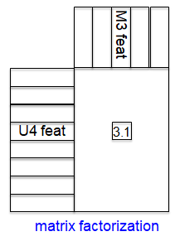

- An RBM alternative to "Matrix Factorization"

Now let's consider an alternative model, using a RBM. It's not obvious how you would apply a RBM to this problem, so we had to do some thinking. In the end we decided that—  - We would treat each user as a training case.  - i.e. a user is a vector of movie ratings.  - For each movie we would have a visible unit that had 5 alternative values.  - So the visible units instead of being binary, are 5-way softmaxes. | 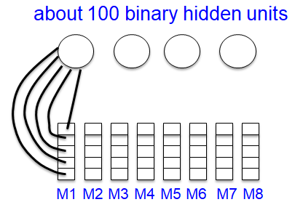
- The network of our Restrictive Boltzmann Machine looks like this:  - Each of it's visible units is a 5-way softmax, with one visible unit per movie. You might start worrying about there being 18,000 visible units here.  - Then we had about 100 binary hidden units.  - Each hidden unit is connected to all 5 values of the softmax and it also has a bias.  So we can see the number of parameters we'll have is large.  - The CD (Contrastive Divergence) learning rule for softmax, incidentally is exactly the same as for a binary unit. And as we mentioned that we've got about a 100 hidden units. | 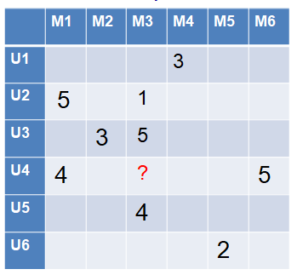

- What we're going to do is— learn a model and then try and fill in one of the missing values using the model.
- One of the visible values is unknown.
- It needs to be filled in by the model.

- How to avoid dealing with all those missing ratings

Now the problem with this approach is— we don't want to have an RBM with 18,000 visible units. Only a few of which have known values. That's a huge number of missing values to begin with. And there's a neat way around that.

- For each user we use an RBM that only has as many visible units as the movies that the user rated. So, it's possible that every user will correspond to a different RBM, with a different subset, with the visible units.
- For each user, use an RBM that only has visible units for the movies the user rated.

- So instead of one RBM for all users, we have a different RBM for every user. Now, all of these RBMs are going to share the same weights.
- i.e. we know which move is which, so if two users saw the same movie and rated the same movie, the weights from that movie to the hidden units will be the same for those two users. So we're doing an awful lot of weight sharing here.
- All these RBMs use the same hidden units.
- The weights from each hidden unit to each movie are shared by all the users who rated that movie.
- And that's lucky, because for each user, we only get one training case.

- Each user-specific RBM only gets one training case: We make this specific RBM for each user with the right architecture, (i.e. the right number of visible units for the movies that the user rated).
- So now there's only one training case, which is that rating vector.
- The weight-sharing makes this OK: All of these half a million training cases share weights to hidden units. So the learning works fine.

- The models are trained with CD1 then CD3, CD5 & CD9: The models are trained with CD1 and then after a while with CD3 (i.e. you go up and down 3 times before you collect the statistics for the negative phase) and then with CD5 and then CD9.

- How well does it work? (Salakhutdinov et al. 2007)

- The RBM's work about as well as the Matrix Factorization methods but they give very different errors.
- So averaging the predictions of the RBM's with the predictions of the Matrix Factorization methods, you get a big win.

- The winning group actually used multiple different RBM models in their average and multiple different matrix factorization models and we think probably other models as well (of over a hundred models).
- Their main models were Matrix Factorization models and RBMs (according to Hinton).

