Chapter 1

**Python for Data Science**

Introduction

* 1. **Law of Large Numbers (LLN)**

In probability theory, the law of large numbers (LLN) is a theorem that describes the result of performing the same experiment a large number of times.

* According to the law, the *average* of the *results* obtained from a *large number of trials* should be close to the expected value and tends to become closer to the expected value as more trials are performed

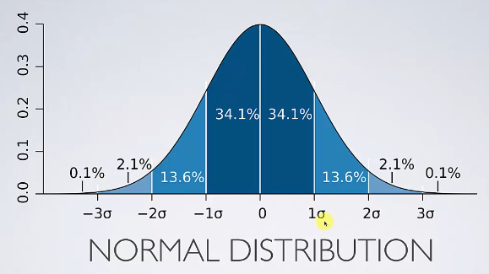

* We've got a bell-shaped Normal-Distribution curve. Let's say the standard deviation $σ=1$. It says:
* There is 34.1% probability that the random number lies between (0, 1)
* There is 34.1% probability that the random number lies between (-1, 0)
* There is total 68.2% probability that the random number lies between (-1, 1)
* Consider the "coin toss example"
* We know we have 50/50 chance of getting HEAD or TAIL. But if we toss the coin for a very fiew time say 10 times, it wont be 50-50
* toss 10 times: HEAD : TAIL = 70% : 30%
* toss 100 times: HEAD : TAIL = 60% : 40%
* toss 1000 times: HEAD : TAIL = 55% : 45%
* toss 10000 times: HEAD : TAIL = 51% : 49%