HTML - 2

**V 2.0**

**2.1 Objectives**

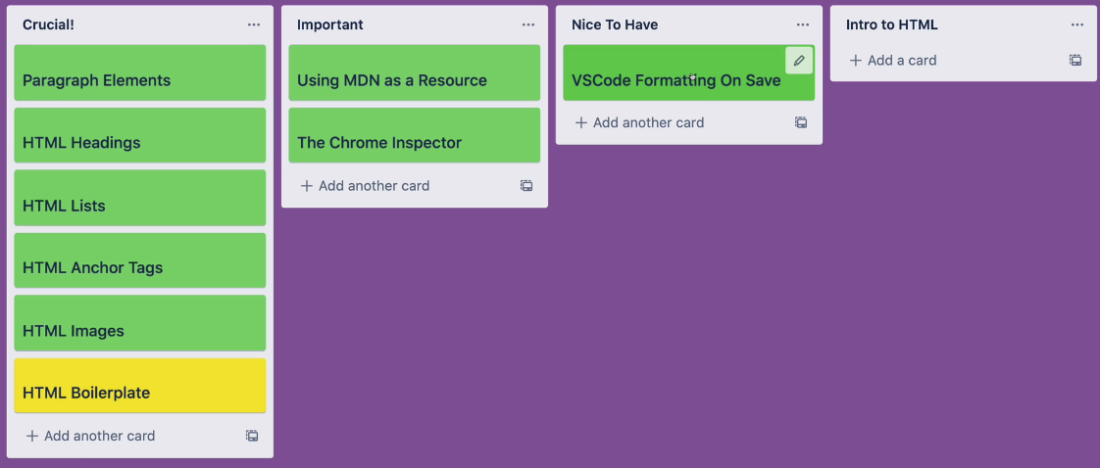

**2.2 Paragraphs**

Same as before

**2.3 Headings**

One <h1> for the entire page. Do not use multiple <h1>.

**2.4 Boilerplate**

Nothing new

**2.5 Lists**

Nothing new

**2.6 image tag**

Nothing new

**2.7 Anchor tag**

Nothing new

**2.8 Comments**

Nothing new

**2.9 HTML 5 Standard**

This website documents HTML standared: <https://html.spec.whatwg.org/>

**2.10 Inline and Block elements**

Nothing new

Use **<div>** to group contents. It's a block elements.

***<span>*** is inline element. It can be style as a button.

**2.11 Html Entities**

Start with "**&**" and end with "**;**" also has **numerical** codes. Useful to display non-keyboard chars and reserved symbols.

**2.12 Semantic markup**

It is important for ***code readability***, ***screen reader*** and ***SEO*** (Search Engine Optimization).

Previously we used *<div>* for main *container*. Now we can use **<main>**. Some others are: **<nav>**, **<header>**, **<footer>** etc. Makes easier to understand which is what.

Categorizing the parts of a marked up page.

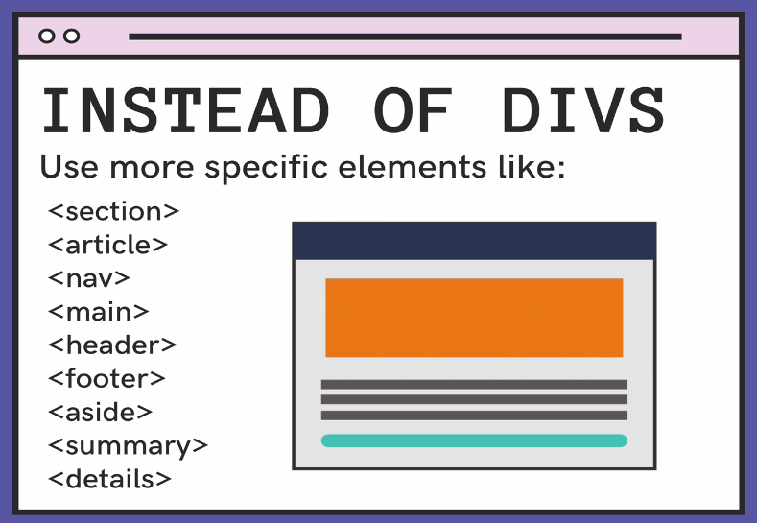

<!DOCTYPE html>

<html lang="en">

<head>

    <meta charset="UTF-8">

    <meta name="viewport" content="width=device-width, initial-scale=1.0">

    <title>About Page</title>

</head>

<body>

    <!-- Header cotaind introductory contens of the page.

    Includes nav bar

    about etc -->

    <header>

        <nav>

            <a>About</a>

        </nav>

    </header>

    <!-- Use only one "main" in a html page -->

    <main>

        <h1>About Me</h1>

        <p>I am a human.</p>

        <a href="chickens.html">Go Home</a>

    </main>

    <!-- There could be multiple section -->

    <section>

        <h2>About Me</h2>

        <p>I am a human.</p>

        <a href="chickens.html">Go Home</a>

    </section>

    <!-- articles are used in newspaper, blog, weather etc widgets -->

    <!-- there should be a heading -->

    <article>

        <h2>About Me</h2>

        <p>I am a human.</p>

        <a href="chickens.html">Go Home</a>

    </article>

    <!-- Use aside for left/rigth navigation pane/links -->

    <aside>

        <p>This is a left side div</p>

    </aside>

    <!-- footer stays in the below of a page -->

    <footer>

        <a href="#">facebook</a>

        <a href="#">facebook</a>

        <a href="#">facebook</a>

        <a href="#">facebook</a>

    </footer>

    <figure>

        <img src ="Intro_To_HTML/pictures/stevie_chicks.jpg" >

        <figcaption>Image of dim</figcaption>

    </figure>

</body>

</html>

**2.13 Emmit: Shortcut html code**

It is a VS code extension to write html quickly.

**2.14 HTML table**

1. Ceate well-formatted HTML Tables
2. Understand when and when not to use tables

* WHAT ARE TABLES: Tables are *structured* *sets of data*, made up of *rows* and *columns*. They can be a great way of *displaying* *data* clearly.
* EARLY USAGE: In the early days of the web, tables were commonly used to create *page* *layouts*. Today, you should only use the table element when you are creating an *actual data table*.
* LOTS OF ELEMENTS: To create a table, you'll use 5-10 different elements! It can be tricky to remember them all. but don't panic!

***Colspan & Rowspan Demo***

<!DOCTYPE html>

<html lang="en">

<head>

    <meta charset="UTF-8">

    <meta name="viewport" content="width=device-width, initial-scale=1.0">

    <title>Col/Row-Span</title>

</head>

<body>

    <header>

        <h1>Tables Demo</h1>

        <h2>Heaviest Birds</h2>

    </header>

    <table border="1">

        <thead>

            <!-- colsapn & rowspan works with defined cols and rows -->

            <tr>

                <th rowspan="2">Animal</th>

                <th >Average mass [kg (lb)]</th>

                <th >Maximum mass [kg (lb)]</th>

                <th >Flighted</th>

            </tr>

            <tr>

                <th >Species</th>

                <th colspan="2">Average Speed</th>

            </tr>

        </thead>

        <tbody>

            <tr>

                <td>Ostrich</td>

                <td>104(230)</td>

                <td>156.8 (346)</td>

                <td>No</td>

            </tr>

            <tr>

                <td>Somali Ostrich</td>

                <td>90 (200)</td>

                <td>130 (287)</td>

                <td>No</td>

            </tr>

            <tr>

                <td>Wild Turkey</td>

                <td>13.5 (29.8)</td>

                <td>39 (86)</td>

                <td>Yes</td>

            </tr>

        </tbody>

    </table>

</body>

</html>

* *colsapan* is used to make a cell wide that takes *specified no of columns* of the table.
* *rowapan* is used to make a cell longer that takes *specified no of rows* of the table.

**2.14 HTML Forms**

1. Explain the role of the form element
2. Utilize a variety of form controls
3. Define complex HTML forms
4. Add HTML5 Form Validations
5. Ensure accessibility of our forms

* It is used for **signup/log-in/product/** or to create a **search bar**.
* It is used with **post/get** method attributes. It contains the *address* where the data needs to *send* using ***action*** attribute.
* **CREATING FORMS**
* The ***<form>*** element itself is a shell or container that doesn't have any visual impact.
* We then fill the form with a collection of ***inputs***, ***checkboxes***, ***buttons***, etc.
* **<form>**
* The ***form*** element "represents a document section containing interactive controls for submitting information."
* The ***action*** attribute specifies WHERE the form data should be sent.
* The ***method*** attribute specifies which HTTP method should be used (don't worry about this for now)
* From Elements
* common input types: **< input type="">** element is used to create a variety of different form controls. We have 20+ possible types of inputs.
* The **type** attribute is where the magic happens. Changing ***type*** dramatically *alters* the *input’s behavior* and *appearance*.
* As default (with no type specified) it is a text input.
* **Placeholder** to indicate what type of input this is.
* In label "for" & "id" attributes are use to coonect input and label.
* Buttons to submit the form:
* Any button inside a **<form>** will submit the form by default.
* We can make the button to ***not submit*** the form by specifying ***type***.

<button type="button">Regular button (won't submit)</button>

* We can specify explicitly type to **submit** the form <button type="button">
* This will create also a ***button***. We can name the button using ***value*** attribute.

<input type="submit" value="Click Me!">

* You can submit the form by hitting "Enter" if there is no button.
* **"name"** attributes:
* "name" is important to send data to Database.

<input id="username" type="text" placeholder="username" name="username">

We cannot view the data in URL when we use a POST request.

* Use search engines in your web page

    <!-- Form search google/yandex practice -->

    <form method="get" action="https://www.google.com/search?client=firefox-b-d">

        <input type="text" name="q" placeholder="search google">

    </form>

    <form method="get" action="https://yandex.com/search/?">

        <input type="text" name="text" placeholder="search yandex">

    </form>

* Other form elements:
* Check box:

<label for="agree">I agree to everything</label>

Or use "checked" if you want it already checked.

<label for="agree" checked>I agree to everything</label>

* Radio Button: Group the radio buttons by giving the same name to them. It is good to use them in a container like <p>. Use unique "***values***" unless on/off will sent to the server.

        <p>

            <label for="xs">XS:</label>

            <input type="radio" name="size" id="xs" value="xs">

            <label for="s">S</label>

            <input type="radio" name="size" id="s" value="s">

            <label for="m">M</label>

            <input type="radio" name="size" id="m" value="m">

        </p>

* Select/Dropdown menu: Specify **values** also. You can make some option "preselected" or some default

    <form>

        <p>

            <label for="meal">Please Select an Entree</label>

            <select name="meal" id="meal">

                <option value="">Selecto</option>

                <option value="fish">Fish</option>

                <option value="veg" >Vegetarian</option>

                <!-- <option value="veg" selected>Vegetarian</option> -->

                <option value="steak">Steak</option>

            </select>

        </p>

    </form>

* Range: Following is preselected to 75 initial value. You can use steps also eg: step ="7".

        <p>

            <label for="cheese">Amount of Cheese:</label>

            <input type="range" id="cheese" min="1" max="100" value="75" step = "7" name="cheese_level">

        </p>

* Number input:

            <label>

                Enter a Number:

                <input type="number" placeholder="enter a number" name="num" min="1" max="1000">

            </label>

* Text area:

<p>

<label for="requests">Any Special Requests?</label>

<br>

<textarea id="requests" rows="10" cols="40" name="Requests?" placeholder="Type something here"></textarea>

</p>

**All form at once**

<!DOCTYPE html>

<html lang="en">

<head>

    <meta charset="UTF-8">

    <meta name="viewport" content="width=device-width, initial-scale=1.0">

    <title>Forms Demo</title>

</head>

<body>

    <h1>Forms Demo</h1>

    <h2>Our First Form</h2>

    <form action="/tacos">

        <p>

            <label for="username">Enter a Username:</label>

            <input id="username" type="text" placeholder="username" name="username">

        </p>

        <p>

            <label for="password">Enter a Password:</label>

            <input type="password" placeholder="password" id="password" name="password">

        </p>

        <p>

            <label for="color">Enter a Color:</label>

            <input type="color" id="color" name="color">

        </p>

        <p>

            <!-- Alternative way to label an input (less common) -->

            <label>

                Enter a Number:

                <input type="number" placeholder="enter a number" name="num" min="1" max="1000">

            </label>

        </p>

        <!-- this button doesn't submit the form b/c of the "type" attribute -->

        <button type="button">Regular button (won't submit)</button>

        <!-- This button submits the form! -->

        <button>Submit!!!</button>

        <!-- So does this one: -->

        <input type="submit" value="Click Me!">

    </form>

    <hr>

    <!-- Outside of a form, no default behavior -->

    <button>Not Inside Form</button>

    <h2>Hijacking Searches</h2>

    <h3>Search Reddit</h3>

    <form action="https://www.reddit.com/search">

        <input type="text" name="q">

        <button>Search Reddit</button>

    </form>

    <h3>Search Google</h3>

    <form action="https://www.google.com/search">

        <input type="text" name="q">

        <button>Search Google</button>

    </form>

    <h3>Search Youtube</h3>

    <form action="https://www.youtube.com/results">

        <input type="text" name="search_query">

        <button>Search Youtube</button>

    </form>

    <h2>More Inputs!</h2>

    <form action="/birds">

        <input type="checkbox" name="agree_tos" id="agree">

        <label for="agree">I agree to everything</label>

        <p>

            <label for="xs">XS:</label>

            <input type="radio" name="size" id="xs" value="xs">

            <label for="s">S</label>

            <input type="radio" name="size" id="s" value="s">

            <label for="m">M</label>

            <input type="radio" name="size" id="m" value="m">

        </p>

        <p>

            <label for="meal">Please Select an Entree</label>

            <select name="meal" id="meal">

                <option value="fish">Fish</option>

                <option value="veg">Vegetarian</option>

                <option value="steak">Steak</option>

            </select>

        </p>

        <p>

            <label for="cheese">Amount of Cheese:</label>

            <input type="range" id="cheese" min="1" max="100" value="75" name="cheese_level">

        </p>

        <p>

            <label for="requests">Any Special Requests?</label>

            <br>

            <textarea id="requests" rows="10" cols="40" name="Requests?" placeholder="Type something here"></textarea>

        </p>

        <button>Submit</button>

    </form>

    <h2>Validations Demo</h2>

    <form action="/dummy">

        <p>

            <label for="first">Enter First Name</label>

            <input type="text" id="first" name="first" required>

        </p>

        <p>

            <label for="user">Username</label>

            <input type="text" id="user" name="username" minlength="5" maxlength="20" required>

        </p>

        <p>

            <label for="email">Email</label>

            <input type="email" id="email" name="email" required>

        </p>

        <p>

            <label for="website">Website</label>

            <input type="url" id="website" name="website">

        </p>

        <button>Submit</button>

    </form>

</body>

</html>

* Form Validations: Valid Email-address, Password cannot be empty, address must be filled up etc.
* Someone can also **send/write** a **bug** to your **database** just using **<form>** from your web page. So you must set some restrictions to your form and your server to make them safe.
* Using regular expression: Use regular expression to make some pattern to your input. It can make your server more safe. Use RegExp with "pattern" attribute.
* Use "***required***" attribute, set some ***minlength*** and ***maxlength*** to your input. In range input setting ***min*** & ***max*** also validates the inputs.

    <h2>Validations Demo</h2>

    <form action="/dummy">

        <p>

            <label for="first">Enter First Name</label>

            <input type="text" id="first" name="first" required>

        </p>

        <p>

            <label for="user">Username</label>

            <input type="text" id="user" name="username" minlength="5" maxlength="20" required>

        </p>

        <p>

            <label for="email">Email</label>

            <input type="email" id="email" name="email" required>

        </p>

        <p>

            <label for="website">Website</label>

            <input type="url" id="website" name="website">

        </p>

        <button>Submit</button>

    </form>

* Example 2.1: Practice marathonForm.

<!DOCTYPE html>

<html lang="en">

<head>

    <meta charset="UTF-8">

    <meta name="viewport" content="width=device-width, initial-scale=1.0">

    <title>Register Form</title>

</head>

<body>

    <h1>Race Registration!</h1>

    <form action="">

        <div>

            <label for="first">First Name</label>

            <input type="text" id="first" name="firstname" required>

            <label for="last">Last Name</label>

            <input type="text" id="last" name="firstname" required>

        </div>

        <p>Select a Race: </p>

        <div>

            <input type="radio" name="race" id="funrun" value="funrun">

            <label for="funrun">Fun Run 5k</label>

        </div>

        <div>

            <input type="radio" name="race" id="half" value="half">

            <label for="half">Half Marathon</label>

        </div>

        <div>

            <input type="radio" name="race" id="full" value="full">

            <label for="full">Full Marathon</label>

        </div>

        <div>

            <label for="email">Email</label>

            <input type="email" name="email" id="email" required>

            <label for="password">Password</label>

            <input type="password" name="password" id="password" required>

        </div>

        <div>

            <label for="division">Select Age Group</label>

            <select name="division" id="division">

                <option value="kids">under 18</option>

                <option value="ya">18-30</option>

                <option value="adults">30-50</option>

                <option value="seniors">50+</option>

            </select>

        </div>

        <button>Register</button>

    </form>

</body>

</html>